**Link**

[**https://www.build18.org/garage/project/565/**](https://www.build18.org/garage/project/565/)

**General Overview:**

We want to create a robotic hand that can simulate the sign language alphabet as well as other simple one handed signs. This hand will be able to listen to voice command and sign based on these voice commands. We will also have a software component that will translate English into sign language and vice versa.

**Detailed Description:**

**Robot Hand**

The robot hand will use torsion springs that will allow the fingers of the hand to be straight. The springs will be connected to the base of the hand using strings connected to servo motors. These motors will pull the strings and thus the fingers of the hands down and to the left and the right, allowing for movement of the hand. The exoskeleton of the hand will be 3D printed using PLA filament. The hand will rest on a laser cut box which will contain the arduino and the motors.

**Translating Sign Language to English**

We will be using a Leap motion sensor to take in hand position and movement as well as facial emotions. This is because sign language is very context-specific and so just hand movement does not suffice. We also need it because different hand positions look very similar and so just using OpenCV or some other library would not be accurate enough. We will then use an NLP algorithm to translate sign language into English. We will have to depend on context in order to reconstruct grammar as sign language does not have formal grammar rules and thus certain traditional NLP algorithms will not work. Once we have translated the component, we will use the microphone on a computer to say the translation out loud.

**Translating English to Sign Language**

We will be using a computer microphone to listen for English rules. We will then translate the words into sign language either using basic words that can be done with one hand or letters and having our robot hand sign out the letters using the robot hand.

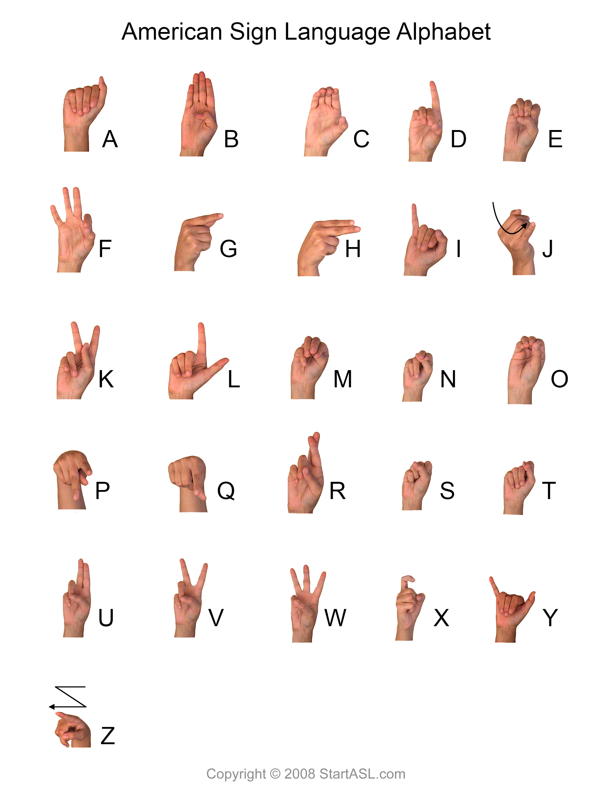

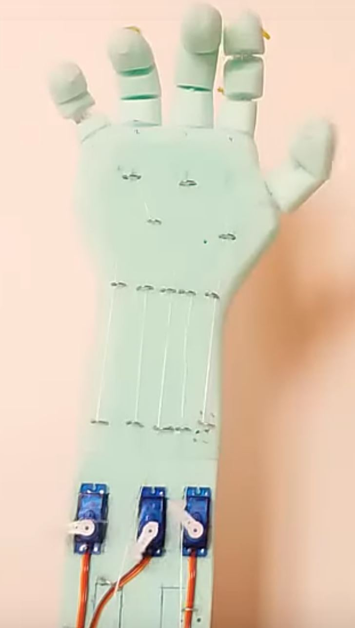

**Individual Letters**

* A, B, C, D, E, F, I, L, X, Y only depend on curling each finger
* M, N, O can be differentiated by the amount that each finger curls
* R, U, V, W, K, S, T require the fingers to be spaced further apart which can be accomplished using another servo per finger that changes the angle of the finger
* P, Q require up and down movement of the wrist
* G, H, Z, J require side to side movement of the wrist

**Mechanism Resources**

* [3D printed hand controlled by strings](https://www.instructables.com/id/DIY-Robotic-Hand-Controlled-by-a-Glove-and-Arduino/)
* [Foam hand controlled by strings](https://www.instructables.com/id/Arduino-Make-a-Robotic-Hand-Low-Cost/)
* [String controlled hand with springs](https://www.instructables.com/id/Simple-Animatronics-robotic-hand/)
* [Hand with larger base](https://www.instructables.com/id/Glove-Controlled-Robotic-Hand-Cheap-and-Simple-Ver/)
* [Hand with opposable thumb (sort of)](https://www.instructables.com/id/3D-Printed-Robotic-Hand/)
* [Pan-Tilt mechanism](https://www.adafruit.com/product/1967)
* <https://www.servomagazine.com/magazine/article/august2015_Ohlmus>

Wishlist Links

<http://www.adafruit.com/wishlists/496677>

<https://www.mcmaster.com/order/rcvRtedOrd.aspx?ordid=9715274727169&lnktyp=txt>

<https://www.amazon.com/hz/wishlist/ls/3TCHPZ7BF3E6A?ref_=wl_share>

https://www.pololu.com/wishlist/1J13547

**Parts List**

|  |  |  |  |
| --- | --- | --- | --- |
| **Description** | **Cost** | **#** | **Total** |
| [Micro Servo](https://www.adafruit.com/product/169?gclid=CjwKCAiA_MPuBRB5EiwAHTTvMRwym9jt-SLJqmr8C1-lt3nvOM42iuc4XKCLEm7SSWkjUCo9A7L6_RoCrc8QAvD_BwE)  For controlling the hand mechanism | $5.95 | 7 | $41.65 |
| [**LCD Screen**](https://www.amazon.com/Adafruit-Standard-16x2-Extras-ADA181/dp/B00NAY1B2Y)  For displaying the translated text | $14.02 | 1 | $14.02 |
| [**Leap Motion**](https://www.adafruit.com/product/2106)  For tracking hand gestures so that they can be translated to English | $89.95 | 1 | $89.95 |
| [**Fishing line (8lb 110yd)**](https://www.amazon.com/Berkley-Trilene-Casting-Monofilament-6-Pound/dp/B001F5EZ8W/ref=sr_1_6?ie=UTF8&qid=1424133632&sr=8-6&keywords=fishing+line)  For controlling the movement of the fingers with the motors | $6.19 | 1 | $6.19 |
| **Springs**  For each finger  2 compression springs (<https://www.mcmaster.com/9657k312>)  12 torsional springs (<https://www.mcmaster.com/9271k607>) | $10.77  $4.63 | 1  2 | $20.03 |
| [**Microphone**](https://www.ebay.com/itm/Voice-Recognition-Module-microphone-RS232-Converter-Dupont-Arduino-Compatible/191150204194?ssPageName=STRK%3AMEBIDX%3AIT&_trksid=p2057872.m2749.l2649) |  |  | $19.90 |
| [**Micro SD card**](https://www.amazon.com/Samsung-MicroSDXC-Adapter-MB-ME128GA-AM/dp/B06XWZWYVP/ref=sr_1_3?keywords=micro%2Bsd%2Bcard&qid=1573966104&sr=8-3&th=1) |  |  | $19.49 |
| [**Bigger Stepper Motor**](https://www.pololu.com/product/1472) **(7.4V, 1A)** |  |  | $39.95 |
| [**Smaller Stepper Motor**](https://www.adafruit.com/product/324) **(12V, 350 mA)** |  |  | $14 |
| [**Stepper Motor Driver**](https://www.adafruit.com/product/1438) |  |  | $19.95 |
| [**Servo Motor Driver**](https://www.adafruit.com/product/1411) |  |  | $17.50 |
| **3D Printing Budget**  For building the hand’s exoskeleton |  |  | $106.16 |
|  |  |  | $452.63 |

**3D printing costs**

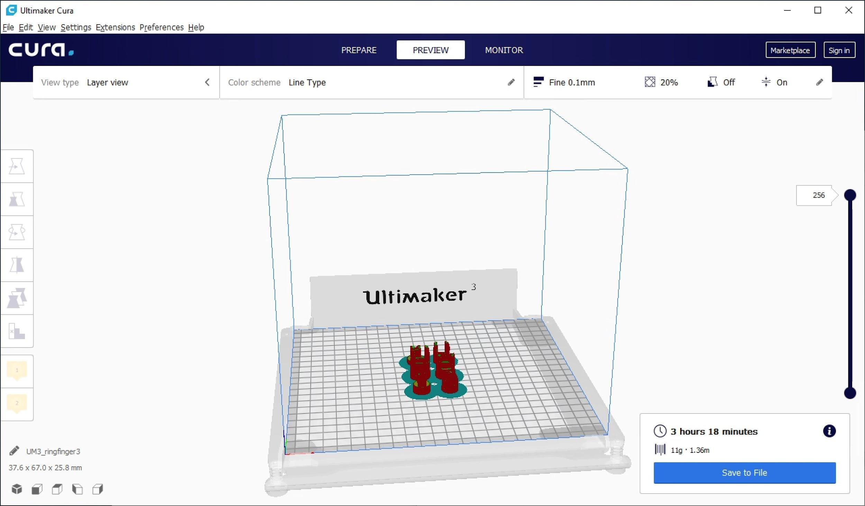

We are estimating our 3D printing costs using a sample CAD file of a jointed finger found online. After putting a file of the ring finger into Cura (shown in the screenshot above), by estimating the price of PLA per gram of $0.20, we can say that the costs of 5 fingers is about $25. Additionally, the price of the wrist, estimated from the same source, would be about $20. The base of the hand would be around $20. This design incorporated separate parts for each joint in the finger. Since this is a rough estimate for what our hand could cost, and we want the ability to have extra printing money in case builds fail in the printer, we are asking for $150 for 3D printing money to cover the expenses of the hand and any potential design optimizations.