**Software Project Report**

Name:Tejas Shenoy , Shubham Shirke, Harshal Shetty

Online Examination Portal

**Table of Contents**

**Abstract**

**List of Figures**

**List of Tables**

**Index**

**Project Description :**

This web application provides facility to conduct Online examination world wide.

It saves time as it allow number of student to give the exam at a time and displays the result as the test get over ,so no need to wait for results. Its is automatically generated by the server.

User can register , login and give the test with his specific id , and can see the result as well.

**Project Overview**.

The Purpose of the Project

Scope of the Project

**Background to the problem**

**Naming Conventions and Definitions**

Definitions of Key Terms

**Functional Requirements :**

Client Side: .NET Framework, Web Browser, Windows XP/2000/Vista

Web Server: .NET Framework, Windows XP/2000/Vista

Data Base Server: DB2

This project is a web application that is developed in ASP.NET

having DB2 as back end.

1. Database Design (DB2)

2. Input Design (ASP.NET)

3. Coding (VB.NET)

**Security Requirements:**

Application will allow only valid users to access the system.

Access to any application resource will depend upon user’s designation.

There are two types of users namely Administrator and Student. Security is based upon the individual user ID and Password.

**Design :**

**ER Diagram:**

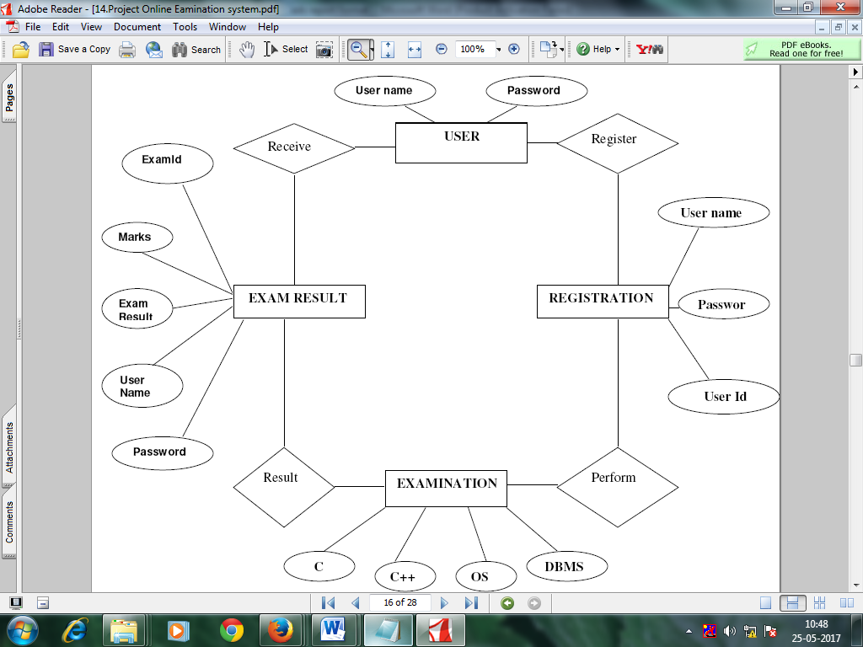

**User Stories**

**Users:**

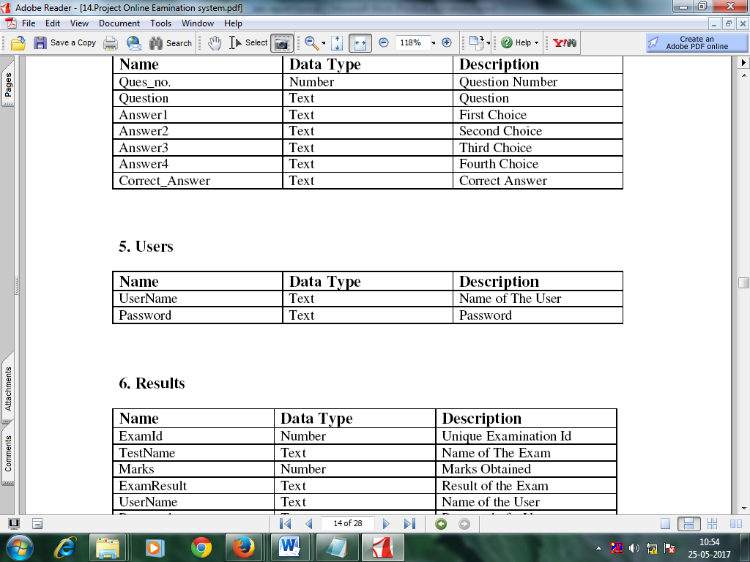

**Results:**

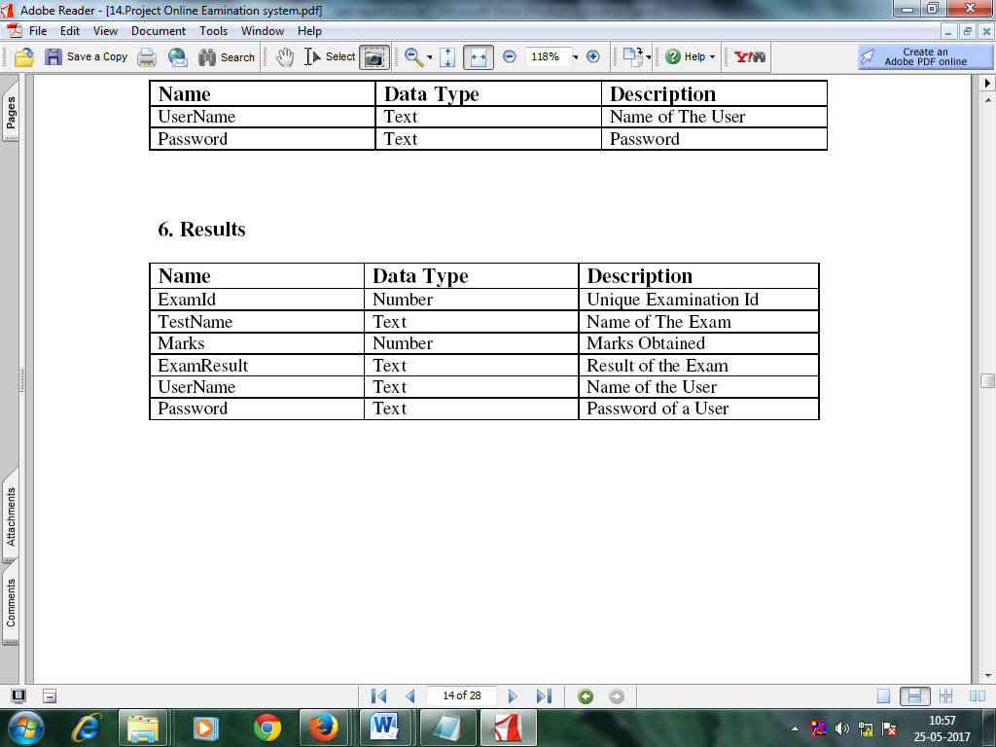

Flow Graph

**Test Plans**

**Acceptance Criteria:**

The software should meet the functional requirement and perform the

functionality effectively and efficiently.

A user-friendly interface with proper menus.

Data transfer should be accurate and with in a reasonable amount of

time keeping in mind the network traffic.

The system should not allow entry of duplicate key values.

System should have the ability to generate transactional Logs to avoid

any accidental loss of data.

Approach

Suspension and resumption

Testing materials (hardware / software requirements)

Test cases

**Glossary**

**Bibliography**

**1. Asp.Net Bible**.

**2. Asp.Net Complete Reference**

**3. www.codeguru.com**

**4. www.devex.com**

**\*\*\*\***