**🧠 What is Model Context Protocol?**

Model Context Protocol (MCP) refers to a set of rules or a standardized interface that defines how contextual information is passed to AI models, especially large language models (LLMs), during inference or conversation. It ensures that AI models behave more consistently, understand their task better, and can engage in multi-turn or stateful conversations effectively.

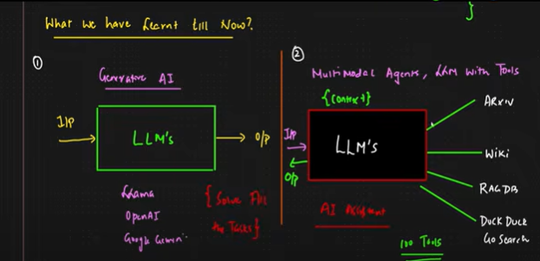

As the number of external tools integrated into multimodal AI agents increases, so does the complexity of managing, maintaining, and updating custom integration code.

This leads to **scaling inefficiencies, fragility, and maintenance overhead**, making the system unsustainable beyond a certain threshold (e.g., 100+ tools).

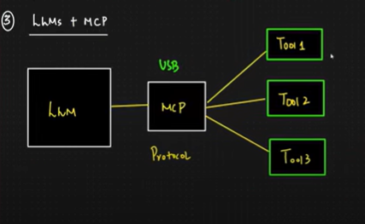

A standardized **middleware protocol** that acts as a **communication manager** between the LLM and all tools.

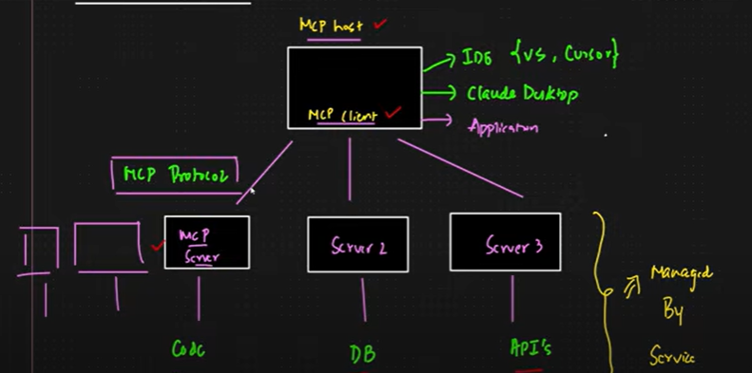

✅ **Context: The Problem You Raised**

When a **single LLM** needs to interact with **100 tools**, each with its own API or format:

* You need **custom code** for each tool.
* If a tool updates, you must update its code again.
* It becomes hard to **scale**, **maintain**, and **debug**.

🚀 **Solution: MCP (Model Context Protocol)**

This diagram introduces **MCP** as a **middleware or protocol layer** to abstract and standardize tool interactions.

🔄 **How It Works (From the Diagram)**

***1. MCP Host (Client Layer)***

* This is your **user interface** or **entry point**.
* It runs in an IDE (like VS Code), cloud desktop (like AWS Cloud9), or within applications.
* Acts as a **client** for MCP.

***2. MCP Protocol***

* This is the **standard protocol** that defines how tools, servers, databases, and LLMs talk to each other.
* You don’t write custom code per tool—instead, you write to the protocol.
* Think of it like **USB** for AI tools: plug-and-play.

***3. MCP Server***

* This handles **code-related tools** (e.g., compilers, code execution tools).
* It's designed to execute or manage tasks related to source code.
* Uses MCP Protocol to talk to the host/client.

***4. Server 2 (DB Layer)***

* Manages **Databases** (DB).
* Could connect to SQL, NoSQL, etc.
* Unified under the same MCP Protocol.

***5. Server 3 (APIs Layer)***

* Handles **APIs** or web tools.
* Unified with others through MCP Protocol.
* If a new API is added, no need to update client code—just update this server or the service layer.

📦 **Managed By a Service Layer**

* All backend servers (code, DB, APIs) are **managed centrally**.
* This reduces redundancy and makes it easy to **update tools** without affecting the LLM or front-end logic.

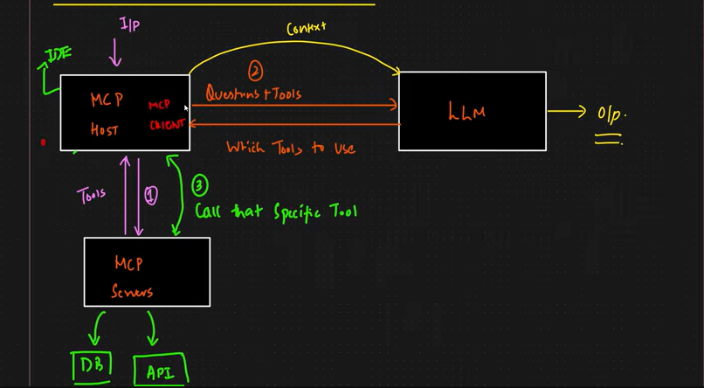

**Communication Between MCP three main components (MCP HOST , MCP CLIENT and MCP SERVER) + LLM :**

🔄 Step-by-Step Communication Flow :

*✅****Step 1: Input from IDE to MCP Host***

* The user enters a **query** in the IDE.
* This input is sent to the **MCP Host**, which acts as a **client** managing all further routing.

*✅****Step 2: MCP Host sends context to LLM***

* MCP Host builds **context** (input + available tools list).
* It sends this to the **LLM**.
* The LLM processes it and determines:
* The **intent** of the user.
* **Which tools** are needed to fulfill the request.

*✅****Step 3: LLM replies with questions + tools***

* The LLM sends back:
* **Questions** it needs to resolve.
* **Which tools** are required to get the necessary info (DB, API, etc.).
* This response includes **tool choices**, not raw data.

*✅****Step 4: MCP Host calls the specific tool***

* Now that it knows what’s needed, MCP Host:
* Calls **MCP Server**.
* Tells it exactly **which tool** to invoke.
* Passes the required **parameters**.

*✅****Step 5: MCP Server runs the tool***

* MCP Server:
* Executes the specific **DB query** or **API call**.
* Returns results to MCP Host.

*✅****Step 6: MCP Host passes final context to LLM***

* Host feeds tool results **back into the LLM**.
* LLM uses this to **generate the final output**.

*✅****Step 7: Output sent back to IDE***

* Final answer is returned to the user via the IDE.