A
CASE STUDY REPORT
ON
“STUDENT FEEDBACK SENTIMENT AND TOPIC ANALYSIS”
Subject : COMPLEX ENGINEERING PROBLEM (CEP)
SUBMITTED BY
Anuja Birajdar (A-5)
Pallavi Metri (A-40)
Sakshi Revaje (A-51)
Sneha Khairate (A-67)
Vijayalaxmi Kamble (A-71)
Chaitali Mhetras (A-73)
Group 1 | Unit 5-CEP 1 | Problem Statement A
UNDER THE GUIDANCE OF
Prof. S. C. Papade

DEPARTMENT OF COMPUTER SCIENCE AND ENGINEERING
P.N.E.S.P.’S
NAGESH KARAJAGI ORCHID COLLEGE OF ENGG. & TECH, SOLAPUR.
An Autonomous Institute
(AFFILIATED TO DR. BABASAHEB AMBEDKAR TECHNOLOGICAL UNIVERSITY, LONERE)
A.Y. 2026-2027

CERTIFICATE
This is to certify that the case study entitled “STUDENT FEEDBACK SENTIMENT AND TOPIC ANALYSIS” has been completed by the following students of Final Year (CSE) class in a satisfactory manner under my guidance.
Anuja Birajdar (A-5)
Pallavi Metri (A-40)
Sakshi Revaje (A-51)
Sneha Khairate (A-67)
Vijayalaxmi Kamble (A-71)
Chaitali Mhetras (A-73)
The case study is found to be complete in partial fulfillment for the award of Degree of Bachelor in Computer Science & Engineering.
Prof. S.C. Papade
SUBJECT INCHARGE
DEPARTMENT OF COMPUTER SCIENCE AND ENGINEERING
P.N.E.S.P.’S
NAGESH KARAJAGI ORCHID COLLEGE OF ENGG. & TECH, SOLAPUR.
An Autonomous Institute
(AFFILIATED TO DR. BABASAHEB AMBEDKAR TECHNOLOGICAL UNIVERSITY, LONERE)
A.Y. 2026-2027

Index
Chapter No. | Title | Page No.
1 | Abstract | 1
2 | Introduction | 2
2.1 | Background of the Problem | 2
2.2 | Importance in Industry/Society | 2
2.3 | Objectives of the Study | 2
3 | Problem Statement | 3
3.1 | Clear Definition of the Engineering Problem | 3
3.2 | Scope and Limitations | 3-4
4 | Design and Analysis | 5
4.1 | Problem Design and Topic Taxonomy | 5
4.2 | Functional Requirements | 6
5 | Implementation Details | 7
5.1 | Tools and Technologies Used | 7
5.2 | Hardware/Software Requirements | 8
6 | Results and Discussion | 9
6.1 | System Architecture Diagram | 9
6.2 | System Workflow Diagram | 11
6.3 | Algorithm and Pseudocode | 13
6.4 | Test Cases and Evaluation Metrics | 14
6.5 | Experimental Results and Error Analysis | 15
6.6 | Sample Output | 16
6.7 | Visual Summary of Results | 17
7 | Conclusion | 18
7.1 | Summary of Findings | 18
7.2 | Achievement of Objectives | 18
7.3 | Limitations and Future Work | 19
8 | References | 20

List of Figures
FIG. NO. | TITLE | PAGE NUMBER
1 | System Architecture Diagram | 9
2 | System Workflow Diagram | 11
3 | Algorithm Flowchart: Topic and Sentiment Classification | 13
4 | Observed Sentiment Distribution for 30 Synthetic Comments | 17
5 | Recurring Topics and Negative/Mixed Mentions | 17

List of Tables
TABLE NO. | TITLE | PAGE NO.
4.1 | Student Feedback Topic Taxonomy | 5
4.2 | Sample Feedback Record Schema | 5
4.3 | Functional Requirements | 6
5.1 | Tools and Technologies Used | 7
5.2 | Hardware and Software Requirements | 8
6.1 | Representative Test Cases | 14
6.2 | Observed Experimental Results | 15
6.3 | Sentiment Confusion Matrix | 15
6.4 | Topic Frequency and Concern Counts | 16

CHAPTER 1: ABSTRACT
Universities receive large volumes of student feedback about teaching quality, examinations, infrastructure, library facilities, and student support. These comments are usually written in free text and may include spelling errors, informal wording, negation, mixed sentiments, and references to more than one issue. Manual reading can be slow and inconsistent, making it difficult for decision-makers to recognize repeated concerns across hundreds of responses.
This case study proposes a Student Feedback Sentiment and Topic Analysis system using Natural Language Processing (NLP). The system normalizes each comment, corrects a small set of common spelling variants, assigns one or more topic labels, estimates overall sentiment, counts recurring themes, and generates a concise evidence summary. Five institutional topics are used: Teaching and Learning, Examinations and Assessment, Infrastructure and Facilities, Library Services, and Student Support and Administration. Sentiment is represented by Positive, Negative, Mixed, and Neutral.
The working prototype uses transparent keyword rules for multi-label topic detection and a compact sentiment lexicon with simple negation handling. The design includes data input, preprocessing, topic and sentiment analysis, aggregation, visualization, evaluation, and human review. A synthetic test set of 30 hand-labelled comments was used to demonstrate the workflow. The baseline matched all curated topic labels and correctly classified 29 of 30 sentiment labels (96.7% accuracy; macro F1 0.972 on this small sample).
These scores are illustrative rather than evidence of real-world accuracy because the examples are synthetic and were written to exercise the rules. A practical deployment would require anonymized institutional feedback, an independently labelled held-out test set, ongoing error review, and comparison with a supervised machine-learning model. The system is intended as a decision-support aid, not as an automatic judge of the truth or severity of a complaint.
Keywords: Natural Language Processing, sentiment analysis, multi-label classification, student feedback, text normalization, negation handling, topic mining, institutional decision support.

CHAPTER 2: INTRODUCTION
2.1 Background of the Problem
Student feedback is a valuable source of evidence for improving teaching, assessment, campus facilities, library services, and student administration. Comments may describe a lecturer who explains concepts clearly, an examination timetable released too late, a broken projector, a shortage of reference books, or unanswered scholarship questions. The same concern may be expressed in different words, with typographical errors, short phrases, or incomplete sentences.
Traditional review often depends on staff reading comments individually and then manually grouping them. This can become difficult when response counts increase, and it may lead to inconsistent categorization or repeated concerns being overlooked. An NLP pipeline can assist by grouping similar topics and estimating whether comments express positive, negative, mixed, or neutral sentiment.
2.2 Importance in Industry/Society
- University management: obtains a concise overview of recurring issues and areas that may need investigation.
- Teaching staff: can review evidence about explanation clarity, syllabus coverage, practical sessions, and doubt-solving.
- Examination section: can identify comments about schedules, question papers, marking, results, and assessment processes.
- Facility and library teams: can prioritize inspection of equipment, classrooms, connectivity, books, and library services.
- Student support teams: can locate repeated concerns about portals, registration, fees, scholarships, counselling, and help desks.
- Students and society: benefit when feedback is reviewed systematically and decisions are made with appropriate human oversight.
2.3 Objectives of the Study
- Develop an NLP workflow for processing short student feedback comments.
- Normalize text and handle a small set of spelling variants and contractions.
- Assign multiple topic labels when a comment discusses more than one institutional issue.
- Classify overall sentiment with basic awareness of negation and mixed polarity.
- Identify recurring concerns using topic counts and negative/mixed counts.
- Generate interpretable outputs, evaluate a working prototype, and document errors, assumptions, constraints, and limitations.

CHAPTER 3: PROBLEM STATEMENT
3.1 Clear Definition of the Engineering Problem
A university receives hundreds of feedback comments about teaching, examinations, infrastructure, library facilities, and student support. The comments may contain spelling errors, negation, mixed sentiments, and references to multiple issues. The engineering problem is to design an NLP system that classifies feedback by topic and sentiment, identifies recurring problems, and generates a summary suitable for institutional decision-makers.
Given a set of feedback records F = {f1, f2, …, fn}, the system must produce for each comment: (1) one or more topic labels from a predefined taxonomy, (2) one overall sentiment label, and (3) evidence that can be aggregated across records. The output is a ranked summary of topic frequency, negative/mixed feedback patterns, and representative comments for human review.
Topic classification is multi-label rather than single-label. For example, “The examination schedule is on the portal, but the page is not loading” may refer to both Examinations and Student Support. Sentiment is currently assigned to the whole comment. A future aspect-level model could separately classify the examination issue and the portal issue. The prototype must retain the original feedback for review while avoiding unnecessary exposure of personal identifiers.
3.2 Assumptions and Constraints
- Each input row contains one feedback comment in a field named feedback.
- The first prototype is designed for English text and is not validated for Marathi, Hindi, or code-switching.
- The topic taxonomy is predefined and should be agreed on by the institution before real use.
- One comment may map to multiple topics, while only one overall sentiment is currently returned.
- The 30 demonstration comments are synthetic, hand-labelled examples, not real university feedback.
- Human reviewers are available to verify labels and investigate serious concerns.
- The prototype uses deterministic rules, so performance depends on the configured keywords and lexicons.
- Real feedback must be authorized, minimized, anonymized, and access-controlled before analysis.

3.2 Scope and Limitations (continued)
Scope
- Read feedback from a CSV file or accept a single comment as input.
- Normalize case, whitespace, selected punctuation, contractions, and known spelling variants.
- Assign zero or more relevant labels from five topic categories.
- Estimate positive, negative, mixed, or neutral sentiment using a small inspectable lexicon.
- Summarize topic counts, sentiment distribution, and negative/mixed comments for review.
- Report evaluation metrics when reference labels are available in a separate test file.
- Show representative comments and explain the observed error rather than hiding uncertainty.
Limitations
- Keyword matching may miss comments using vocabulary not represented in the dictionaries.
- Simple negation handling can fail with long sentences, sarcasm, double negation, or complex grammar.
- A word such as “difficult” can be descriptive rather than negative; the baseline may misinterpret context.
- The prototype does not infer the factual truth, root cause, or severity of a complaint.
- Topic and sentiment counts can be biased by the chosen taxonomy, vocabulary, and response patterns.
- The demonstration uses only 30 synthetic comments and does not estimate performance on real data.
- The initial design does not include multilingual processing, user authentication, a production database, or a deployed web dashboard.
Therefore, results must be interpreted as signals for qualitative review. The system should not automatically rank staff performance or make decisions about individuals. High-impact findings must be checked against the source comment and additional institutional evidence.

CHAPTER 4: DESIGN AND ANALYSIS
4.1 Problem Design and Topic Taxonomy
The system uses a small fixed taxonomy based on the categories named in the problem statement. Each topic includes example words and phrases that are checked in normalized text. Since one comment can mention several institutional services, a multi-label design is used instead of forcing every comment into only one topic.
Topic Label | Example Terms or Phrases
Teaching and Learning | teacher, lecturer, explanation, lecture, doubts, syllabus coverage, practical session
Examinations and Assessment | exam, question paper, marks, results, assessment, internal, viva, grading, timetable
Infrastructure and Facilities | classroom, bench, fan, projector, Wi-Fi, internet, lab, washroom, hostel, canteen
Library Services | library, book, journal, reading room, librarian, borrowing, library hours
Student Support and Administration | scholarship, counselling, help desk, administration, portal, registration, complaint, placement, fee
Other / Unclassified | No configured topic keyword is detected; the comment is retained for manual review

Sample Feedback Record Schema
Field | Meaning | Example
id | Optional row identifier | 27
feedback | Original student comment | “The examination schedule is on the portal.”
expected_topics | Reference topic labels for evaluation only | examinations; student_support
expected_sentiment | Reference sentiment for evaluation only | neutral
predicted_topics / predicted_sentiment | Labels generated by the prototype at runtime | Examinations; Student Support / Neutral

In routine use, expected labels are not supplied with incoming feedback. They are stored only in a separate, access-controlled evaluation dataset. This separation prevents the evaluation labels from being mistaken for predictions.

4.2 Functional Requirements
The functional requirements define what the system must do from input through report generation. Each requirement can be checked through a repeatable demonstration or test case.
ID | Requirement | Expected Behaviour
FR-01 | Feedback input | Read a CSV file containing a feedback column or accept one text comment.
FR-02 | Text normalization | Normalize case, punctuation, spaces, selected contractions, and known typos.
FR-03 | Topic classification | Return all matching topic categories; do not discard additional topics.
FR-04 | Sentiment classification | Return Positive, Negative, Mixed, or Neutral using configured polarity and negation rules.
FR-05 | Recurring-issue analysis | Count topic mentions and negative/mixed comments within each topic.
FR-06 | Decision summary | Show topic and sentiment totals plus cautionary notes for interpretation.
FR-07 | Evaluation | Compare predictions with reference labels when evaluation fields are present.
FR-08 | Traceability | Retain a link between each prediction and its input comment for review.
FR-09 | Human review | Allow staff to examine original comments before taking action.

Non-Functional Requirements
- Usability: outputs should be understandable to staff who are not NLP specialists.
- Reliability: identical input and rule configuration should produce reproducible output.
- Efficiency: a lightweight rule baseline should process a small CSV quickly on a normal laptop.
- Privacy: personal identifiers should be removed or masked before wider analysis.
- Maintainability: topic keywords and sentiment words should be easy to inspect and update.
- Transparency: the report should state limitations and not present automated labels as facts.

CHAPTER 5: IMPLEMENTATION DETAILS
5.1 Tools and Technologies Used
Tool / Concept | Purpose in the System
Python | Implements input handling, text normalization, classification, aggregation, and metrics.
Regular expressions (re) | Normalize whitespace and punctuation, recognize simple patterns, and support typo rules.
CSV module | Reads the feedback dataset and optional reference labels.
Keyword dictionaries | Map normalized comments to the five predefined topic categories.
Sentiment lexicon | Contains positive and negative terms to estimate overall polarity.
Negation window | Reverses polarity when a negator such as “not” appears close to a sentiment word.
Pandas / Matplotlib (optional for extension) | Can be used for larger datasets and charts; the core baseline does not require external packages.
Microsoft Word / diagrams | Used to prepare the report, algorithm flowchart, architecture and result visualizations.

Selected AI and NLP Methods
Text preprocessing reduces superficial variation before classification. The prototype converts comments to lowercase, normalizes punctuation and whitespace, expands selected contractions, and corrects a limited set of known errors such as “techer” to “teacher”. It does not attempt broad automatic spelling correction, because an incorrect correction can change the meaning of a comment.
Multi-label topic classification checks every topic dictionary and returns all categories with at least one matching phrase. Sentiment analysis inspects a small lexicon and applies a local negation rule. If positive and negative evidence are both present, the overall class is Mixed; if only one polarity is found, the matching class is returned; if no polarity is detected, the class is Neutral.
The chosen method is simple, interpretable, offline, and inexpensive to run. It is a suitable teaching prototype but not a substitute for a validated model trained on representative institutional feedback.

5.2 Hardware/Software Requirements
Category | Requirement
Hardware | Laptop or desktop computer; 4 GB RAM minimum recommended; 8 GB RAM preferred; sufficient disk space.
Operating System | Windows, Linux, or macOS.
Python | Python 3.10 or later recommended; the core baseline uses the Python standard library.
Input Data | CSV file with a feedback column; expected_topics and expected_sentiment are optional evaluation fields.
Network | No internet connection is needed for the offline prototype.
Optional Visualization | Matplotlib or a spreadsheet application may be used for charts; the core analysis can run without them.

Prototype Execution and Demonstration
The project bundle contains a Python source file and a synthetic sample CSV. Save both files in the same directory, open a terminal in that directory, and run one of the commands below. The first command runs the complete demonstration, the second analyzes one comment, and the third processes a supplied CSV.
python student_feedback_analyzer.py --demo
python student_feedback_analyzer.py --text "The library is clean but Wi-Fi is not working."
python student_feedback_analyzer.py --csv sample_feedback.csv
The demonstration output contains record-level predictions, sentiment totals, topic counts, concern counts, and evaluation metrics when reference labels are available. The displayed figures in this report are based on the bundled synthetic dataset and should not be interpreted as measured results from a university.
Basic Security and Data Handling
- Remove student names, email addresses, phone numbers, IDs, and unnecessary personal details before analysis.
- Restrict access to raw comments; share aggregate counts and reviewed excerpts wherever possible.
- Use the results to prioritize investigation, not to automatically penalize students, teachers, or departments.

CHAPTER 6: RESULTS AND DISCUSSION
6.1 System Architecture Diagram
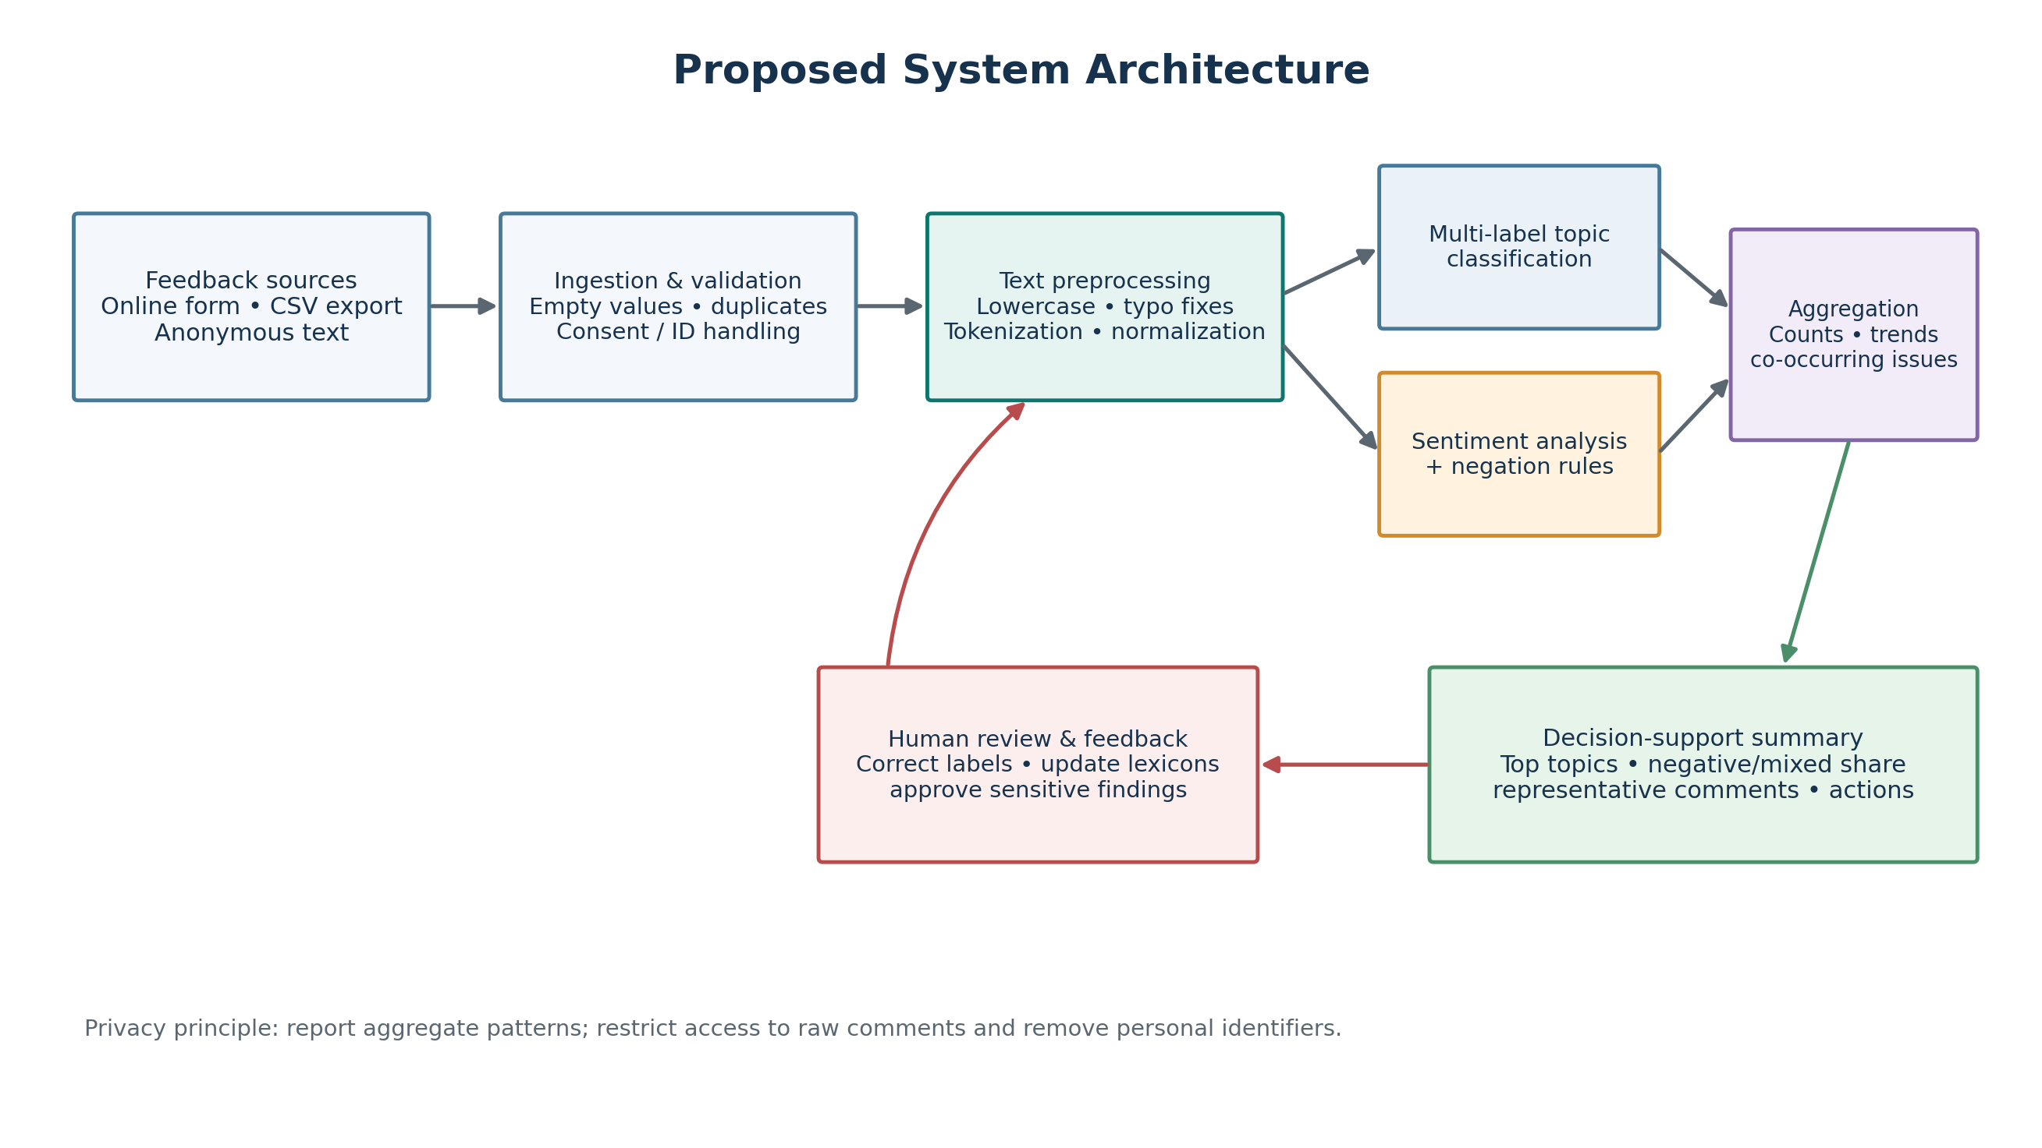
Fig. 1: Proposed System Architecture - Student Feedback Sentiment and Topic Analysis
The architecture separates the system into the input, preprocessing, analysis, aggregation, and review layers. Student feedback is imported from a survey export or CSV file. The text preparation layer normalizes content and corrects selected spelling variants. The normalized text is then passed to the topic and sentiment branches, which operate independently.
Topic labels and sentiment labels are combined into aggregated counts and concern indicators. A decision-support summary presents recurring topics, negative/mixed counts, and representative comments. Human reviewers validate important patterns and can recommend updates to the dictionaries. Privacy is supported by removing identifiers and limiting raw-comment access.

System Architecture - Layer-wise Explanation
1. Input Layer
The input layer receives free-text student responses collected through feedback forms or exported from an institutional system. During evaluation, the CSV may include reference labels. In operational use, these labels are absent and must not be inferred from the prediction output.
2. Text Preprocessing Layer
Preprocessing converts text to lowercase, normalizes spacing and punctuation, expands selected contractions, and applies a small typo map. This makes common variants easier to match. The original text should remain available for reviewer traceability. Aggressive cleaning is avoided because emphasis, negation, and punctuation can affect meaning.
3. Topic and Sentiment Analysis Layer
The topic branch checks all category-specific phrases and can return multiple labels. The sentiment branch identifies positive and negative terms, checks a local window for negators such as “not” and “never”, and assigns one overall sentiment. Topic and sentiment are separate tasks: a comment can be negative about infrastructure or positive about teaching, for example.
4. Aggregation and Decision-Support Layer
The aggregation layer counts topic assignments and sentiment labels. It also counts negative or mixed comments within each topic, which can guide further review. Because a comment may have more than one topic, topic counts may sum to more than the number of comments. Negative/mixed counts are indicators for investigation, not severity scores.
5. Human Review Layer
A staff member checks representative original comments, interprets the pattern in context, and decides whether follow-up is justified. Reviewers can correct labels and update the topic or sentiment dictionaries. This feedback loop is important because an automated system may miss local terminology, sarcasm, or ambiguous wording.

6.2 System Workflow Diagram
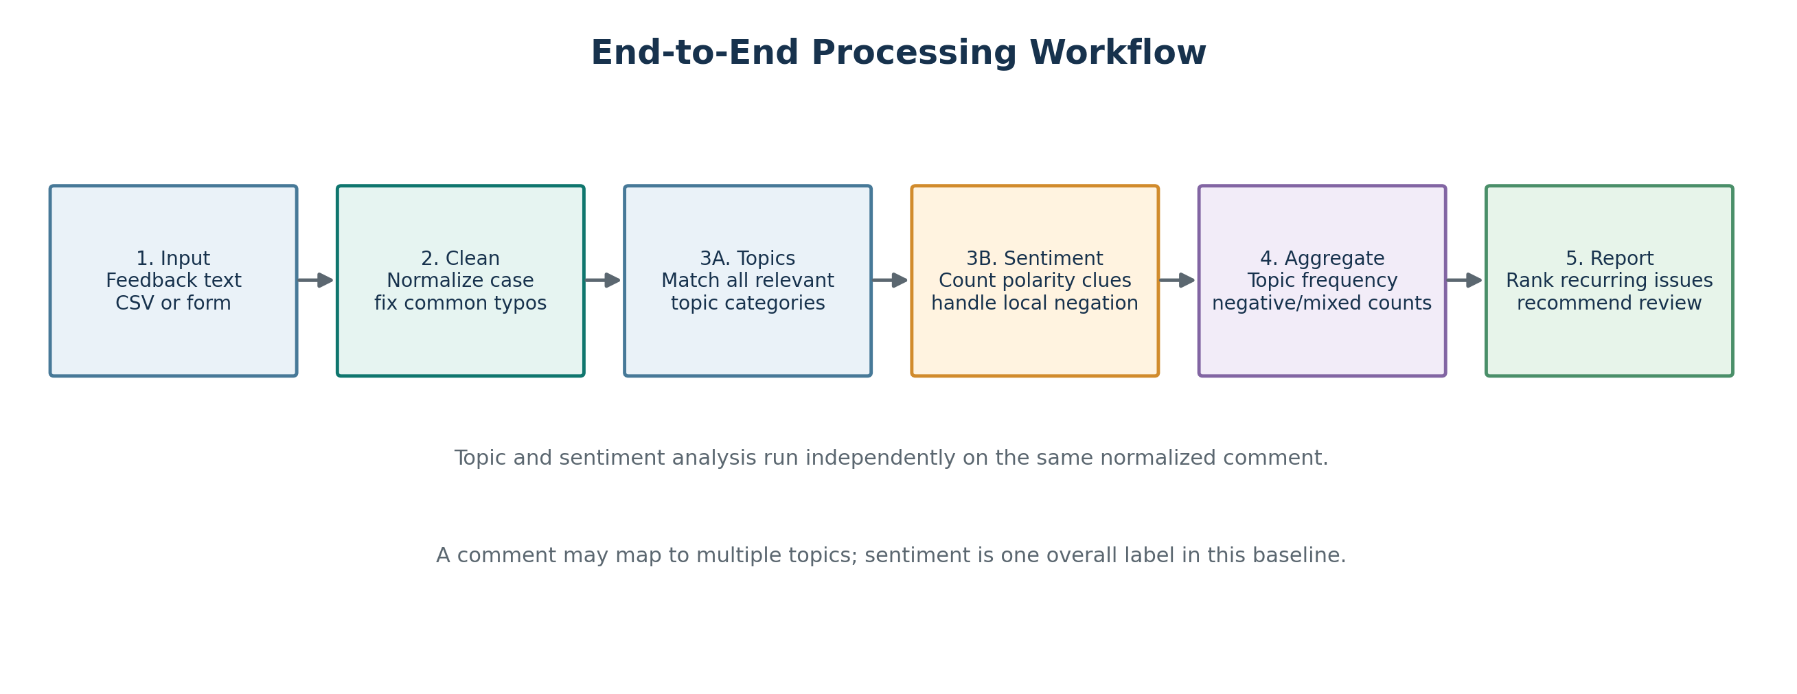
Fig. 2: System Workflow from Feedback Input to Institutional Summary
The workflow starts when one feedback comment is read from the input file. The comment is normalized, then passed to two parallel processes: topic matching and sentiment analysis. Their outputs are joined with the input record, and the system aggregates counts across the whole dataset. If evaluation labels are present, predictions are compared against the reference labels.
The final report provides sentiment totals, topic frequency, negative/mixed topic counts, and sample records. The summary should preserve a route back to source comments so that staff can check whether a repeated term represents a genuine problem, a positive description, or an unrelated context.

Detailed Working of the System
1. Feedback Input: Load a CSV file containing a feedback column or provide a single comment. Validate that each record has text and preserve an identifier if one is provided.
2. Text Cleaning: Normalize case, whitespace, punctuation, and selected contractions. Apply limited typo corrections while retaining the original comment.
3. Topic Assignment: Check the text against all five topic dictionaries. Return every category with a matching term or phrase, because one response may discuss multiple issues.
4. Sentiment Assignment: Inspect lexicon terms, use a short preceding-word window for negation, and determine whether positive, negative, mixed, or no polarity evidence is present.
5. Aggregation: Count comments by sentiment and count topic assignments plus negative/mixed assignments for each topic.
6. Summary Generation: Rank recurring issues, display counts and selected examples, and label the output as a prototype summary. Avoid interpreting frequency as a verified cause or severity.
7. Evaluation and Review: When reference labels are available, compute precision, recall, F1, exact-set match and sentiment accuracy. Inspect errors and have reviewers validate high-impact observations.
Output Produced
- A record-level table with predicted topics and sentiment.
- A sentiment distribution and topic frequency summary.
- Counts of negative or mixed comments within each topic.
- A short summary for decision-makers with cautionary interpretation notes.

6.3 Algorithm and Pseudocode
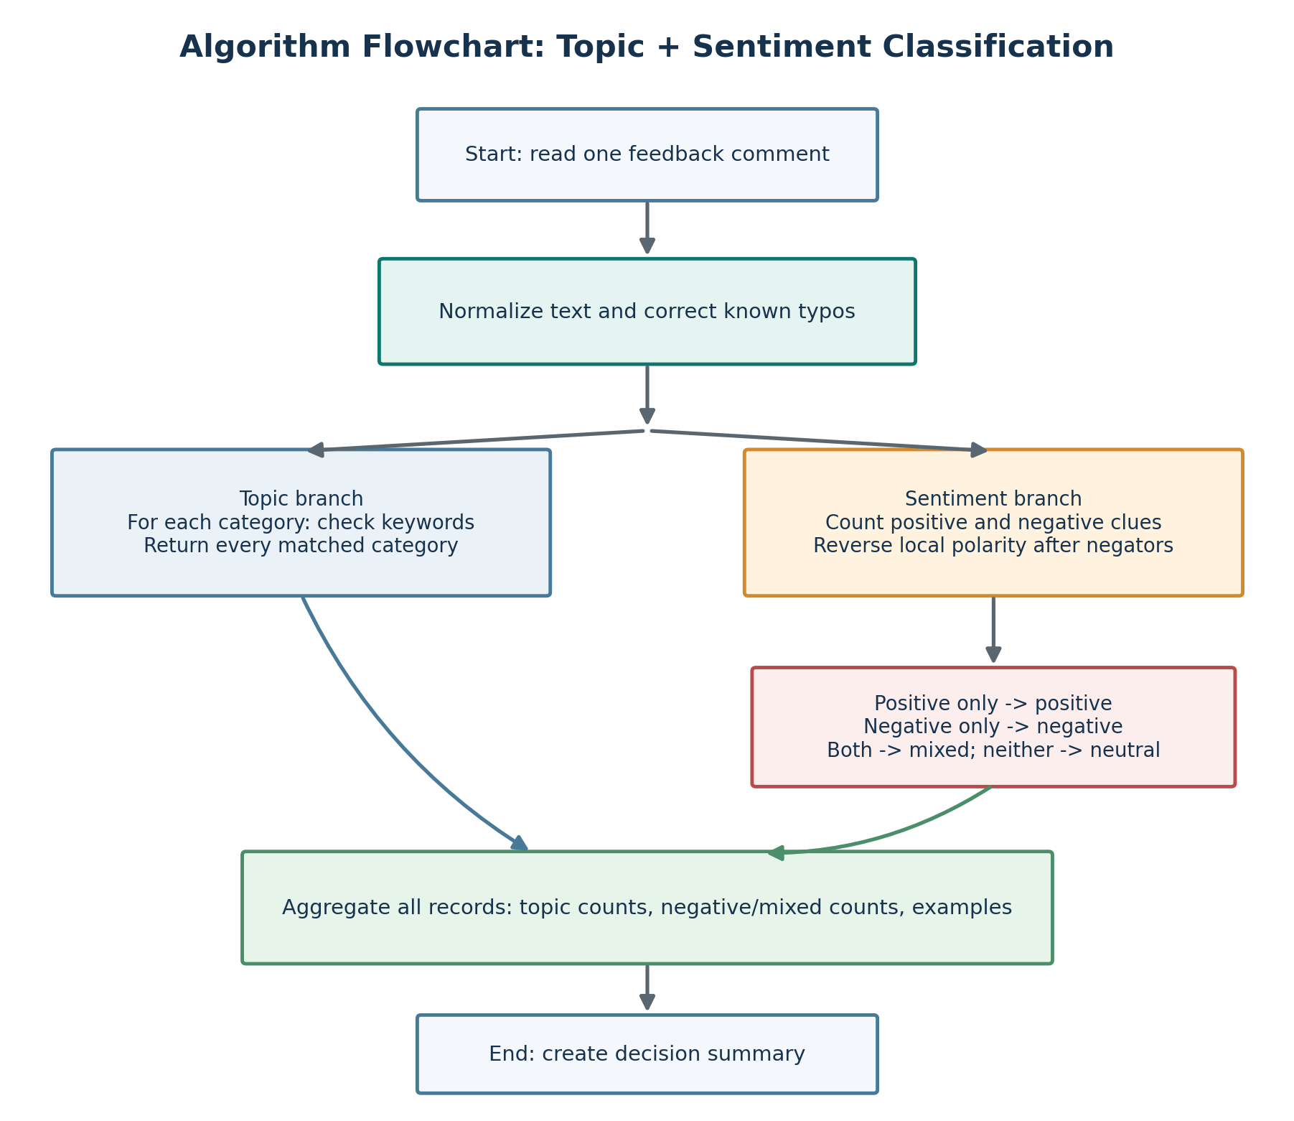
Fig. 3: Algorithm Flowchart for Topic and Sentiment Classification
Algorithm
- Read the comment and normalize its text.
- For each topic, check configured keywords and add every matched topic to the result set.
- Scan sentiment words and reverse polarity when a known negator occurs in the local context window.
- Assign Mixed when positive and negative evidence both occur; otherwise assign Positive, Negative, or Neutral.
- Store the predictions and aggregate topic and sentiment counts for all records.
- If reference labels are present, calculate evaluation metrics and list incorrect examples.
Pseudocode
FUNCTION ANALYZE(comment):
text = NORMALIZE_AND_CORRECT(comment)
topics = all categories with a keyword match
IF topics is empty: topics = {OTHER}
positive_score, negative_score = sentiment_evidence(text)
IF both scores > 0: sentiment = MIXED
ELSE IF positive_score > 0: sentiment = POSITIVE
ELSE IF negative_score > 0: sentiment = NEGATIVE
ELSE: sentiment = NEUTRAL
RETURN topics, sentiment
For n comments of average length L and a fixed number of topic and sentiment rules, the baseline is approximately linear in the number of comments and the text scanned, with constants determined by the number of configured phrases. Its small memory requirement and deterministic output make it useful for a classroom prototype.

6.4 Test Cases and Evaluation Metrics
A set of representative cases was designed to verify spelling normalization, topic overlap, negation, mixed sentiment, neutral comments, and an expected contextual failure. The examples below summarize the behaviour of the current prototype on its fixed synthetic test set.
Test ID | Input / Scenario | Expected Topic(s) | Reference Sentiment | Observed Result
TC-01 | Good syllabus coverage; supportive professor | Teaching | Positive | Pass
TC-02 | “Techer does not explain well”; doubts ignored | Teaching | Negative | Pass
TC-03 | Helpful teacher but confusing examination paper | Teaching; Examinations | Mixed | Pass
TC-04 | Crowded library; reference books unavailable | Library | Negative | Pass
TC-05 | Examination schedule published on portal | Examinations; Student Support | Neutral | Pass
TC-06 | Lab is good but teacher is not helpful | Infrastructure; Teaching | Mixed | Pass
TC-07 | Projector has not been fixed for weeks | Infrastructure | Negative | Pass
TC-08 | Teacher explains difficult topics clearly and is helpful | Teaching | Positive | Fail: predicted Mixed

Evaluation Metrics
Precision = TP / (TP + FP); Recall = TP / (TP + FN); F1 = 2 × Precision × Recall / (Precision + Recall). For multi-label topics, micro-averaging combines true positives, false positives, and false negatives across all topic labels. Exact-set match measures the share of comments for which the entire predicted topic set equals the reference set. Sentiment accuracy is the number of correct overall sentiment labels divided by the number of evaluated comments.
A real evaluation should use independently annotated data, a held-out test split, per-topic precision/recall/F1, per-sentiment class results, confusion matrices, and a review of representative false positives and false negatives.

6.5 Experimental Results and Error Analysis
The prototype was executed on 30 synthetic English comments created and hand-labelled for demonstration. The dataset covers five topic categories, multiple-topic comments, a small number of spelling variants, local negation, positive and negative phrases, and neutral examples. It was not collected from students and should not be used to estimate deployment performance.
Metric | Observed Result | Interpretation
Records evaluated | 30 | Fixed demonstration set
Topic micro precision / recall / F1 | 1.000 / 1.000 / 1.000 | All curated topic assignments matched the configured rules
Topic exact-set match | 1.000 | All predicted topic sets matched reference sets in this designed sample
Sentiment accuracy | 0.967 (29/30) | One comment had an incorrect sentiment class
Sentiment macro F1 | 0.972 | Unweighted mean across the four sentiment classes

Sentiment Confusion Matrix
Actual / Predicted | Positive | Neutral | Negative | Mixed
Positive | 9 | 0 | 0 | 1
Neutral | 0 | 3 | 0 | 0
Negative | 0 | 0 | 9 | 0
Mixed | 0 | 0 | 0 | 8

Observed Error
The only sentiment error occurred on “The teacher explains difficult topics clearly and is very helpful.” The reference label is Positive, but the baseline predicted Mixed because it treats “difficult” as negative evidence. In this sentence, “difficult” describes the topics rather than the teacher or the overall experience. This is a context problem that a simple bag-of-words lexicon cannot reliably resolve.
Interpretation: the perfect topic score is optimistic because the synthetic examples were deliberately written around the configured keyword rules. The test set is small, does not include all styles of student writing, and lacks a separate training/validation/test split. The figures demonstrate the workflow, not production-level accuracy.

6.6 Sample Output
The following illustrative examples show the kind of record-level results and topic summary produced by the prototype. Names and details should be removed from real data before wider review. The output is designed to support investigation, not to establish the truth of an allegation.
Output 1: Sample Comment Analysis
Input Feedback | Predicted Topic(s) | Sentiment | Reason for Review
“The projector is broken and has not been repaired.” | Infrastructure and Facilities | Negative | Repeated equipment problems may need inspection.
“The teacher is helpful, but the exam paper was confusing.” | Teaching; Examinations | Mixed | Positive teaching feedback plus a concern about assessment.
“The examination schedule is published on the portal.” | Examinations; Student Support | Neutral | Informational comment with no clear polarity.
“The library is clean but Wi-Fi is not working.” | Library; Infrastructure | Mixed | Two topics with different service implications.

Output 2: Topic Frequency and Concern Counts
Topic | Topic Mentions | Negative / Mixed Mentions | Interpretation
Infrastructure and Facilities | 8 | 6 | Review repeated concerns; count is not a severity score.
Teaching and Learning | 7 | 5 | Review repeated concerns; count is not a severity score.
Examinations and Assessment | 7 | 5 | Review repeated concerns; count is not a severity score.
Student Support and Administration | 7 | 4 | Review repeated concerns; count is not a severity score.
Library Services | 7 | 2 | Fewer negative/mixed mentions in this synthetic sample.

Decision-Maker Summary
In this demonstration, infrastructure has the largest number of topic assignments (8) and the largest number of negative/mixed mentions (6). Teaching and examinations each have 7 topic assignments and 5 negative/mixed mentions. These numbers can guide which comments to read first, but they do not establish the underlying cause or severity. Institutional staff should inspect the original comments, compare results across time periods, and check whether response patterns are representative.

6.7 Visual Summary of Results
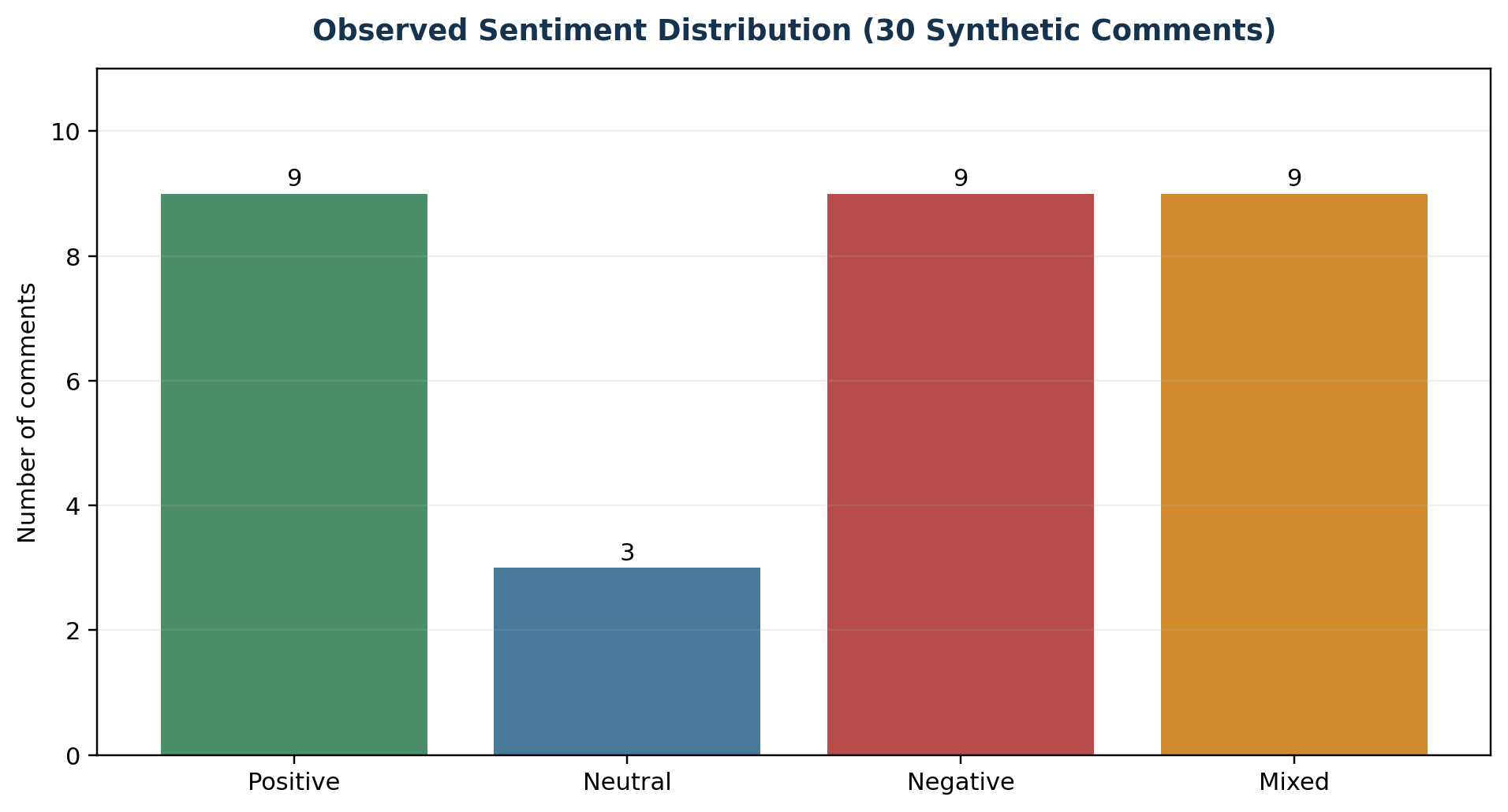
Fig. 4: Observed Sentiment Distribution for 30 Synthetic Demonstration Comments
The sample contains 9 Positive, 3 Neutral, 9 Negative, and 9 Mixed predictions. These counts are outputs of the current rule-based prototype on the authored test set, not a measure of student satisfaction at a real institution.
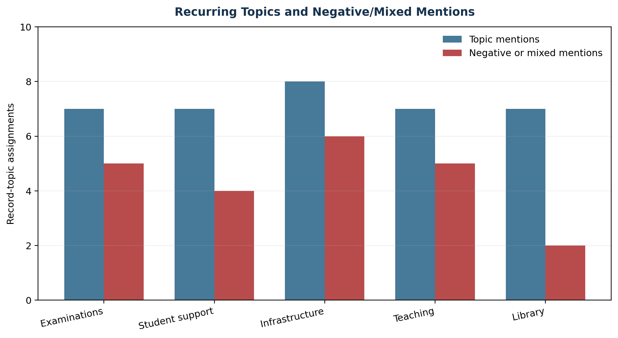
Fig. 5: Topic Mentions and Negative/Mixed Mentions in the Synthetic Test Set
Infrastructure has the highest number of topic mentions and negative/mixed mentions in this small demonstration. The system should be used to discover and organize signals for follow-up. Before action, decision-makers should inspect the source comments and check the quality, coverage, and representativeness of the dataset.

CHAPTER 7: CONCLUSION
7.1 Summary of Findings
This case study addressed the problem of analyzing large volumes of university feedback by proposing an NLP workflow that maps unstructured comments into topic labels and sentiment classes. The design includes normalization, limited spelling correction, multi-label topic detection, sentiment and negation rules, aggregation of recurring concerns, evaluation, and human review.
The prototype illustrates how student comments can be organized into five meaningful categories: Teaching and Learning, Examinations and Assessment, Infrastructure and Facilities, Library Services, and Student Support and Administration. The multi-label design preserves comments that refer to several topics, while a four-class sentiment output helps distinguish Positive, Negative, Mixed, and Neutral comments.
On the 30-comment synthetic demonstration set, the topic rules matched all curated labels and sentiment was correct for 29 of 30 comments. The one sentiment error demonstrates a key weakness of simple lexicons: a word that appears negative in isolation may be positive or neutral in context. These results are useful for confirming execution and illustrating metrics, but cannot be generalized to real feedback.
7.2 Achievement of Objectives
- A repeatable feedback-processing pipeline and a runnable baseline were documented.
- Text normalization and selected spelling-variant handling were included.
- Multiple topic labels can be assigned to a single comment.
- Overall sentiment is represented with positive, negative, mixed, and neutral classes.
- Recurring issues are summarized with topic counts and negative/mixed counts.
- Test cases, evaluation metrics, an error analysis, and demonstration steps are documented.
- Engineering limitations, privacy safeguards, and a path toward a stronger model are identified.
The project therefore demonstrates a practical application of NLP to institutional decision support while preserving the need for human review and responsible use.

7.3 Engineering Decisions, Limitations and Future Work
Engineering Decisions and Justification
Decision | Reason | Trade-off
Rule-based baseline | Transparent, offline, reproducible, and does not require training labels. | Limited vocabulary and weak contextual understanding.
Multi-label topics | Preserves comments that discuss more than one service area. | Topic counts may exceed the number of comments.
Four sentiment classes | Allows mixed and neutral responses instead of forcing binary polarity. | One overall label can hide aspect-level differences.
Synthetic hand-labelled demo | Enables a repeatable test run without exposing real student data. | Cannot prove performance or representativeness.
Human review | Keeps decision-making grounded in original context and institutional evidence. | Requires reviewer time and a documented process.

Key Limitations
The current prototype is not production-ready. It relies on fixed vocabulary, a small lexicon, and simple negation windows; it does not train a model, estimate calibrated confidence, resolve sarcasm, or assign aspect-specific sentiment. It is not validated for Marathi, Hindi, code-switching, or diverse department-specific terminology. Because the examples are synthetic, the perfect topic score is partly a consequence of designing cases around the rules.
Privacy and Responsible Use
Before real deployment, obtain institutional approval, minimize and anonymize data, restrict raw-comment access, share aggregates where possible, and document how labels are checked. Avoid using sentiment scores to penalize individual people or departments. Provide a manual correction path and audit whether the system performs differently for different languages, cohorts, or less frequent concerns.
Future Enhancements
The next experiment should compare this rule-based baseline with a TF-IDF model using word and character n-grams and a One-vs-Rest Logistic Regression classifier for topic labels. For sentiment, compare the baseline with a validated lexicon model such as VADER and a domain-validated transformer where feasible. Use independent human annotations, a fixed held-out test set, per-label metrics, error examples, and time-based evaluation when monitoring changes across semesters.

CHAPTER 8: REFERENCES
[1] Hutto, C. J., and Gilbert, E. E. (2014). “VADER: A Parsimonious Rule-Based Model for Sentiment Analysis of Social Media Text.” Proceedings of the International AAAI Conference on Web and Social Media, 8(1), 216-225. https://doi.org/10.1609/icwsm.v8i1.14550
[2] scikit-learn developers. “TfidfVectorizer API Reference.” scikit-learn documentation. https://scikit-learn.org/stable/modules/generated/sklearn.feature_extraction.text.TfidfVectorizer.html
[3] scikit-learn developers. “Metrics and Scoring: Quantifying the Quality of Predictions.” scikit-learn documentation. https://scikit-learn.org/stable/modules/model_evaluation.html
[4] Hugging Face. “Text Classification.” Transformers documentation. https://huggingface.co/docs/transformers/main/tasks/sequence_classification
[5] NLTK Project. “NLTK Sentiment Analysis / VADER API.” NLTK documentation. https://www.nltk.org/api/nltk.sentiment.vader.html
[6] Python Software Foundation. “csv - CSV File Reading and Writing.” Python documentation. https://docs.python.org/3/library/csv.html
[7] Manning, C. D., Raghavan, P., and Schütze, H. (2008). Introduction to Information Retrieval. Cambridge University Press. https://nlp.stanford.edu/IR-book/
[8] Liu, B. (2012). “Sentiment Analysis and Opinion Mining.” Synthesis Lectures on Human Language Technologies, 5(1), 1-167. https://doi.org/10.2200/S00416ED1V01Y201204HLT016
Note: The evaluation values in this report are calculated from a synthetic demonstration dataset included with the prototype. They are not institution-wide findings.

