**Q1. Retrieve the total number of orders placed.**

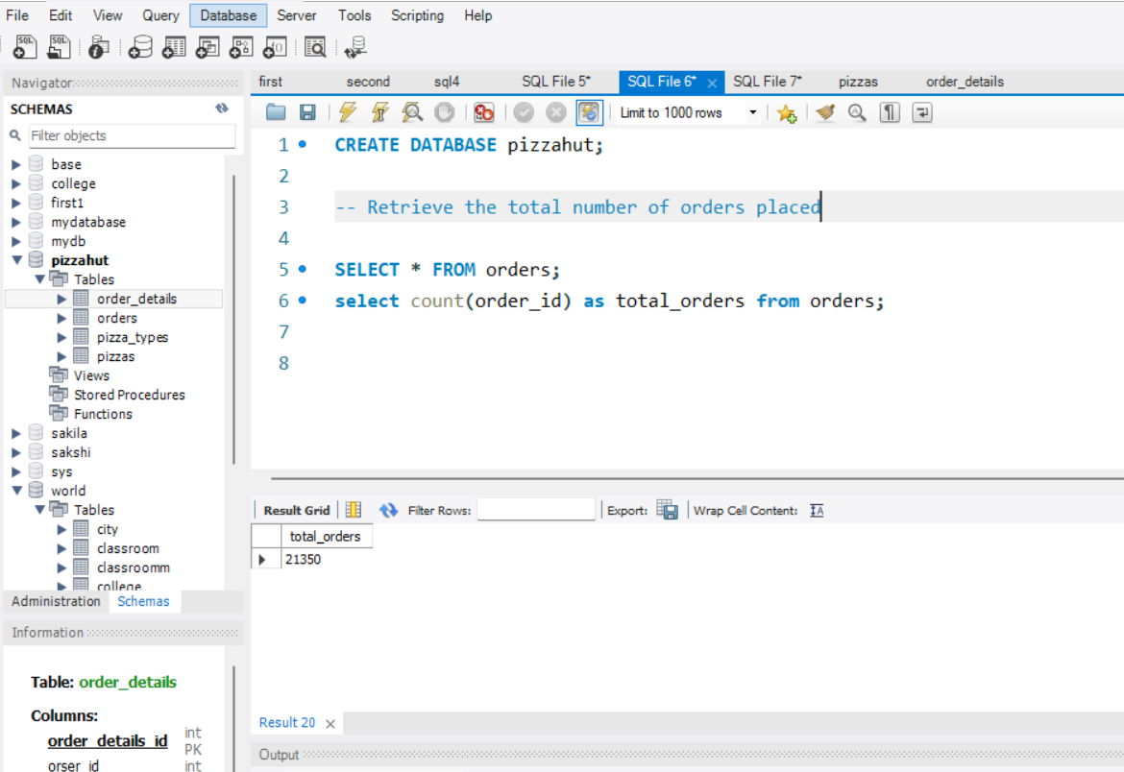

**Q2. Calculate the total revenue generated from pizza sales.**

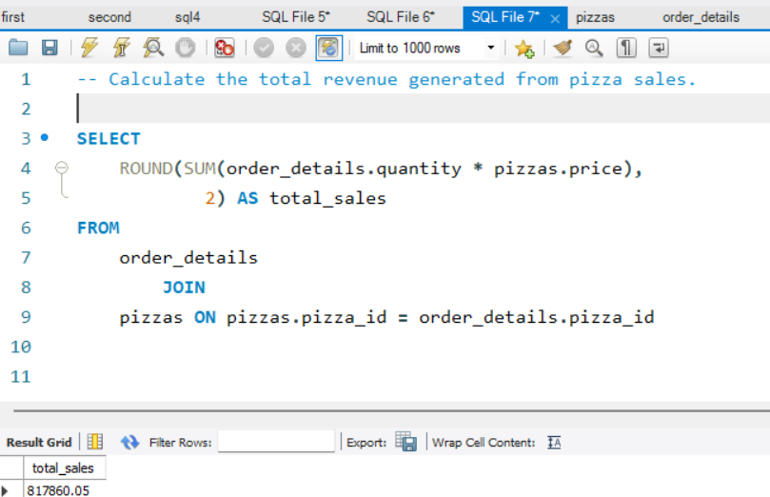

**Q3. Identify the highest-priced pizza.**

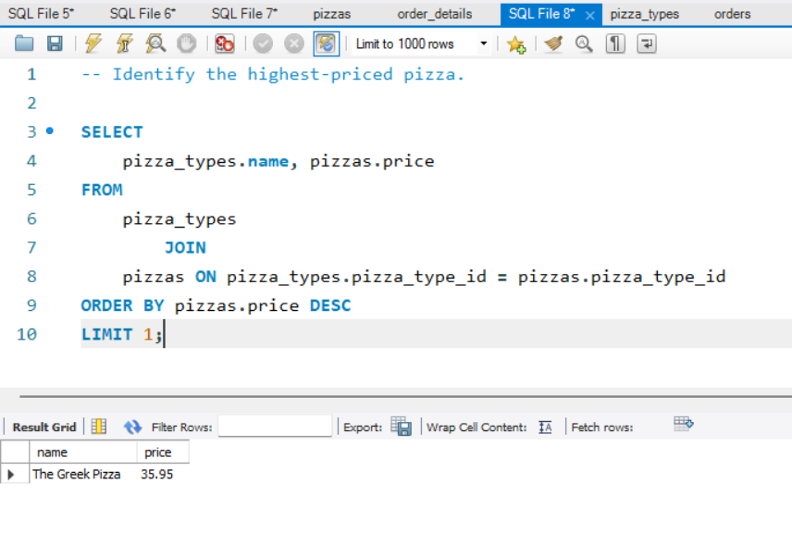

**Q4. Identify the most common pizza size ordered.**

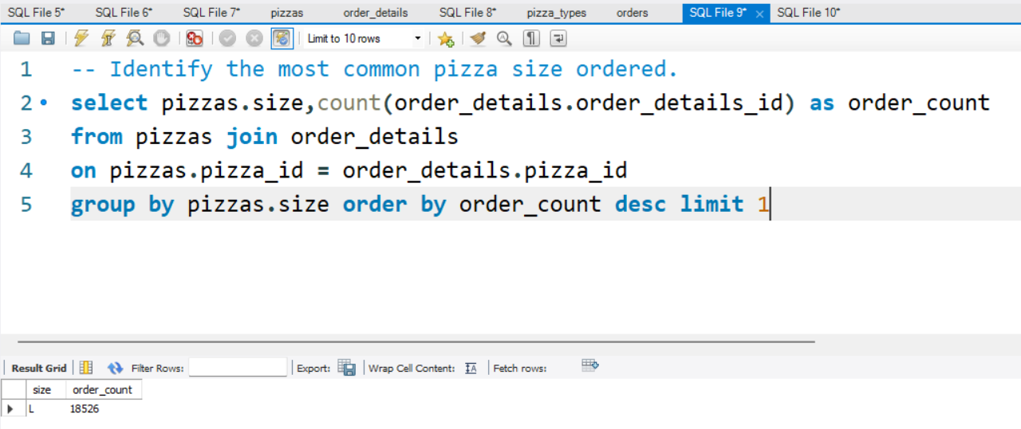

**Q5. List the top 5 most ordered pizza types along with their quantities.**

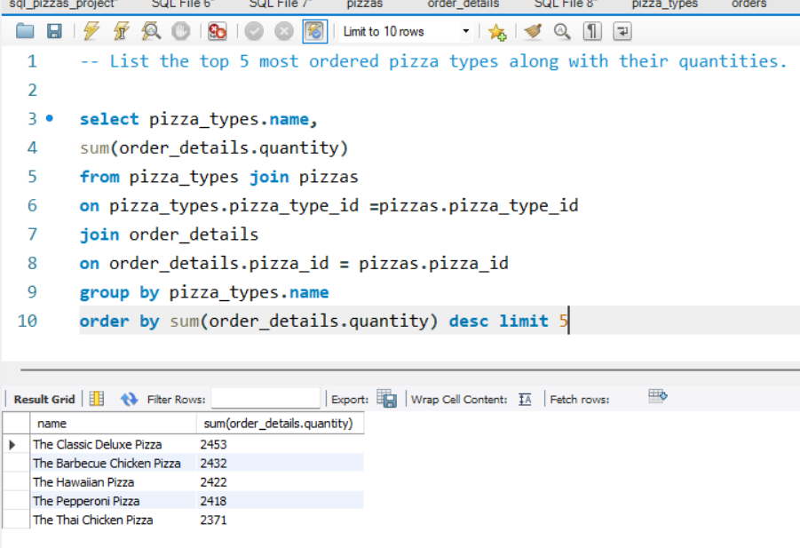

**Q6. Join the necessary tables to find the total quantity of each pizza category ordered.**

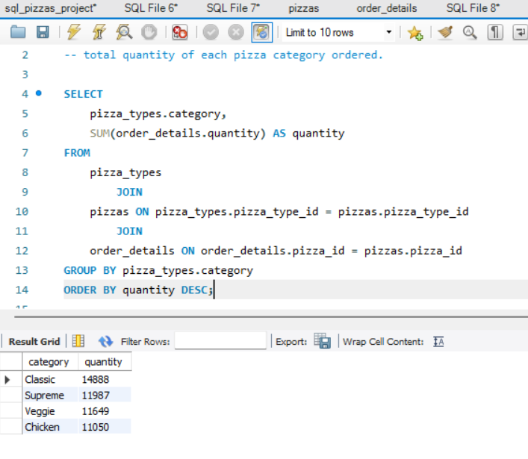

**Q7. Determine the distribution of orders by hour of the day.**

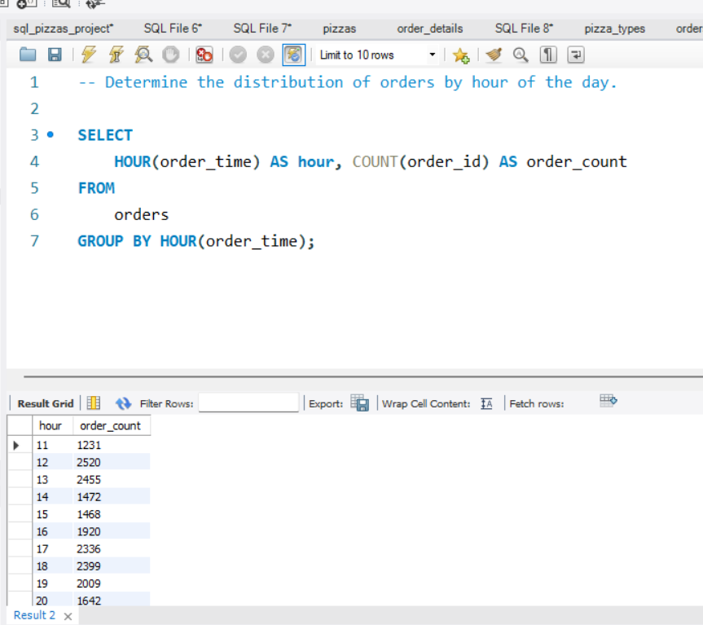

**Q8. Join relevant tables to find the category-wise distribution of pizzas.**

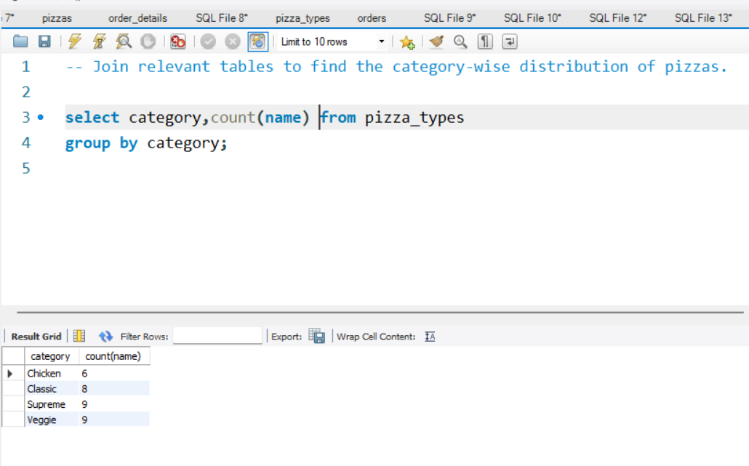

**Q9.Group the orders by date and calculate the average number of pizzas ordered per day.**

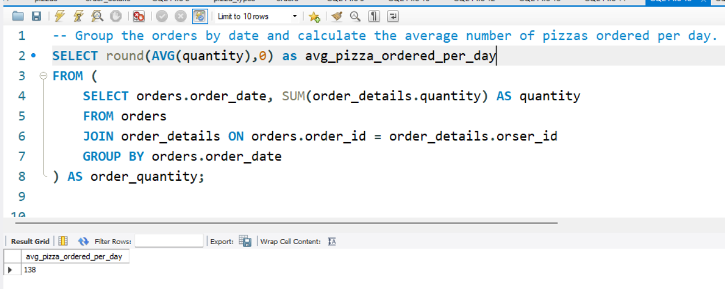

**Q10. Determine the top 3 most ordered pizza types based on revenue.**

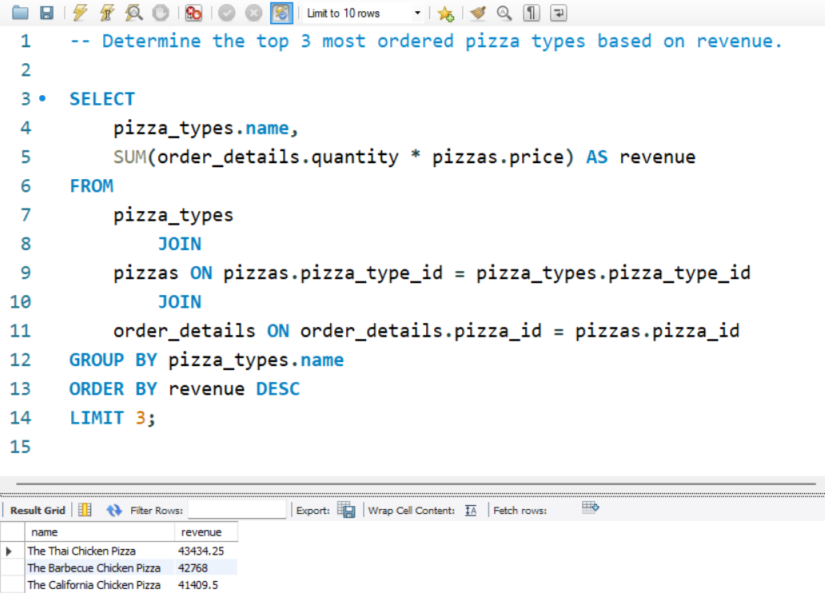

**Q11. Analyze the cumulative revenue generated over time.**

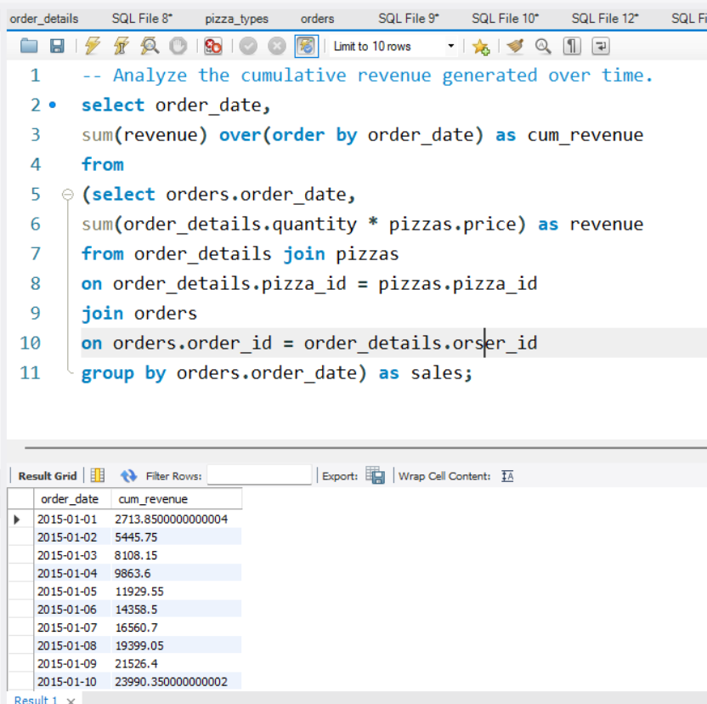

**Q12. Calculate the percentage contribution of each pizza type to total revenue.**

