# JAYPEE UNIVERSITY OF ENGINEERING AND TECHNOLOGY, GUNA (M.P)



**ADVANCE PROGRAMMING LAB**

**Name: SAKSHI SAXENA**

**Enrollment No.: 171B108**

**Batch: B4**

**WELCOME TO QUIZ PORTAL**

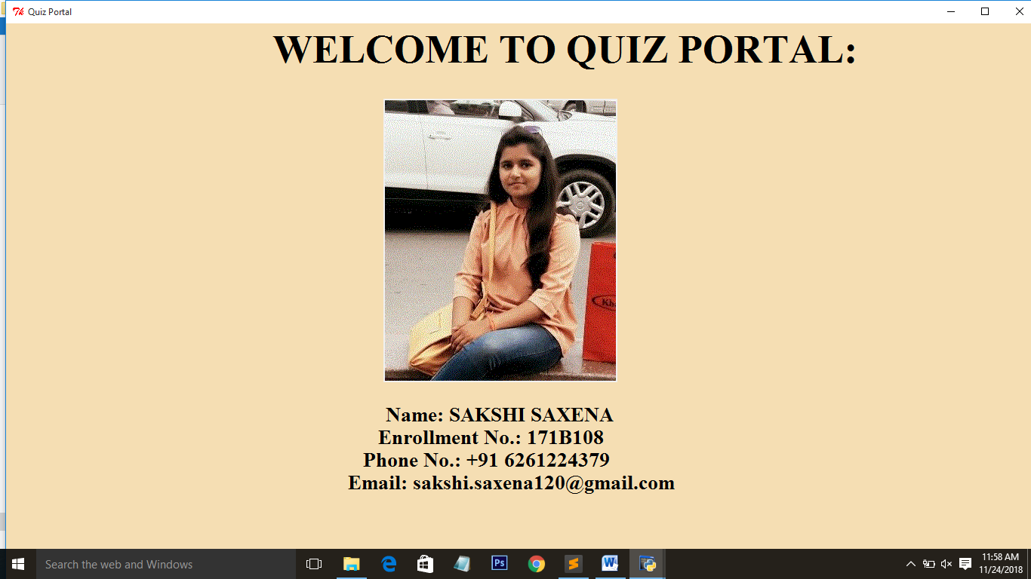

**Python Quiz Portal**

This is a Quiz Portal based on Computer language: PYTHON

A Quiz is test of knowledge, especially a brief, informal test given to students to explore their skills.

The first screen of Quiz Portal as shown above uses Splash python script.

This page contain introduction—

Name: SAKSHI SAXENA

Enrollment no.:171b108

Phone no: +91 6261224379

Email id: [sakshi.saxena120@gmail.com](mailto:sakshi.saxena120@gmail.com)

After 5 seconds the page is closes continued by the Home screen of Quiz Portal.

**WIDGETS:**

Label (attributes: image , bg(background color) ,place, font), Tkinter window

Image has been inserted in center of the page.

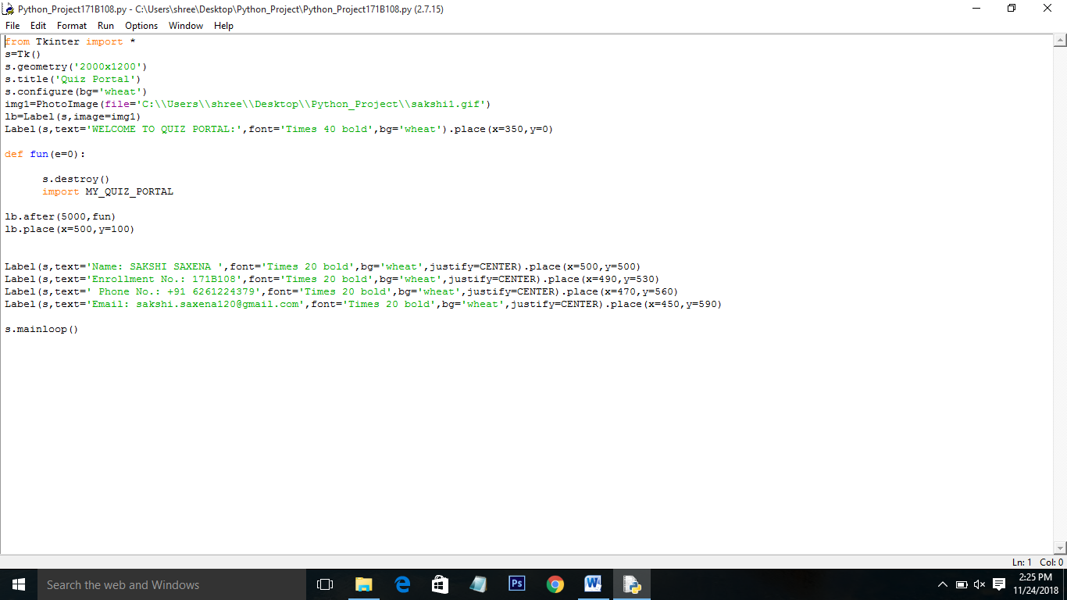

**HOME SCREEN CODE:**

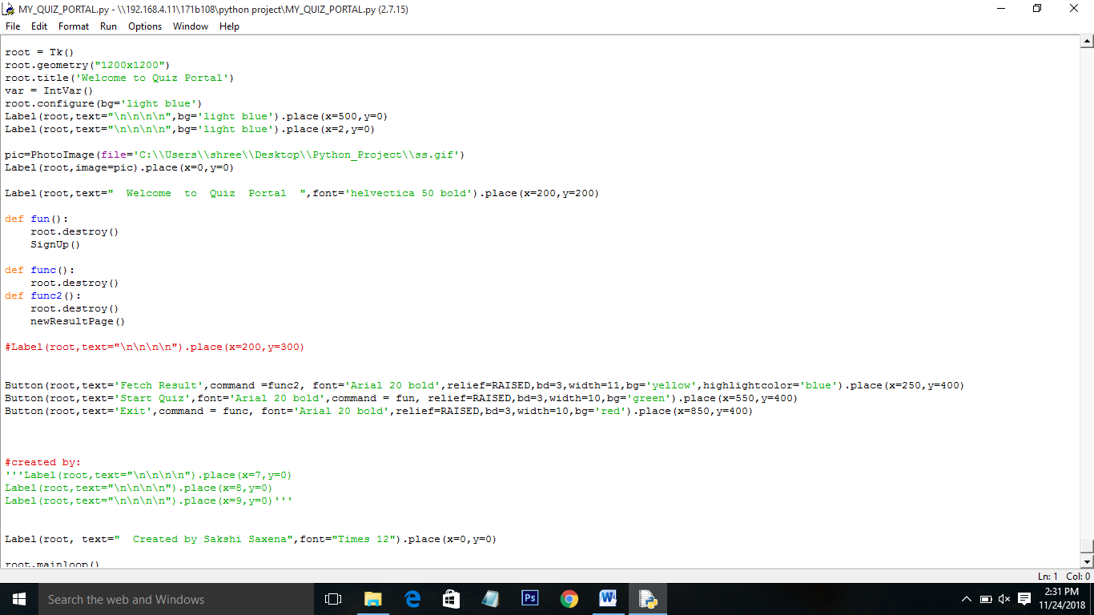

**DATABASES: QUIZ PORTAL, QUIZ POTAL1**

**Quiz Portal database contains the following fields and datatypes:**

Fname-varchar(first name)

lname –varchar(last name)

nname –varchar(enrollment number)

age –number(age)

dob- varchar(date of birth)

college- varchar(college name)

score- number(scores achieved)

attempted- number(attempted number of questions)

topic –varchar(topic of the quiz)

**Quiz Portal1 database contains the following fields and datatypes:**

(Used for fetching result/details of users who have attempted the quiz)

Fname1-varchar(first name)

Lname1 –varchar(last name)

Nname1 –varchar(enrollment number)

Age1 –number(age)

Dob1- varchar(date of birth)

College1- varchar(college name)

Score1- number(scores achieved)

Attempted1- number(attempted number of questions)

Topic1 –varchar(topic of the quiz)

**Main Functions Used:**

#Sign Up Page: def SignUp()

#topic page: def Topics():

#Questions:

def Question1() def Question4() def Question7() def Question10()

def Question2() def Question5() def Question8()

def Question3() def Question6() def Question9()

#Result Page: def resultPage()

#Fetching Page: def newResultPage():

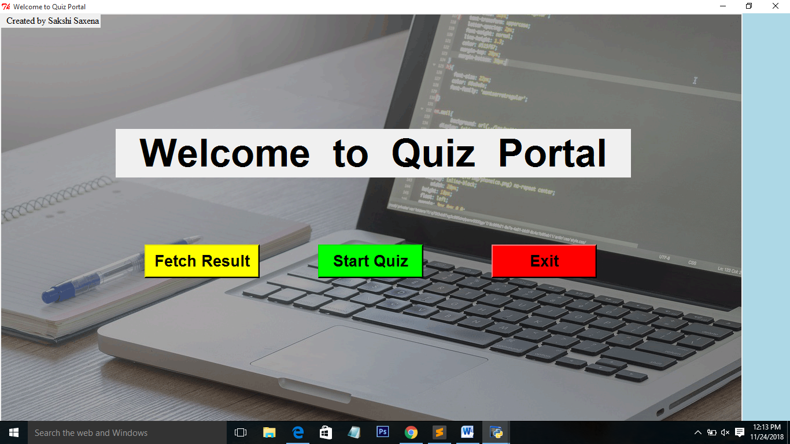

**Home Screen:**

This is the welcome screen of the project which contains options to Start the quiz, Exit from the portal and Fetch details of users that have already attempted the quiz.

**WIDGETS USED:**

Label, Button, Tkinter window

 : This button is used to Search the details of the users that have already attempted the quiz before. Open a new window for Fetching the details (score, name, attempted questions etc.)

**Function:** **def func2():**

 : This button Starts the quiz for new users. It open the sign Up page for new users.

**Function: def fun():**

: This is used to exit from the portal.

**Function:** **def func():**

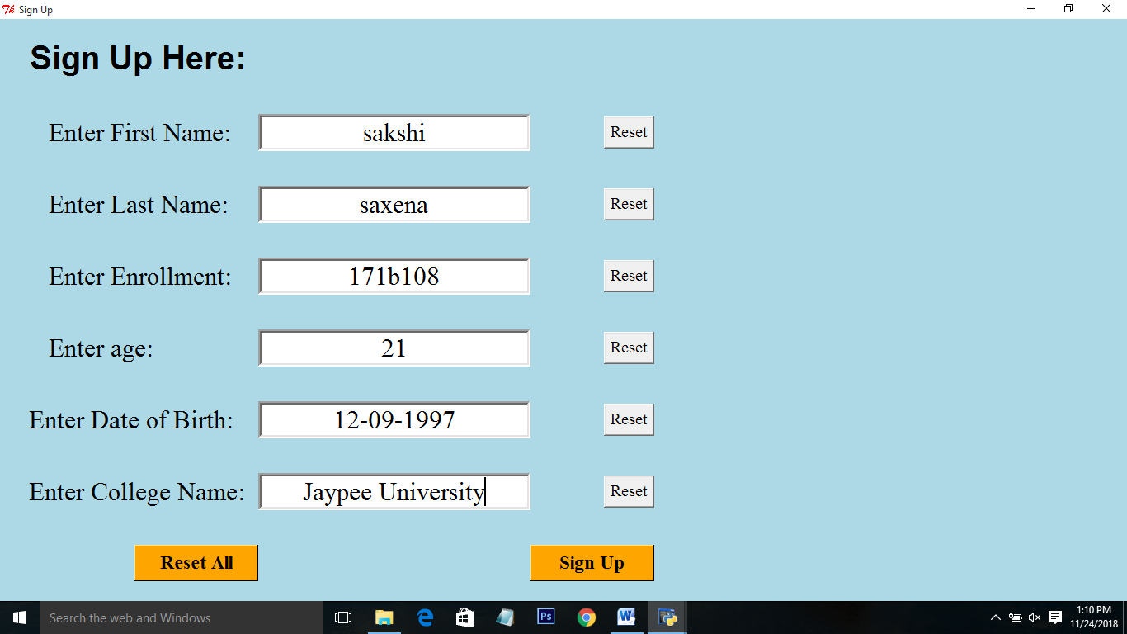

**Sign Up Page:**

This page is for new users for signing up for the quiz. In this page the users have to fill there details which will be stored in the database: Quiz Portal and continue with sign up button which opens topic page.

**WIDGETS:**

Entry box, label, buttons

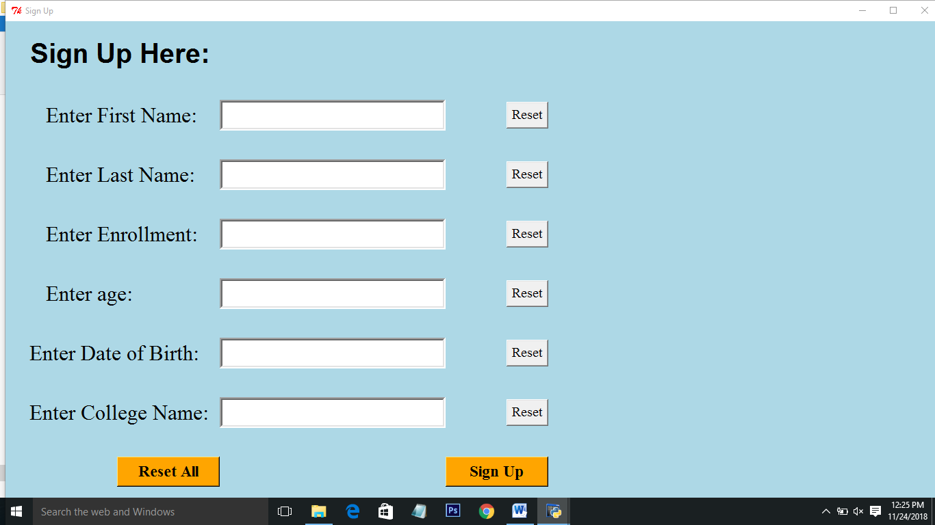: Use to reset current field.

**Function: def resete(1/2/3/4/5/6)()**

: Resets all the entry fields.

**Function: def reset()**

: Continues to start the quiz. New users registered.

**Function: def signup()**

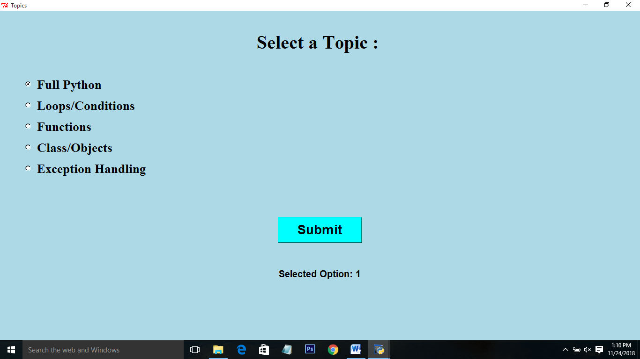

**Topics:**

User can select a topic as per their wish to attempt the quiz from the options

Provided.

**WIDGET:**

Radio-buttons ,button ,labels

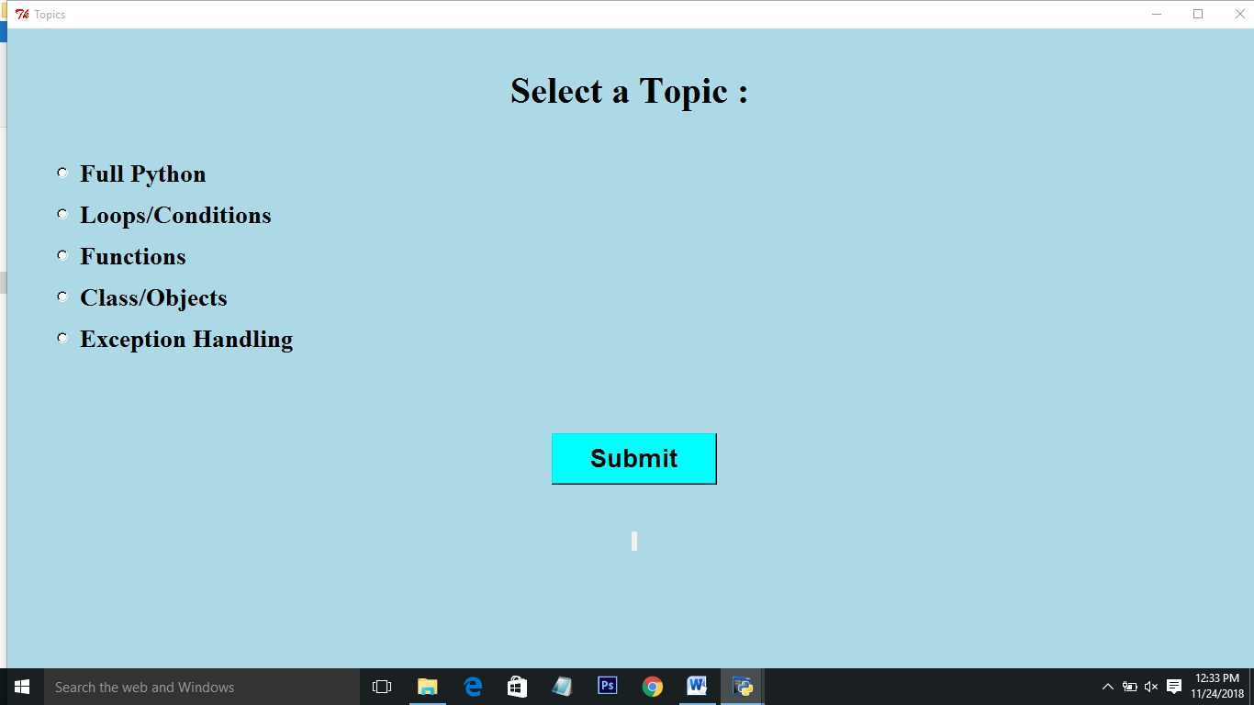: User can select a topic on which they want to attempt the quiz.

: After selecting the topic submit proceeds to the main quiz.

**Function: def calcu():**

**Question no.1**

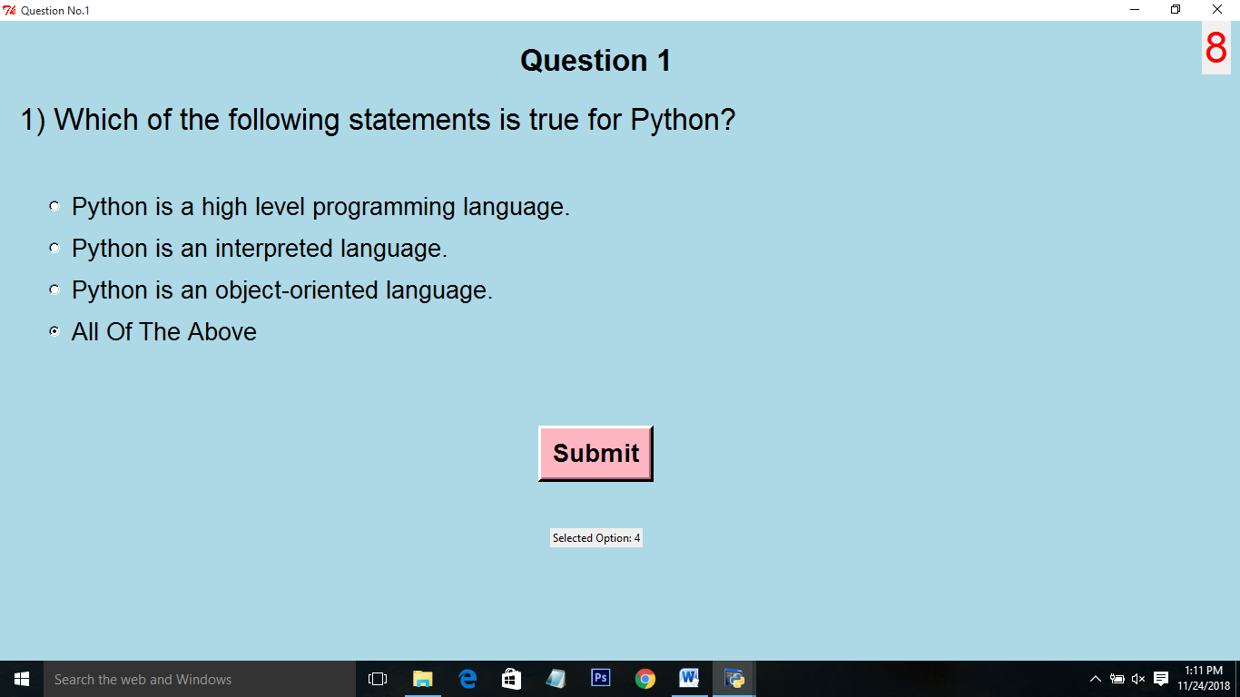

**Quiz Begins here:**

This is the starting of quiz which contains questions from 1 to 10.User needs to select one options from the given options Here is also a timer used which will submit the quiz automatically and lands to the score page.

**WIDGETS:**

Buttons, label, clock(code), radio-buttons

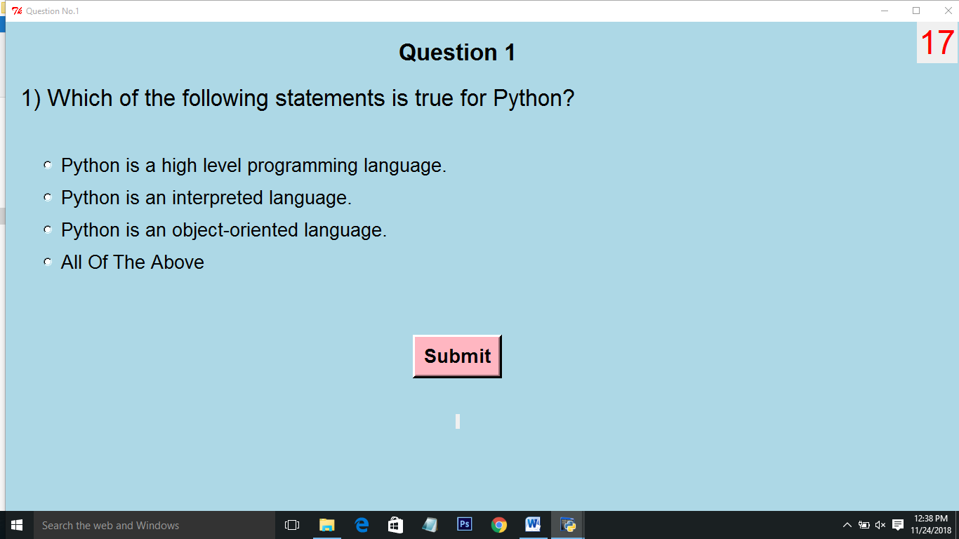: Options provided.

: Used to submit the answer.

**Functions: def calcu():**

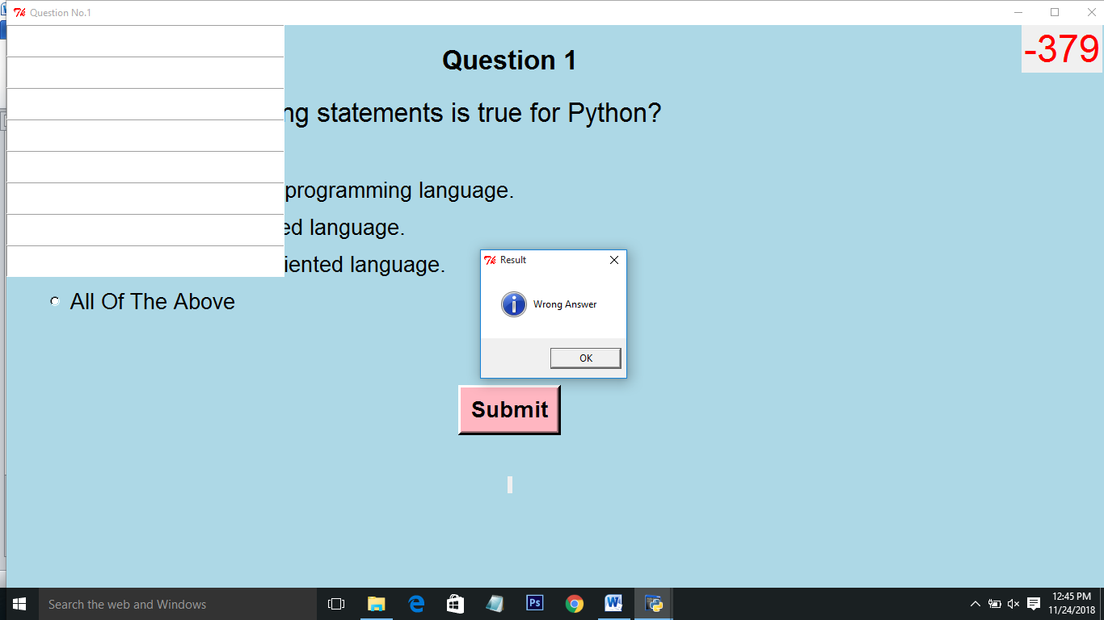: Message box showing if answer is correct or wrong.

**Similarly we have 10 Questions following one after another. Following are the respective screens**.

**Question no.2**

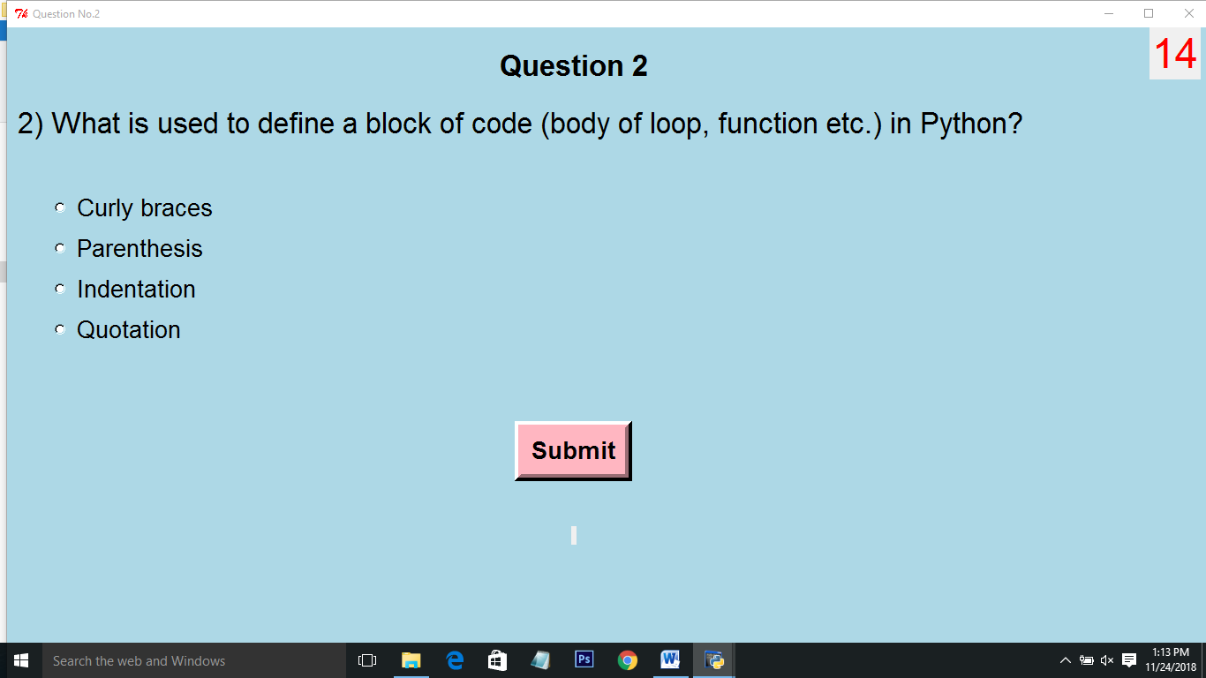

**Question no.3**

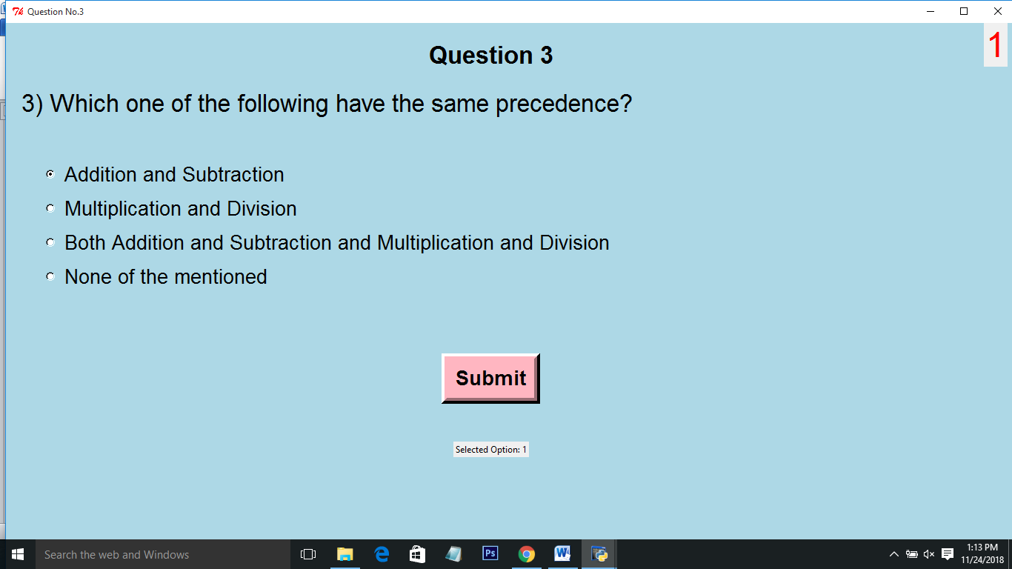

**Question no.4**

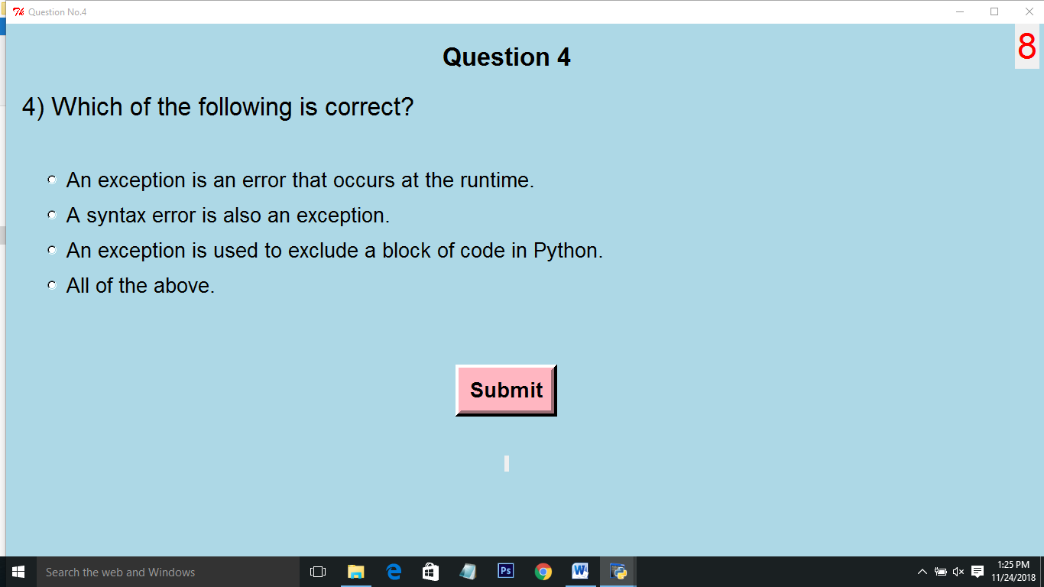

**Question no.5**

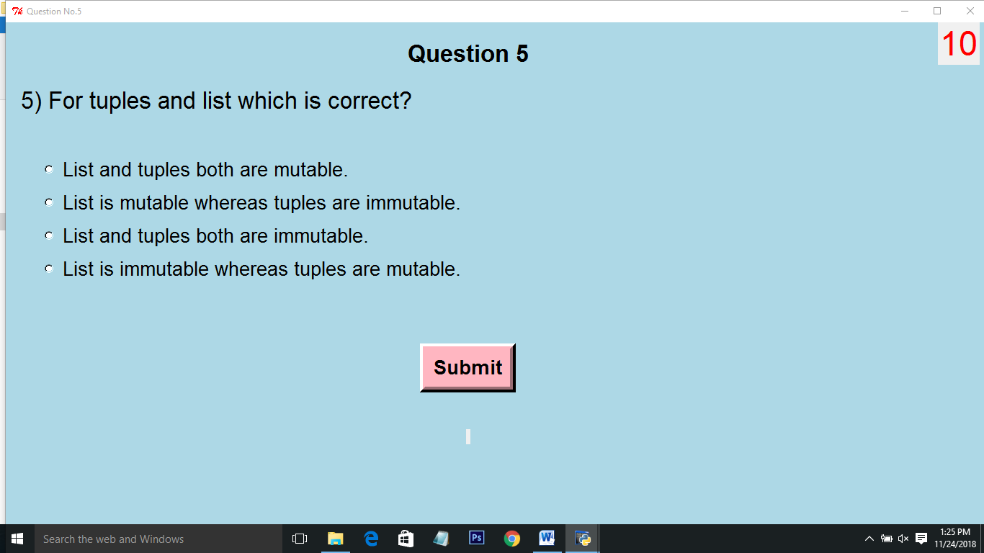

**Question no.6**

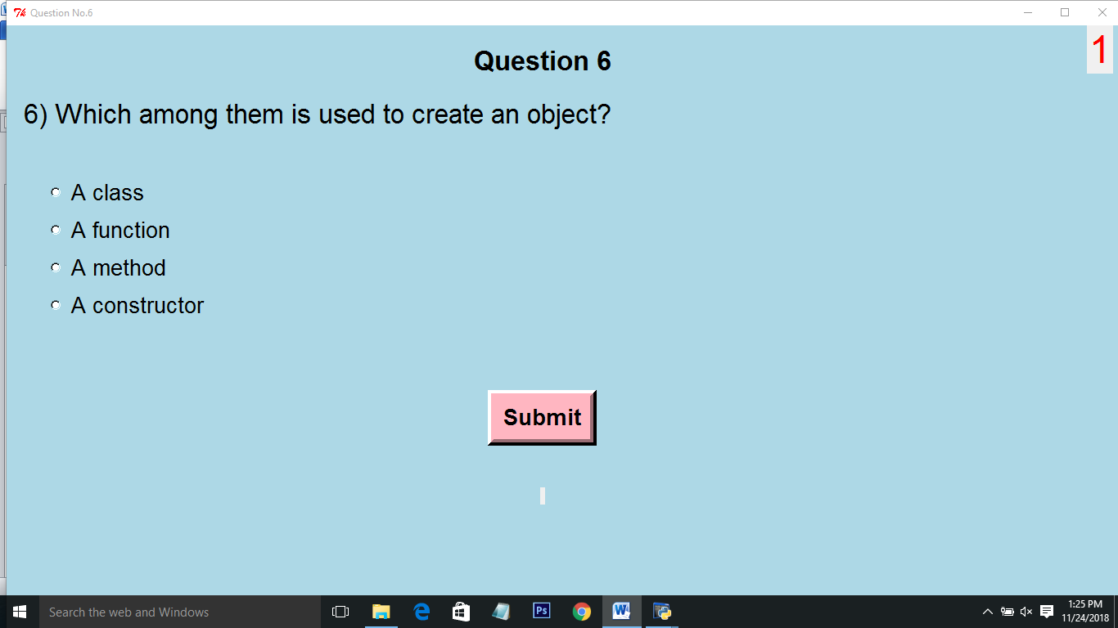

**Question no.7**

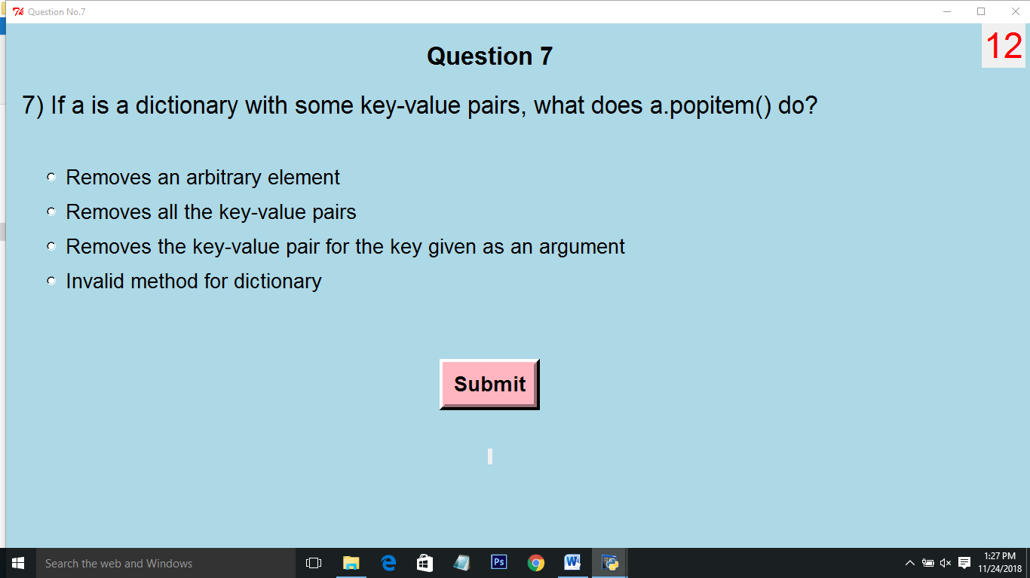

**Question no.8**

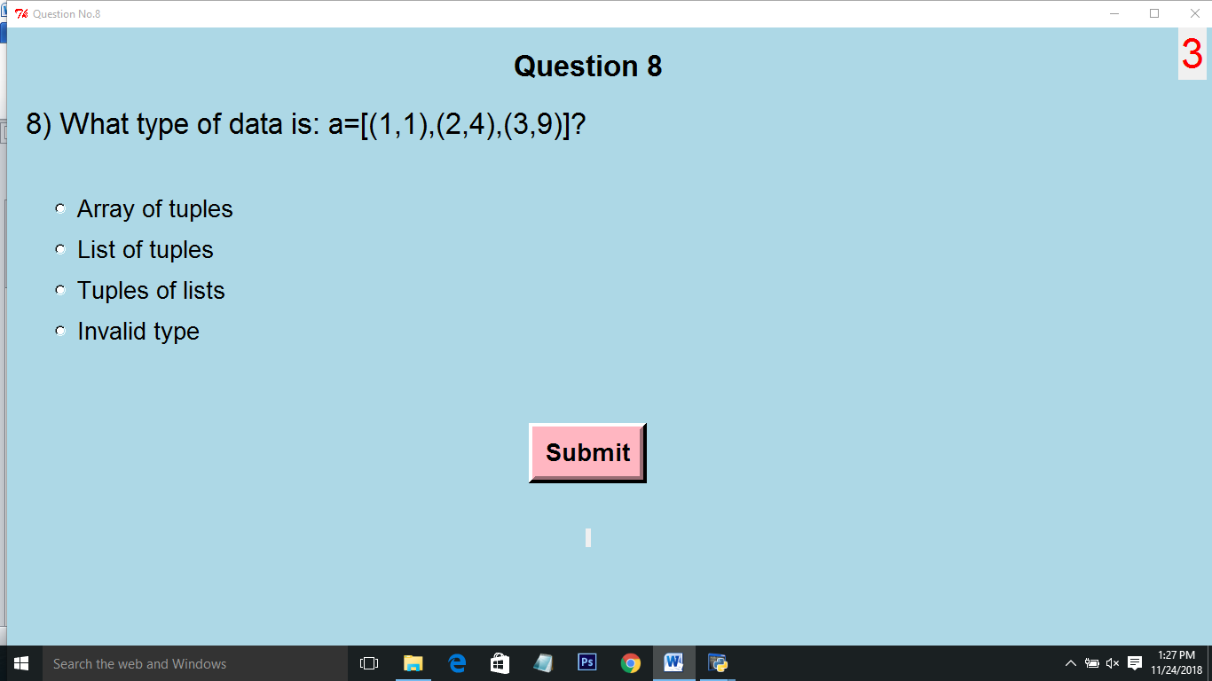

**Question no.9**

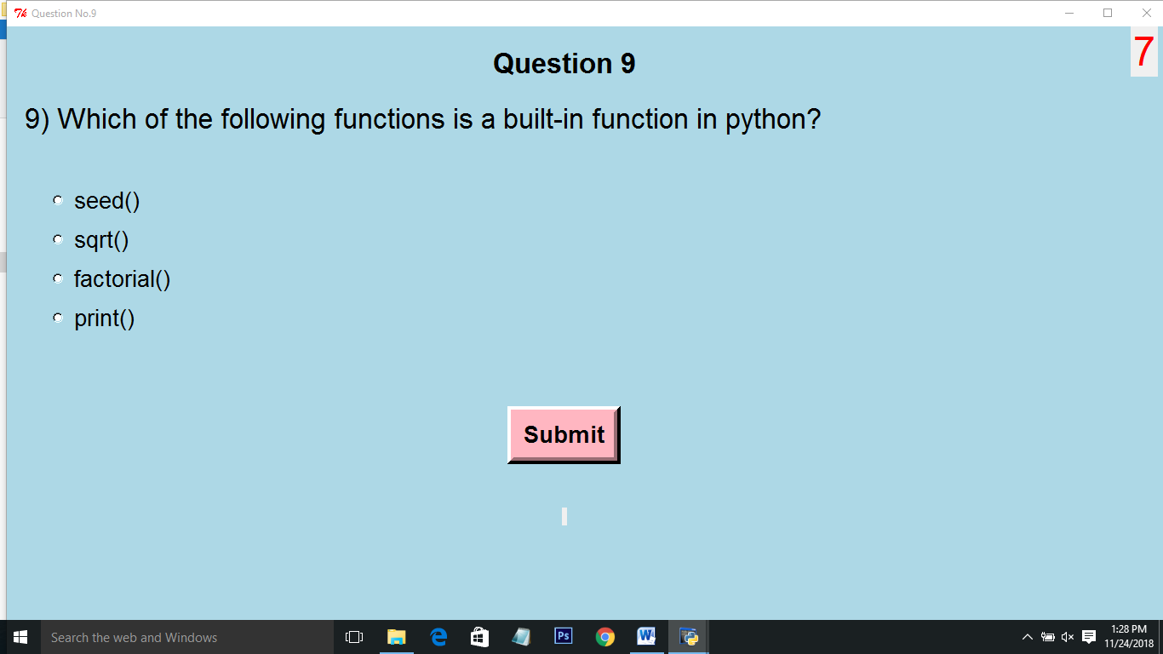

**Question no.10**

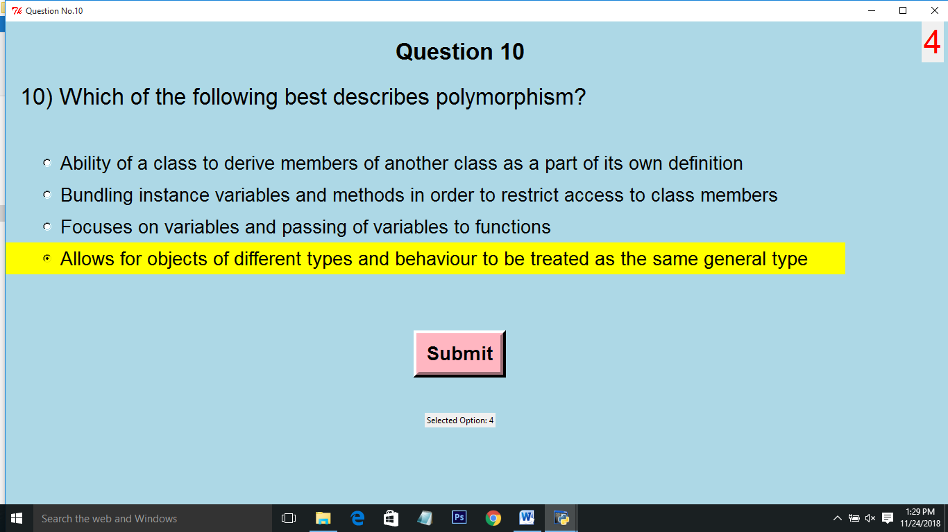

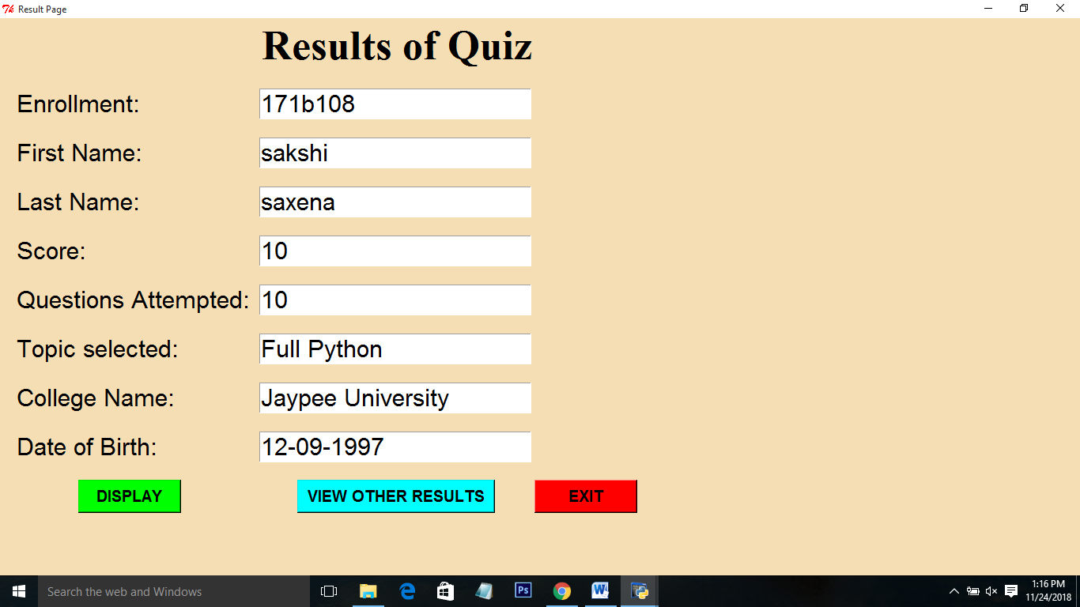

**Result screen:**

This screen contains the result of the currently attempted quiz once you press the DISPLAY button. Data is retrieved from database: **Quiz portal** and displayed in the fields.

:Used to display scores of current quiz.

**Functions:def show()**

:Take to the fetch result page where user can search details of any user previously played.

**Functions: def newResultPage1():**

 :Exits from portal.

**Functions: def reset():**

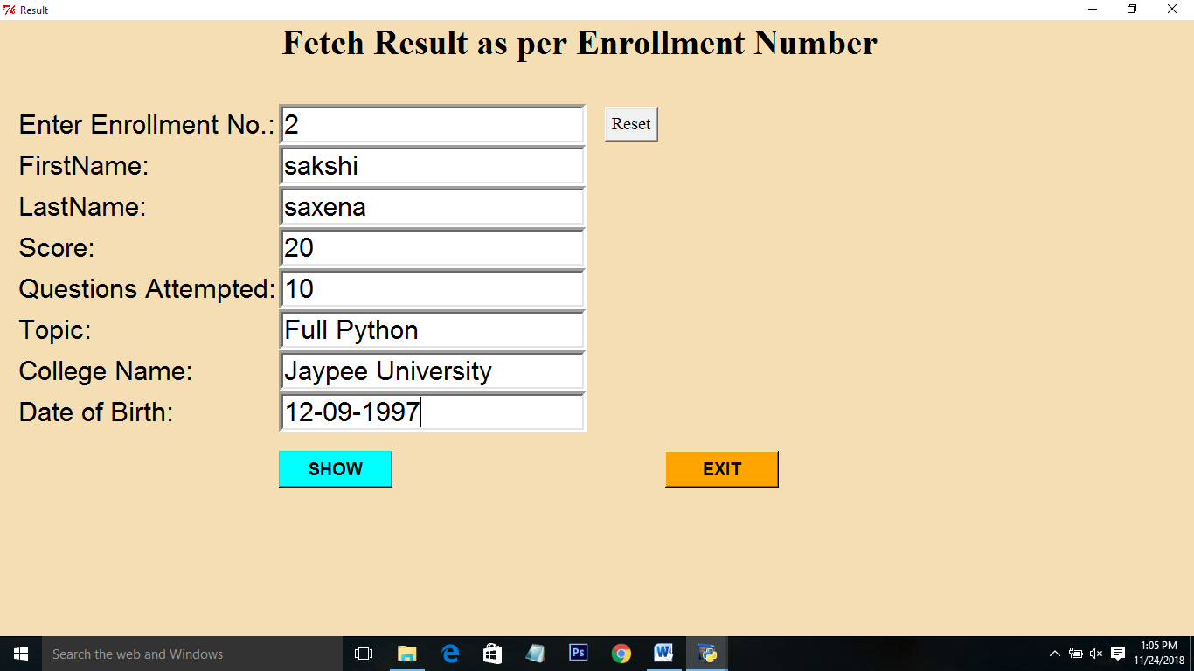

**Fetching Results as per enrollment number:**

Through this page user can fetch there score by entering their enrollment number and click on SHOW. Data is retrieved from database: **Quiz portal1** and displayed in the fields.

**WIDGETS:**

Label, button, entry-box

: This is used to display the score after the user has attempted the quiz.

**Functions:** **def EXIT():**

**:** Exits from the portal.

**Functions: def shownew()**

: Resets the enrollment number in enrollment number entry field.

**Function:** **def reset():**

******************************************************************

**End of Documentation**