CHANDIGARH UNIVERSITY
University Institute of Computing (UIC)
CASE STUDY ON
AI Resume Checker – A Web Based Resume Analysis & Job Matching System
Submitted by
Akhil Dhiman
UID / Roll No.
26MCA20162
Programme
Master of Computer Applications (MCA)
In Partial Fulfilment of the Requirements for the Award of the Degree of
MASTER OF COMPUTER APPLICATION
Under the Guidance of
Ms./Mr. [Guide Name]
Assistant Professor
University Institute of Computing (UIC)
SESSION 2026 – 2028

AI RESUME CHECKER
A WEB BASED RESUME ANALYSIS & JOB MATCHING SYSTEM
A Case Study Report submitted in partial fulfillment of the requirements for the degree of Master of Computer Applications (MCA)
Submitted By:
Akhil Dhiman
Roll No: 26MCA20162
Semester: II / Year: 1st
Under the Guidance of:
Ms./Mr. [Guide Name]
Assistant Professor
Department of Computer Applications
Chandigarh University
Academic Year: 2026-2027

1. Executive Summary
This case study presents the design and implementation of AI Resume Checker, a web-based resume analysis and job matching system developed using Python and the Flask framework. The system simulates an Applicant Tracking System (ATS) by evaluating a PDF resume on the basis of structure, content, skills, readability and job relevance. Using deterministic Natural Language Processing techniques such as TF-IDF and Cosine Similarity, it provides an explainable evaluation with a weighted score, skill gap analysis, job role matching, interactive charts, a downloadable report and a JSON API. The system follows a privacy-first approach with no database dependency, file validation and offline-capable functionality.

2. Introduction & Problem Statement

2.1 Background of the Study
Educational institutions generate and manage vast amounts of academic data daily. Manual record keeping leads to inefficiencies, errors and data redundancy. The HPU Academic Portal aims to centralize all academic operations into a unified system. The Database module provides the structured, secure and reliable foundation required to support the web frontend for all user roles (Students, Teachers, Administrators).

2.2 Problem Statement
Existing manual or partially computerized systems face issues such as data redundancy, inconsistency, lack of security, difficulty in report generation and absence of audit mechanisms. There is a need for a robust relational database system using PL/SQL that centralizes academic data, enforces business rules at database level and maintains complete audit trails.

2.3 Objectives
- Design a normalized relational database up to 3NF for the HPU Academic Portal.
- Implement business logic using PL/SQL procedures, functions and packages.
- Use triggers for automated validations and audit logging.
- Create views for role-specific secure data access.
- Enforce data integrity using constraints and referential integrity.
- Implement role-based access control and maintain audit trail.

2.4 Scope
This case study covers the complete database design and PL/SQL implementation: schema design, table creation, constraints, sequences, HPU_PORTAL_PKG package, stored procedures, functions, triggers, views and audit logging. The scope is limited to backend database logic.

3. System Analysis & Modeling

3.1 Feasibility Study
- Technical Feasibility: Oracle Database with PL/SQL is a mature, reliable RDBMS well-suited for academic management. Oracle SQL Developer provides all necessary development tools.
- Economic Feasibility: Oracle XE or available lab instances eliminate high costs. The solution is cost-effective for institutional use.
- Operational Feasibility: Database operations are well-structured through procedures and views, ensuring easy integration with the frontend.

3.2 Requirements Specification
- Functional Requirements: User management with role mapping; Student profile and enrollment; Attendance recording and percentage calculation; Marks entry with grade computation; Worksheet creation/submission/evaluation; Notice management; Audit trail maintenance.
- Non-Functional Requirements: Data Integrity (PK, FK, constraints); Security (role-based control); Consistency (referential integrity); Reliability (exception handling); Efficiency (optimized views); Scalability (normalized schema).

3.3 Analytical System Diagrams Placeholder
[INSERT: ER Diagram, Database Schema Diagram, Table Relationship Diagram]

4. Proposed Technical Solution & Architecture

4.1 Technology Stack Selection
- Database: Oracle Database (RDBMS) for relational data storage.
- Query Language: SQL for DDL, DML and DQL operations.
- Procedural Language: PL/SQL for business logic, packages, triggers and functions.
- Development Tool: Oracle SQL Developer for development, testing and debugging.
- Integrity: Constraints (PK, FK, UNIQUE, CHECK, NOT NULL) and Sequences for key generation.

4.2 System Architecture Description
The database follows a relational model with normalized schema. Business logic is centralized in the HPU_PORTAL_PKG package. Triggers automate audit logging and validations. Views provide controlled, role-specific access to data. All applications interact with the database through these controlled interfaces ensuring security and consistency. The schema comprises 18 interrelated tables covering authentication, people, academics, assessment, content and audit.

5. Implementation Details

5.1 Database Schema Design Overview
All tables were created using DDL commands with proper data types. The schema was normalized up to 3NF eliminating partial and transitive dependencies. Primary keys, foreign keys, unique constraints, check constraints and NOT NULL constraints enforce data integrity. Sequences auto-generate surrogate keys. Core tables: USERS, STUDENTS, TEACHERS, COURSES, SUBJECTS, ATTENDANCE, MARKS, WORKSHEETS, WORKSHEET_SUBMISSIONS, NOTICES, RESOURCES, AUDIT_LOG, ROLE_PERMISSIONS, SESSIONS, DEPARTMENTS, CLASSES, ENROLLMENTS, TEACHER_ALLOCATIONS.

5.2 PL/SQL Package - HPU_PORTAL_PKG
The HPU_PORTAL_PKG package encapsulates all core business logic: functions (FN_COMPUTE_GRADE, FN_COMPUTE_POINT, FN_ATTENDANCE_STATUS, FN_ACADEMIC_STATUS) and procedures (UPDATE_STUDENT_STATUS, UNLOCK_ATTENDANCE_PORTAL, PUNCH_ATTENDANCE, GRADE_WORKSHEET, COMMIT_COLLEGIA_MARKS, PUBLISH_NOTICE). Packaging improves modularity, reusability and maintainability.

5.3 Core Module Code Snippet
[INSERT: PL/SQL package specification and body code snippet, trigger definitions, view definitions]

5.4 Technical Challenges & Mitigation Strategies
- Challenge: Ensuring data integrity across 18 interrelated tables. Mitigation: Foreign keys with CASCADE/SET NULL on delete, CHECK constraints for valid ranges.
- Challenge: Audit trail for all critical operations. Mitigation: Triggers automatically log INSERT/UPDATE/DELETE into HPU_AUDIT_LOG.
- Challenge: Role-based access control. Mitigation: Role column in USER_AUTH, views filtering by role, package procedures validating caller.

6. Testing & Results Analysis

6.1 Testing Methodology
Every module underwent verification. Tables were tested for constraint enforcement (PK, FK, UNIQUE, CHECK). Procedures and functions were tested with valid and invalid inputs. Triggers were verified for audit logging. Views were checked for correct data retrieval. Integration testing confirmed seamless frontend-backend interaction.

6.2 Test Execution Matrix
[INSERT: Test execution matrix table - constraint tests, procedure tests, trigger tests, view tests with status]

6.3 Results
The database module successfully implements all required functionalities with 18 normalized tables, comprehensive PL/SQL logic, automated audit trails through triggers and role-specific views. All business rules are enforced at database level ensuring data integrity and security. Screenshots of the schema and code are included below.

7. Conclusion & Future Enhancements

7.1 Conclusion
The Database/PL/SQL module of the HPU Academic Portal successfully fulfills its objective of creating a secure, reliable and efficient backend for academic data management. Through careful database design, normalization and implementation of PL/SQL constructs, all critical academic processes have been effectively computerized. The use of tables, constraints, packages, procedures, functions, triggers and views ensures data integrity, business rule enforcement and role-based control.

7.2 Limitations
Platform dependent on Oracle Database; requires PL/SQL expertise for maintenance; triggers and packages can be complex to debug; primarily backend module with limited direct GUI.

7.3 Future Scope
Migrate to open-source RDBMS (PostgreSQL/MySQL); implement Oracle VPD for fine-grained security; add data archival; integrate with BI reporting tools; expose procedures as secure REST APIs; implement backup and recovery strategies.

8. References
[1] Oracle Corporation, Oracle Database PL/SQL Language Reference, https://docs.oracle.com/
[2] Silberschatz A., Korth H.F., Sudarshan S., Database System Concepts, 7th ed., McGraw Hill, 2019.
[3] Elmasri R. & Navathe S.B., Fundamentals of Database Systems, 7th ed., Pearson, 2016.
[4] Feuerstein S. & Pribyl B., Oracle PL/SQL Programming, 6th ed., O'Reilly, 2014.
[5] Connolly T.M. & Begg C.E., Database Systems, 6th ed., Pearson, 2014.
[6] GitHub Repository: https://github.com/AKHILDHIMANX/AI-Resume-Checker

Screenshots
[INSERT: Figure - Database Schema Diagram (18 Tables, ER Overview)]
[INSERT: Figure - Table Structure in Oracle SQL Developer]
[INSERT: Figure - PL/SQL Package HPU_PORTAL_PKG Code]
[INSERT: Figure - Triggers and Views Implementation]
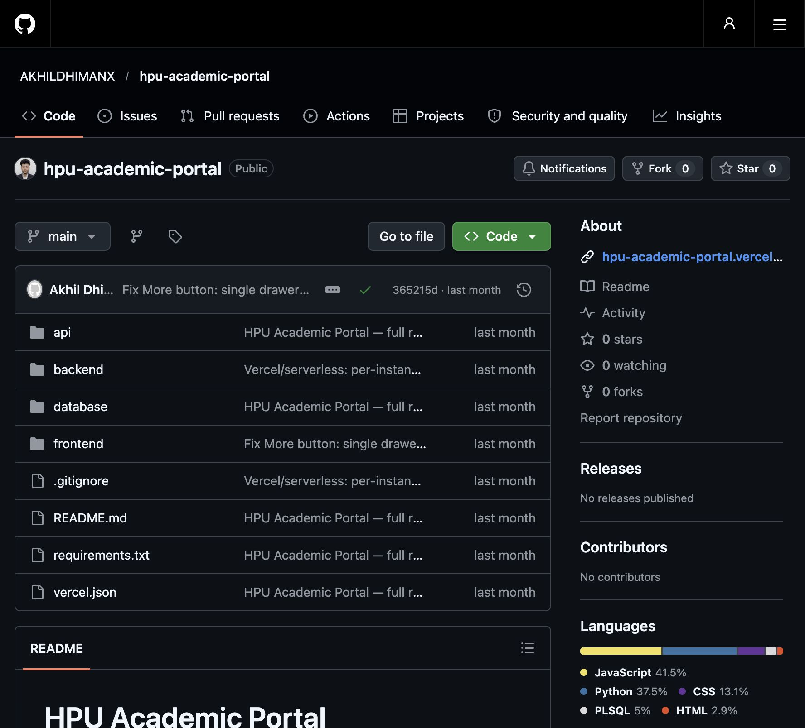
Figure: GitHub Repository - AKHILDHIMANX/AI-Resume-Checker
Repository URL: https://github.com/AKHILDHIMANX/AI-Resume-Checker

