CHANDIGARH UNIVERSITY
University Institute of Computing (UIC)

A PROJECT REPORT ON
AI RESUME CHECKER - AN NLP BASED RESUME ANALYSIS AND JOB MATCHING SYSTEM

Submitted by
AKHIL DHIMAN
UID / Roll No.: 26MCA20162
Programme: Master of Computer Applications (MCA)

In Partial Fulfilment of the Requirements for the Award of the Degree of
MASTER OF COMPUTER APPLICATIONS

Under the Guidance of
DR NISHA SHARMA
Assistant Professor
University Institute of Computing (UIC)
SESSION 2026 – 2028

ABSTRACT
The project entitled "AI Resume Checker - An NLP Based Resume Analysis and Job Matching System" is a web-based application developed to help job seekers evaluate their resumes against Applicant Tracking System (ATS) standards. The system uses deterministic Natural Language Processing techniques to extract text from a PDF resume, detect sections, extract technical and soft skills, perform an 8-point ATS readability analysis, compute a weighted resume score and match the resume against published job roles using coverage and cosine similarity. The application generates interactive charts, a downloadable text report and a JSON API. It follows a privacy-first approach with no database, no external API calls by default and no storage of user data, making it suitable for students and job seekers who need transparent and reproducible feedback before applying for jobs.

TABLE OF CONTENTS
1. INTRODUCTION
1.1 Problem Statement
1.2 Objectives of the Project
1.3 Scope of the Project
2. SOFTWARE AND HARDWARE REQUIREMENTS
2.1 Hardware Requirements
2.2 Software Requirements
3. SYSTEM ANALYSIS AND DESIGN
3.1 System Analysis
3.2 Feasibility Study
4. SYSTEM ARCHITECTURE
4.1 System Architecture Description
4.2 Algorithms
4.3 Flow Chart
5. IMPLEMENTATION AND CODE EXPLANATION
5.1 Modules Used
5.2 Main Source Code
5.3 Working of the Project
6. TESTING AND RESULTS
7. ADVANTAGES AND LIMITATIONS
8. FUTURE SCOPE
9. CONCLUSION
10. REFERENCES
11. GIT REPOSITORY LINK AND SCREENSHOTS

1. INTRODUCTION
With the increasing demand for jobs and the widespread use of Applicant Tracking Systems (ATS) in the recruitment process, most resumes are filtered out before reaching a human recruiter. Many job seekers are unaware of why their resumes are rejected. Hence, there arises a need for a system that can simulate an ATS and provide constructive feedback to improve resume quality before applying for jobs.

1.1 PROBLEM STATEMENT
The major problems identified are:
- Unorganized Resumes: Resumes often lack standard sections and clear structure, making them hard for ATS parsers to read.
- Manual Effort: Job seekers have no way to self-evaluate their resume against ATS criteria without paid services.
- Opacity: Most commercial ATS checkers give a single score without explaining the reasoning behind it.
- Privacy Concerns: Many tools require uploading personal resumes to third-party servers.

1.2 OBJECTIVES OF THE PROJECT
- To develop a web-based application that analyses PDF resumes against ATS criteria.
- To extract resume content using PDF parsing techniques (pypdf with pdfplumber fallback).
- To identify and extract technical and soft skills from the resume using a curated vocabulary and TF-IDF.
- To match the resume with relevant job roles using skill coverage and cosine similarity.
- To provide visual charts, a downloadable text report and a JSON API for results.
- To perform an 8-point ATS readability analysis and generate explainable feedback.
- To compute a weighted resume score and grade the resume.
- To match the resume with relevant job roles using skill coverage and cosine similarity.

1.3 SCOPE OF THE PROJECT
This project is designed to analyse a single PDF resume uploaded by the user. It covers text extraction, section detection, skill extraction, ATS analysis, scoring, job role matching, chart generation and report download. It does not cover OCR for scanned PDFs, multi-resume comparison, or career counselling. The system runs locally or on the user's own deployment and does not store user data in a database.

2. SOFTWARE AND HARDWARE REQUIREMENTS

2.1 HARDWARE REQUIREMENTS
- Processor: Intel Core i3 or above
- RAM: 4 GB or higher
- Hard Disk: Minimum 500 MB free space
- Input Device: Keyboard, Mouse
- Output Device: Monitor

2.2 SOFTWARE REQUIREMENTS
- Operating System: Windows 7/10/11, Linux or macOS
- Programming Language: Python 3.10 or newer (tested on 3.14)
- Web Framework: Flask 3.1
- IDE: VS Code / PyCharm
- Other Tools: Git, GitHub for version control, Vercel for deployment

3. SYSTEM ANALYSIS AND DESIGN

3.1 SYSTEM ANALYSIS
System analysis is the process of studying the existing system and finding out its drawbacks. An ATS simulates the screening process used by employers. The proposed system analyses a resume the way an ATS would, but explains every step so the user can improve the resume.

3.2 FEASIBILITY STUDY
- Technical Feasibility: The project is developed using Python which is easily available and has rich libraries for NLP and web development.
- Economic Feasibility: The system is cost-effective as it uses only open-source tools and technologies with no licensing cost.
- Operational Feasibility: The system is very easy to use and requires no prior technical knowledge from the end user.

4. SYSTEM ARCHITECTURE

4.1 SYSTEM ARCHITECTURE DESCRIPTION
The AI Resume Checker follows a modular approach. The user interacts through a web browser. The Flask backend handles uploads, validation and routing, and delegates analysis to a framework-free backend module set (resume_parser, skill_extractor, ats_analyzer, scoring, job_matcher, analyzer, charts). Data is stored as editable JSON files for skills and job roles, with reports saved to a writable directory or in-memory cache. Charts are rendered with matplotlib and returned as base64 data URIs in inline mode.

5. ALGORITHMS
Algorithm for Resume Analysis:
- Start the application and accept a PDF resume upload.
- Validate file extension, size (max 4 MB) and PDF signature.
- Extract text from the PDF using pypdf, falling back to pdfplumber if needed.
- Detect resume sections, fields, word count and page count.
- Extract skills using alias matching and TF-IDF keyword weighting.
- Perform 8-point ATS readability checks.
- Calculate weighted resume score based on multiple parameters.
- Match resume with job roles using skill coverage and cosine similarity.
- Stop.

6. FLOW CHART
Figure 4.1: Flow Chart of AI Resume Checker
(Flowchart diagram inserted below)

7. IMPLEMENTATION AND CODE EXPLANATION

7.1 MODULES USED
- Flask – For creating the web application framework and handling routes.
- pypdf – For extracting text from PDF files.
- pdfplumber – For fallback text extraction from complex PDF layouts.
- scikit-learn – For TF-IDF vectorization and cosine similarity calculation.
- NumPy – For numerical computations during similarity checks.
- matplotlib (Agg backend) – For generating charts for the dashboard.

The main file of the project is app.py. The analysis logic lives in the backend/ package (resume_parser.py, skill_extractor.py, ats_analyzer.py, scoring.py, job_matcher.py, analyzer.py, charts.py, skill_data.py). The skill and job-role data is stored in data/skills.json and data/job_roles.json. The web interface is rendered through Jinja2 templates in templates/.
The main file of the project is app.py. The analysis logic lives in the backend/ package (resume_parser.py, skill_extractor.py, ats_analyzer.py, scoring.py, job_matcher.py, analyzer.py, charts.py, skill_data.py). The skill and job-role data is stored in data/skills.json and data/job_roles.json. The web interface is rendered through Jinja2 templates in templates/.

7.3 WORKING OF THE PROJECT
The sequence of operations from input to final output is as follows:
- The user opens the application in a browser and uploads a PDF resume.
- The user optionally selects a target job role from the dropdown.
- The file is validated (extension, size, PDF signature) before processing.
- Skills are extracted using alias matching and TF-IDF keyword weighting.
- An 8-point ATS readability analysis is performed.
- A weighted resume score and grade are computed.
- Test 3: Valid PDF upload - text extracted successfully.
- Test 4: Section detection - standard sections identified correctly.
- Test 5: Skill extraction - known skills and aliases matched correctly.
- Test 6: ATS analysis - all 8 checks returned with pass/needs-attention status.
- Test 7: Resume scoring - overall score within 0-100 with a grade band.
- Test 8: Job role matching - roles ranked by relevance correctly.
- Test 9: Chart generation in inline mode - base64 data URIs generated successfully.
- Test 10: Report restoration - missing server copy restored from browser storage.
- The resume is matched against all job roles using coverage and cosine similarity.
- Charts are generated and results are displayed on the dashboard.
- The user can download a text report or view the JSON output.
- Text is extracted from the PDF using pypdf, with pdfplumber as a fallback.
- Sections, fields, word count and page count are detected.

8. TESTING AND RESULTS
The application was tested with various resume samples to verify correctness and robustness. A total of 152 automated tests were executed and all passed.
Test 1: Upload of a non-PDF file renamed with .pdf extension - correctly rejected.
Test 2: Upload of an empty/corrupt PDF - correctly reported as unreadable.

TABLE 5.1: SAMPLE TEST CASES

9. ADVANTAGES AND LIMITATIONS

9.1 ADVANTAGES
- Saves time and reduces manual resume review effort.
- User-friendly web interface accessible to non-technical users.
- Safe file handling with size and signature validation.
- Explainable scores with per-rule ATS outcomes.
- Works offline without internet connection.
- No external packages beyond standard Python libraries.
- Privacy-first: no database, no tracking, no external API calls.

9.2 LIMITATIONS
- Does not support OCR for scanned or image-based PDFs.
- Limited to a predefined set of 10 job roles.
- Analyses one resume at a time (no multi-resume comparison).
- Heuristic, rule-based scoring may not match every company's custom ATS.
- Primarily designed for English resumes.

10. FUTURE SCOPE
The system can be enhanced in future by adding the following features:
- OCR support for scanned/image-based PDFs.
- Expanded job role catalogue across more industries.
- Multi-language resume parsing.
- Resume comparison feature to compare two versions.
- ATS keyword optimizer suggesting missing high-impact keywords.
- Mobile-responsive design and mobile application.
- Cloud storage with user-controlled history.
- Customizable scoring weights per industry.

11. CONCLUSION
The "AI Resume Checker" has been successfully designed and developed using Python and Flask. The system provides a transparent, deterministic and privacy-preserving way for job seekers to evaluate their resumes against ATS standards. By combining PDF parsing, NLP-based skill extraction, an 8-point ATS analysis, weighted scoring and job role matching, the application delivers actionable feedback along with visual charts and a downloadable report. The project demonstrates the practical application of natural language processing and web development in solving a real-world problem faced by students and job seekers.

12. REFERENCES
[1] Pallets Projects, "Flask Documentation", Available: https://flask.palletsprojects.com/
[2] pypdf Developers, "pypdf Documentation", Available: https://pypdf.readthedocs.io/
[3] Jeremy Singer-Vine, "pdfplumber Documentation", Available: https://github.com/jsvine/pdfplumber
[4] scikit-learn Developers, "scikit-learn: Machine Learning in Python", Available: https://scikit-learn.org/stable/
[5] Harris, C.R. et al., "Array programming with NumPy", Nature, 585, 357-362 (2020).
[6] AKHIL DHIMAN, "AI Resume Checker using Python", GitHub Repository, Available: https://github.com/AKHILDHIMANX/AI-Resume-Checker
[7] Manning, C.D., Raghavan, P., Schutze, H., "Introduction to Information Retrieval", Cambridge University Press, 2008.
[8] Turney, P.D. & Pantel, P., "From Frequency to Meaning: Vector Space Models of Semantics", Journal of AI Research, 37, 141-188, 2010.
[9] Vercel Inc., "Vercel Documentation - Python", Available: https://vercel.com/docs/functions/runtimes/python
[10] AKHIL DHIMAN, "AI Resume Checker using Python", GitHub Repository, Available: https://github.com/AKHILDHIMANX/AI-Resume-Checker

13. GIT REPOSITORY LINK AND SCREENSHOTS
GitHub Repository Link: https://github.com/AKHILDHIMANX/AI-Resume-Checker

Figure 11.1: GitHub Repository of AI Resume Checker - AKHILDHIMANX/AI-Resume-Checker

Figure 11.2: AI Resume Checker Home Page - Upload Resume Interface

Figure 11.3: System Architecture of AI Resume Checker

Figure 11.1: GitHub Repository of AI Resume Checker - AKHILDHIMANX/AI-Resume-Checker
Figure 11.2: AI Resume Checker Home Page - Upload Resume Interface
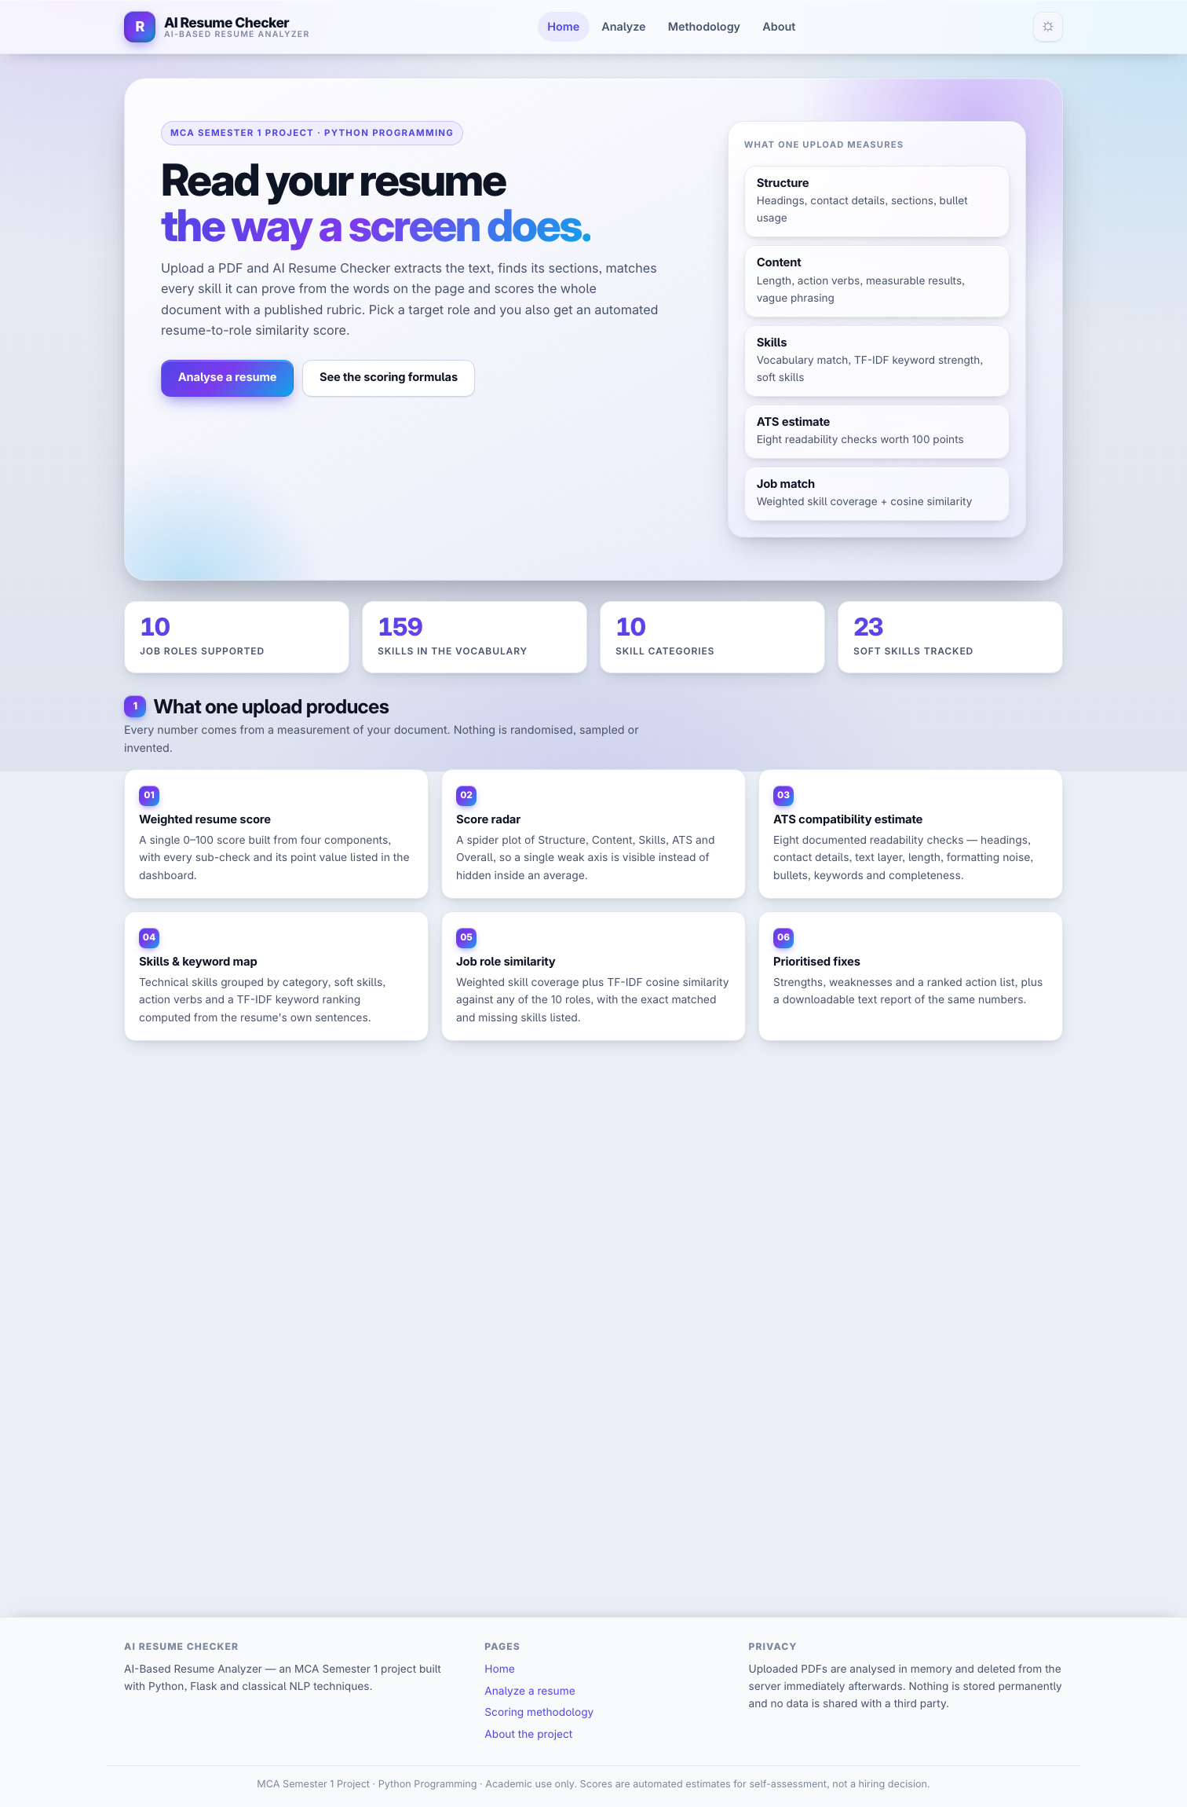
Figure 11.3: System Architecture of AI Resume Checker


