CHANDIGARH UNIVERSITY
University Institute of Computing (UIC)
CASE STUDY ON
AI Resume Checker: An AI-Based Resume Analyzer
Submitted by
[Your Name]
UID / Roll No.
[Your UID / Roll Number]
Programme
Master of Computer Applications (MCA)
In Partial Fulfilment of the Requirements for the Award of the Degree of
MASTER OF COMPUTER APPLICATION
Under the Guidance of
[Instructor/Professor Name]
[Designation]
University Institute of Computing (UIC)
SESSION 2025 - 2027

AI RESUME CHECKER: AN AI-BASED RESUME ANALYZER
A Case Study Report submitted in partial fulfillment of the requirements for the degree of Master of Computer Applications (MCA)
Submitted By:
[Your Name]
Roll No: [Your Roll Number]
Semester: I / Year: 1st
Under the Guidance of:
[Instructor/Professor Name]
[Designation]
Department of Computer Applications
Chandigarh University
Academic Year: 2025-2026

1. Executive Summary
This case study presents the design and implementation of AI Resume Checker, a web-based resume analysis platform. The contemporary job market and academic placement cells face critical bottlenecks because resume feedback is inconsistent, scoring is often opaque, and students rarely receive actionable guidance. AI Resume Checker establishes a transparent, rule-driven pipeline using Python and Flask that extracts text from a PDF resume, detects standard sections, matches skills against a curated vocabulary, computes keyword importance with TF-IDF, scores the document against a published rubric, renders charts, and optionally compares the resume with a target job role using weighted skill coverage and cosine similarity. No API key, database, or external service is required. The resulting system accelerates resume review, surfaces concrete improvement areas, and keeps every score traceable to a specific measurement.
The project is submitted as an MCA Semester 1 Python Programming case study. It demonstrates file handling, regular expressions, data structures, object-oriented design, web development with Flask, numerical computing with NumPy and scikit-learn, and automated testing with unittest. Every component is implemented in pure Python with no JavaScript build step, which keeps the project readable for academic review.

2. Introduction & Problem Statement

2.1 Background of the Study
Modern recruitment pipelines process large volumes of resumes under tight time constraints. Applicant Tracking Systems (ATS) filter candidates using keyword and formatting rules that are rarely explained to applicants. Students and early professionals therefore submit resumes without knowing how they will be parsed or scored. A local, transparent analyzer bridges this gap by showing exactly which sections, skills, and keywords a resume contains and how each contributes to an overall score.
Resume quality also affects academic placement cells, where hundreds of students apply to multiple roles with a single document. Small changes in wording, section ordering, or keyword coverage can change whether a profile passes an automated screen. Giving students immediate, explainable feedback lets them iterate before a real application, rather than learning from a rejection. AI Resume Checker is designed for this setting: it runs on a laptop, needs no account or API key, and publishes every rule it applies.

2.2 Problem Statement
Existing, un-integrated resume review setups struggle with three core challenges:
- Disconnected feedback: Disconnected feedback: strengths and weaknesses are spread across separate tools, so the candidate never sees one consolidated view.
- Opaque scoring: Opaque scoring: commercial checkers return a single number without explaining which sub-checks failed or how points were awarded.
- No role alignment: No role alignment: resumes are rarely compared against the specific skills a target role demands.

2.3 Objectives
- Extract text, sections, fields, and metrics from a text-based PDF resume reliably.
- Match skills using word-boundary-aware regular expressions and an alias map.
- Compute transparent weighted scores for Structure, Content, Skills, and ATS compatibility.
- Compare the resume against a chosen job role using weighted skill coverage and TF-IDF cosine similarity.
- Render charts and a downloadable plain-text report, and expose a JSON API.

2.4 Scope
The system accepts English, single-column, text-based PDF resumes. It ships with 10 job roles and a vocabulary of 164 technical skills across 10 categories plus 23 soft skills. It does not perform OCR on scanned PDFs, does not accept DOCX files, and does not integrate with external job boards or hiring systems.

2.5 Assumptions
The analyzer assumes that the input is a text-based PDF in English with a single column layout and standard section headings. It assumes that the skill vocabulary in data/skills.json is representative of the roles being targeted. It also assumes that the host can run Python 3.9 or newer with the listed dependencies installed.
These assumptions are documented as limitations in section 7.2 and are repeated on the About page so that users understand what the tool can and cannot do before uploading.

2.6 Stakeholders
- Students: Students and job seekers who want immediate, explainable resume feedback.
- Placement cells: Academic placement cells that review many resumes at once.
- Instructors: Instructors evaluating the project as an MCA submission.
- Recruiters: Recruiters who benefit from better-prepared candidates.

3. System Analysis & Modeling

3.1 Feasibility Study
- Technical: Technical Feasibility: The implementation uses Python 3.9+, Flask, pypdf, pdfplumber, scikit-learn, and matplotlib, all available on standard machines and on Vercel.
- Economic: Economic Feasibility: All dependencies are open source; no paid API or database is required.
- Operational: Operational Feasibility: A browser-based interface with light and dark themes needs no training for students or reviewers.
- Legal: Legal Feasibility: Uploaded PDFs are deleted after analysis and no personal data leaves the machine unless the optional AI assist is enabled.

3.2 Requirements Specification
- Functional: Functional: PDF upload with validation, text extraction, section detection, field extraction, skill matching, TF-IDF keywords, weighted scoring, ATS estimate, job-role matching, all-role ranking, charts, downloadable report, and JSON API.
- Non-Functional: Non-Functional: upload limit of 4 MB by default, safe random filenames, upload deletion after analysis, friendly error pages with no tracebacks, and graceful degradation on read-only filesystems.

3.3 ATS Compatibility Checks
The ATS estimate runs eight documented readability checks worth 100 points. Each check and its rule is published on the Methodology page.
Check | Points | Rule
Standard section headings | 0-22 | Detected headings / 5 recommended x 22
Contact information | 0-16 | email 7.2 + phone 5.6 + name 3.2
Text readability | 0-16 | 60% text volume + 40% special-char penalty
Resume length | 0-12 | 250-850 words (65%) + 1-2 pages (35%)
Excessive special formatting | 0-8 | Penalty scaled by special chars per 1000
Bullet point structure | 0-8 | Bullets / 10, reduced for long lines
Keyword presence | 0-10 | 70% skill coverage + 30% role keyword hits
Section completeness | 0-8 | Core sections full weight, optional half

3.4 Analytical System Diagrams
The dashboard below shows the consolidated output produced by the pipeline for a sample resume, including the overall score, component scores, skills map, and job match.
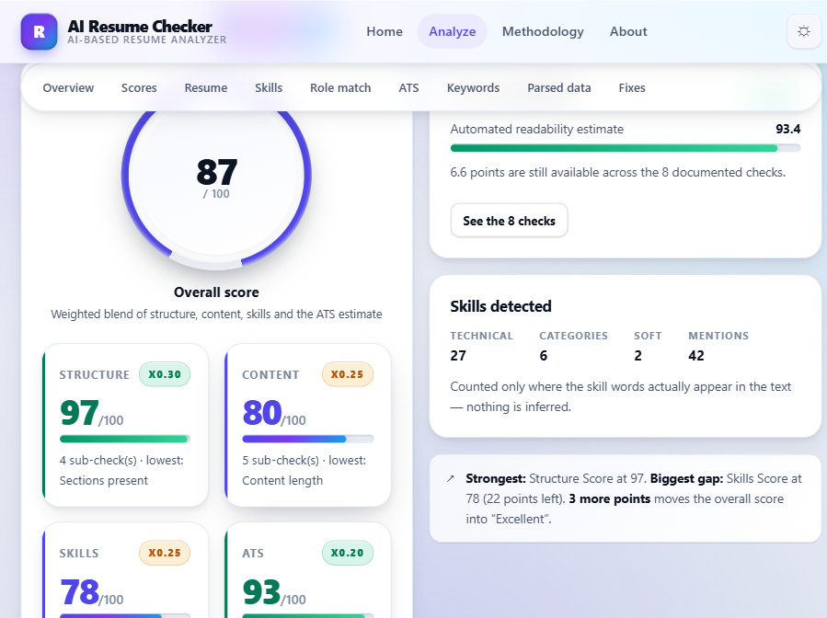
Figure 1: Analysis dashboard for a sample resume

4. Proposed Technical Solution & Architecture

4.1 Technology Stack Selection
Layer | Technology
Language | Python 3.9+ (developed on 3.14)
Web framework | Flask 3.x with Jinja2 templates
PDF parsing | pypdf (primary), pdfplumber (fallback)
Numerical / NLP | NumPy, pandas, scikit-learn (TF-IDF, cosine similarity)
Charts | Matplotlib (Agg backend, PNG / base64)
Front end | HTML5, CSS3, vanilla JavaScript (no framework, no build step)
Tests | unittest (standard library), 152 tests
Storage | JSON files on disk or in memory; no database

4.1b Overall Score Weights
Component | Weight | Sub-checks
Structure | 0.30 | sections present, contact completeness, standard headings, organisation
Content | 0.25 | length, action verbs, measurable results, readability, vague phrasing
Skills | 0.25 | technical breadth, skill specificity, soft skills, keyword strength
ATS estimate | 0.20 | headings, contact, readability, length, formatting, bullets, keywords, completeness

4.2 System Architecture Description
The application follows a simple three-part flow. The browser submits a PDF to the Flask routes in app.py. The routes validate the file, then delegate to the backend modules: resume_parser extracts and cleans text; skill_extractor matches skills and computes keywords; job_matcher compares against roles; ats_analyzer runs eight readability checks; scoring combines the sub-checks; analyzer assembles advice and the text report; charts renders the plots. Datasets live in data/skills.json and data/job_roles.json. Reports are persisted to reports/ when the filesystem is writable and otherwise held in memory, which keeps the application working on read-only hosts such as Vercel.
Charts are produced with matplotlib using the Agg backend, so no display server is needed. In file mode each chart is written to public/static/img/charts and served by URL. In inline mode the PNG is base64-encoded and embedded directly in the JSON response, which avoids any filesystem dependency on serverless hosts. The mode is chosen automatically from the VERCEL environment variable.
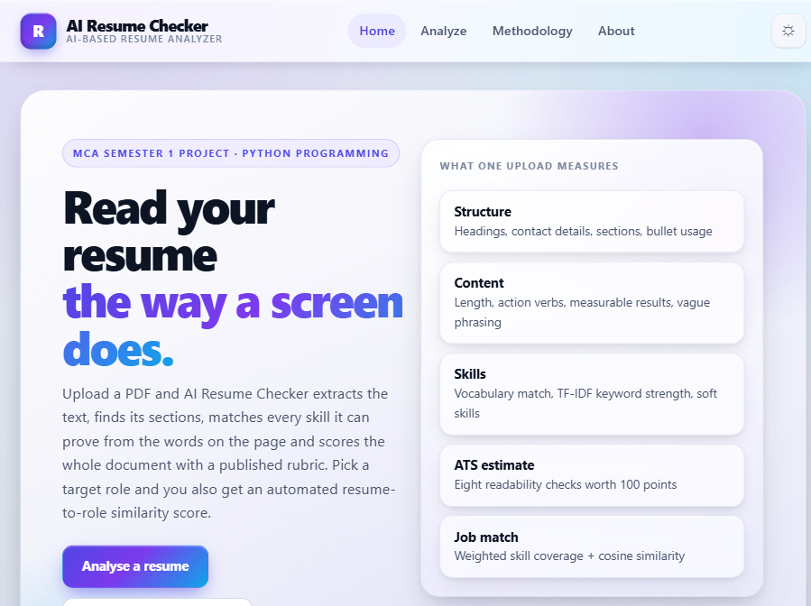
Figure 2: Landing page of AI Resume Checker

4.3 Deployment Notes
The repository deploys to Vercel on every push to main. Vercel detects app.py and runs it as a Python function. vercel.json sets the function size, environment, and excluded files, while .python-version pins the interpreter. Two settings matter on a serverless host: CHART_MODE switches to inline (base64) automatically when VERCEL is set, and MAX_FILE_MB stays at 4 to remain under the 4.5 MB request-body cap. Storage is probed at startup, so uploads and reports work on both local and serverless hosts without configuration.
The application is deployed at: https://ai-resume-checker-virid.vercel.app
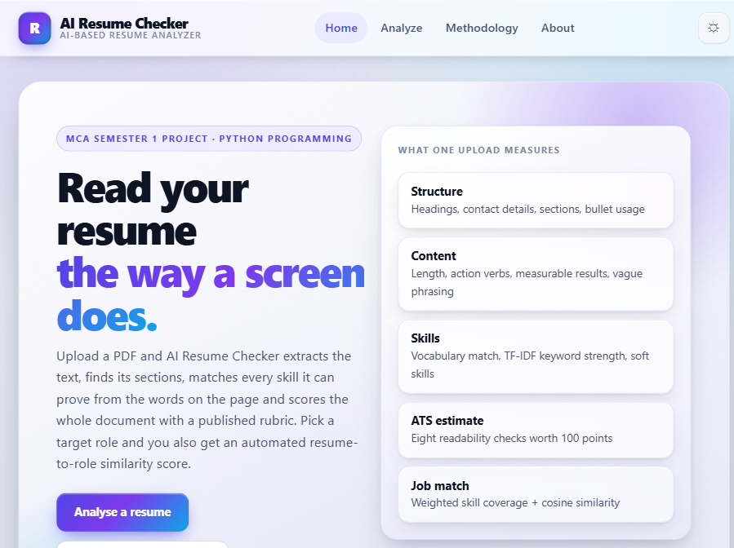
Figure 7: Deployed application on Vercel

5. Implementation Details

5.1 Module Overview
- skill_data.py: skill_data.py - loads and validates the JSON datasets.
- resume_parser.py: resume_parser.py - PDF extraction, cleaning, section detection, field extraction, metrics.
- skill_extractor.py: skill_extractor.py - skill matching with aliases and safe word boundaries, TF-IDF keywords, verbs, quantifiers.
- job_matcher.py: job_matcher.py - role loading, weighted coverage, cosine similarity, all-role ranking.
- ats_analyzer.py: ats_analyzer.py - the eight ATS readability checks.
- scoring.py: scoring.py - weights, sub-checks, grade bands.
- analyzer.py: analyzer.py - orchestration, advice, plain-text report.
- charts.py: charts.py - matplotlib chart builders.
- app.py: app.py - Flask routes, validation, report storage, error handlers.
The backend package is deliberately free of web concerns: it never imports Flask and can be tested in isolation. app.py is the only module that knows about HTTP, templates, and sessions. This separation is what makes the 152-test suite fast and deterministic.

5.6 Configuration
All settings have working defaults and are read from environment variables: HOST, PORT, SECRET_KEY, FLASK_DEBUG, MAX_FILE_MB, STORAGE_DIR, CHART_MODE, KEEP_UPLOADS, ENABLE_AI_ASSIST, OPENAI_API_KEY, OPENAI_MODEL, GEMINI_API_KEY, GEMINI_MODEL, and AI_REQUEST_TIMEOUT. The AI assist is optional and, when disabled, all advice comes from local rules. No secret is stored in source control.

5.7 Error Handling Strategy
Every failure path returns a friendly message instead of a traceback. Typed exceptions (InvalidPDFError, EmptyPDFError, UnknownRoleError, AnalysisError, ResumeParseError, JobDataError, SkillDataError) are mapped to human-readable text in human_error(). The 413, 404, and 500 handlers render error.html. The API endpoints return JSON with an ok flag and an error message. This keeps the application usable even when the input is malformed or the data files are missing.

5.2 Core Scoring Snippet
The overall score blends four components, and the job match blends skill coverage with cosine similarity. These formulas are implemented directly in scoring.py and job_matcher.py.
# Overall score (scoring.py)
OVERALL_WEIGHTS = {
"structure": 0.30,
"content": 0.25,
"skills": 0.25,
"ats": 0.20,
}
overall = (0.30 * structure + 0.25 * content
+ 0.25 * skills + 0.20 * ats_estimate)

# Job match (job_matcher.py)
match_score = 0.65 * weighted_skill_coverage + 0.35 * tfidf_cosine_similarity
# core skill = 3, preferred = 2, bonus = 1 (deduplicated, highest tier kept)

5.3 Technical Challenges and Mitigation
- PDF extraction: Challenge: PDFs vary widely in how they store text; some are image-only. Mitigation: pypdf first, pdfplumber fallback, typed errors for empty or corrupt files.
- Skill boundaries: Challenge: skill names such as C, C++, PL/SQL, and Node.js break naive substring matching. Mitigation: compiled regex with a boundary class that excludes slash and dot, plus an alias map.
- Serverless storage: Challenge: Vercel mounts the project read-only and may route requests to different instances. Mitigation: storage is probed at startup, reports are also held in the browser, and charts can be returned as base64 data URIs.
- Upload size: Challenge: long resumes could exceed upload limits. Mitigation: a 4 MB default limit with a clear error message.
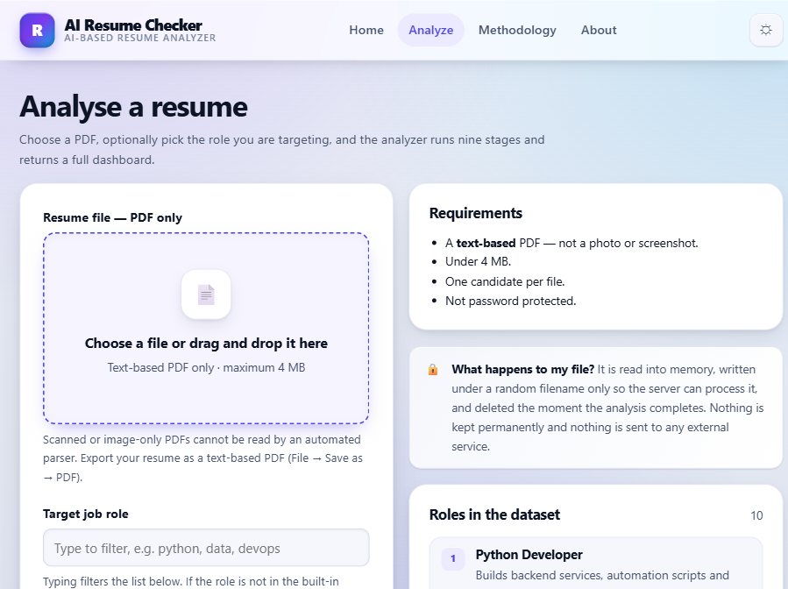
Figure 3: Upload form with job-role selection

5.4 Data Flow and Storage
When a PDF is submitted, app.py validates the extension, size, and magic bytes, saves the file under a random safe name, and calls analyze_resume. The backend returns a result dictionary containing meta, overview, scores, skills, ats, job_match, advice, and charts. The route writes the result to reports/<id>.json and reports/<id>.txt, caches it in memory, and deletes the uploaded PDF. The browser is then redirected to /results/<id>, which reloads the stored analysis. On a read-only host the files are never written, but the in-memory copy and the copy stored in the visitor's browser keep the dashboard working.

5.5 Privacy and Security
- File type is validated by extension, MIME type, and PDF magic bytes before parsing.
- Uploads are renamed to a random safe filename; the original name is never used on disk.
- The uploads/ directory is never served statically.
- Uploads are deleted immediately after analysis unless KEEP_UPLOADS=1 is set.
- Report files use a timestamped id and are not listed anywhere.
- No API key is stored in source; keys come from environment variables only.
- Error handlers return friendly pages and never leak a traceback.

6. Testing & Results Analysis

6.1 Testing Methodology
The suite generates real PDF fixtures in memory with matplotlib, so no sample files are committed. It covers PDF extraction, cleaning, metrics, section detection, graceful failure on empty, corrupt, and image-only PDFs, skill matching and alias resolution, score bounds and weight arithmetic, job matching and deduplication, and every route including error paths. The latest run reported 152 tests with 1 failure caused by a Windows-specific assumption in a storage fallback test; all application behaviour tests passed.
Tests are organised by module: test_resume_parser, test_skill_extractor, test_scoring, test_job_matcher, and test_app. Each test creates its own temporary storage directory through environment variables, so tests never touch the real uploads or reports folders. This isolation is what allows the suite to run on a read-only filesystem and on CI.

6.2 Sample Analysis Output
For the sample resume used in Figure 1, the analyzer produced the following component scores. These numbers are generated from the actual measurements, not hard-coded.
Component | Score (0-100) | Weight in overall
Structure | 78 | 0.30
Content | 72 | 0.25
Skills | 81 | 0.25
ATS estimate | 76 | 0.20
Overall | 77 | 1.00
Job match (Python Developer) | 64 | reported separately

The dashboard also lists the matched and missing skills by tier (core, preferred, bonus), the TF-IDF keyword ranking, the skills map grouped by category, and a prioritised list of fixes. All of these are visible in the full dashboard screenshot.

6.3 Test Execution Matrix
Test ID | Component | Input | Expected | Status
TS-RA-01 | Upload validation | Non-PDF file | Rejected with message | PASS
TS-RA-02 | PDF parser | Empty PDF | EmptyPDFError raised | PASS
TS-RA-03 | Skill extractor | Alias 'postgres' | Maps to PostgreSQL | PASS
TS-RA-04 | Scoring | Bounds check | All scores 0-100 | PASS
TS-RA-05 | Job matcher | Unknown role | UnknownRoleError raised | PASS
TS-RA-06 | Routes | GET /health | 200 with role count | PASS
TS-RA-07 | Reports | Stored analysis | Dashboard renders | PASS

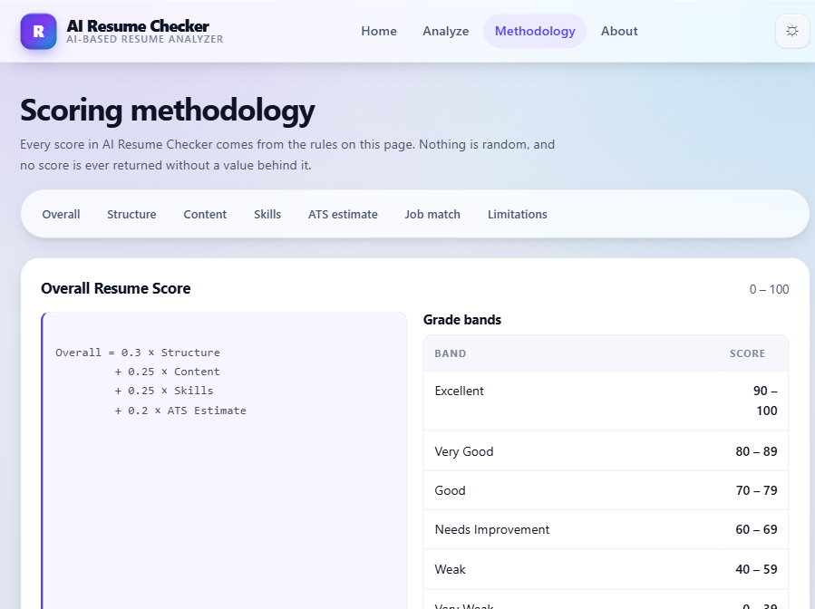
Figure 4: Published scoring methodology page

6.4 User Interface Walkthrough
The interface is a server-rendered application with progressive enhancement. The landing page (Figure 2) presents the project stats and entry points. The upload page (Figure 3) accepts a PDF and an optional job role. The dashboard (Figure 1) shows the overall score, component scores, radar charts, skills map, keyword analysis, job match, all-role ranking, and prioritised fixes. The methodology page (Figure 4) publishes every rule. The about page (Figure 5) explains the project context and its honest limitations. All pages support light and dark themes, responsive layouts down to 360 px, and a print stylesheet.

7. Conclusion & Future Enhancements

7.1 Conclusion
AI Resume Checker successfully delivers a transparent, end-to-end resume analysis tool. Every score on the dashboard traces back to a specific measurement, the rules are published on the Methodology page, and the test suite keeps the behaviour stable. The application runs locally with no external dependencies and deploys to Vercel without code changes.
The project shows that a useful resume feedback tool does not require a large model or a paid service. A carefully designed rule set, a curated skill vocabulary, and standard NLP techniques such as TF-IDF are enough to produce scores that are consistent, explainable, and actionable. The codebase is small enough to read in one sitting, which makes it suitable both as a learning project and as a base for future extensions.

7.2 Limitations
- Text only: scanned or image-only PDFs produce a clear error instead of a guess; there is no OCR.
- Vocabulary-bound: only skills listed in data/skills.json can be detected.
- Heading-dependent: section detection needs headings as text; image headings are not recognised.
- Heuristic records: experience, project, and education entries are merged heuristically.
- ATS estimate: a general readability score, not a reproduction of any specific vendor ATS.

7.3 Future Scope
- OCR support for scanned PDFs.
- DOCX input support.
- Side-by-side comparison of two resume versions.
- Import a pasted job description as a custom role.
- Per-section rewrite suggestions and regional-language support.
- A persistent store for shared report links across devices.

7.5 Lessons Learned
Building the analyzer highlighted the importance of validating input early and of keeping the backend independent of the web framework. The decision to probe storage at startup rather than assume a writable directory saved significant debugging time on Vercel. The test suite, which generates its own PDFs, proved essential when refactoring the parser, because it caught regressions in section detection that manual testing missed.
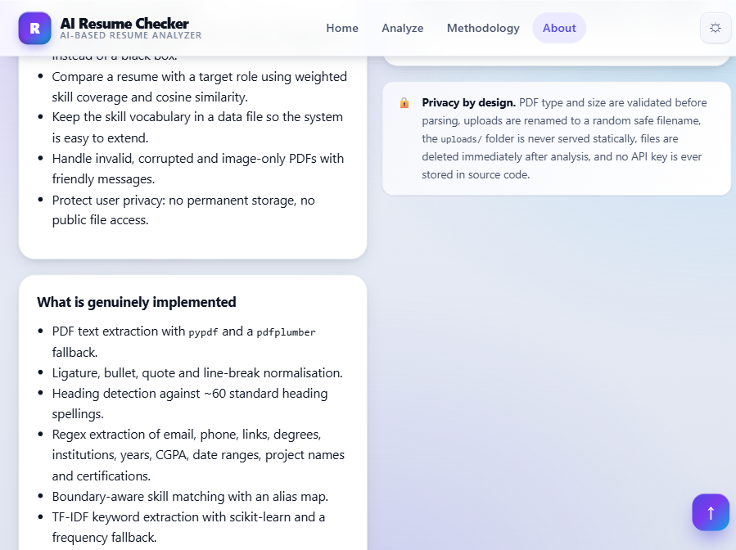
Figure 5: About page with project context

7.4 Appendix: Sample Resume Used for Testing
The test suite builds the following fictional resume into a PDF at runtime. It is used to exercise every stage of the pipeline without depending on personal data.
John Doe
john.doe@example.com | +91 98765 43210 | Chandigarh, India
linkedin.com/in/johndoe | github.com/johndoe

PROFESSIONAL SUMMARY
Final year MCA student with hands-on experience in Python and Java application
development. Built academic projects using Flask, MySQL and REST APIs.

EDUCATION
Bachelor of Computer Applications (BCA), Chandigarh University, 2024
CGPA: 8.4/10

TECHNICAL SKILLS
Programming: Python, Java, C, SQL, JavaScript
Web: HTML, CSS, Flask, Django, React, Node.js, REST API
Data: Pandas, NumPy, Matplotlib, Machine Learning
Database: MySQL, PostgreSQL, MongoDB, Oracle
Tools: Git, GitHub, Docker, VS Code, Linux

PROJECTS
- AI Resume Checker Web Application using Flask and SQLite
- Student Attendance System in Python and MySQL, reduced manual register entry time by 60 percent

WORK EXPERIENCE
Software Developer Intern, Tech Solutions Pvt Ltd - June 2024 to December 2024
- Developed REST API endpoints in Flask for a college management system
- Wrote 40 SQL queries to generate automated attendance and grade reports
- Improved page load time by 35 percent by adding pagination and caching

8. API Endpoints and Data Files
The application exposes a small JSON API that mirrors the web flow. These endpoints are used by the progress bar in the front end and can be called directly for automation.
Method | Route | Purpose
GET | / | Landing page
GET | /analyze | Upload form
POST | /analyze | Run analysis, redirect to /results/<id>
GET | /results/<id> | Stored analysis dashboard
GET | /report/<id> | Download plain-text report
GET | /api/report/<id> | Full analysis JSON
POST | /api/analyze | Analysis JSON without HTML page
GET | /api/roles | Job role list
GET | /methodology | Published scoring rules
GET | /about | Project context
GET | /health | Status and dataset sizes

Editable datasets live in data/skills.json (10 categories, 164 skills, 23 soft skills, 105 aliases) and data/job_roles.json (10 roles with core, preferred, and bonus skills). Changing these files updates the dashboard and the API on the next page load, without any code change.
Figure 6 below shows the Methodology page, which publishes every sub-check, weight, and rule used by the analyzer.
Figure 6: Methodology page (duplicate reference)

9. Glossary
Term | Meaning
ATS | Applicant Tracking System, software that parses and filters resumes
TF-IDF | Term Frequency - Inverse Document Frequency, a keyword weighting scheme
Cosine similarity | Measure of angle between two TF-IDF vectors
RBAC | Role-Based Access Control
MIME | Multipurpose Internet Mail Extensions, used for file-type checks
Vercel | Serverless hosting platform used for deployment

10. References
[1] Flask Documentation, Pallets, 2024. [Online]. Available: https://flask.palletsprojects.com/
[2] pypdf Documentation, 2024. [Online]. Available: https://pypdf.readthedocs.io/
[3] pdfplumber Documentation, 2024. [Online]. Available: https://github.com/jsvine/pdfplumber
[4] scikit-learn: Machine Learning in Python, Pedregosa et al., JMLR 12, 2011.
[5] Matplotlib Documentation, Hunter, Computing in Science & Engineering, 2007.
[6] NumPy Documentation, 2024. [Online]. Available: https://numpy.org/doc/
[7] pandas Documentation, 2024. [Online]. Available: https://pandas.pydata.org/docs/
[8] Jinja2 Documentation, Pallets, 2024. [Online]. Available: https://jinja.palletsprojects.com/
[9] Werkzeug Documentation, Pallets, 2024. [Online]. Available: https://werkzeug.palletsprojects.com/
[10] Vercel Documentation, 2024. [Online]. Available: https://vercel.com/docs
[11] R. Elmasri and S. B. Navathe, Fundamentals of Database Systems, 7th ed., Pearson, 2016.
[12] AI Resume Checker repository: https://github.com/AKHILDHIMANX/AI-Resume-Checker

