**CASE 1: Block diagram of the ticket dispenser system (SIMPLE)**

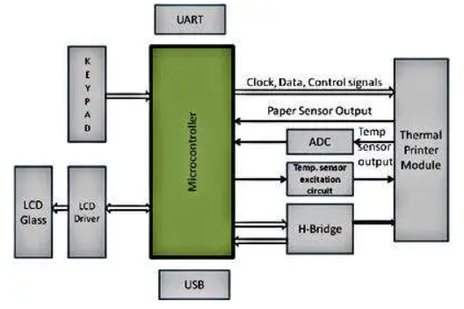

* **Thermal Printer module: It consists of thermal head, temperature sensor, stepper motor.**
* **Paper sensor circuit: *A reflective photosensor is used for detecting paper and is an integral part of the thermal head unit. However, R1, R2, and C1 need to be connected externally. In this circuit, R2 is the current limiting resistance for LED, R1 is the emitter resistance, and C1 is the bypass capacitor.***
* ***High-end SoCs are capable of handling almost all of these tasks in a single chip. These SoCs have on-chip ADCs, DACs, comparators, PGA, hardware shift register, LCD controllers, etc. DMA is one of the most important features in advanced SoCs. They offload CPU to do other tasks related to data manipulation; for example, some mathematic calculations, execution of an algorithm to selectively control the thermal element excitation, communicating with other host processors in the system, etc. DMA can also be used to write data to the shift register to be sent to the thermal head.***
* ***An implementation using DMA and hardware shift register/SPI, avoids having to impose overhead on the CPU to generate the bit stream as is required for a conventional microcontroller-based implementation. For  motor control and generation of control signals, the CPU should run at a reasonably high frequency as compared to when most of these tasks are being handled in hardware.***

***CASE 2: BLOCK DIAGRAM OF CASH REGISTER (MID LEVEL TO COMPLEX)***

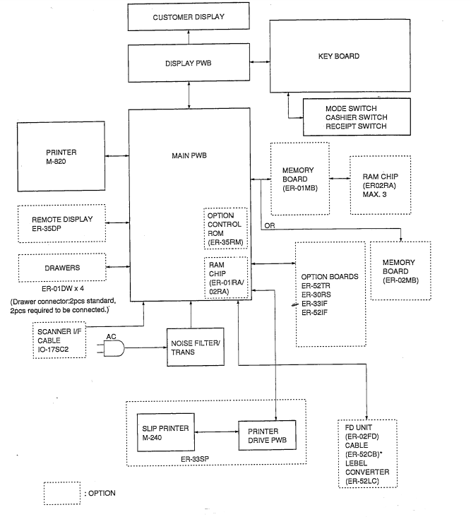

* ***The Electronic Cash Register (ECR) keeps track of sales transactions quickly and effectively. An abundance of PLUs (Price Look Ups) and department keys accommodate a variety of merchandise items. This means a faster, more accurate check out process and the ability to manage a wider variety of goods and services more efficiently. And with features like fast, attractive receipt print outs and an easy-to-view LCD operator display, the ECR makes managing the business a pleasure.***
* ***The microcontroller is one chip which includes the non-volatile memory for the events (ROM or flash), the clock, processor (the CPU), and volatile memory for input and output (RAM), and an I/O control unit. This is also known as “computer on a chip” and numerous microcontroller units (MCUs) are implanted yearly under innumerable items from toys to automobiles.***
* ***The hardware is processed through the combination of software or program instructions. It is known that software and hardware, the costumer is able to use the microcontroller to solve the issues easily. The AT89S52 is a less-power, great-accomplishment CMOS 8-bit microcontroller including 8K bytes of programmable Flash memory***.