Vulnerability Report – Predictable TMSI & Non-Compliance Enables Over-The-Air Tracking of User in Singtel and StarHub 5G SA Networks

Summary
The wireless security team at NTU@TL would like to report a security vulnerability which allows the presence and coverage area location of a subscriber to be easily tracked across Singapore due to reuse or predictable generation of the 5G Temporary Mobile Subscriber Identity (TMSI) in already deployed commercial 5G cellular networks from Singtel and StarHub. Furthermore, we have detected a 3GPP TS 33.501 specification non-compliance with StarHub that further increases exposure of the user to the reported vulnerability.
- Vulnerability Name: 5G-GUTI Reuse (Mitre FiGHT ID FGT5012.003).
- Impact (Confidentiality): Tracking presence of specific users across multiple cell towers and CWE-200: Exposure of Sensitive Information to an Unauthorized Actor (Specifically, cell-level location data).
- Pre-Condition (Low): Attacker is within radio range of probed 5G cell-towers. No knowledge of encryption keys is needed since TMSI is transmitted in plain text.
- Hardware Setup Cost (Low): ~2000 SGD
(Practical Attack Vector that can be exploited today with cheap radio equipment).
- CVSS Score (v3.1): 6.3 (Medium).
Vector: AV:A/AC:L/PR:N/UI:N/S:U/C:L/I:L/A:L
- Mitigation: Existent, recommended by 3GPP specification and NIST guidelines (NIST.CSWP.36C – Attached in this report).

Detailed Description of Vulnerability
When the phone (User Equipment - UE) connects to a 5G SA base station (gNB), certain plain text messages are exchanged between base station and UE. During this common exchange, namely RRC attach procedure, the Temporary Mobile Subscriber Identity (TMSI) is used by the gNB to recognize a previously registered user and exposed by the UE via RRC Connection Request (Uplink) or during Paging messages (Downlink). The exchange is shown in Figure 1.

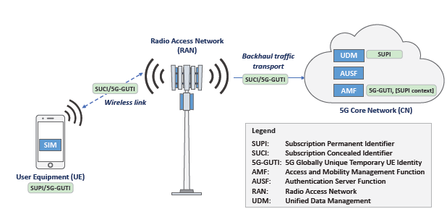
Overview of standard 5G-GUTI exchange between UE and gNB
2. Subsequent 5G Attachment (Initiated by the UE or gNB)
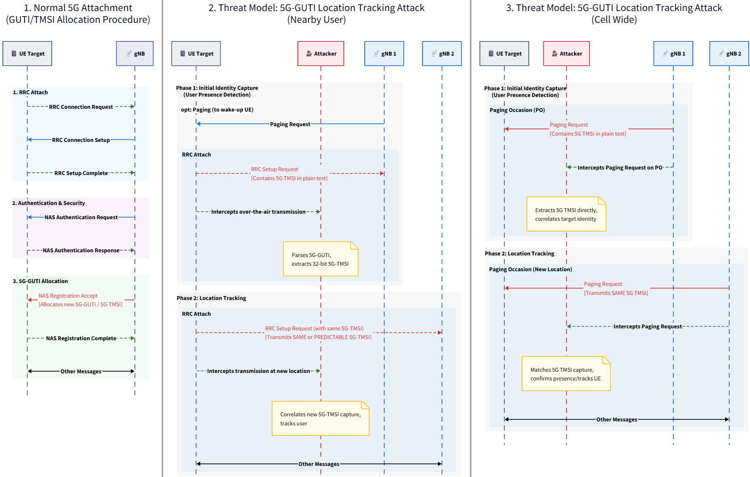
Other Messages
A new TMSI might be reassigned in subsequent connection from the UE depending on certain events.
TMSI (32 bit)
TMSI (32 bit)
..010101000..
Figure 1 - Overview of standard 5G-GUTI (TMSI) Exchange between UE and gNB
..XXXXXXXXX..
New TMSI
Here, the TMSI is the same as the previous connection to help gNB identify the subscriber
…….
..010101000..
The TMSI (inner part of the 5G-GUTI - Globally Unique Temporary Identity) works as a temporary identification number that is meant to reduce computing load in the core network while keeping the identity of the user unknown to external parties. Therefore, the value of the TMSI is refreshed constantly to avoid linkage between a specific user and their general location and thus preserve user privacy. The 3GPP specification release 15 onwards allows 5G vendors to decide how to generate TMSI values, however the specification recommends vendors to follow standard secure practices such as distributing TMSI values evenly across subscribers to avoid linkage.
Furthermore, the specification strictly enforces generation of new TMSI in certain events such as when the gNB asks the UE to connect back to the network so it can deliver data (SMS, notifications, calls, etc.) to the UE. The generation of a new TMSI for the UE is mandated (by use of SHALL wording) in specification 3GPP TS 33.501 (Security Architecture and Procedures for 5G System), Clause 6.12.3 as follows:
- Initial Registration (Figure 1, Step 1)
- Mobility Registration (Outside the scope of this report)
- Network-initiated Service Request due to paging (Figure 1, Step 2)
In this context, we have observed that Singapore mobile operators allow their TMSI value generation to either (i) be linked to a particular subscriber solely by observing the over-the-air communication (Singtel) or (ii) not comply with TS 33.501 Clause 6.12.3 (StarHub), thus aggravating potential privacy abuse by threat actors.
The bit-level structure of the 5G-GUTI and its embedded 5G-TMSI (subject of this report) is shown in Table 1:
Field | Length | Bit offset | Description
MCC | 12 bits | 0–11 | 3 digits; part of PLMN ID
MNC | 12 bits | 12–23 | 2–3 digits; part of PLMN ID
AMF Region ID | 8 bits | 24–31 | AMF region within the PLMN
AMF Set ID | 10 bits | 32–41 | AMF Set within the region
AMF Pointer | 6 bits | 42–47 | One AMF within the AMF Set
5G-TMSI  (Plain Text) | 32 bits | 48–79 | Temporary ID; the reused/predictable value
Table 1. Bit-level structure of the 5G-GUTI. The GUAMI (MCC, MNC, AMF Region ID, AMF Set ID, AMF Pointer) identifies the serving AMF; the 32-bit 5G-TMSI (highlighted) is the temporary identifier whose reuse enables the reported user tracking.
In the next sections, we will detail the privacy security vulnerability found for each Mobile Network Operator, starting with Singtel and then proceeding with StarHub.

Singtel
After analyzing how Singtel generates its TMSI values with multiple phones and SIM cards, we observe that the TMSI generation allows an attacker to link a specific subscriber and track the user across any cell tower. The TMSI bit generation pattern for 1 specific subscriber is shown in Figure 2.
Unique Static Bits per UE
AMF Set ID (1 bit) + Pointer
Figure 2 - Singtel TMSI Frequency bit Pattern for specific Subscriber
While “R” represents bits that are randomly assigned, “C” represents bits that are monotonically increasing and 1, or 0 identifies bits that are statically assigned based on our analyzed data. We detected that the 8th–15th least significant bit (LSB) range (from right to left) of the first 32 bits of the UE TMSI are statically assigned per UE, allowing attackers to track a specific user as it moves across Singapore. For example:
S-TMSI UE 1: 100111011001111101101001111001000000001
S-TMSI UE 2: 100101011100000000011001011000000110100
S-TMSI UE 3: 100110111100100011100101000111010111111
As highlighted above, the range of 8 bits (highlighted in red) can reliably be used to fingerprint and discern between UEs as these bit values are uniquely assigned per UE and remain the same across multiple weeks and even when moving to different cell towers (as observed from our collected data within NTU). Since 8 bits is not enough to discern between all possible users, the counter bits (highlighted in orange) can be used to identify and track a user as it moves along other cell towers.
An example of the counter bits incrementing as a specific user moves along NTU is shown in Figure 3. The horizontal axis represents time and the vertical lines (dotted points) represent the absolute value of the counter bits region (C bits).
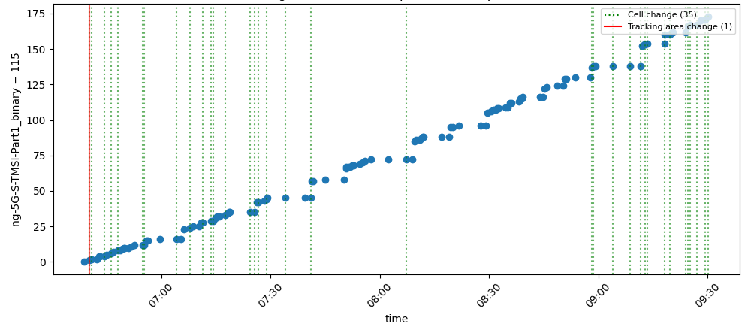
Figure 3 - TMSI Counter bits for specific UE with Singtel Subscription (C bits) as user moves around NTU
The counter bits are incremented with a constant slope (possibly due to timestamping), even as the user moves along other cell towers as highlighted by the green vertical lines indicating change of cell tower within NTU. Since the offset of the counter bits is observed to be assigned locally per UE rather than globally for all UEs, an attacker can use the static bits + counter bits to fingerprint a UE and identify a specific user as it moves in other coverage areas.
The usage of counter bits is an inherited privacy security vulnerability known since 4G and documented in research papers such as “GUTI Reallocation Demystified: Cellular Location Tracking with Changing Temporary Identifier”. However, we detected that the same issue persists in the currently deployed Singtel networks.
The 3GPP specification TS 33.501 and NIST.CSWP.36C include recommendations on generating the TMSI values evenly across all UEs to avoid linkage vulnerabilities such as the one observed in this report.

StarHub
StarHub TMSI bit pattern distribution for a specific user is illustrated in Figure 4.
AMF Set ID (1 bit) + Pointer
Figure 4 - StarHub TMSI Frequency bit Pattern for specific Subscriber
StarHub distributes TMSI bits more evenly across subscribers. For example:
S-TMSI UE 1: 101010111000000101001000111010001010001
S-TMSI UE 2: 101010111000000101001110100001011100010
S-TMSI UE 3: 001000011001000010101110100111011000010
In this case, the only difference from one UE to the other are the relative start of the counter value and similar bits in the beginning of the TMSI which is attributed to the AMF pointer. Unfortunately, StarHub reuses the same TMSI for an extended period of time spanning minutes to often hours, the same UE can still be tracked using the AMF Set + Pointer (initial 6 bits) and counter bits to distinguish a user with other UEs as it moves along Singapore. This effect is illustrated in Figure 5.
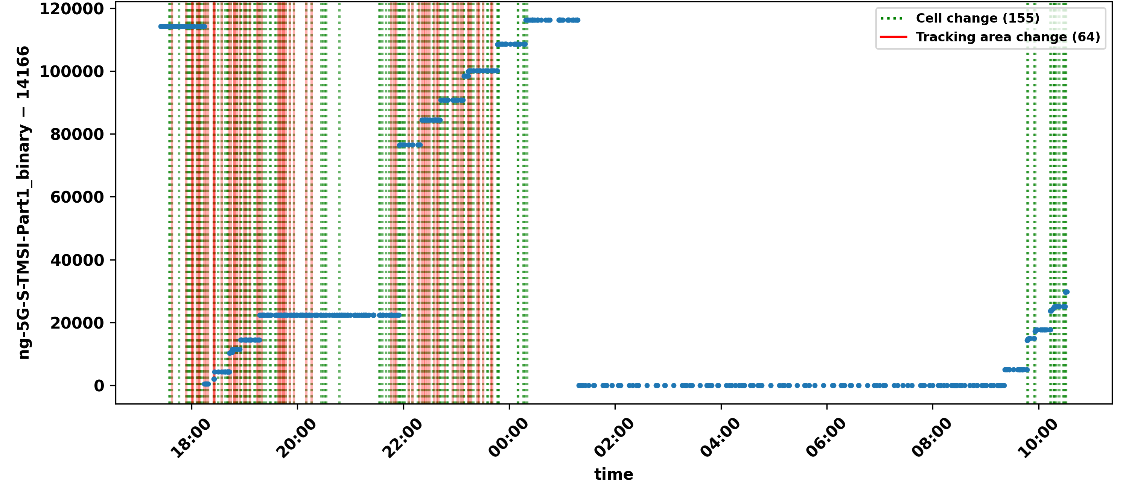
GUTI / TMSI Reuse
TS 33.501 Clause 6.12.3 violated
due to reuse of TMSI after paging (mt-access)
Figure 5 - TMSI Counter bits for specific UE with StarHub Subscription (C bits) as user moves around Singapore (NTU through SUTD round trip)
More specifically, StarHub does not refresh the TMSI value in the event which is explicitly enforced in the 3GPP TS 33.501 Clause 6.12.3 as illustrated in the WireShark capture in Figure 6. The column ng-5G-S-TMSI-Part1 highlights the security vulnerability and non-compliance due to lack of enforcing new TMSI values to the UE after reconnections due to paging (attachment cause mt-access).

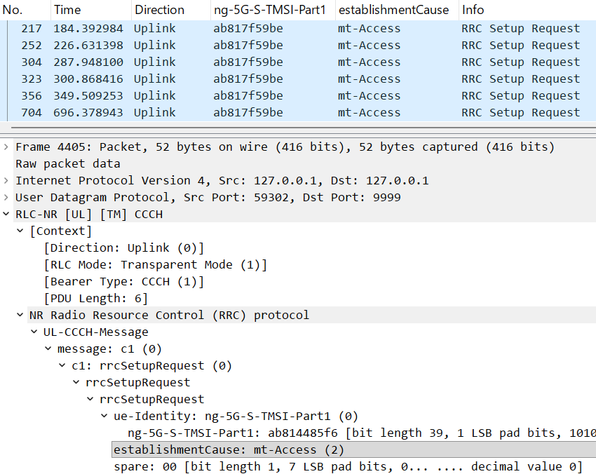
Privacy Security Vulnerability + 3GPP Non-Compliance
Figure 6 - TMSI Reuse non-compliance due to lack of GUTI refresh after paging the UE
While the specification allows the TMSI to be reused when the UE itself reattaches to the gNB (attach cause mo-data), TMSI refreshment due to network-initiated connections (mt-access) are explicitly required in the highlighted clause of the spec. in Figure 7:
“Upon receiving Service Request message sent by the UE in response to a Paging message, the AMF shall send a new 5G-GUTI to the UE. This new 5G-GUTI shall be sent before the current NAS signalling connection is released or the N1 NAS signalling connection is suspended.”
The non-compliance is due to StarHub not sending a new 5G-GUTI to the UE in response to both a Paging message and Service Request. Eventually the TMSI is refreshed from any period ranging from minutes to hours (as shown in Figure 5). Particularly, if the user stays connected to the same cell tower, the TMSI stays the same after hours, facilitating an attacker to track or detect the presence of a user.
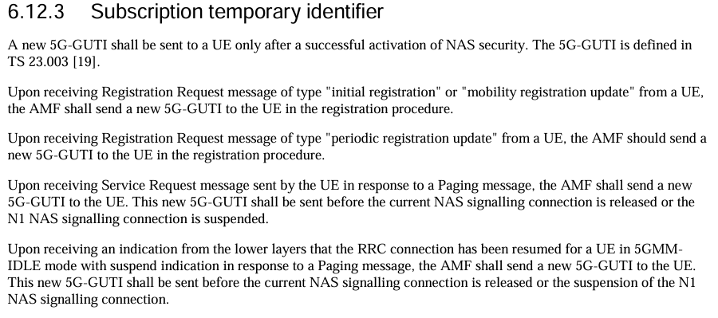
Figure 7 - TS 33.501 (Subscription temporary identifier)
This behavior has not been observed in Singtel or open-source gNBs we experimented with in our laboratory at Temasek@NTU.

Threat Model and Security Implications
5G temporary identifiers are designed to prevent subscriber tracking and linkability attacks (e.g., from modern IMSI catchers). Therefore, a predictable counter in any portion of the 5G-TMSI completely destroys this cryptographic randomness, introducing privacy security concerns.
Figure 8 - Threat Model of leveraging GUTI reuse for tracking users as it moves across cell towers.
As exemplified in Figure 6, an attacker can exploit TMSI reuse to:
- Identify the presence of the user: An attacker can continuously listen to the expected TMSI pattern to detect whether the user is idle in the same coverage area for extended periods of time (e.g., hours).
- Track location of the user: An attacker can continuously listen to the expected TMSI pattern across cell towers to detect whether the user is present at certain coverage areas in Singapore as the user moves along towards different cell towers.
- The attacker can capture the TMSI either from (i) the uplink signal of the UE within radio range of the user, or (ii) directly from the downlink paging message that is frequently broadcast from the gNB. The attacker can use approach (i) when close to the victim to link a TMSI to a particular person and use approach (ii) to track the person at a distance within a coverage area.
The radio hardware required to perform passive sniffing in commercial networks is currently affordable due to the release of small, capable Software Defined Radios such as LimeSDR XTRX (~1000 USD) or LimeSDR Micro (~300 USD). The latter can be potentially installed in a laptop due to its small form factor down to a m.2 SSD. Currently our proof-of-concept tool runs on a LimeSDR XTRX installed in a small PC costing a maximum of ~2000 SGD. Therefore, performing this attack in the wild is now possible due to commoditization of SDRs that are fast enough to capture radio signals at sample rates of 100 MHz, which is the maximum sample rate used by Singtel and StarHub 5G networks in Singapore.

Concluding Remarks
We hope that this report sheds some light on issues that could be abused if known by threat actors, more specifically linkage of specific user with its location activity in Singapore. In this context, the mitigation guidelines provided by 3GPP TS 33.501 and NIST are appropriate to avoid the reported issue.
To assist with the triaging and remediation of the vulnerability, we attached the following files with this report:
Reference specifications and guidelines
- 3gpp-ts-33.501.pdf - 3GPP TS 33.501 (Security Architecture and Procedures for the 5G System), the specification whose Clause 6.12.3 mandates 5G-GUTI refresh.
- NIST.CSWP.36C.pdf - NIST guidance on TMSI generation and mitigation of subscriber-linkage vulnerabilities.
Captured evidence (report_data folder)
- singtel-xiaomi11-ntu.txt - Raw radio capture log for the Singtel subscriber recorded at NTU.
- singtel-xiaomi11-ntu-tmsi.csv - Extracted TMSI values for the Singtel subscriber (NTU).
- singtel-xiaomi11-ntu-pattern-analysis.csv - Bit-level pattern analysis of the Singtel TMSI values (static, counter and random bits).
- starhub-xiaomi11-ntu-sutd.pcap - Wireshark packet capture for the StarHub subscriber over the NTU–SUTD round trip, showing TMSI reuse and non-compliance.
- starhub-xiaomi11-ntu-sutd-tmsi.csv - Extracted TMSI values for the StarHub subscriber, showing TMSI reuse and non-compliance.
- starhub-xiaomi11-ntu-sutd-pattern-analysis.csv - Bit-level pattern analysis of the StarHub TMSI values.

