EXCEL DATA REPORT

1. **IF Function**:

o Determine if employees are earning above or below $50,000. Use the IF function to display "Above" or "Below".

WE have used formula for this I.e

=IF(F2>50000,"ABOVE","BELOW")

2. **IFS Function**:

o Assign a performance rating based on the number of project hours: "Excellent" for

50 or more hours, "Good" for 40-49 hours, "Average" for 30-39 hours, and "Poor" for below 30 hours.

WE have used formula for this I.e

=IFS(J2>=50,"EXCELLENT",J2>=40,"GOOD",J2>=30,"AVREAGE",J2<30,"POOR")

3. **AND Function**:

o Check if employees from the HR department and North region have sales above $15,000.

WE have used formula for this I.e

=IF(AND(E2="HR",I2="NORTH",F2>15000),"YES","NO")

4. **OR Function**:

o Identify employees who are either in the IT department or have a salary above $60,000.

WE have used formula for this I.e

=IF(OR(E2="IT",F2>60000),"YES","NO")

5. **NOT Function**:

o Determine if employees are not from the Marketing department.

WE have used formula for this I.e

=IF(NOT(E2="MARKETING"),"NOT FROM MARKETING","MARKETING DEPT")

6. **SUMIF Function**:

o Calculate the total salary of employees from the Sales department.

WE have used formula for this I.e

==SUMIF(E3:E201,"SALES",H3:H201)

7. **SUMIFS Function**:

o Calculate the total salary of employees in the IT department who have more than 35 project hours.

WE have used formula for this I.e

=SUMIFS(F2:F201,E2:E201,"IT",J2:J201, ">35")

8. **COUNTIF Function**:

o Count the number of employees in the HR department.

WE have used formula for this I.e

=COUNTIF(E2:E201,"HR")

9. **COUNTIFS Function**:

o Count the number of female employees in the Finance department.

WE have used formula for this I.e

=COUNTIFS(E2:E201,"FINANCE",D2:D201,"F")

10. **AVERAGEIF Function**:

o Find the average salary of employees in the Marketing department.

WE have used formula for this I.e

=AVERAGEIF(E2:E201,"MARKETING",F2:F201)

11. **AVERAGEIFS Function**:

o Find the average sales for employees in the North region with project hours above 40.

WE have used formula for this I.e

=IFERROR(AVERAGEIFS(H2:H201,I2:I201,"NORTH",J2:J201,">40"),"NODATA")

12. **MAXIFS Function**:

o Determine the maximum salary among employees in the South region.

WE have used formula for this I.e

=MAXIFS(F2:F201,I2:I201,"SOUTH")

13. **MINIFS Function**:

o Find the minimum number of project hours for employees in the Finance department.

WE have used formula for this I.e

=MINIFS(J2:J201,E2:E201,"FINANCE")

14. **VLOOKUP Function**:

o Use VLOOKUP to find the salary of an employee based on their ID.

WE have used formula for this I.e

=VLOOKUP(A2,A2:X201,6,"FALSE")

15. **HLOOKUP Function**:

o Use HLOOKUP to find the joining date of employees based on their department.

WE have used formula for this I.e

=HLOOKUP(G2,A2:J201,7,FALSE)

16. **INDEX and MATCH Functions**:

o Use INDEX and MATCH to find the sales amount for a specific employee.

WE have used formula for this I.e

17. **Conditional Formatting**:

o Highlight cells in the Salary column that are above $60,000.

WE have used formula for this I.e

In this I have taken range from F2:F201 and given a condition that is greater then equal to “60000”

19. **Data Validation**:

o Set up data validation to allow only dates after 2015-01-01 in the Joining Date

column.

WE have used formula for this I.e

18. **Pivot Table**:

o Create a pivot table to summarize average sales by region and department.

WE have used formula for this I.e

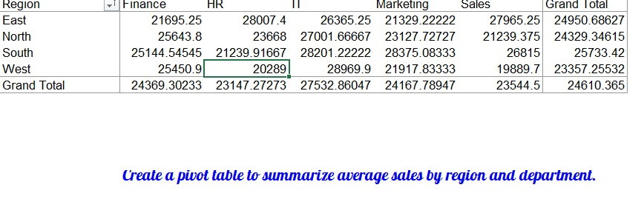

20. **Chart Creation**:

o Create a bar chart to visualize the total sales by department.

WE have used formula for this I.e

