**Assignment-1**

**Problem 2**

<html>

    <head>

        <title>Problem 2</title>

    </head>

    <body>

        <ol >

            <li>

                Language

                <ol type="i">

                    <li>

                        English

                        <ol type="A">

                            <li>Prose</li>

                            <li>Poetry</li>

                        </ol>

                    </li>

                    <li>

                        Hindi

                        <ol type="A">

                            <li>prose</li>

                            <li>poetry</li>

                        </ol>

                    </li>

                    <li>

                        Marathi

                        <ol type="A">

                            <li>Prose</li>

                            <li>poetry</li>

                        </ol>

                    </li>

                </ol>

            </li>

            <li>Social Study

                <ol type="i">

                    <li>History</li>

                    <li>Geography</li>

                </ol>

            </li>

            <li>

                Science

                <ol type="i">

                    <li>

                        Physics

                        <ol type="A">

                            <li>Part1</li>

                            <li>Part2</li>

                        </ol>

                    </li>

                    <li>

                        Chemistry

                        <ol type="A">

                            <li>Organic</li>

                            <li>Inorganic</li>

                        </ol>

                    </li>

                    <li>

                        Biology

                        <ol type="A">

                            <li>Botany</li>

                            <li>Zoology</li>

                        </ol>

                    </li>

                </ol>

            </li>

            <li>

                Maths

                <ol type="i">

                    <li>Algebra</li>

                    <li>Geometry</li>

                </ol>

            </li>

        </ol>

    </body>

</html>

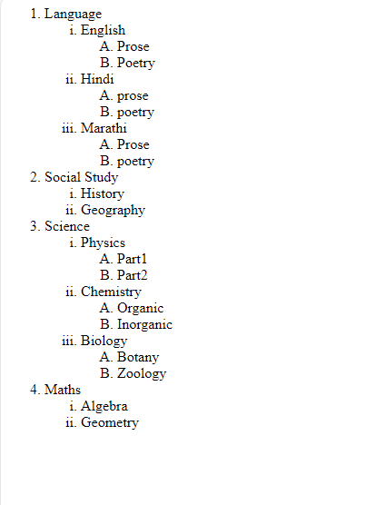

**Problem-2**

<!DOCTYPE html>

<html lang="en">

<head>

    <title>Problem3(A)</title>

</head>

<body>

    <h1>List of Java Books</h1>

    <table border="2px">

        <tr>

            <th>Book Title</th>

            <th>Author</th>

            <th>Book Price</th>

        </tr>

        <tr>

            <td>

                <a href="https://horstmann.com/corejava/">Core Java</a>

            </td>

            <td>Cay Horstman</td>

            <td>400</td>

        </tr>

        <tr>

            <td>

                <a href="https://link.springer.com/book/10.1007/978-1-4302-3910-9">Beggining Java</a>

            </td>

            <td>Ivar Horton</td>

            <td>600</td>

        </tr>

        <tr>

            <td>

                <a href="https://www.oreilly.com/library/view/learning-java/1565927184/">Laerning Java</a>

            </td>

            <td>Kishori Shahane</td>

            <td>400</td>

        </tr>

        <tr>

            <td><a href="https://www.oreilly.com/library/view/java-cookbook-4th/9781492072577/">Java CookBook</a></td>

            <td>John Keller</td>

            <td>800</td>

        </tr>

    </table>

</body>

</html>

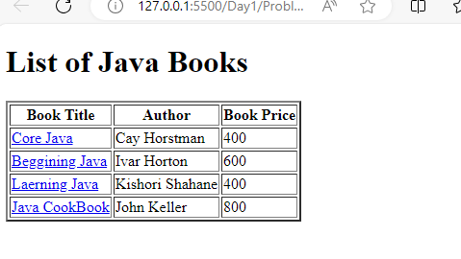

**PROBLEM-1**

<!DOCTYPE html>

<html lang="en">

<head>

    <title>Problem1: Resume</title>

</head>

<body>

    <p style="text-align: center;"><u><b>RESUME</b></u></p>

    <p>Ritu Bajpai<p>

    <p>43, Bajpai Apartments</p>

    <p>Sarafa Bazaar, Gwalior</p>

    <p>Madhya Pradesh-474001</p>

    <p>Mobile No: 9584444318</p>

    <p>Email: ritubajpai711@gmail.com</p>

    <hr>

    <h3>Educational Qualifications</h3>

    <table>

        <tr>

            <th>Qualification</th>

            <th>Institute</th>

            <th>Uiversity/Board</th>

            <th>Marks</th>

        </tr>

        <tr>

            <td>BE(CS)</td>

            <td>UIT</td>

            <td>RGPV</td>

            <td>89.6%</td>

        </tr>

        <tr>

            <td>HSC</td>

            <Td>LAHS</Td>

            <td>CBSE</td>

            <Td>87.6%</Td>

        </tr>

        <tr>

            <td>SSC</td>

            <Td>LAHS</Td>

            <td>CBSE</td>

            <td>93%</td>

        </tr>

    </table>

    <h3>Skill Set :</h3>

    <div>

        <table>

            <tr>

                <td><span ><b>Operating System: </b></span></td>

                    <td><span>Windows</span><br></td>

            </tr>

            <tr>

                <td><span ><b>Language: </b></span></td>

                    <td><span>C/C++, Core Java</span><br></td>

            </tr>

            <tr>

                <td><span ><b>Front-END: </b></span></td>

                    <td><span>HTML</span><br></td>

            </tr>

            <tr>

                <td><span ><b>DBMS: </b></span></td>

                    <td><span>Oracle 9i</span><br></td>

            </tr>

        </table>

    </div>

</body>

</html>

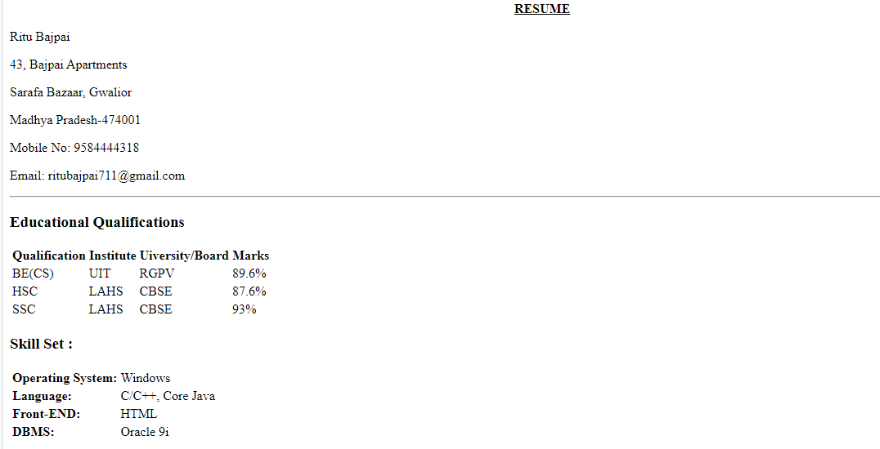

**PROBLEM-4**

<!DOCTYPE html>

<html lang="en">

<head>

    <title>Problem4</title>

</head>

<body>

    <h1>Stratovolcanoes</h1>

    <div>

        <p><p>This is a schematic diagram of a strato volcano, intended to illustrate the different layers of different materials that comprise them. The purple colors are meant to represent ash layers, either the products of fall-out from big eruption clouds or the products of pyroclastic flows. Notice that these ash layers tend to be thin but widespread. The orange colors represent lava flows, and note that some of them have cinder cones associated with them at the vent. The green colors are meant to represent lava domes, and notice that they do not flow very far. Each eruption, regardless of what it produces, is fed from the magma chamber by a dike. Most dikes come up through the center of the volcano and therefore most eruptions occur from at or near the summit. However, some dikes head off sideways to feed eruptions on the flanks. This is a pit that has been dug into the ground at Cotopaxi, a big strato volcano near Quito, the capital city of Ecuador. The pit is about 2 meters deep and in it you can clearly see a number of ash layers exposed. It is also easy to see that the layers are different - some are coarse and others are fine, some are dark-colored and others are light-colored.</p></p>

    </div>

    <img src="./images/stratovolcanoes.jpg" alt="picture of stratovolcanoes"  height="200px" width="300px" align="left" vspace="5px" hspace="5px" border="2px">

    <div>

    <p>Strato Volcanoes comprise the largest percentage (~60%) of the Earth's individual volcanoes and most are characterized by eruptions of andesite and dacite - lavas that are cooler and more viscous than basalt. These more viscous lavas allow gas pressures to build up to high levels (they are effective "plugs" in the plumbing), therefore these volcanoes often suffer explosive eruptions. Strato volcanoes are usually about half-half lava and pyroclastic material, and the layering of these products gives them their other common name of composite volcanoes.</p>

</div>

<img src="./images/stratopit.jpg" alt="picture of stratopit" height="200px" width="300px" align="right" valign="bottom" vspace="5px" hspace="5px" border="2px">

<div>

    <p><p>This is a schematic diagram of a strato volcano, intended to illustrate the different layers of different materials that comprise them. The purple colors are meant to represent ash layers, either the products of fall-out from big eruption clouds or the products of pyroclastic flows. Notice that these ash layers tend to be thin but widespread. The orange colors represent lava flows, and note that some of them have cinder cones associated with them at the vent. The green colors are meant to represent lava domes, and notice that they do not flow very far. Each eruption, regardless of what it produces, is fed from the magma chamber by a dike. Most dikes come up through the center of the volcano and therefore most eruptions occur from at or near the summit. However, some dikes head off sideways to feed eruptions on the flanks. This is a pit that has been dug into the ground at Cotopaxi, a big strato volcano near Quito, the capital city of Ecuador. The pit is about 2 meters deep and in it you can clearly see a number of ash layers exposed. It is also easy to see that the layers are different - some are coarse and others are fine, some are dark-colored and others are light-colored.</p></p>

</div>

</body>

</html>

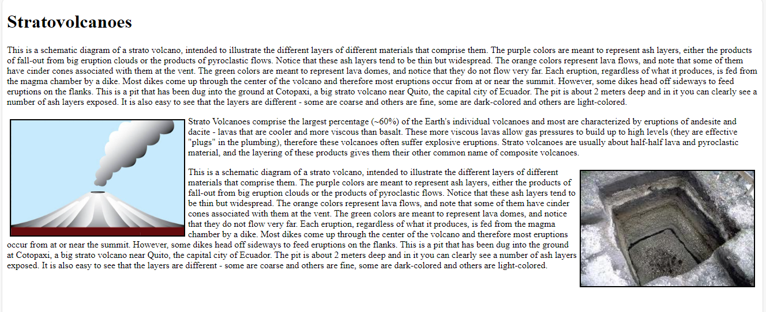

**Problem-7**

<!DOCTYPE html>

<html lang="en">

<head>

    <title>Document</title>

    <table border="1px">

        <tr>

            <td  colspan="7" style="text-align: center; background-color: yellow; " ><b>January</b></td>

        </tr>

        <tr style="background-color: fuchsia;">

            <td><b>Sun</b></td>

            <td><b>Mon</b></td>

            <td><b>Tue</b></td>

            <td><b>Wed</b></td>

            <td><b>Thu</b></td>

            <td><b>Fri</b></td>

            <td><b>Sat</b></td>

        </tr>

        <tr >

            <td></td>

            <td></td>

            <td></td>

            <td></td>

            <td></td>

            <td style="background-color: yellow;">1</td>

            <td style="background-color: aqua;">2</td>

        </tr>

        <tr>

            <td style="background-color: green;">3</td>

            <td>4</td>

            <td>5</td>

            <td>6</td>

            <td>7</td>

            <td>8</td>

            <td style="background-color: aqua;">9</td>

        </tr>

        <tr>

            <td style="background-color: green;">10</td>

            <td>11</td>

            <td>12</td>

            <td>13</td>

            <td>14</td>

            <td>15</td>

            <td style="background-color: aqua;">16</td>

        </tr>

        <tr>

            <td style="background-color: green;">17</td>

            <td>18</td>

            <td>19</td>

            <td>20</td>

            <td>21</td>

            <td>22</td>

            <td style="background-color: aqua;">23</td>

        </tr>

        <tr>

            <td style="background-color: green;">24</td>

            <td>25</td>

            <td style="background-color: yellow;">26</td>

            <td>27</td>

            <td>28</td>

            <td>29</td>

            <td style="background-color: aqua;">30</td>

        </tr>

        <tr>

            <td style="background-color: green;">31</td>

            <td></td>

            <td></td>

            <td></td>

            <td></td>

            <td></td>

            <td></td>

        </tr>

    </table>

</head>

<body>

</body>

</html>

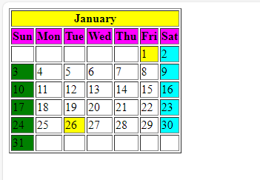

**Problem Statement-1 Appointment Scheduler**

<!DOCTYPE html>

<html lang="en">

<head>

    <meta charset="UTF-8">

    <meta http-equiv="X-UA-Compatible" content="IE=edge">

    <meta name="viewport" content="width=device-width, initial-scale=1.0">

    <title>Problem Statement 1</title>

</head>

<body>

    <h1>Appointment Scheduler</h1>

    <fieldset style="margin: 40px; padding-bottom: 20px;">

        <legend>Personal Information </legend>

        <form>

            Name: <br>

            <label for="name"></label>

            <input type="text" name="name" id="name" required><br>

            Telephonr number: <br>

            <input type="tel" name="tel" id="tel" required><br>

            <label for="tel"></label>

            Email-address <br>

            <input type="email" name="email" id="email" required> <br>

            <input type="date" name="date" id="date"> <br>

        </form>

    </fieldset>

    <fieldset ">

<legend>Appointment Request </legend>

What is the reason for your visit?<br>

<textarea name="txt" id="txt" cols="60" rows="1"></textarea><br>

Current Plain Level <br>

<input type="range" name="range" id="range" min="0" max="10"><br>

Preferred Date <br>

<input type="date" name="dt" id="dt"><br>

    </fieldset>

    <br>

    <input type="submit" value="submit" id="submit" name="submit">

<!--

<a href="./AppointmentScheduler.html" target="f1">click me</a>

    <iframe name="f1" frameborder="0"></iframe> -->

</body>

</html>

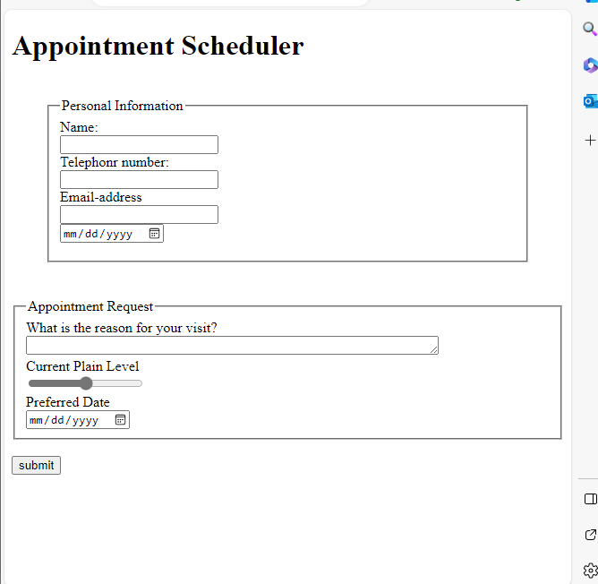

<!DOCTYPE html>

<html lang="en">

<head>

    <meta charset="UTF-8">

    <meta http-equiv="X-UA-Compatible" content="IE=edge">

    <meta name="viewport" content="width=device-width, initial-scale=1.0">

    <title>Problem STatement 2</title>

    <style>

        div{

            margin: 20px;

            padding: 10%;

            border-color:white;

        }

        fieldset{

            height: auto;

           width: 45%;

            margin-left: 400px;

           color:white;

           border-color:2px solid white;

        }

    </style>

</head>

<body    bgcolor=" #007FFF">

    <fieldset >

        <legend><h1>Registration Details</h1></legend>

        <form method="post">

            <div>

                University: <input type="text" name="name" value="name " required><br><br>

                Institute : <input type="txt" name="clg" id="clg" required><br><br>

                Branch : <select name="select" id="select" >

                    <option value="">-select one-</option>

                    <option value="BE">B.E</option>

                    <option value="MTECH">MTECH</option>

                    <option value="PHD">PHD</option>

                </select>

                <input type="radio" name="rd" id="rd"> Pursuing

                <input type="radio" name="rd" id="rd">Completed <br><br>

                Average CPI: <input type="text" name="nb" id="nb"  required size="1" max="10" > Upto <input type="number" name="num" id="num" required size="1"> <sup>th</sup> Semester <br><br>

                Experience: <input type="number" name="exp" id="exp" required size="1"> Years <br><br>

                Your Wesite or Blog : <input type="url" name="url" id="url" placeholder="enter url">

            </div>

        </form>

    </fieldset>

</body>

</html>

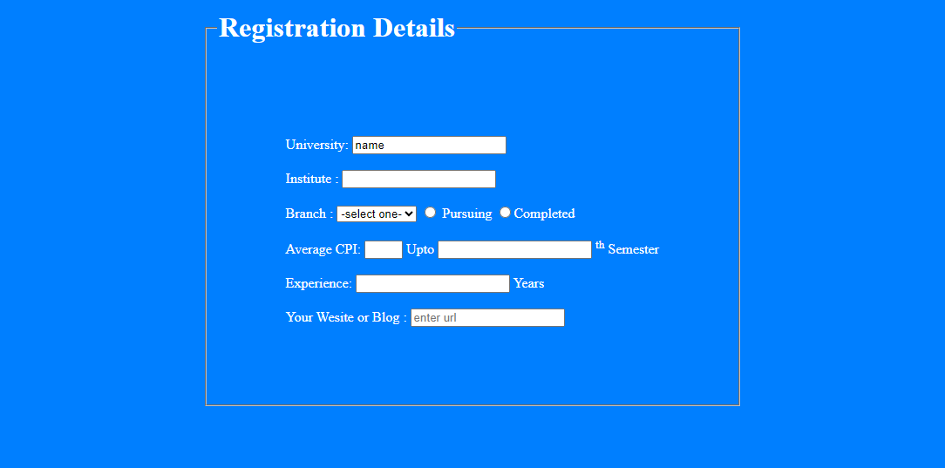

**Problem 1-Web Page**

body{

    background-color: black;

    color: white;

}

fieldset{

    border:5px solid rgb(48, 64, 204);

    border-radius: 15px;

    width:max-content ;

    margin: 30px;

}

legend{

    background-color: rgb(48, 64, 204);

    border-radius: 3px;

    color: white;

}

p:last-child{

    background-color: rgb(48, 64, 204);

    color: white;

}

#btn{

    margin-left: 40px;

    background-color: rgb(48, 64, 204);

    color: white;

}

<!DOCTYPE html>

<html lang="en">

<head>

    <meta charset="UTF-8">

    <meta http-equiv="X-UA-Compatible" content="IE=edge">

    <meta name="viewport" content="width=device-width, initial-scale=1.0">

    <title>Problem Statement-1 WEBpage Name and Address</title>

<link rel="stylesheet" href="./CSS/prblm1.css">

</head>

<body>

    <fieldset>

        <legend>Name and Address</legend>

        <table>

            <div>

            <tr>

                <td>SSN:</td>

                <td><input type="text" name="txt" id="txt"></td>

                <td><p>Fill in Name and Address</p></td>

            </tr>

            <tr>

                <td>Full Name:</td>

                <td><input type="text" name="uname" id="uname"></td>

            </tr>

            <tr>

                <td>Street and Number:</td>

                <td><input type="text" name="add" id="add"></td>

            </tr>

            <tr>

                <td>PostalCode</td>

                <td><input type="text" maxlength="6"></td>

            </tr>

            <tr>

                <td>City</td>

                <td><input type="text" name="city" id="city"></td>

            </tr>

        </div>

        </table>

    </fieldset>

    <fieldset>

        <legend>Username and Password</legend>

        <form >

            <table>

                <tr> <td>Username:</td>

                <td><input type="text" name="user" id="user"></td>

                </tr>

                <tr>

                <td>Password</td>

                <td><input type="password" name="pass" id="pass"></td>

                </tr>

                <tr>

                    <td></td>

                    <td><input type="checkbox" name="pass1" id="pass1">Show password</td>

                </tr>

            </table>

        </form>

    </fieldset>

    <div>

<input type="submit" value="Register" id="btn">

</div>

</body>

</html>

