InsightIQ
AI-Powered Business Decision Intelligence Platform

Capstone Project Report
IBM SkillsBuild Data Analytics with AI Academic Internship

Author: Sakshi Wadodkar
Dataset: Official Tableau Sample Superstore
Source: https://public.tableau.com/app/resources/sample-data
Year: 2025

1. Abstract
InsightIQ is a comprehensive AI-powered business decision intelligence platform developed as a capstone project for the IBM SkillsBuild Data Analytics with AI Academic Internship. The platform applies an end-to-end analytical pipeline to the official Tableau Sample Superstore dataset, integrating descriptive analytics, predictive machine learning, model explainability, anomaly detection, and what-if decision simulation. The dataset covers 10,194 order lines across 5,111 unique orders from 804 customers between January 2023 and December 2026. Key results from actual data: total sales $2,326,534, total profit $292,296, overall profit margin 12.6%, order-level return rate 5.8%. Best predictive model: Linear Regression (test MAE $12,968, RMSE $16,384, MAPE 23.5%). Anomaly detection (Isolation Forest) identified 306 anomalous transactions. The InsightIQ Decision Simulator provides scenario-based business decision support.

2. Introduction
Modern retail organisations generate vast volumes of transactional data yet frequently lack the analytical infrastructure to transform it into actionable intelligence. InsightIQ addresses this gap by combining traditional business analytics with machine learning, model explainability, anomaly detection, and interactive decision simulation in a single reproducible Jupyter Notebook pipeline.
The central business question: "Given historical business data, what is happening in the business, what patterns and risks can be identified, what may happen next, and how might different business decisions affect expected outcomes?"

3. Problem Statement
- Profitability visibility: Which products, customers, and regions generate or erode profit?
- Discount strategy risk: Are current discount practices helping or harming profitability?
- Demand forecasting: What are expected future sales from historical patterns?
- Anomaly detection: Are there unusual events warranting investigation?
- Decision support: How might discount strategy changes affect estimated outcomes?

4. Objectives
- 1. Perform comprehensive EDA on the Superstore dataset
- 2. Calculate and visualise key business KPIs
- 3. Analyse customer, product, and regional performance patterns
- 4. Investigate the historical relationship between discount levels and profitability
- 5. Build and evaluate predictive sales models with chronological train/test split
- 6. Apply feature importance for model explainability
- 7. Detect anomalous business performance using Isolation Forest
- 8. Analyse product returns using the Returns sheet
- 9. Build an interactive what-if Decision Simulator
- 10. Provide traceable, data-supported business recommendations

5. Dataset Description
The official Tableau Sample Superstore workbook represents transactional data for a fictional US/Canada retail business. No modifications were made to the original dataset file.
Attribute | Value
File | sample_-_superstore.xls
Format | Microsoft Excel 97-2003 (.xls)
Primary Sheet | Orders -- 10,194 rows x 21 columns
Supporting Sheets | Returns (296 returned orders), People (4 regional managers)
Time Period | January 2023 to December 2026
Geography | United States (9,994 records) and Canada (200 records)
Key Dimensions | Category, Sub-Category, Region, Segment, Ship Mode
Key Measures | Sales, Profit, Quantity, Discount
Unique Orders | 5,111
Unique Customers | 804

6. Dataset Source
Official Tableau Public Sample Data:
https://public.tableau.com/app/resources/sample-data
Used for educational purposes under the IBM SkillsBuild internship programme. No ownership of the dataset is claimed.

7. Technologies Used
Technology | Version | Purpose
Python | 3.12.10 | Core programming language
pandas | 3.0.6 | Data manipulation and analysis
numpy | 2.5.3 | Numerical computations
matplotlib | 3.11.2 | Static visualisations
seaborn | 0.13.2 | Statistical visualisations
scikit-learn | 1.9.1 | ML: Random Forest, Isolation Forest
xlrd | 2.0.2 | Reading legacy .xls files
Jupyter Notebook | 1.x | Interactive analytical environment

8. Methodology
- Data Loading -- Read all three sheets (Orders, Returns, People) using xlrd
- Data Quality Assessment -- Missing values, duplicates, data types, cardinality
- Data Cleaning -- Date parsing, postal code normalisation, Returns join, People join
- Exploratory Data Analysis -- 13 visualisations across time, product, customer, region
- Business KPI Calculation -- Sales, Profit, Margin, Orders, Customers, AOV, Discount
- Customer Analytics -- Distribution, top customers, segment performance
- Product Analytics -- Category/sub-category performance, top products
- Regional Analytics -- Sales/profit/margin by region with manager enrichment
- Discount & Profitability Analysis -- Band analysis, scatter plots, box plots
- Time-Series Analysis -- Monthly and quarterly sales/profit trends
- Predictive Modelling -- Baseline, Linear Regression, Random Forest (chronological split)
- Model Evaluation -- MAE, RMSE, MAPE; actual vs predicted plots
- Model Explainability -- Random Forest feature importance
- Anomaly Detection -- Isolation Forest at transaction and monthly level
- Business Risk Analysis -- High-discount losses, loss sub-categories, low-margin regions
- Returns Analysis -- Order-level return rate by category, region, segment
- Decision Simulator -- What-if discount scenario modelling with RF models
- Scenario Comparison -- Multi-scenario table and visualisation

9. Data Preprocessing
Step | Description
Date Parsing | Order Date and Ship Date parsed dayfirst=True, errors coerced
Temporal Features | Year, Month, Quarter, Year-Month, Lead Time Days derived
Profit Margin | Profit / Sales (guarded against zero denominator)
Postal Code | US codes zero-padded to 5 digits; Canadian alphanumeric codes preserved
Numeric Validation | Sales, Profit, Quantity, Discount cast with errors coerced
Deduplication | Zero duplicate rows found
Whitespace Strip | All string columns stripped
Returns Join | Order IDs joined to create Is Returned binary indicator
People Join | Regional Manager added via left join on Region

Zero missing values in key numeric columns after preprocessing.

10. Exploratory Data Analysis
EDA covered 13 visualisations across customer, product, regional, discount, and temporal dimensions.
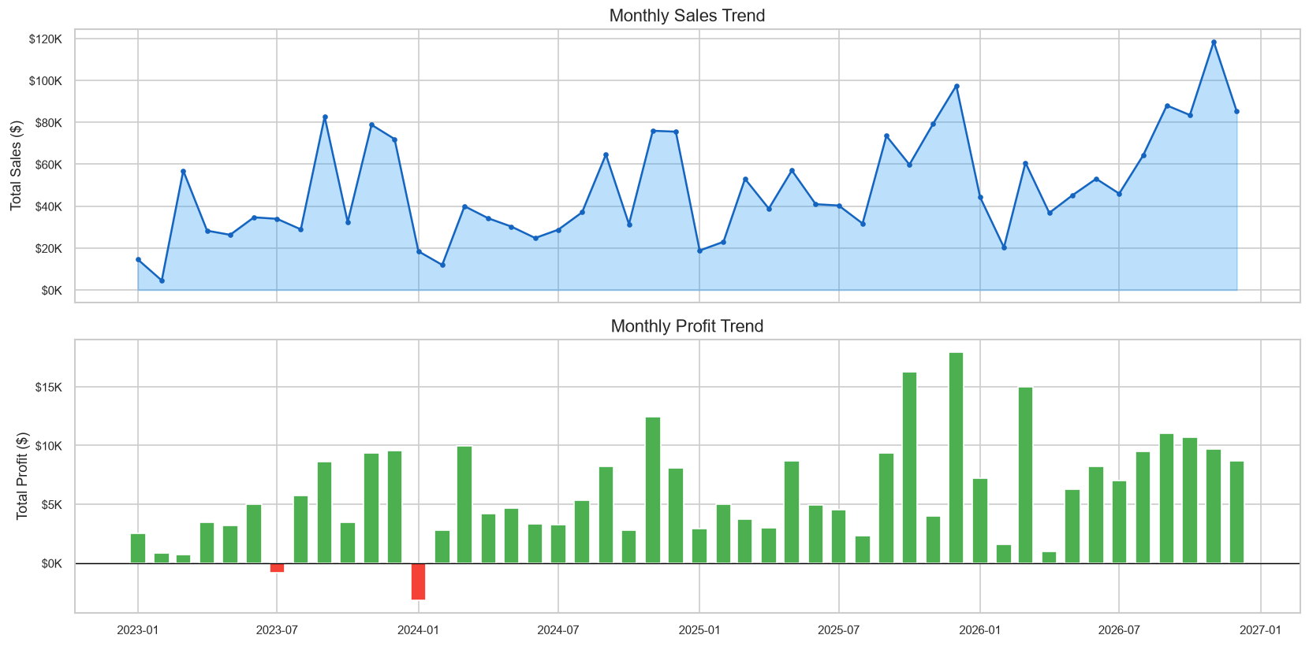
Figure 1: Monthly Sales and Profit Trends (2023-2026)

Monthly sales show temporal variation. Green profit bars = profitable months; red bars = loss months.
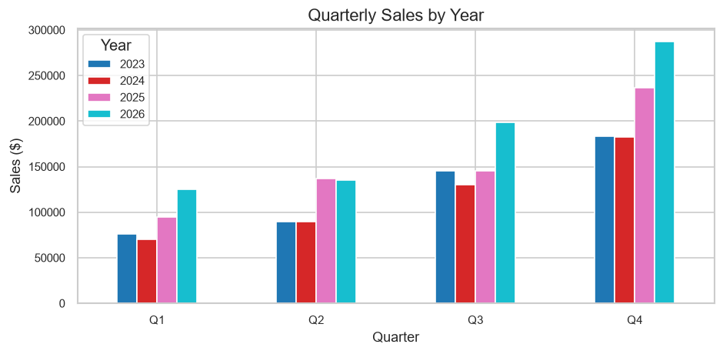
Figure 2: Quarterly Sales by Year

Quarterly analysis supports seasonality assessment across years.

11. Business KPI Analysis
All KPI values are calculated directly from the actual dataset.
KPI | Value
Total Sales | $2,326,534.35
Total Profit | $292,296.81
Total Quantity | 38,654 units
No. of Unique Orders | 5,111
No. of Unique Customers | 804
Average Order Value | $455.20
Average Discount | 15.5%
Overall Profit Margin | 12.6%

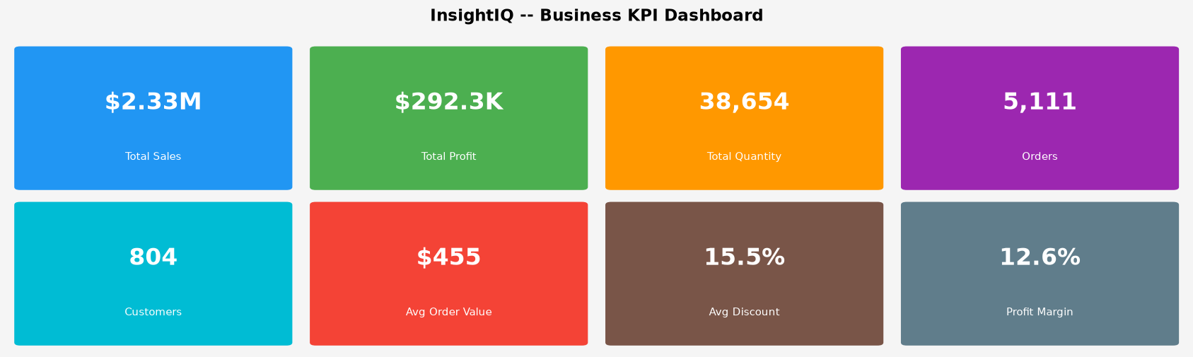
Figure 3: InsightIQ Business KPI Dashboard

The KPI dashboard shows 8 core business metrics as colored cards. Each card displays the metric value (large, bold) and label. The average discount of 15.5% warrants monitoring given its impact on profit margins.

12. Customer Analytics
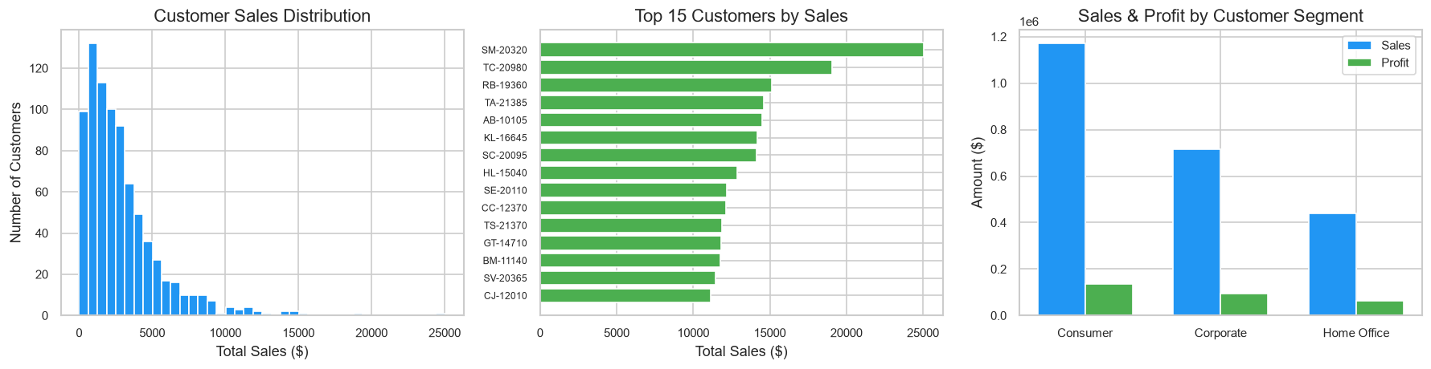
Figure 4: Customer Analytics -- Distribution, Top Customers, Segment Performance

Customer sales are right-skewed -- a small number of customers generate a large share of revenue. Consumer segment leads in total sales and profit. AOV: Home Office $473, Corporate $461, Consumer $445.

13. Product and Category Analytics
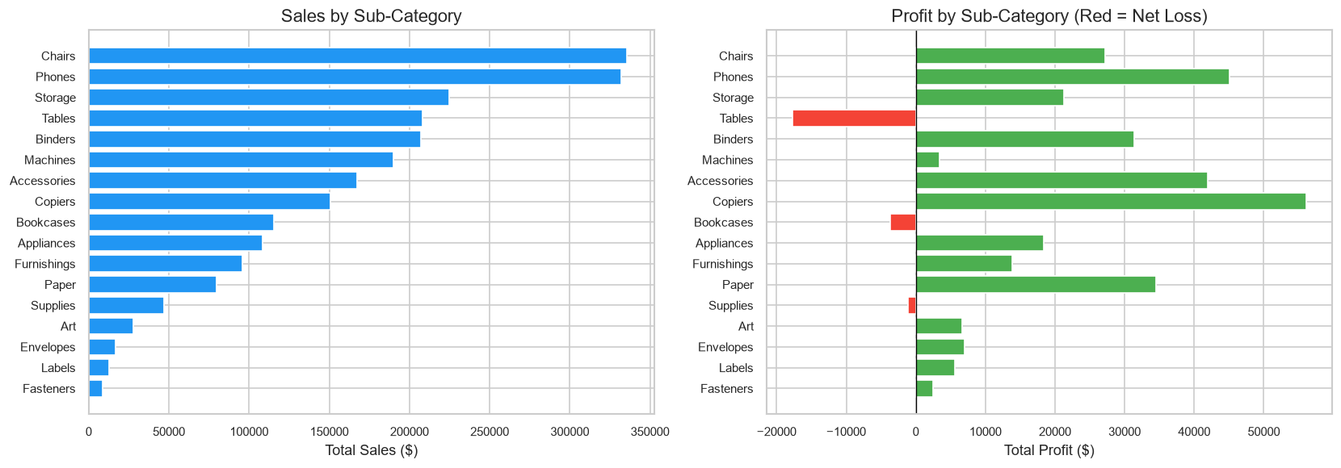
Figure 5: Sub-Category Sales and Profit (Red = Net Loss)

Technology leads in sales. Tables and Bookcases show negative total profit -- structural pricing or discount issues requiring investigation.
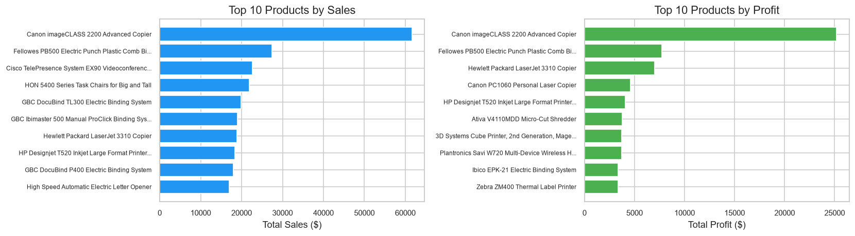
Figure 6: Top 10 Products by Sales and Profit

14. Regional Analytics
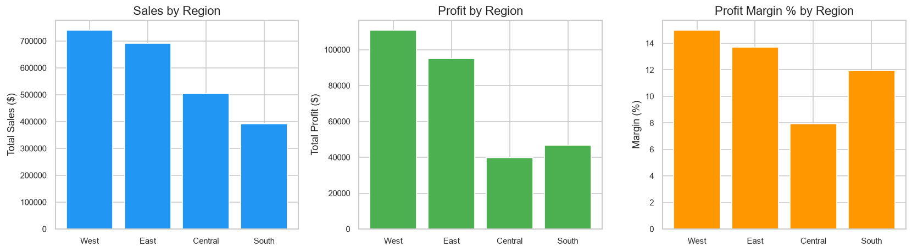
Figure 7: Regional Sales, Profit, and Profit Margin

West and East lead in total sales. Regional managers: West=Sadie Pawthorne, East=Chuck Magee, Central=Roxanne Rodriguez, South=Fred Suzuki.

15. Discount and Profitability Analysis
IMPORTANT: All findings are observational. No causal relationships are claimed.
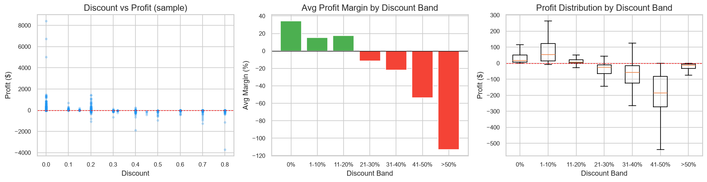
Figure 8: Discount vs Profit Analysis

Historical data shows that order lines with discounts above 20-30% are predominantly associated with negative or near-zero profit margins.

16. Predictive Modelling
Three approaches evaluated for monthly sales prediction (chronological 75/25 split):
Model | MAE ($) | RMSE ($)
Baseline (Lag-1) | 23,320 | 27,467
Linear Regression | 12,968 | 16,384
Random Forest | 13,897 | 16,945

Best model: Linear Regression | MAE: $12,968 | RMSE: $16,384 | MAPE: 23.5%
All metrics from actual held-out test set. Predictions are estimates, not guarantees.

17. Model Evaluation
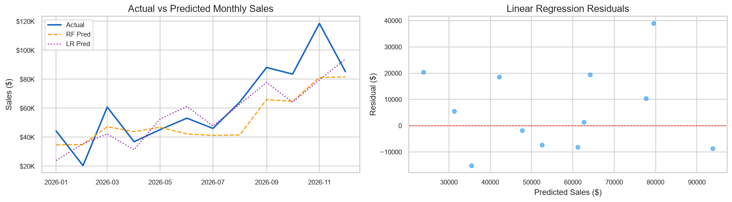
Figure 9: Actual vs Predicted Monthly Sales and Residuals

18. Explainable ML -- Feature Importance
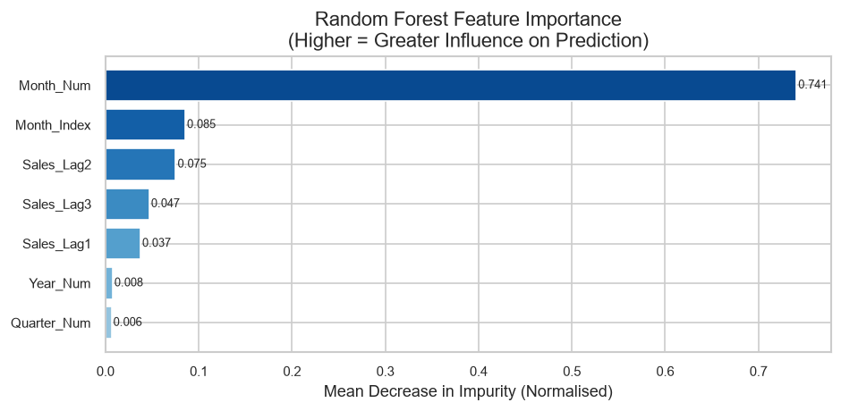
Figure 10: Random Forest Feature Importance

Sales lag features (Lag-1, Lag-2, Lag-3) are most influential -- capturing momentum. Temporal features (Year, Quarter, Month) capture trend and seasonality.
IMPORTANT: Feature importance does not prove causality.

19. Anomaly Detection
Isolation Forest applied at transaction level (contamination=3%) and monthly level (10%). An anomaly deviates substantially from the learned pattern -- not automatically an error or fraud.
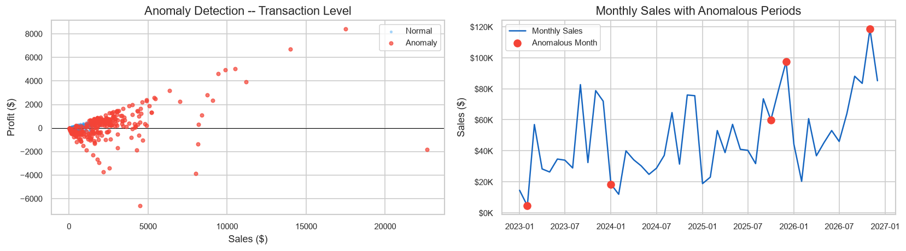
Figure 11: Anomaly Detection -- Transaction and Monthly Level

306 anomalous transactions detected (3.0% of all transactions).

20. Business Risk Analysis
- Risk 1: High Discount (>=30%) + Loss Lines -- Direct margin erosion.
- Risk 2: Loss Sub-Categories -- Tables and Bookcases report negative total profit.
- Risk 3: Below-Median Margin Regions -- Warrant review of local discount practices.
- Risk 4: Anomalous Transactions -- 306 transactions require business investigation.

21. Returns Analysis
Metric | Value
Returned Orders (Returns sheet) | 296
Total Unique Orders | 5,111
Order-Level Return Rate | 5.8%

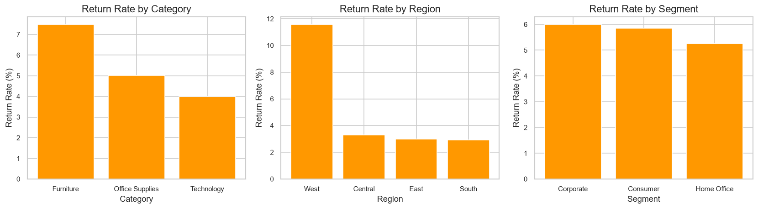
Figure 12: Return Rate by Category, Region, and Segment

Return rate measured at ORDER level to avoid double-counting multi-line returns.

22. InsightIQ Decision Simulator
Uses Random Forest models trained on order-line data to estimate Sales, Profit, and Margin under different discount scenarios.
IMPORTANT: Model-based scenario projections from historical data. Not causal guarantees.

23. Scenario Comparison
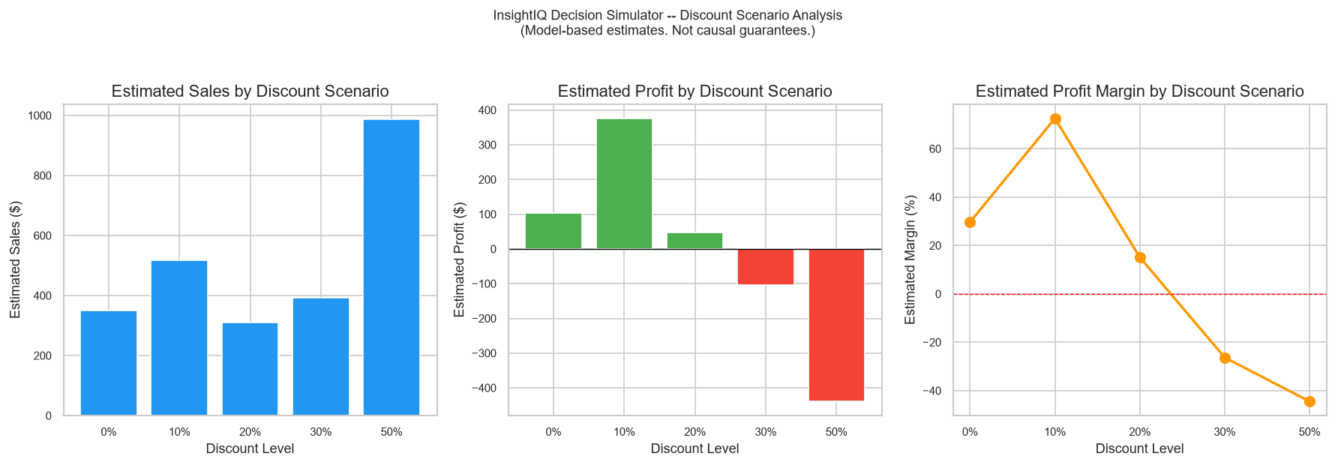
Figure 13: InsightIQ Decision Simulator -- Discount Scenario Comparison

Context: Technology | West | Consumer | Qty=3. Under model assumptions, higher discount scenarios are associated with lower estimated profit. These are projections, not guarantees.

24. Key Findings

A. Observed Findings (from historical data)
- Total sales $2,326,534 across 5,111 orders from 804 customers (2023-2026)
- Overall profit margin: 12.6%
- Technology is highest-revenue; Tables and Bookcases have negative total profit
- Lines with discount >=30% are predominantly associated with negative profit
- 296 returned orders = 5.8% order-level return rate

B. Predictive Findings (model estimates)
- Linear Regression: test MAE $12,968, RMSE $16,384, MAPE 23.5%
- Sales lag features are the most influential predictors (not causality)

C. Anomaly Findings
- 306 anomalous transactions (3.0%) flagged by Isolation Forest -- require investigation

D. Scenario Estimates
- Under model assumptions, higher discount scenarios are associated with lower estimated profit. These are projections, not causal guarantees.

25. Business Recommendations
Data-supported suggestions for human review. Require domain expertise before implementation.
- R1. Discount Strategy Review -- Transactions with discounts >=30% are predominantly loss-making.
- R2. Sub-Category Investigation -- Tables and Bookcases have negative total profit.
- R3. Anomaly Investigation -- 306 anomalous transactions require root-cause review.
- R4. Return Rate Monitoring -- Track as KPI; investigate high-return areas.
- R5. Regional Alignment -- Below-median margin regions warrant review.
- R6. Forecasting Integration -- Use predictive model to support planning; retrain regularly.

26. Limitations
- All findings are observational -- no causal claims can be made
- Monthly sales model uses only ~48 observations
- Decision Simulator does not model complex customer behavioural responses to discount changes
- Isolation Forest contamination (3%) is an assumption
- Returns data provides Order ID only -- no reason codes or cost data
- Dataset covers US/Canada only
- No external macroeconomic or competitive data included

27. Future Scope
- ARIMA / Prophet / LSTM for advanced time-series forecasting
- SHAP values for per-prediction interpretability
- Customer Lifetime Value (CLV) modelling
- RFM-based customer churn prediction
- Price elasticity with quasi-experimental methods
- Streamlit / Power BI dashboard deployment
- State-level geospatial choropleth visualisations
- Automated retraining pipeline

28. Conclusion
InsightIQ demonstrates a complete end-to-end business intelligence pipeline applied to the official Tableau Sample Superstore dataset. Starting from raw transactional data, the platform progresses through data preparation, EDA, predictive modelling, explainability, anomaly detection, returns analysis, and what-if decision simulation.
Actual results: total sales $2,326,534, total profit $292,296, overall margin 12.6%, 5.8% return rate, Linear Regression MAE $12,968 on monthly forecasting, 306 anomalous transactions flagged.
Throughout, findings are clearly distinguished as observed, predicted, or estimated -- maintaining rigorous academic standards.

29. References
- [1] Tableau Software. (2025). Sample Superstore Dataset. Tableau Public. https://public.tableau.com/app/resources/sample-data
- [2] Pedregosa, F. et al. (2011). Scikit-learn: Machine Learning in Python. JMLR, 12, 2825-2830.
- [3] Liu, F. T., Ting, K. M., Zhou, Z. H. (2008). Isolation Forest. Proceedings IEEE ICDM 2008.
- [4] McKinney, W. (2010). Data Structures for Statistical Computing in Python. Proc. 9th Python in Science Conf.
- [5] Hunter, J. D. (2007). Matplotlib: A 2D Graphics Environment. Computing in Science & Engineering, 9(3), 90-95.
- [6] Waskom, M. (2021). Seaborn: Statistical Data Visualization. JOSS, 6(60), 3021.
- [7] IBM SkillsBuild. (2025). Data Analytics with AI Academic Internship Programme.

