SOFTWARE REQUIREMENTS SPECIFICATION

FOR

SKIN DISEASE CLASSIFICATION

Prepared by:

**GROUP MEMBER 1 : SHRUTI SAKPAL (2015061)**

**GROUP MEMBER 2 : SAKSHI ZAGADE (2015074)**

**Under the guidance of**

**PROF. MERRIN MARY SOLOMON**



Department of Data Science

Usha Mittal Institute of Technology

S.N.D.T Women’s University, Mumbai

**24-01-2023**

TABLE OF CONTENTS

| SR. NO. | CONTENTS | PAGE NO. |
| --- | --- | --- |
| **1** | **Introduction**  1.1 Purpose  1.2 Intended audience  1.3 Project scope | **2 - 3** |
| **2** | **Overall description**  2.1 Product perspective  2.2 Product features  2.3 Operating environment  2.4 Design and Implementation Constraints | **4 - 7** |
| **3** | **System features**  3.1 Description and priority  3.2 Functional Requirements | **8 - 10** |
| **4** | **External interface**s  4.1 User interfaces  4.2 Hardware interfaces  4.3 Software Interfaces  4.4 Communication interfaces  4.5 Performance Requirements | **11 - 12** |
| **5** | **Other non functional requirements** | **13** |
| **6** | **Conclusion** | **14** |
| **7** | **Appendix** | **15** |
| **8** | **References** | **16 - 17** |

INTRODUCTION

**1.1 Purpose**

The skin is the largest organ in the human body, consisting of the epidermis, dermis, subcutaneous tissues, blood vessels, lymphatic vessels, nerves, and muscles. Skin diseases can arise because of fungal development over the skin, hidden bacteria, allergic reactions, microbes affecting the skin’s texture, or creating pigment. To minimize their development and proliferation, skin diseases must be treated immediately. Research on procedures to identify the effects of diverse skin diseases based on imaging technology is now mainly in demand.

The advancement of lasers and photonics-based medical technology has made it possible to diagnose skin diseases much more quickly and accurately. However, the cost of such diagnosis is still limited and expensive. Deep learning models are comparatively efficient in performing the classification process from the images and the data. The precise identification of the disease category will assist in providing better treatment for patients. Deep learning models can solve critical problems by automatically identifying the input data features, and the deep learning models are adaptable to the change in the considered problem.

**1.2 Intended audience**

This SRS describes how Skin Disease can be classified by using an application with the help of CNN. It is primarily written for the individuals directly involved in the development of this project. This includes software developers, project consultants, and team managers, for future references as well as the software users.

1.3 Project Scope

Skin is the largest organ in the human body, which is important to cover human bone, and to protect humans from any harm, fight the bacteria and other kinds of diseases, and may have numerous potential abnormalities. Several factors may affect the skin directly or indirectly and cause diseases which can be treated with specific medicine and others require doctor’s consultation. This project will help people to know what are the required procedures for treatment of skin disease by analyzing the image and extract useful information that help to show the infected skin area and classification of image based on the kind of skin disease.

The patient provides an image of the infected area of the skin as an input to the prototype. Image processing techniques are performed on this image and the detected disease is displayed at the output.

Our objective of the project is to detect the type of skin disease easily with accuracy and recommend the best. First stage of the image the skin disease is subject to various kinds of pre-processing techniques followed by feature extraction. Then the second stage involves the Deep learning algorithms to identify diseases based on the analyzing and observance of the skin. The proposed system is highly beneficial in rural areas where access to dermatologists is limited.

**OVERALL DESCRIPTION**

**2.1 Product perspective**

Skin diseases are one of the most common types of health illnesses faced by the people for ages. The identification of skin disease mostly relies on the expertise of the doctors and skin biopsy results, which is a time-consuming process. An automated computer-based system for skin disease identification and classification through images is needed to improve the diagnostic accuracy as well as to handle the scarcity of human experts.

This method is mobile based and hence very accessible even in remote areas and it is completely noninvasive to the patient's skin. The patient provides an image of the infected area of the skin as an input to the prototype. Image processing techniques are performed on this image and the detected disease is displayed at the output. The proposed system is highly beneficial in rural areas where access to dermatologists is limited

The main objective of this project is to bring in the state of art technique, namely Convolution Neural Networks (CNN) for the purpose of the precise classification of skin disease from the image that is captured from the mobile device. The practical implication of the model is to design the app through which the image of the affected region of the skin is captured to determine the class of the skin disease.The proposed model would assist medical practitioners and the patient in an effective non-invasive way of diagnosis of the disease with least possible cost and workforce.

**2.2 Product features**

In this study, an automated system is proposed for the diagnosis of skin diseases by using data from clinical images and patient information using deep learning models.

This project includes development of a mobile application where we can classify the skin disease on the basis of the image that is clicked through the camera. It uses concepts of Deep Learning, Image Classification, Convolutional Neural Network and ML Ops.

These algorithms use feature values from images as input to make a decision. The process consists of three stages-The feature extraction stage, the training stage and the testing stage. The process makes use of deep learning technology to train itself with the various skin images. The objective of this process is to increase accuracy of skin disease detection. Three important features in image classification are texture, color, shape, and combination of these. In this work, color and texture features are used to classify the skin disease. Hence, these features are explored to identify skin disease effectively.

**2.3 Operating environment**

The hardware, software and technology used should have following specifications:

* Ability to connect to the Wi-Fi or mobile network.
* Ability to exchange data over the network.
* Processor with speed of 500 MHz.
* Ability to use camera, gallery and other services of mobile.
* Ability to take input from user.
* Device must have 512MB RAM or above.
* Functional on iOS and android.

**2.4 Design and Implementation Constraints**

Deep learning models will acquire the inferred data to identify and explore the features in the unexposed data patterns with even low computational models resulting in considerable efficiency. That has motivated the authors in considering a deep learning model in classifying the skin disease category from the affected region's proposed work. This project can help in classifying twenty-three skin diseases:

* Acne and Rosacea Photos
* Actinic Keratosis Basal Cell Carcinoma and other Malignant Lesions
* Atopic Dermatitis Photos
* Bullous Disease Photos
* Cellulitis Impetigo and other Bacterial Infections
* Eczema Photos
* Exanthems and Drug Eruptions
* Hair Loss Photos Alopecia and other Hair Diseases
* Herpes HPV and other STDs Photos
* Light Diseases and Disorders of Pigmentation
* Lupus and other Connective Tissue diseases
* Melanoma Skin Cancer Nevi and Moles
* Nail Fungus and other Nail Disease
* Poison Ivy Photos and other Contact Dermatitis
* Psoriasis pictures Lichen Planus and related diseases
* Scabies Lyme Disease and other Infestations and Bites
* Seborrheic Keratoses and other Benign Tumors
* Systemic Disease
* Tinea Ringworm Candidiasis and other Fungal Infections
* Urticaria Hives
* Vascular Tumors
* Vasculitis Photos
* Warts Molluscum and other Viral Infections

We can use data augmentation, and this technique balances the data and generates more images either by rotations or transformations from the existing data.

This dataset contains a total of 19500 dermatoscopic images. A random (rand) function is applied to split the data into the training data which is a total of 15500 images and testing data containing 4000 images. In which the training data is further divided into 90% as actual training dataset (215 images) and the remaining 10% as validation dataset (25 images). The considered dataset is slightly imbalanced because some skin diseases are more, and some are less in number. To overcome such problems, we used data augmentation, and this technique balances the data and generates more images either by rotations or transformations from the existing data.

**Model Building:**

CNNs are a class of Deep Neural Networks that can recognize and classify particular features from images and are widely used for analyzing visual images. Their applications range from image and video recognition, image classification, medical image analysis, computer vision and natural language processing.

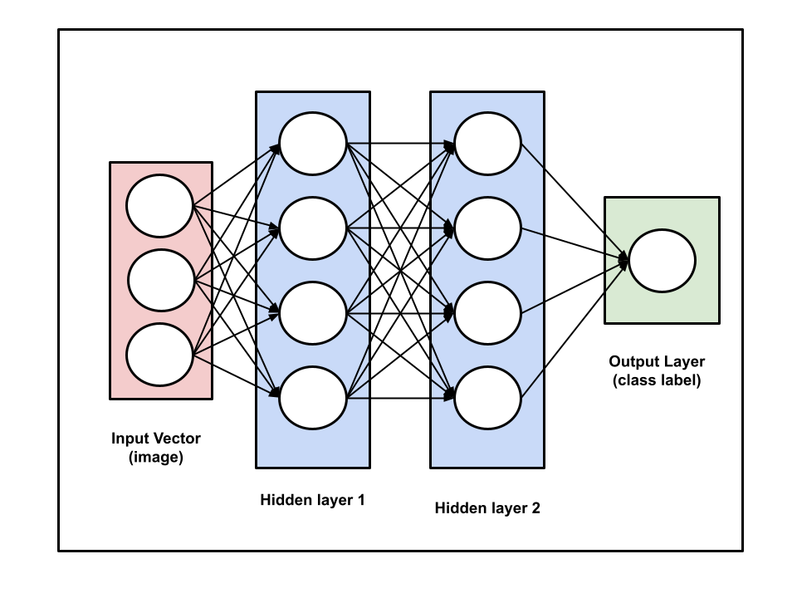

The term ‘Convolution” in CNN denotes the mathematical function of convolution which is a special kind of linear operation wherein two functions are multiplied to produce a third function which expresses how the shape of one function is modified by the other. In simple terms, two images which can be represented as matrices are multiplied to give an output that is used to extract features from the image. There are two main parts to a CNN architecture.

First is a convolution tool that separates and identifies the various features of the image for analysis in a process called Feature Extraction and second is a fully connected layer that utilizes the output from the convolution process and predicts the class of the image based on the features extracted in previous stages.

**SYSTEM FEATURES**

**3.1 Project Description**

* This machine learning project starts with data collection. Data which we can use as a training dataset. In our case, we need to collect images of different skin diseases.
* For Data cleaning and preprocessing, we will be using tf data set and data augmentation. Data Augmentation is required as we might not have enough diverse set of images, so we rotate, flip, and adjust contrast to create more training samples.
* Once we have that, we will use model building using convolutional neural networks, since it is a standard way of image classification. We’ll export the trained model onto our disk.
* We will further cover ML Ops concept using TF serving where a tf server will run on top of the exported model, this tf serving will be called from fast API.
* We will build a website in React JS which will be calling the fast API server. On this website, we can drag and drop the image and it will tell us the disease.
* The next phase would be mobile app development. We will convert the exported float model into TF lite model using quantization. Quantization is a way to reduce the size of the model, so that the model is occupying less memory and to increase inference speed. We will deploy the TF Lite model to Google Cloud and we will write Google Cloud Functions which will be serving the mobile application. This application will be written in React Native (hybrid mobile app development framework).

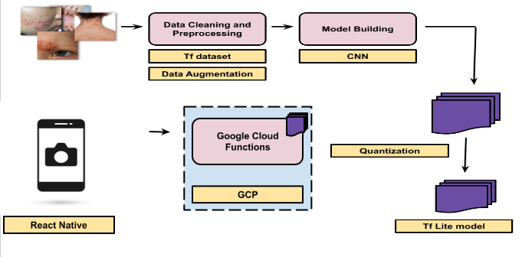

| **Model Building** | TensorFlow, Convolutional Neural Network, Data Augmentation, TF dataset |
| --- | --- |
| **Backend Server** | TF serving, Fast API |
| **Model Optimization** | Quantization, TensorFlow Lite |
| **Frontend and Deployment** | React JS, React Native, Deployment TO GCP |

**Dataset:**

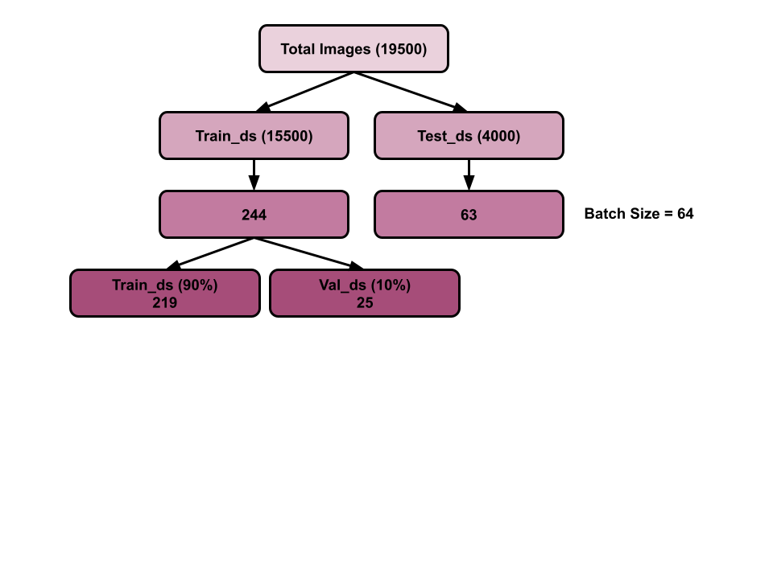

**3.3 Functional Requirements**

**FUNCTIONAL REQUIREMENT 1 : Camera**

Input: Click a picture

Processing state: User can set timer/enable flash and then click a selfie or click a picture.

Output: A picture can be uploaded.

**FUNCTIONAL REQUIREMENT 2 : Upload photo from gallery**

Description: This module allows users to upload photos from the device gallery.

Input: The image from the device.

Processing state: When a user selects an image from gallery, it will be uploaded.

Output: Image uploaded.

**FUNCTIONAL REQUIREMENT 3: Skin Disease Detection**

Description: These algorithms use feature values from images as input to make a decision.

Input: The image uploaded.

Output: The disease will be detected.

**EXTERNAL INTERFACES**

**4.1 User interfaces**

The user interface should be intuitive, such that 99% of all new Users must be able to use the app without any assistance.

**4.2 Hardware interfaces**

The hardware should have following specifications:

* Ability to read gallery
* Ability to exchange data over network
* Ability to connect to network
* Ability to take input from user
* Should be user friendly

**4.3 Software Interfaces**

The software interfaces are specific to the target demands software like GPS, camera, etc. on the following mobileOS(environment):

* iOS
* Android

**4.4 Communication interfaces**

The required communication requirements are:

* Internet Connectivity
* Working Camera
* Permission to access Camera/Gallery

**4.5 Performance Requirements**

* SCALABILITY

The application should be able to provide instant output to users at any given time.

* PERFORMANCE

Application must be lightweight and must predict results instantly.

* SPEED

Application’s processing speed should be so high that there should be no delay in executing the user's instructions. Also, the application should not crash repeatedly.

* CACHE MEMORY

The app shall not consume more cache memory. Even if it does, it must provide a choice to the user to clear the app cache manually.

**OTHER NON FUNCTIONAL REQUIREMENTS**

* PRIVACY

The users are provided with the benefit of customizing their privacy settings. Hence, they shall make the best use of these settings.

* SECURITY AND SAFETY

Keep your password safe and don't share it with any other people, applications, or websites under any circumstances. We also suggest using a different password for every service you use.

* RELIABILITY

It is very important that the app is reliable. All data collected by the application shall be preserved safely and should follow data hiding.

* PORTABILITY

The application can be used on any apple or android phones and tablets.

* USER FRIENDLY

This application should be user-friendly, meaning to say even if one just installs the app and uses it for the first time, they’d find it easy to operate the application.

**CONCLUSION**

The objective of the project is to detect the type of skin disease easily with accuracy and recommend the best. First stage of the image the skin disease is subject to various kinds of pre-processing techniques followed by feature extraction. Then the second stage involves the Deep learning algorithms to identify diseases based on the analyzing and observance of the skin.

REFERENCES

[1] <https://codebasics.io/blogs/programming>.

[2] <https://codebasics.io/blog/what-is-a-neural-network>

[3] <https://youtube.com/playlist?list=PLeo1K3hjS3uu7CxAacxVndI4bE_o3BDtO>

[4] Geron Aurelien, Hands-On Machine Learning with Scikit-Learn and TensorFlow: Concepts, Tools, and Techniques to Build Intelligent Systems, 2017.

[5] Adam Gibson, Josh Patterson, Deep Learning, A Practitioner’s Approach, Shroff Publisher /O’Reilly Publisher Media

[6] <https://youtube.com/playlist?list=PLeo1K3hjS3uv5U-Lmlnucd7gqF-3ehIh0>

[7] Dan Ward, React Native Cookbook - Second Edition, 2019

[8] Artemij Fedosejev, React.js Essentials: A fast-paced journey, 2015

[9]<https://www.hindawi.com/journals/cin/2022/6504616/?utm_source=google&utm_medium=cpc>&utm_campaign=HDW_MRKT_GBL_SUB_ADWO_PAI_DYNA_SPEC_X_X0000_Nov2022&gclid=Cj0KCQiAw8OeBhCeARIsAGxWtUxiWzi1howcEdekrmCzk1nIm4RtH8xC4Igs_q7qxhQgcEr-VqBNAXUaAqQPEALw_wcB

[10] <https://www.frontiersin.org/articles/10.3389/fpls.2016.01419/full>

[11]<https://www.who.int/news-room/questions-and-answers/item/radiation-ultraviolet-(uv)-radiation-and-skin-cancer>

[12] <https://towardsdatascience.com/>

[13] <https://cjme.springeropen.com/articles/10.1186/s10033-021-00629-5>

[14] Hafiz, A.M.; Bhat, G.M. A Survey of Deep Learning Techniques for Medical Diagnosis. In Information and Communication Technology for Sustainable Development; Advances in Intelligent Systems and Computing; Tuba, M., Akashe, S., Joshi, A., Eds.; Springer: Singapore, 2020; Volume 933.

[15] D.A. Okuboyejo, O.O. Olugbara and S.A. Odunaike, “Automating skin disease diagnosis using image classification,” In proceedings of the world congress on engineering and computer science 2013 Oct 23, Vol. 2, pp. 850-854.

[16] Avanzato, R.; Beritelli, F. Automatic ECG Diagnosis Using Convolutional Neural Network. Electronics 2020, 9, 951. [Google Scholar]

[17] A.A. Amarathunga, E.P. Ellawala, G.N. Abeysekar and C.R Amalraj, “Expert system for diagnosis of skin diseases,” International Journal of Scientific & Technology Research, 2015 Jan 4;4(01):174-8.

[18] S. Chakraborty, K. Mali, S. Chatterjee, S. Anand, A. Basu, S. Banerjee, M. Das and A. Bhattacharya, “Image based skin disease detection using hybrid neural network coupled bag-of-features,” In 2017 IEEE 8th