Mini Project Phase-II on

SKIN DISEASE CLASSIFICATION

Submitted in partial fulfillment for the degree of

Bachelor of Technology in Data Science

Submitted by

**GROUP MEMBER 1 : SHRUTI SAKPAL (2015061)**

**GROUP MEMBER 2 : SAKSHI ZAGADE (2015074)**

**Under the guidance of**

**MS. MERRIN MARY SOLOMON**



**Department of Data Science**

**Usha Mittal Institute of Technology,**

**S.N.D.T Women’s University, Mumbai - 400049**

**2022-2023**

**CERTIFICATE**

This is to certify that **Ms. Shruti Ajit Sakpal** and **Ms. Sakshi Ajit Zagade** have completed the Mini Project Phase-II on the topic

“**Skin Disease Classification**”

satisfactorily in partial fulfillment for the Degree of Bachelor of Technology in Data Science under the guidance of **Ms. Merrin Mary Solomon** during the year 2022-23 as prescribed by S.N.D.T. Women’s University, Mumbai.

Guide Examiner 1 Examiner 2

Ms. Merrin Mary Solomon

HOD

Prof. Rajesh Kolte

**ACKNOWLEDGEMENTS**

We would like to take up this opportunity to express gratitude to everyone who supported us throughout the course of this project. We are thankful for their aspiring guidance, invaluably constructive criticism and friendly advice during the project work.

We are highly indebted to our project guide Ms. Merrin Solomon for her guidance and constant supervision as well as for providing necessary information regarding the project also for her support in working towards the project.

We also express our sincere gratitude to our friends and family who provided us with the facilities being required and conductive conditions for our project and being a part of the literature survey.

**ABSTRACT**

Skin diseases are one of the most common types of health illnesses faced by the people for ages. The skin is so vital in managing core temperature and protecting the body from skin disorders, it's important to keep it healthy. The identification of skin disease mostly relies on the expertise of the doctors and skin biopsy results, which is a time-consuming process. Skin diseases may appear harmless, yet they can be dangerous if not treated properly. Many diseases have early symptoms, but most of them are identical, making it difficult to diagnose the condition at an initial point.

In recent years, with the fast advancement of technology and the use of different data mining approaches, treatment of skin predictive classification has really become highly predictive as well as accurate. As an outcome, automated assessment of these illnesses has become more important due to its ability to produce accurate results in a short space of time when applied to human analysis utilizing clinical laboratories processes.

An automated computer-based system for skin disease identification and classification through images is proposed to improve the diagnostic accuracy as well as to handle the scarcity of human experts.

**CONTENTS**

**List of Figures**

**1** Introduction 6

**1.1** Problem Statement …………………………………………………..………..…6

**2** Literature Survey 7

**2.1** Technical Papers .…………………………………………………..………..…7

**3** Existing System 9

**4** Proposed System 10

**5** Software Requirements 11

**6** Hardware Requirements 11

**7** Implementation 12

8 Applications 18

9 Future Scope 19

1. **INTRODUCTION**

Deep learning has become an extremely popular method in recent years, and can be a powerful tool in complex, prior-knowledge-required areas, especially in the field of biomedicine, which is now facing the problem of inadequate medical resources. The application of deep learning in disease diagnosis has become a new research topic in dermatology. The current trend of research on Deep Learning along with Image Classification using Convolutional Neural Network (CNN). Several variants of these algorithms have been developed.

The current research is to study and develop an algorithm that helps to classify skin diseases by using data from clinical images. We aim to develop an effective performance strategy for categorizing dermoscopy images data into twenty-three groups. Preprocessing, feature extraction, and classification are all elements of the architecture that may be subdivided.

**1.1 PROBLEM STATEMENT**

The skin is the largest organ in the human body, consisting of the epidermis, dermis, subcutaneous tissues, blood vessels, lymphatic vessels, nerves, and muscles. Skin diseases can arise because of fungal development over the skin, hidden bacteria, allergic reactions, microbes affecting the skin’s texture, or creating pigment. To minimize their development and proliferation, skin diseases must be treated immediately. Research on procedures to identify the effects of diverse skin diseases based on imaging technology is now mainly in demand.

Our objective of the project is to detect the type of skin disease easily with accuracy and recommend the best. First stage of the image the skin disease is subject to various kinds of pre-processing techniques followed by feature extraction. Then the second stage involves the Deep learning algorithms to identify diseases based on the analyzing and observance of the skin.

1. **LITERATURE SURVEY**

**2.1 Technical Papers**

| Sr.No. | Name  of  Research paper | Author Name | Technology used | Observation |
| --- | --- | --- | --- | --- |
| 1 | A Smartphone-Based Skin Disease Classification Using MobileNet CNN  ( October 2019) | Jessica Velasco, Cherry Pascion, Jean Wilmar Alberio, Jonathan Apuang, John Stephen Cruz, Mark Angelo Gomez, Benjamin Jr. Molina, Lyndon Tuala, August Thio-ac, Romeo Jr. Jorda | CNN MobileNet model, App Development | Oversampling and data augmentation generate the most  accurate result. |
| 2 | Potato Plant’s Disease Classification using  CNN and Transfer Learning  (July 2022) | Amit R.S, Sheetal Mittal, Heena Kouser, Akshitha Katkeri | CNN and Transfer Learning | Transfer Learning models are simple to use and have a high  degree of accuracy. |
| 3 | Skin Disease Detection using Machine Learning | Kritika Sujay Rao,  Pooja Suresh Yelkar, Omkar Narayan Pise, Dr. Swapna Borde | Convolutional Neural Network | Validation Data makes the system more accurate |
| 4 | Detection and classification of skin diseases  with ensembles of deep learning networks in  medical imaging | A. Kalaivani,  Dr. S. Karpagavalli |  | A multi-model ensemble approach to combine these two data mining techniques to  get the greatest accuracy of 96.1 percent. |
| 5 | Classification of Apple Tree Leaves Diseases using  Deep Learning Methods | Ashwaq Alsayed, Amani Alsabei, Muhammad Arif | ResNet-V2  (convolutional neural network) | The Adam optimizer is effective in the transfer learning of the ResNetV2 model. Increasing the number of instances may further improve  classification accuracy. |

1. **EXISTING SYSTEM**

Several existing approaches are mechanized to recognize and classify skin diseases. Most of the diagnosing methods rely on imaging technology, and the epidermal recognition of such skin diseases does not need radiological imaging technologies. They can recognize the condition based on the standard images through image processing techniques, including image transformation, equalization, enhancement, edge detection, and segmentation. The skin images that are captured for disease identification and classification are processed and fed as input for the advanced artificial intelligence approaches like Machine Learning, Deep Learning, Artificial Neural Network, Convolutional Neural Network, Back Propagation Neural Network, and classifiers such as Support Vector Machines, Bayesian classifier for the prediction of the type of skin disease.

1. **PROPOSED SYSTEM**

In this study, an automated system is proposed for the diagnosis of skin diseases by using data from clinical images and patient information using deep learning models. This project includes development of a mobile application where we can classify the skin disease on the basis of the image that is clicked through the camera. It uses concepts of Deep Learning, Image Classification, Convolutional Neural Network and ML Ops.

These algorithms use feature values from images as input to make a decision. The process consists of three stages - The feature extraction stage, the training stage and the testing stage. The process makes use of deep learning technology to train itself with the various skin images. The objective of this process is to increase accuracy of skin disease detection. Three important features in image classification are texture, color, shape, and combination of these. In this work, color and texture features are used to classify the skin disease. Hence, these features are explored to identify skin disease effectively.

1. **SOFTWARE REQUIREMENTS**

The software requirements include:

1. Jupyter Notebook
2. Python Libraries
3. Git Bash
4. **HARDWARE REQUIREMENTS**

The hardware should have following specifications:

1. Windows Version 11
2. Efficient GPU
3. **IMPLEMENTATION**
4. This machine learning project starts with data collection. Data which we can use as a training dataset. In this case, we need to collect images of different skin diseases.
5. For Data cleaning and preprocessing, we will be using tf data set and data augmentation. Data Augmentation is required as we might not have enough diverse set of images, so we rotate, flip, and adjust contrast to create more training samples.
6. Once that is acquired, we will then use model building using convolutional neural networks, since it is a standard way of image classification. We’ll export the trained model onto our disk.
7. We will further cover ML Ops concept using TF serving where a tf server will run on top of the exported model, this tf serving will be called from fast API.
8. The next phase would be mobile app development. In order to deploy the model in a mobile application, we quantize it and convert it into a tf lite model which will be serving as the basic model for the app. This application will be written in Java.
9. This application will help in classifying various skin diseases within a fraction of minute. The patient will provide an image of the infected area of the skin as an input to the prototype. Image processing techniques will be performed on this image and the detected disease will then be displayed as the output.

This project can help in classifying twenty-three skin diseases:

1. Acne and Rosacea Photos
2. Actinic Keratosis Basal Cell Carcinoma and other Malignant Lesions
3. Atopic Dermatitis Photos
4. Bullous Disease Photos
5. Cellulitis Impetigo and other Bacterial Infections
6. Eczema Photos
7. Exanthems and Drug Eruptions
8. Hair Loss Photos Alopecia and other Hair Diseases
9. Herpes HPV and other STDs Photos
10. Light Diseases and Disorders of Pigmentation
11. Lupus and other Connective Tissue diseases
12. Melanoma Skin Cancer Nevi and Moles
13. Nail Fungus and other Nail Disease
14. Poison Ivy Photos and other Contact Dermatitis
15. Psoriasis pictures Lichen Planus and related diseases
16. Scabies Lyme Disease and other Infestations and Bites
17. Seborrheic Keratoses and other Benign Tumors
18. Systemic Disease
19. Tinea Ringworm Candidiasis and other Fungal Infections
20. Urticaria Hives
21. Vascular Tumors
22. Vasculitis Photos
23. Warts Molluscum and other Viral Infections

| **Model Building** | TensorFlow, Convolutional Neural Network, Data Augmentation, TF dataset |
| --- | --- |
| **Backend Server** | TF serving, Fast API |
| **Model Optimization** | Quantization, TensorFlow Lite |
| **Frontend and Deployment** | Mobile Application using Java |

**Dataset:**

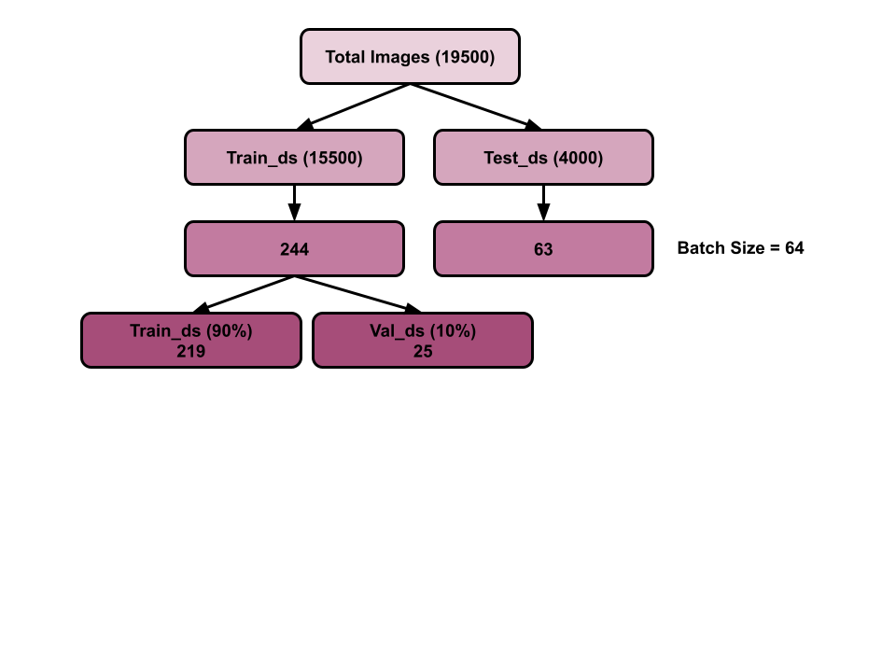

**Data Preprocessing Code:**

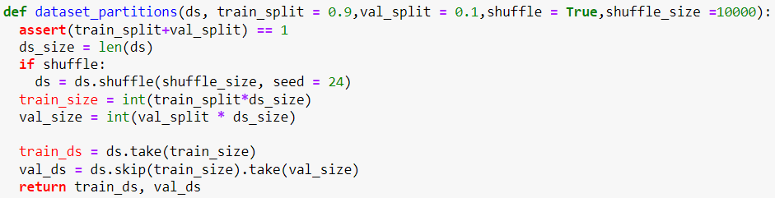

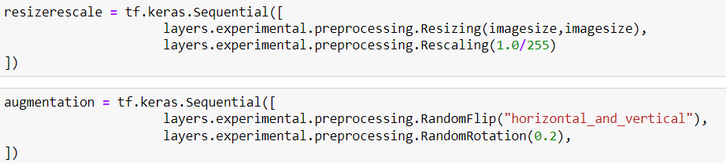

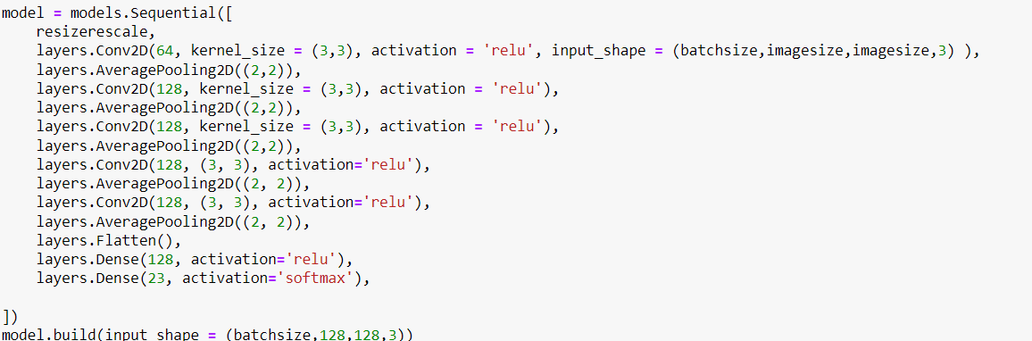

**Output:**

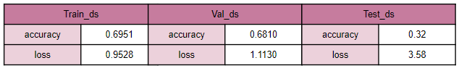

**Flowchart:**

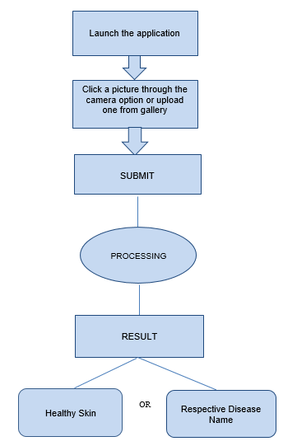

1. **APPLICATIONS**
2. The proposed system is highly beneficial in rural areas where access to dermatologists is limited.
3. Visual assessment in combination with clinical information is the common diagnostic procedure for diseases. However, these procedures are manual, time-consuming, and require experience and excellent visual perception. By using a mobile application, users are just a device away from identifying the disease and getting it treated.
4. Just a simple visit to a doctor for identifying the allergy can cost quite a hefty amount of money excluding the treatment charges. This skin disease model is absolutely cost effective and requires only a good camera and internet connection to help you recognize the type of disease.
5. User friendly and requires very little effort.
6. No need of technical knowledge and very handy to use.
7. **FUTURE SCOPE**

India is prominent for their traditional natural remedies and authentic medicinal properties. Natural remedies in Indian culture have been a traditional medical solution that still holds its value as the best medicinal resource in the country, that help reduce troublesome symptoms. The upcoming generations lack knowledge about the things at home which can be really of great use in situations. Many of the times, situations can be handled quicker with the help of home remedies when they are at earlier stages. This application can be further used in providing home remedies or cures to the skin disease which has been detected.

Several factors may affect the skin directly or indirectly and cause diseases, factors like the environment, food allergies, irritants, genetic makeup, certain diseases, immune system, etc. The location where a person stays might be of vital importance in knowing the actual cause of the disease. For ex: from eczema to allergies, toxic air causing skin problems among Delhi residents is becoming an issue these days. This application can further use the user’s location as one of the parameters in classifying the skin disease.

This system can further help in providing the user with the nearby hospitals and dermatologists details which would be helpful.

**REFERENCES**

[1] <https://codebasics.io/blogs/programming>.

[2] <https://codebasics.io/blog/what-is-a-neural-network>

[3] <https://youtube.com/playlist?list=PLeo1K3hjS3uu7CxAacxVndI4bE_o3BDtO>

[4] Geron Aurelien, Hands-On Machine Learning with Scikit-Learn and TensorFlow: Concepts, Tools, and Techniques to Build Intelligent Systems, 2017.

[5] Adam Gibson, Josh Patterson, Deep Learning, A Practitioner’s Approach, Shroff Publisher /O’Reilly Publisher Media

[6] <https://youtube.com/playlist?list=PLeo1K3hjS3uv5U-Lmlnucd7gqF-3ehIh0>

[7] Dan Ward, React Native Cookbook - Second Edition, 2019

[8] Artemij Fedosejev, React.js Essentials: A fast-paced journey, 2015

[9]<https://www.hindawi.com/journals/cin/2022/6504616/?utm_source=google&utm_medium=cpc>&utm_campaign=HDW_MRKT_GBL_SUB_ADWO_PAI_DYNA_SPEC_X_X0000_Nov2022&gclid=Cj0KCQiAw8OeBhCeARIsAGxWtUxiWzi1howcEdekrmCzk1nIm4RtH8xC4Igs_q7qxhQgcEr-VqBNAXUaAqQPEALw_wcB

[10] <https://www.frontiersin.org/articles/10.3389/fpls.2016.01419/full>

[11]<https://www.who.int/news-room/questions-and-answers/item/radiation-ultraviolet-(uv)-radiation-and-skin-cancer>

[12] <https://towardsdatascience.com/>

[13] <https://cjme.springeropen.com/articles/10.1186/s10033-021-00629-5>

[14] Hafiz, A.M.; Bhat, G.M. A Survey of Deep Learning Techniques for Medical Diagnosis. In Information and Communication Technology for Sustainable Development; Advances in Intelligent Systems and Computing; Tuba, M., Akashe, S., Joshi, A., Eds.; Springer: Singapore, 2020; Volume 933.

[15] D.A. Okuboyejo, O.O. Olugbara and S.A. Odunaike, “Automating skin disease diagnosis using image classification,” In proceedings of the world congress on engineering and computer science 2013 Oct 23, Vol. 2, pp. 850-854.

[16] Avanzato, R.; Beritelli, F. Automatic ECG Diagnosis Using Convolutional Neural Network. Electronics 2020, 9, 951. [Google Scholar]

[17] A.A. Amarathunga, E.P. Ellawala, G.N. Abeysekar and C.R Amalraj, “Expert system for diagnosis of skin diseases,” International Journal of Scientific & Technology Research, 2015 Jan 4;4(01):174-8.

[18] S. Chakraborty, K. Mali, S. Chatterjee, S. Anand, A. Basu, S. Banerjee, M. Das and A. Bhattacharya, “Image based skin disease detection using hybrid neural network coupled bag-of-features,” In 2017 IEEE 8th