# **Persistent Storage**

Persistent means something that doesnot disappear when a shutdown is performed in a devices.

Persistent storage is a system which stores data in a system . If a server is stopped and again started , it shows all data present there or previously performed tasks .

This is what persistent is all about.

# **Database System**

I have used MYSQL database to store my data as it is free of cost to use and it is open source RDBMS which uses Structured Query Language. It supports triggers,foreign key constraint key. Transactions can be done.

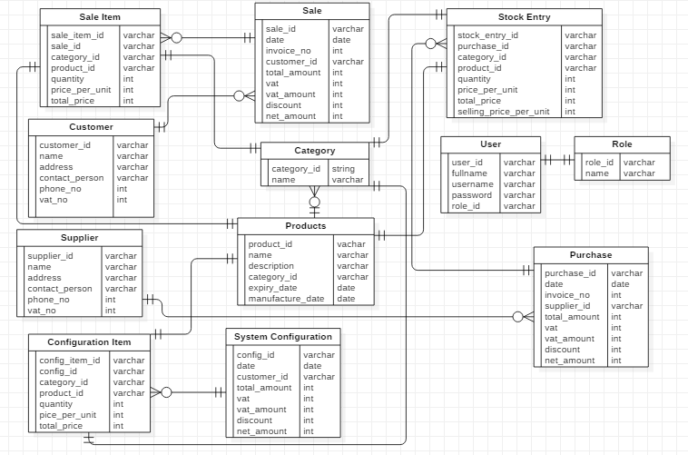

Figure 1.1 ER- Diagram (Database Design)

As shown in above Figure 1.1 , this is my database design. Here, all together 12 tables is created.

My system is Inventory management which will be used in store , mart, department to track the daily product stock count, customer information and supplier information . Know who customer is buying which products and who the supplier or vendor is selling products.

Role Table contains the usertype for login . It stores type like admin or user.

User table contains credentials field to login and here is role id which defines either that particular user is admin or user.

Category table stores the name like laptop, computer, mobile,gadgets ,etc .

This table id is acquired on Products table

Product table stores the product details and this product id is used during system configuration, sales and purchase.

Purchase table is for to add the stock and its details . It stores the product details and its quantity , purchased price and selling price . Selling price is used during product selling time to the customer.

Stock_entry table is used to store the stocked quantity of product so that this stock can be used during selling time and its total stock count and all other functionality can be acquired.

Customer table is used to store the details of customer so that this can be used during selling and system configuration to track the records of customer id .

Supplier table is used to store the details of supplier so that this id can be used during purchase to track who the vendor or supplier is.

Similarly, for sale and system configuration , the process goes like purchase . Just, here , is customer which is for who the customer is buying the product.

# **Metadata (Data Dictionary):**

In a simple word , it is a data about a data.

Role :

|  |  |  |
| --- | --- | --- |
| SN | Column Name | Data Type |
| 1. | Id | Varchar(64) (P.K.) |
| 2. | Name | mediumtext |

User:

|  |  |  |
| --- | --- | --- |
| SN | Column Name | Data Type |
| 1. | Id | Varchar(64) (P.K.) |
| 2. | FullName | longtext |
| 3. | IsActive | tinyint |
| 4. | PasswordHash | Longtext |
| 5. | AccessFailedCount | integer |
| 6. | UserName | Varchar(256) |
| 7. | RoleId | Varchar(64) (F.K.) |

Category :

|  |  |  |
| --- | --- | --- |
| SN | Column Name | Data Type |
| 1. | Id | Varchar(64) (P.K.) |
| 2. | Name | mediumtext |

Customer :

|  |  |  |
| --- | --- | --- |
| SN | Column Name | Data Type |
| 1. | Id | Varchar(64) (P.K.) |
| 2. | Name | mediumtext |
| 3. | Address | Longtext |
| 4. | Contact_person | Longtext |
| 5. | Phone_no | Varchar(255) |
| 6. | Status | Int(11) |
| 7. | Vat_no | Varchar(255) |

Supplier :

|  |  |  |
| --- | --- | --- |
| SN | Column Name | Data Type |
| 1. | Id | Varchar(64) (P.K.) |
| 2. | Name | mediumtext |
| 3. | Address | Longtext |
| 4. | Contact_person | Longtext |
| 5. | Phone_no | Varchar(255) |
| 6. | Status | Int(11) |
| 7. | Vat_no | Varchar(255) |

Products :

|  |  |  |
| --- | --- | --- |
| SN | Column Name | Data Type |
| 1. | Id | Varchar(64) (P.K.) |
| 2. | Name | longtext |
| 3. | Code | mediumtext |
| 4. | IsActive | Tinyint(1) |
| 5. | Description | longtext |
| 6. | CategoryId | Varchar(64) (F.K.) |
| 7. | ExpiryDate | Varchar(64) |
| 8. | ManufacturerDate | Varchar(64) |

Purchase :

|  |  |  |
| --- | --- | --- |
| SN | Column Name | Data Type |
| 1. | Id | Int(11) (P.K.) |
| 2. | Date | date |
| 3. | InvoiceNo | Varchar(45) |
| 4. | Vendor | Varchar(45) (F.K.) |
| 5. | TotalAmount | double |
| 6. | Vat | Smallint(3) |
| 7. | VatAmount | double |
| 8. | Discount | double |
| 9. | NetAmount | double |

StockEntry :

|  |  |  |
| --- | --- | --- |
| SN | Column Name | Data Type |
| 1. | Id | Int(11) (P.K.) |
| 2. | PurchaseId | Int(11) (F.K.) |
| 3. | CategoryId | Varchar(64) (F.K.) |
| 4. | ProductId | Varchar(64) (F.K.) |
| 5. | Quantity | Int(11) |
| 6. | PriceperUnit | double |
| 7. | TotalPrice | double |
| 8. | SellingPricePerUnit | double |

Sale :

|  |  |  |
| --- | --- | --- |
| SN | Column Name | Data Type |
| 1. | Id | Int(11) (P.K.) |
| 2. | Date | date |
| 3. | InvoiceNo | Varchar(45) |
| 4. | Customer | Varchar(45) (F.K.) |
| 5. | TotalAmount | double |
| 6. | Vat | Smallint(3) |
| 7. | VatAmount | double |
| 8. | Discount | double |
| 9. | NetAmount | double |

SaleItem :

|  |  |  |
| --- | --- | --- |
| SN | Column Name | Data Type |
| 1. | Id | Int(11) (P.K.) |
| 2. | SaleId | Int(11) (F.K.) |
| 3. | CategoryId | Varchar(64) (F.K.) |
| 4. | ProductId | Varchar(64) (F.K.) |
| 5. | Quantity | Int(11) |
| 6. | PriceperUnit | double |
| 7. | TotalPrice | double |

SystemConfiguration :

|  |  |  |
| --- | --- | --- |
| SN | Column Name | Data Type |
| 1. | Id | Int(11) (P.K.) |
| 2. | Date | date |
| 3. | Name | Varchar(45) (F.K.) |
| 5. | TotalAmount | double |
| 6. | Vat | Smallint(3) |
| 7. | VatAmount | double |
| 8. | Discount | double |
| 9. | NetAmount | double |

SystemConfigurationItem :

|  |  |  |
| --- | --- | --- |
| SN | Column Name | Data Type |
| 1. | Id | Int(11) (P.K.) |
| 2. | SystemConfigurationId | Int(11) (F.K.) |
| 3. | CategoryId | Varchar(64) (F.K.) |
| 4. | ProductId | Varchar(64) (F.K.) |
| 5. | Quantity | Int(11) |
| 6. | PriceperUnit | double |
| 7. | TotalPrice | double |

# **Database Table**

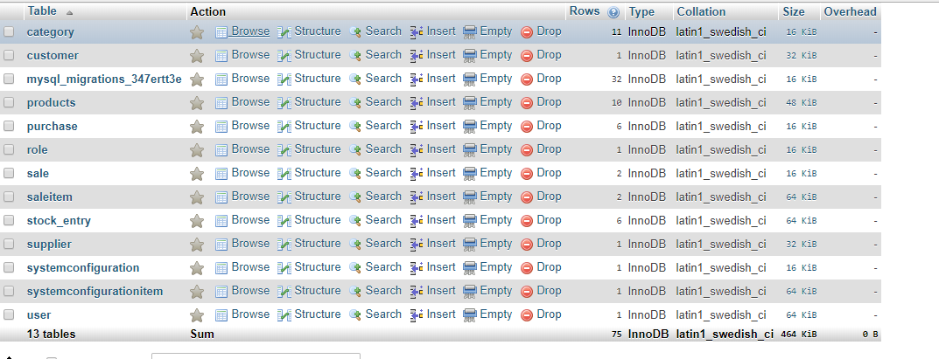

Figure : Database table

Migration is done to create a table in a database. So, mysql_migrations lock is auto created during migration run process. Excluding mysql_migrations table there are all together 12 tables which is used for a proposed system.