**Trigonometry**

**1) Introduction:**

Trigonometry is the branch of mathematics dealing with the relations of the sides and angles of triangles and with the relevant functions of any angles. [ Oxford Language Dictionary]

Trigonometry (from [Greek](https://en.wikipedia.org/wiki/Ancient_Greek) [trigōnon](https://en.wiktionary.org/wiki/%CF%84%CF%81%CE%AF%CE%B3%CF%89%CE%BD%CE%BF%CE%BD" \o "wikt:τρίγωνον), "triangle" and [metron](https://en.wiktionary.org/wiki/%CE%BC%CE%AD%CF%84%CF%81%CE%BF%CE%BD" \o "wikt:μέτρον), "measure") is a branch of [mathematics](https://en.wikipedia.org/wiki/Mathematics) that studies relationships between side lengths and [angles](https://en.wikipedia.org/wiki/Angle) of [triangles](https://en.wikipedia.org/wiki/Triangle). [Wikipedia]

The word trigonometry is derived from Greek word “trigonon” which means triangle and “metron” means measure. i.e. “trigonometry = trigonon + metron” Hence, trigonometry refers to the measurement of triangles. Nowadays trigonometry is used in Engineering, Astronomy, Geology, Survey etc. [Textbook]

**1.1) Introduction of Angles:**

Look at the following picture of house and find the most important connection.



According to picture few workers are constructing a bamboo house/farm. Required materials are:

i) Bamboo

ii) Land

iii) Workers

iv) Instruments

v) Tins

Another most important connection is relation of angles. i.e. without making relation between any two bamboos the construction never complete. Unknowingly, the workers are using many relations between angles vice versa. Other examples we have seen angles or angle plays most importance role are :

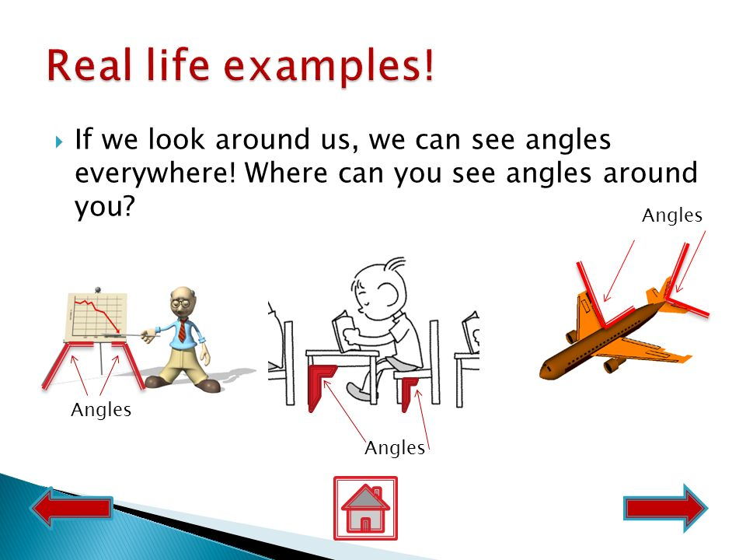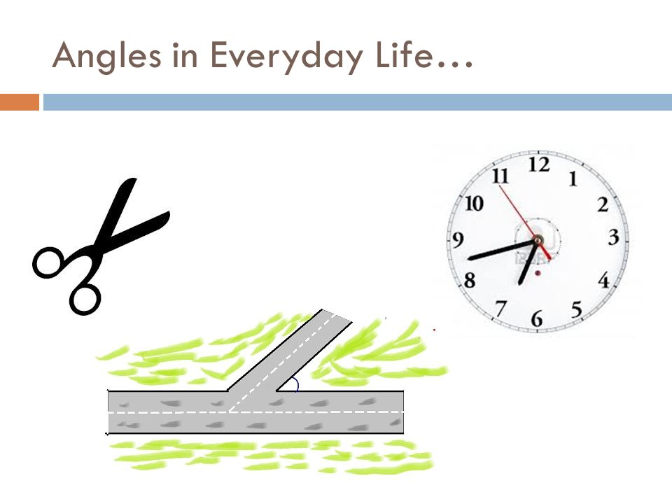



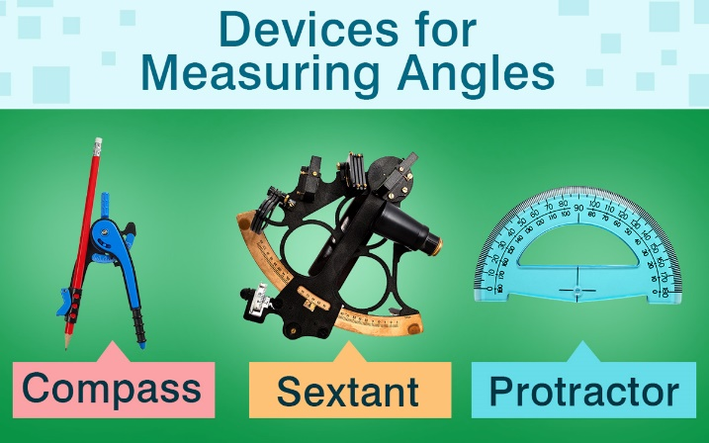There are other instruments to measure angles.

Among them one of the easy instrument is protractor.

Simply, an angle is a figyre formed by two rays(arms) that meets at the common vertex. Angles are measure in degree.

Or, An angle is defined as the amount of turn between two

straight lines that share a common end point.

Or, The rotation of a revolving line about a fixed point with respect to the initial line is known as an angle.

If the rotation of a revolving line = Anticlockwise = +ve angle

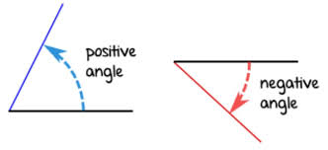 If the rotation of a revolving line = Clockwise = -ve angle

i.e.

**1.2) Measurement of Angles:**

The following systems are used commonly in the measurement of angles. They are;

i) Sexagesimal System (English/Degree system)

ii) Centesimal System (French/Grade System)

iii) Circular System (Radian Measure)

**🖙 Sexagesimal System [Degree measure]:**

Look at the following pictures;

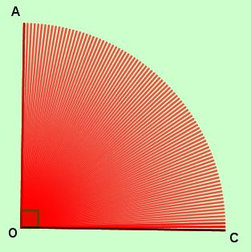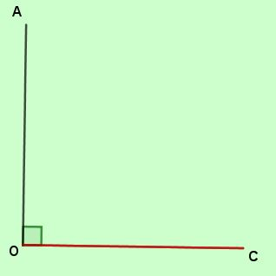

90 red lines are inside the line segment of OA and OC

Divide 900 into 90 equal parts.

The difference between each red line segment is 10.

∠AOC = 900

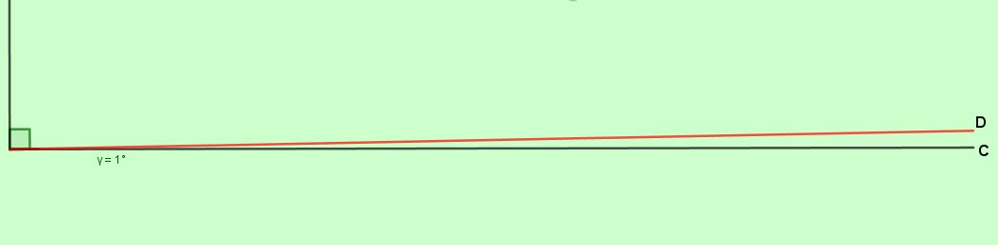

∠COD = 10

D

O

C

Divide 10 into 60 equal parts.

Again, divide 10 into 60 equal part, we get

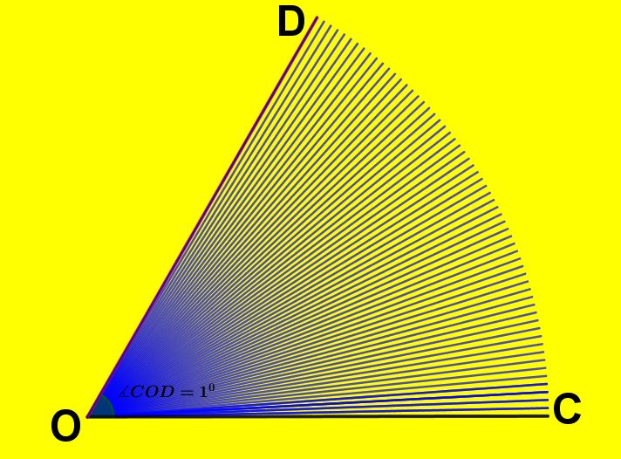

60 blue lines are inside the line segment of OD and OC

The difference between each blue line segment is 1Ꞌ ( 1 minute).

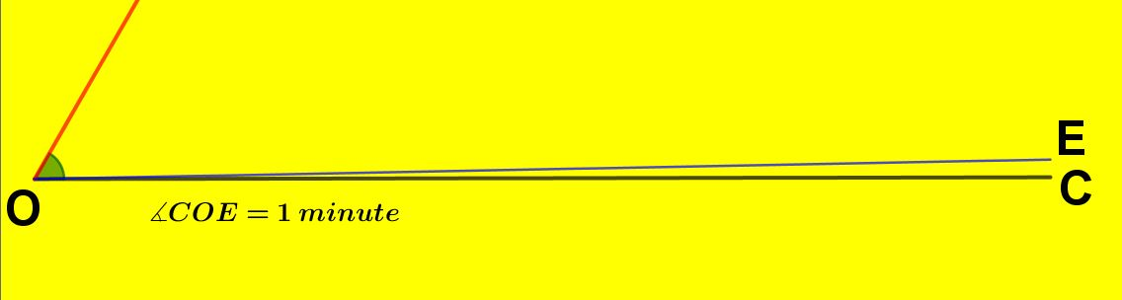

Divide 1Ꞌinto 60 equal parts.

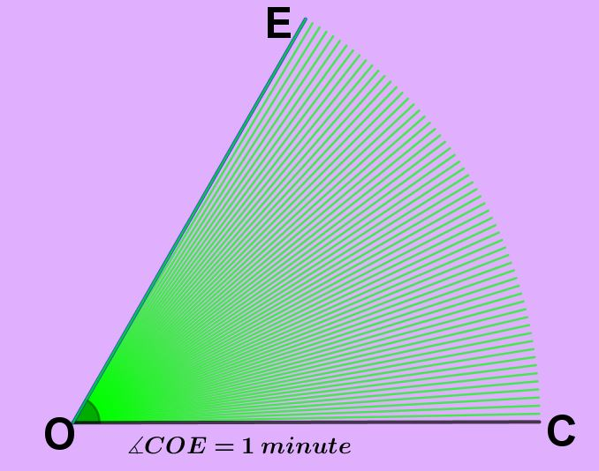

60 green lines are inside the line segment of OE and OC.

The difference between each blue line segment is 1ꞋꞋ ( 1 Second).

Finally, we get the following flowchart

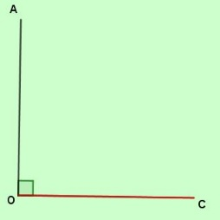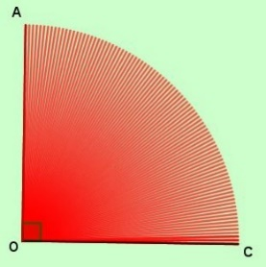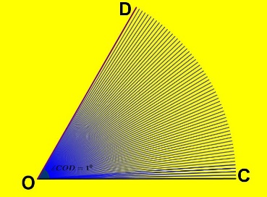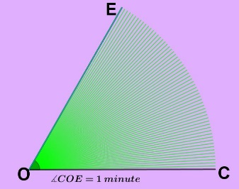

1 right angle

60ꞋꞋ (Seconds)

60Ꞌ (Minutes)

900 (Degree)

Hence, a right angle is dived into 90 equal parts and each part is called degree. A degree divided into 60 equal parts and each part is called minute. A minute is also divided into 60 equal parts and each part is called a second.

1 right angle = 900 (90 degree)

10 (1 degree) = 60Ꞌ (60 minutes)

1Ꞌ (1 minutes) = 60ꞋꞋ (60 seconds)

⇒ 300 20Ꞌ 25ꞋꞋ is read as 30 degrees 30 minutes and 25 seconds.

***Example 1.*** *Reduce 300 20Ꞌ 25ꞋꞋ into sexagesimal second.*

*Solution:*

*Here,*

300 20Ꞌ 25ꞋꞋ = (30×60×60) ꞋꞋ + (20×60) ꞋꞋ + 25 ꞋꞋ

= 108000 ꞋꞋ + 1200 ꞋꞋ  + 25 ꞋꞋ

= 109225*ꞋꞋ*

300 20Ꞌ 25ꞋꞋ = 109225 *ꞋꞋ //*

***Example 2.*** *Reduce 300 20Ꞌ 25ꞋꞋ into degree.*

*Solution:*

*Here,*

300 20Ꞌ 25ꞋꞋ = 300 + + [ ∵ 1Ꞌ =  and 1ꞋꞋ =]

= (30 + 0.333 + 0.00694)0

= 30.339940

*∴* 300 20Ꞌ 25ꞋꞋ = 30.339940 *//*

**🖙 Centesimal System [Grade measure]:**

Look at the following pictures;

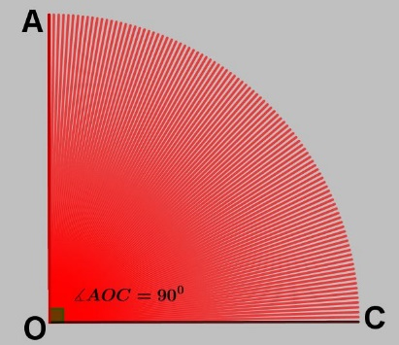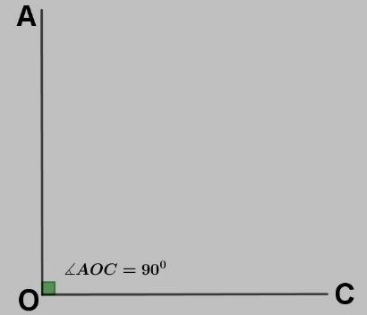

100 red lines are inside the line segment of OA and OC

Divide 900 into 100 equal parts.

The difference between each red line segment is 1g.

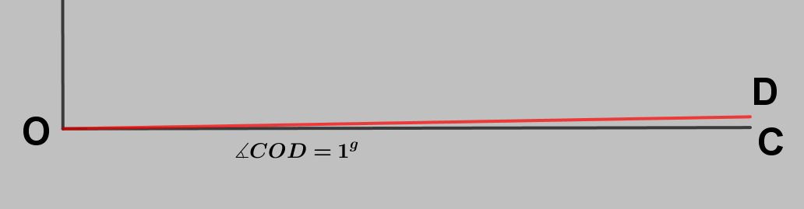

Divide 1g into 100 equal parts.

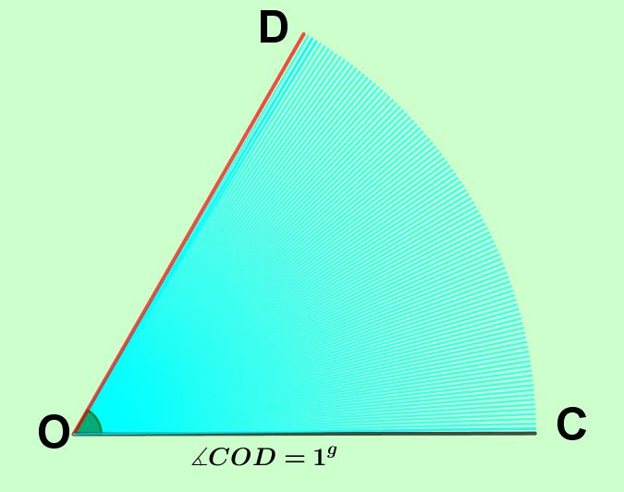

100 sky blue lines are inside the line segment of OD and OC

The difference between each sky blue line segment is 1Ꞌ.

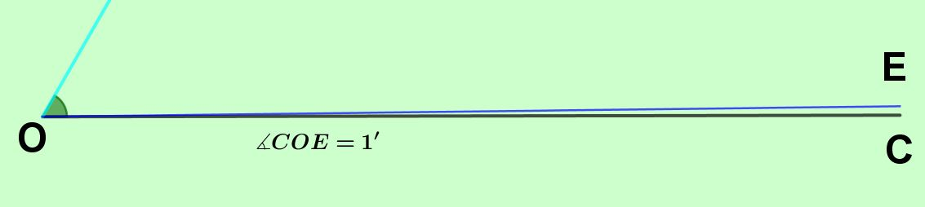

Divide 1Ꞌ into 100 equal parts.

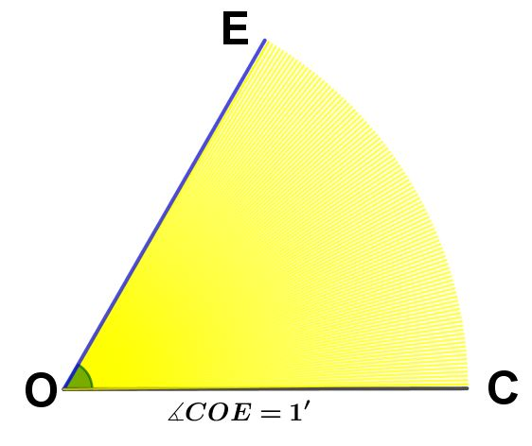

100 yellow lines are inside the line segment of OE and OC

The difference between each yellow line segment is 1ꞋꞋ.

Finally, we get the following flowchart

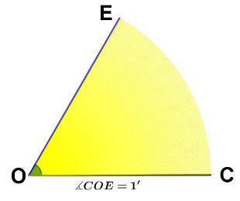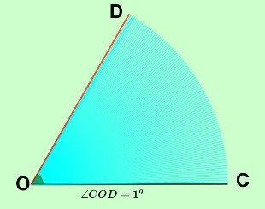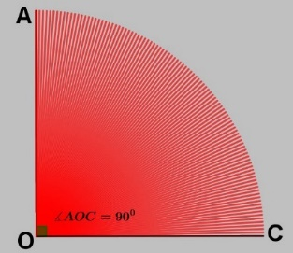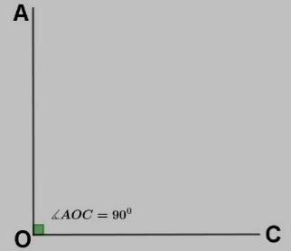Hence, a right angle is dived into 100 equal parts and each part is called grade. A grade divided into 100 equal parts and each part is called minute. A minute is also divided into 100 equal parts and each part is called a second.

100ꞋꞋ (Seconds)

100Ꞌ (Minutes)

1 right angle

100g (Grade)

1 right angle = 100g (100 grade)

1g (1 grade) = 100Ꞌ (100 minutes)

1Ꞌ (1 minutes) = 100ꞋꞋ (100 seconds)

⇒ 30g 20Ꞌ 25ꞋꞋ is read as 30 grades 30 minutes and 25 seconds.

***Example 1.*** *Reduce 30g 20Ꞌ 25ꞋꞋ into centesimal second.*

*Solution:*

*Here,*

30g 20Ꞌ 25ꞋꞋ = (30×100×100) ꞋꞋ + (20×100) ꞋꞋ + 25 ꞋꞋ *[ ∵ 1g = (100×100)Ꞌ and 1Ꞌ=100ꞋꞋ ]*

= 300000 ꞋꞋ + 1200 ꞋꞋ  + 25 ꞋꞋ

= 301225*ꞋꞋ*

30g 20Ꞌ 25ꞋꞋ = 301225 *ꞋꞋ //*

***Example 2.*** *Reduce 30g 20Ꞌ 25ꞋꞋ into grade.*

*Solution:*

*Here,*

30g 20Ꞌ 25ꞋꞋ = 30g + + 

[ ∵ 1Ꞌ =  and 1ꞋꞋ =]

= (30 + 0.2 + 0.0025)g

= 30.2025g

*∴* 30g 20Ꞌ 25ꞋꞋ = 30.2025g *//*

**⇒ Relation Between Degree measure and grade measure:**

   
  
  
  
  
  
  
  
  
  
  
  
  
  
  
  
  
  
  
  
  
  
  
  
  
  
  
  
  
  
  
  
 Therefore, 1 right angle = 900

**900 = 100g**

100g (100 Grade)

900 (90 Degree)

1 right angle = 100g

∴ 900 = 100g

⇒ 10 = 

⇒ 1g = 

***Example 1.*** *Convert 750 into grade..*

*Solution:*

*Here,*

750 = 75 × 10

= 75 ×  [ ∵ 10 =  ]

= 83.333g

∴ 750 = 83.333g //

***Example 2.*** *Convert into degree: 75g .*

*Solution:*

*Here,*

75g = 75 × 1g

= 75 ×  [ ∵ 10 =  ]

= 67.50

∴ 75g = 67.50 //

***Example 3.*** *If D and G the number of degrees and grades of the same angle then prove that .*

Solution:

Here,

10 = 

D0 = 

Now,

D0 = Gg [ D and G the number of degrees and grades of the same angle ]

or = Gg

By using exponential law, we get

or D ×  = G

*  Proved //

**1.3) Circular Measure (Radian Measure):**