***HISTORY OF MICROPROCESSOR:***

In simple word microprocessor is one of the important element which performs instruction and task for the computer to process. In a computer framework, the chip is the central unit that executes information passed to it. Microprocessor is an small chip that helps computer to process in speed and its high processing capacity with its compact size made microprocessor flexible in every system and framework and more special in today's generation.

The period of fourth generation of computer started with invention of microprocessor 1971-1980. The invention of microprocessor made fourth generation computers more strong ,reliable ,compact and powerful. The invention of microprocessor gave higher position to personal computers .

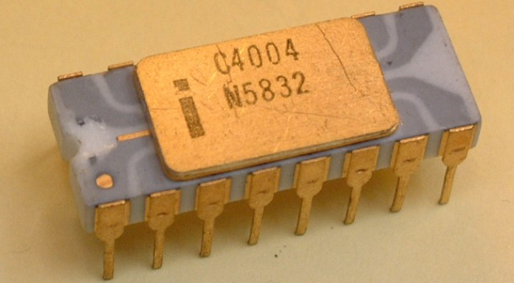

Figure : INTEL 4004

IN 1971 it all started, when microprocessor was invented by Intel and the word "microprocessor " was invented. Lee Boysel in 1969 discovered AL1 the Four-Phase Systems which was an 8 bit chip. But in 1990's it wasn't called "microprocessor" or "chip" until a court case. It was illustrated that AL1 might work as center of a computer.

The era of Personal Computer started with microprocessor which is a little gadget that in any case contained as much power and control as the foremost powerful computer that existed within the world within that time: the ENIAC, that could fill a room by it's huge size. The Intel 4004 was world's first commercially-viable microprocessor it was in rapid growth less than a year afterward by the 8008, which was twice as capable and powerful.

**EVOLUTION OF MICROPROCESSOR WITH BITS AND GENERATION:**

**4-Bit Microprocessors(First Generation ):** The 4 bit microprocessor which is also known as first generation of microprocessor were introduced by Ted Hoff and Stanley Mazor in the year 1971. It had 2300 transistors and clock speed of 740 kilohertz. As it was an 4 bit microprocessor it was named as Intel 4004. The first generation microprocessor instruction were processed serially as they fetched instruction first, decode it and execute finally.

**8-Bit Microprocessors(Second Generation):** The second generation microprocessor intel 8008 were introduced in the year 1972 by intel with clock speed of 500 kilohertz and 3500 number of transistors. And again in year 1974 intel 8080 were introduced with clock speed of 2 Megahertz and 6000 number of transistors and its instruction per second was 10 times faster than 8008.

**16-Bit Microprocessors(Third Generation):** The 16 bit microprocessor also known as third generation microprocessor Intel 8086 were invented in the year 1978 could do multiply and divide instruction. The third generation of microprocessor had 29000 number of transistors and its instruction per second was 2.5 billion. The 16 bits microprocessor were distinctive from the past eras of microprocessor.

**32-Bit Microprocessors(Fourth Generation):** The 32 bit microprocessor Intel 80386 was firstly introduced in the year 1986 with speed of 16 to 33 megahertz and it contained 275000 transistors and later in the year 1986 Intel 80486 was lunched with speed of 16 to 100 megahertz with 1.2 million transistors with instruction per second of 8 KB of cache memory. In the year 1993 Pentium was lunchedwith the speed of 66 Megahertz and instruction per second was 8bit for data and 8bit for instruction of cache memory.

**64-Bit Microprocessors(Fifth Generation):** The fifth generation microprocessor Intel core2 with 64 bit microprocessor was introduced in the year 2006 with clock speed of 1.2 gigahertz with 291 Million transistors and instruction per second was 64 kb of L1 cache per core and 2MB if L2 cache. And later in the year 2007,2009,2010 the i3 with clock speed of 2.2GHz – 3.3GHz,i5 with clock speed of 2.4GHz – 3.6GHz and i7 with clock speed of 2.93GHz – 3.33GHz were lunched.

***Fetch And Execute Instruction Of Microprocessor:***

The instruction cycle of CPU says that firstly microprocessor fetch and decode the instruction after that it reads address from memory and then execute the instruction. In the lecture we analysed the fetch and execute instruction using jasp . Firstly the program counter is sent to Memory Address Register (MAR) after the memory returns the information put away at the memory area shown by the program counter (PC) on the information transport. When the program counter is changed to 0001 from 0000 the data is sent to Memory and Memory Data Register(MDR). Now MDR is transferred to Instruction register and to Control Unit. After fetching the instruction is decoded which is done by control unit. It permits the CPU to decide what instruction is to be done and performed.While executing ALU is utilized if instruction includes math or rationale. It is valuable in the point of view of the end users.

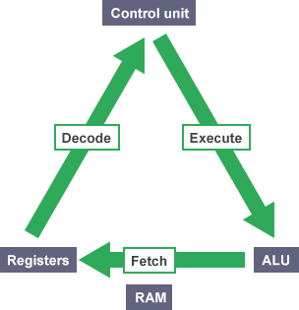

FIGURE:Fetch And Execute Cycle.

Fetching and decoding: As I have described in short how Microprocessor fetch. Having a look on fetching and decoding firstly program is fetched to main memory. The main register is program counter. The program counter is always ready for new instruction in main memory. The programcounter is beigng transferred to MAR because MAR act as guard to memory. The PC is transferred to MAR. Now it reads memory to MDR. Then after the instruction is read and copied by MDR and is sent to instruction register (IR). The IR is divided into two parts according to standard architecture they are opcode and address. As instruction fetch is concered with opcode that is vital because opcode is decoded by control unit. Lastly The program counter is incremented as the next instruction within the program is located within the another memory area.

Executing an instruction: The opcode is decoded by control unit in the time of instruction fetch. The contuol unit present which instruction to execute and can in this manner arrangement of Level and Beats us ways and impact the required the enlist transfers.

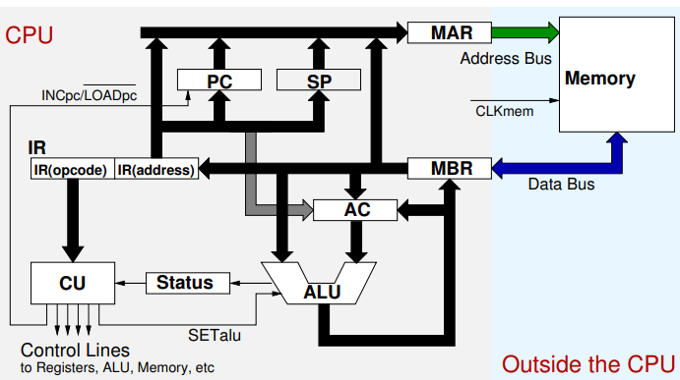

*Working principle of Pipelining and speedup factor due to pipelining:*

The pipelining is an technique through which execution of many instruction are overlapped. The overall instruction increases through pipeline. This pipeline strategy parts up the consecutive handle of an instruction cycle into sub-processes that works concurrently in partitioned sections. Without pipeline every instruction has to wait for their turn to get processed as first previous should be finished. So pipeline gives permission to get executed at similar time for many instructions. We know that processor can execute undefined instruction per second. The pipelining process makes computer program run quick and better.

Each of the section consist of input register which is chased by combinational circuit in a pipelining. As combinational circuit performs operations whereas register holds data.

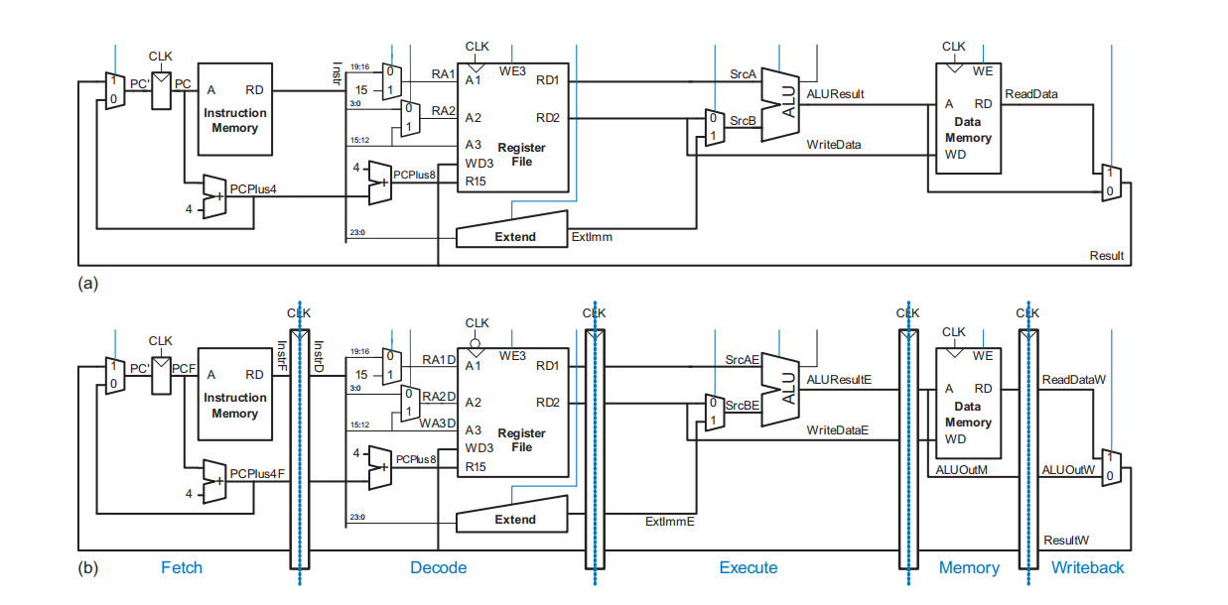

Figure (A):ARM architecture

Figure(B):Pipeline architecture

In pipelining processor the execution of program is divided into five parts:

1. Instruction Fetch Cycle (IF): IF is the first step where instruction is need to be fetched is brought from memory address to Instruction Register.
2. Instruction decode fetch cycle (ID): In this process fetch instruction is decoded instruction is sent to register which is temporary. The decoding of registers and reading of registers is done parallelly.
3. Instruction execution cycle(EX): This is third step where the output is shown in the register file. The result is shown in temporary ALU.
4. Memory access completion cycle(MEM): In this cycle the operand address is measured during the cycle which is used to access the memory. The data is returned from memory and is placed to Load Memory Data register if there is load and store instruction.
5. Register write back cycle (WB): This is the final stage of five segment pipeline processor. In this step the result is shown in ALU written by single cycle and double cycle instruction.

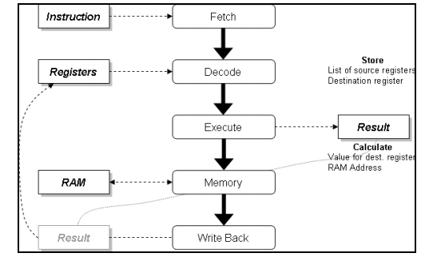Figure: Five Segment Pipelined Proce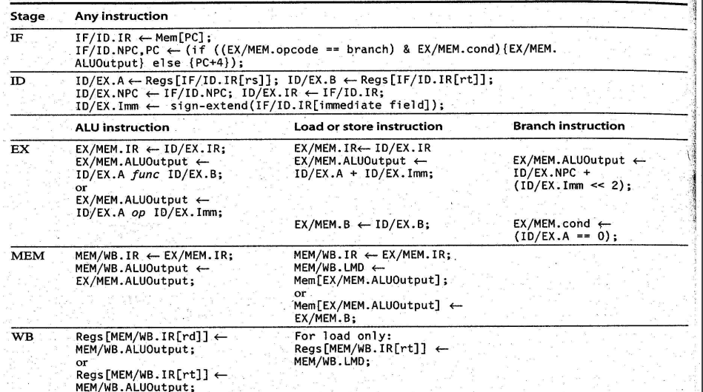ssor.

Figure: Event on every pipe stage of MIPS pipeline.

 Lets take a example of sequential laundry vs pipelined laundry from the picture below:

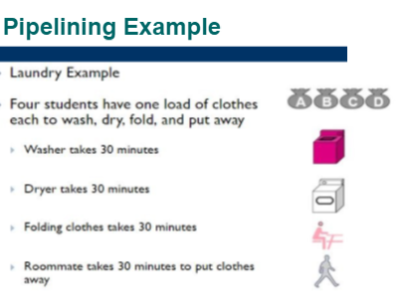

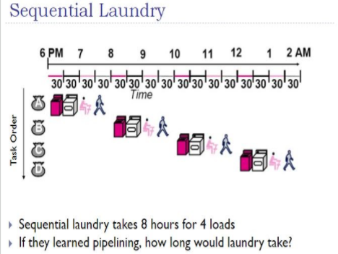

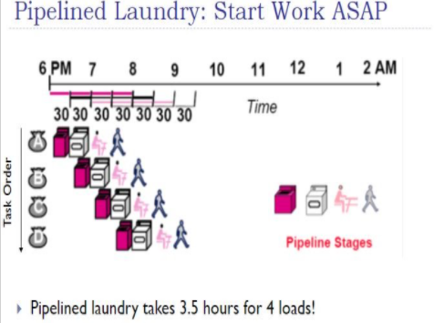

We can see that from the above figure that pipelinig only took 3.5 hours for 4 loads where as sequential laundry would take 8 hours for 4 loads. In simple it says that how pipelining work as an speed up factor in different tasks.

The formula for speed up factor is,

S=Ts/Tp=(nk)/(k=n-1)

Where,

s=speedup factor,

n= Instruction using a clock,

t= cycle time,

Ts=Total time to execute instruction ,

K=stage of pipeline,

Ts=nkt, Kt=time to fill point,

n-1 = time taken to complete remaining instruction per clock cycle,

Tp=kt+(n-1)t

Now let us solve the equation below:

If there are 5 stages and 5 instruction and time cycle is 1second and instruction in sequence is 50 what is value of speed of factor?

Solution,

Speedup factor(s)=?

Instruction in sequence (n)=50,

Stage of pipeline(k)=5,

Where,

Ts=nk, Ts=50*5, Ts=250,

Tp=k+n-1 , Tp=5+50-1, Tp=54,

Now, S=Ts/Tp, S=250/54,

S=4.62.

Hence the speed up factor is 4.62 .

The speed up factor in pipelining comes with the conclusion that pipelining is the ratio of Time to execute N instructions in a non-pipelined design byTime to execute N instructions in a pipelined design. S=Ts/Tp=(nk)/(k=n-1) . The speed up factor determine the the time for a pipelined plan is:

1) The primary instruction takes k*tk time just to urge through the total logic.

2) All informational after that take tk time since they are one arrange behind within the pipeline.