PrimeTrade.AI Assignment - TaskFlow
Complete Project Documentation
Name: Sakshi Salunke
Email: sakshisalunke256@gmail.com
GitHub Repository - Primetrade.ai-Assignment
Postman Workspace – API Testing Collection

Table of Contents
1. | Project Overview
2. | System Architecture
3. | Database Design
4. | Frontend Implementation
5. | Backend Implementation
6. | API Design
7. | Scalability Considerations
8. | Conclusion

1. Project Overview
1.1 Introduction
This project is a full-stack web application featuring user authentication, a dynamic dashboard, and complete CRUD (Create, Read, Update, Delete) operations for task management. Built with modern web technologies, it demonstrates scalable architecture, security best practices, and responsive design principles.
1.2 Technology Stack
Frontend
- Framework: ReactJS
- Build Tool: Vite
- Styling: TailwindCSS
- Routing: React Router
- HTTP Client: Axios
- Icons: Lucide React
- State Management: Context API
Backend
- Runtime: Node.js
- Framework: Express.js
- Database: MongoDB (Atlas)
- ODM: Mongoose
- Authentication: JWT (jsonwebtoken)
- Password Hashing: bcryptjs
- Validation: express-validator
- CORS: cors middleware
1.3 Key Features
Authentication & Authorization
- User registration with validation
- Secure login with JWT tokens
- Protected routes and API endpoints
- Automatic token expiration handling
- Session management
Dashboard
- Real-time task statistics
- Recent tasks preview
- Responsive layout with sidebar navigation
- User profile quick access
Task Management
- Create tasks with title, description, priority, and due dates
- Update task status and details
- Delete tasks with confirmation
- Search functionality across tasks
- Filter by status (pending, in-progress, completed)
- Filter by priority (low, medium, high)
User Profile
- View personal information
- Update profile details (name, bio)
- Account statistics
- Member since information

2. System Architecture
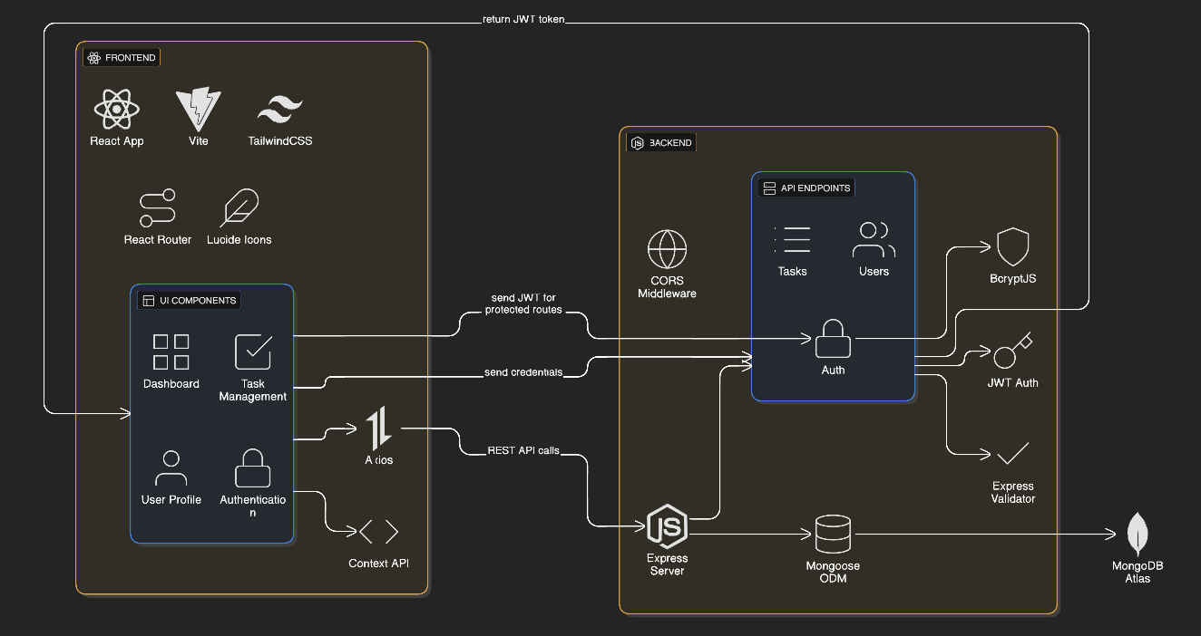
Fig.1. System Architecture

3. Database Design
3.1 Database Schema
3.1.1 Users Collection
{
_id: ObjectId,
name: String (required, max 50 chars),
email: String (required, unique, validated),
password: String (required, hashed, min 6 chars),
bio: String (optional, max 500 chars),
avatar: String (URL, default: UI Avatars),
createdAt: Date (auto-generated),
__v: Number (version key)
}
Indexes:
- Primary: _id (automatic)
- Unique: email (for quick lookups and uniqueness)
Sample Document:
{
"_id": "6581234567890abcdef12345",
"name": "Tester",
"email": "tester@example.com",
"password": "$2a$10$hashed_password_here",
"bio": "Full-stack developer",
"avatar": "https://ui-avatars.com/api/?name=Tester",
"createdAt": "2024-01-15T10:30:00.000Z",
"__v": 0
}

3.1.2 Tasks Collection
{
_id: ObjectId,
user: ObjectId (ref: User, required),
title: String (required, max 100 chars),
description: String (optional, max 1000 chars),
status: String (enum: pending/in-progress/completed),
priority: String (enum: low/medium/high),
dueDate: Date (optional),
tags: Array of Strings (optional),
createdAt: Date (auto-generated),
updatedAt: Date (auto-updated),
__v: Number (version key)
}
Indexes:
- Primary: _id (automatic)
- Foreign Key: user (references Users collection)
- Compound: user + createdAt (for efficient user task queries)
Sample Document:
{
"_id": "6581234567890abcdef67890",
"user": "6581234567890abcdef12345",
"title": "Complete project documentation",
"description": "Write comprehensive docs for the assignment",
"status": "in-progress",
"priority": "high",
"dueDate": "2024-12-31T23:59:59.999Z",
"tags": ["documentation", "assignment"],
"createdAt": "2024-12-28T10:00:00.000Z",
"updatedAt": "2024-12-29T15:30:00.000Z",
"__v": 0
}
3.2 Entity Relationship Diagram
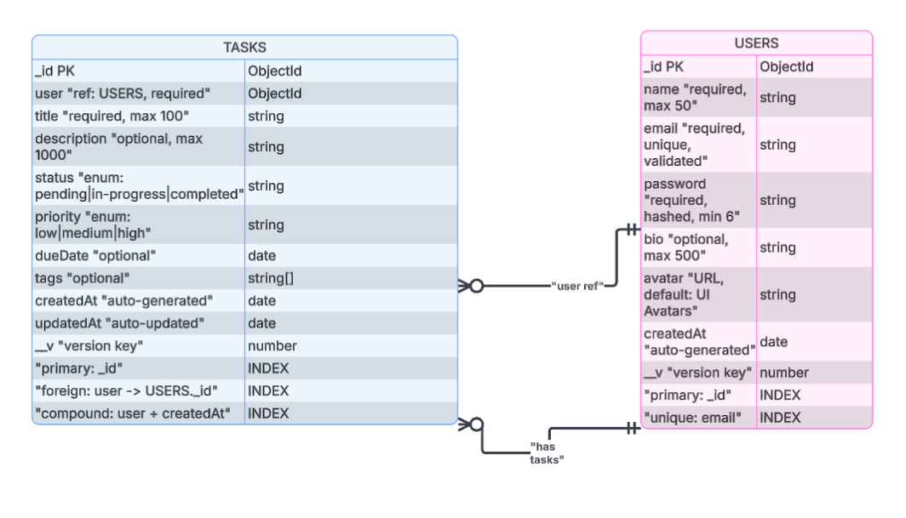
Fig.2. Database Entity Relationship Diagram
3.3 Database Relationships
One-to-Many Relationship
- One User can have Many Tasks
- Implemented via user field in Tasks collection
- Foreign key reference: Tasks.user → Users._id

4. Frontend Implementation
4.1 Technology Stack Details
- React: Latest version with hooks and concurrent features
- Vite: Fast build tool and dev server
- TailwindCSS: Utility-first CSS framework
- React Router: Client-side routing
- Axios: HTTP client with interceptors
4.2 Project Structure
frontend/
├── public/ # Static assets
├── src/
│ ├── components/ # Reusable components
│ │ ├── DashboardLayout.jsx
│ │ └── ProtectedRoute.jsx
│ ├── config/ # Configuration files
│ │ └── api.js # Axios instance
│ ├── context/ # React Context providers
│ │ └── AuthContext.jsx # Authentication state
│ ├── pages/ # Page components
│ │ ├── Login.jsx
│ │ ├── Signup.jsx
│ │ ├── Dashboard.jsx
│ │ ├── Tasks.jsx
│ │ └── Profile.jsx
│ ├── App.jsx # Main app component
│ ├── main.jsx # Entry point
│ └── index.css # Global styles
├── .env # Environment variables
├── vite.config.js # Vite configuration
└── package.json # Dependencies
4.3 Component Architecture
Reusable Components
1. DashboardLayout
- Purpose: Consistent layout for all dashboard pages
- Features:
  - Responsive sidebar navigation
  - Mobile menu toggle
  - User profile display
  - Logout functionality
  - Active route highlighting
2. ProtectedRoute
- Purpose: Guard routes requiring authentication
- Features:
  - Check auth status
  - Loading state handling
  - Automatic redirection
Page Components
1. Login Page
- Form validation (client-side)
- Error message display
- Loading state during submission
- Link to signup page
- Responsive design
2. Signup Page
- Multi-field validation
- Password confirmation
- Character length validation
- Email format validation
- Success/error feedback
3. Dashboard Home
- Statistics cards (total, pending, in-progress, completed)
- Recent tasks preview
- Quick navigation to tasks
- Responsive grid layout
4. Tasks Page
- Create task modal
- Task list with cards
- Search functionality
- Filter dropdowns (status, priority)
- Edit/delete actions
- Responsive grid
5. Profile Page
- View mode and edit mode
- Form for updating profile
- Account statistics
- Save/cancel actions

5. Backend Implementation
5.1 Technology Stack Details
- Node.js: JavaScript runtime
- Express.js: Web application framework
- MongoDB: NoSQL database
- Mongoose: MongoDB ODM
- JWT: Token-based authentication
- bcryptjs: Password hashing
5.2 Project Structure
backend/
├── config/
│ └── db.js # MongoDB connection
├── middleware/
│ └── auth.js # JWT verification
├── models/
│ ├── User.js # User schema
│ └── Task.js # Task schema
├── routes/
│ ├── auth.js # Auth endpoints
│ ├── tasks.js # Task CRUD
│ └── profile.js # Profile endpoints
├── .env # Environment variables
├── .gitignore # Git ignore rules
├── package.json # Dependencies
└── server.js # Entry point
5.3 Environment Variables
- PORT=5000 // Server port
- NODE_ENV=development // Environment
- MONGO_URI=mongodb+srv:// // Database connection
- JWT_SECRET=secret_key // JWT signing key
- JWT_EXPIRE=7d // Token expiration
- CLIENT_URL=http:// // Frontend URL (CORS)

6. API Design
6.1 API Endpoints Documentation
Base URL
Development: http://localhost:5000/api
Production: http://domain_name.com/api
6.2 Authentication Endpoints
1. Register User
POST /api/auth/signup
Content-Type: application/json
Request Body:
{
"name": "Tester",
"email": "Tester@example.com",
"password": "password123"
}
Success Response (201 Created):
{
"success": true,
"message": "User registered successfully",
"token": "eyJhbGciOiJIUzI1NiIsInR5cCI6IkpXVCJ9...",
"user": {
"id": "65abc123...",
"name": "Tester",
"email": "Tester@example.com",
"bio": "",
"avatar": "https://ui-avatars.com/api/?name=Tester+Doe",
"createdAt": "2024-12-29T10:00:00.000Z"
}
}
Error Response (400 Bad Request):
{
"success": false,
"message": "User already exists with this email"
}
2. Login User
POST /api/auth/login
Content-Type: application/json
Request Body:
{
"email": "Tester@example.com",
"password": "password123"
}
Success Response (200 OK):
{
"success": true,
"message": "Login successful",
"token": "eyJhbGciOiJIUzI1NiIsInR5cCI6IkpXVCJ9...",
"user": {
"id": "65abc123...",
"name": "Tester",
"email": "Tester@example.com",
"bio": "Full-stack developer",
"avatar": "https://ui-avatars.com/api/?name=Tester+Doe",
"createdAt": "2024-12-29T10:00:00.000Z"
}
}
Error Response (401 Unauthorized):
{
"success": false,
"message": "Invalid credentials"
}
3. Get Current User
GET /api/auth/me
Authorization: Bearer {token}
Success Response (200 OK):
{
"success": true,
"user": {
"id": "65abc123...",
"name": "Tester",
"email": "Tester@example.com",
"bio": "Full-stack developer",
"avatar": "https://ui-avatars.com/api/?name=Tester+Doe",
"createdAt": "2024-12-29T10:00:00.000Z"
}
}
6.3 Task Endpoints
1. Get All Tasks
GET /api/tasks
Authorization: Bearer {token}
Query Parameters (optional):
- search: string (search in title/description)
- status: pending|in-progress|completed
- priority: low|medium|high
- sort: newest|oldest|priority|dueDate

Example: GET /api/tasks?status=in-progress&priority=high&sort=newest
Success Response (200 OK):
{
"success": true,
"count": 2,
"tasks": [
{
"_id": "65abc456...",
"user": "65abc123...",
"title": "Complete documentation",
"description": "Write comprehensive API docs",
"status": "in-progress",
"priority": "high",
"dueDate": "2024-12-31T23:59:59.999Z",
"tags": ["documentation"],
"createdAt": "2024-12-28T10:00:00.000Z",
"updatedAt": "2024-12-29T15:30:00.000Z"
}
]
}
2. Get Single Task
GET /api/tasks/:id
Authorization: Bearer {token}
Success Response (200 OK):
{
"success": true,
"task": {
"_id": "65abc456...",
"user": "65abc123...",
"title": "Updated title",
"description": "Updated description",
"status": "completed",
"priority": "medium",
"dueDate": "2024-12-31T00:00:00.000Z",
"tags": ["documentation"],
"createdAt": "2024-12-28T10:00:00.000Z",
"updatedAt": "2024-12-29T16:00:00.000Z"
}
}
3. Delete Task
DELETE /api/tasks/:id
Authorization: Bearer {token}
Success Response (200 OK):
{
"success": true,
"message": "Task deleted successfully"
}
Error Response (401 Unauthorized):
{
"success": false,
"message": "Not authorized to delete this task"
}
4. Get Task Statistics
GET /api/tasks/stats/overview
Authorization: Bearer {token}
Success Response (200 OK):
{
"success": true,
"stats": {
"total": 25,
"pending": 8,
"inProgress": 10,
"completed": 7,
"highPriority": 5
}
}
6.4 Profile Endpoints
1. Get Profile
GET /api/profile
Authorization: Bearer {token}
Success Response (200 OK):
{
"success": true,
"user": {
"id": "65abc123...",
"name": "Tester",
"email": "Tester@example.com",
"bio": "Full-stack developer",
"avatar": "https://ui-avatars.com/api/?name=Tester+Doe",
"createdAt": "2024-12-29T10:00:00.000Z"
}
}
2. Update Profile
PUT /api/profile
Authorization: Bearer {token}
Content-Type: application/json
Request Body (all fields optional):
{
"name": "Tester Updated",
"bio": "Senior full-stack developer",
"avatar": "https://example.com/avatar.jpg"
}
Success Response (200 OK):
{
"success": true,
"message": "Profile updated successfully",
"user": {
"id": "65abc123...",
"name": "Tester Updated",
"email": "Tester@example.com",
"bio": "Senior full-stack developer",
"avatar": "https://example.com/avatar.jpg",
"createdAt": "2024-12-29T10:00:00.000Z"
}
}
6.5 Error Responses
Standard Error Format
{
"success": false,
"message": "Error description",
"errors": [] // Optional detailed errors
}
6.6 HTTP Status Codes Used
- 200 OK: Successful GET, PUT, DELETE
- 201 Created: Successful POST (creation)
- 400 Bad Request: Validation errors
- 401 Unauthorized: Authentication failed
- 403 Forbidden: Authorization failed
- 404 Not Found: Resource not found
- 500 Internal Server Error: Server error
6.7 Authentication Flow
Token-Based Authentication
1. User sends credentials to /api/auth/login
2. Server validates credentials
3. Server generates JWT token
4. Client stores token (localStorage)
5. Client includes token in Authorization header
6. Server verifies token for protected routes
7. Server processes request if valid
8. Server returns 401 if invalid/expired

7. Scalability Considerations
The application is designed with scalability as a core principle, utilizing a stateless JWT-based authentication system that enables seamless horizontal scaling across multiple server instances. The modular architecture separates concerns between frontend components and backend services, allowing independent scaling of different system parts. MongoDB indexing on frequently queried fields (email, user, status, priority) ensures optimal database performance. The system is prepared for future enhancements including Redis caching for frequently accessed data, load balancing with Nginx, database replication for read-heavy operations, and eventual migration to a microservices architecture. Connection pooling, async operations, and efficient query patterns ensure the current infrastructure can handle substantial growth before requiring architectural changes.
Future Scaling Path
As user base grows, the application follows a three-phase scaling strategy. Phase one focuses on optimization through Redis implementation, enhanced database indexing, response compression, and rate limiting. Phase two introduces horizontal scaling with multiple server instances behind a load balancer, database replication, CDN integration, and message queues for asynchronous tasks. Phase three transitions to a microservices architecture, separating authentication, task management, and user services into independent deployments with an API gateway managing traffic. This progressive approach ensures cost-effective scaling while maintaining system reliability and performance at each growth stage.

8. Conclusion
This project demonstrates a comprehensive understanding of modern full-stack web development, from database design to user interface implementation. The application is built with scalability, security, and user experience in mind, making it suitable for real-world deployment.
The modular architecture ensures that the application can grow and evolve as requirements change, while the documentation provides a clear roadmap for future developers working on the project.

