**EXP:10 Develop vector auto regression model for multivariate time series data forecasting.**

**Aim:** To Develop vector auto regression model for multivariate time series data forecasting using autism screening dataset

**Procedure:**

**1.Import the necessary libraries:**

import pandas as pd

import numpy as np

import matplotlib.pyplot as plt

from statsmodels.tsa.api import VAR

from statsmodels.tsa.stattools import adfuller

**2. Load the dataset**

df = pd.read_csv("autism_screening.csv")

**3. Visualize the data**

monthly_positive.plot(title="Monthly Positive Autism Screenings")

plt.xlabel("Month")

plt.ylabel("Number of Positive Screenings")

plt.show()

**4. Check for stationarity (ADF test)**

from statsmodels.tsa.stattools import adfuller

result = adfuller(monthly_positive.dropna())

print(f"ADF Statistic: {result[0]}")

print(f"p-value: {result[1]}")

**5. Train-Test Split (80% training, 20% test)**

train_size = int(len(df_subset_diff) * 0.8)

train, test = df_subset_diff[:train_size], df_subset_diff[train_size:]

**6. Fit the VAR Model**

model = VAR(train)

model_fitted = model.fit(maxlags=15, ic='aic') # Use AIC to select the optimal lag length

print(model_fitted.summary())

**7. Visualize the Actual vs Forecasted values**

plt.figure(figsize=(12, 6))

plt.plot(df_subset.index, df_subset['A1_Score'], label="Actual A1_Score")

plt.plot(df_subset.index, df_subset['A2_Score'], label="Actual A2_Score")

plt.plot(forecast_df.index, forecast_df['A1_Score'], label="Forecasted A1_Score", linestyle='--')

plt.plot(forecast_df.index, forecast_df['A2_Score'], label="Forecasted A2_Score", linestyle='--')

plt.title("Actual vs Forecasted Scores for A1_Score and A2_Score")

plt.xlabel("Date")

plt.ylabel("Scores")

plt.legend()

plt.show()

**OUTPUT:**

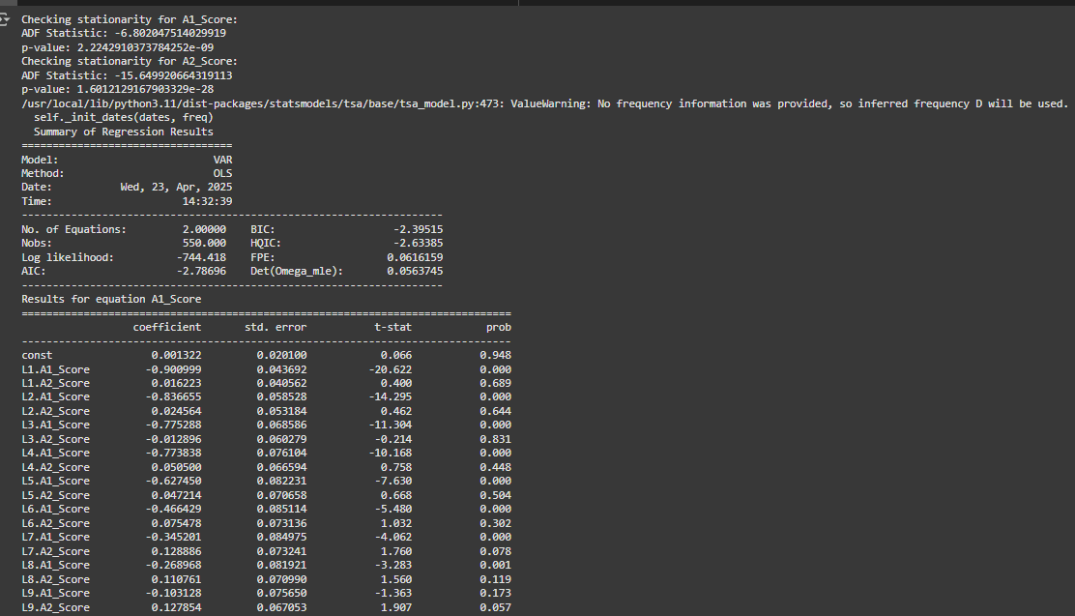

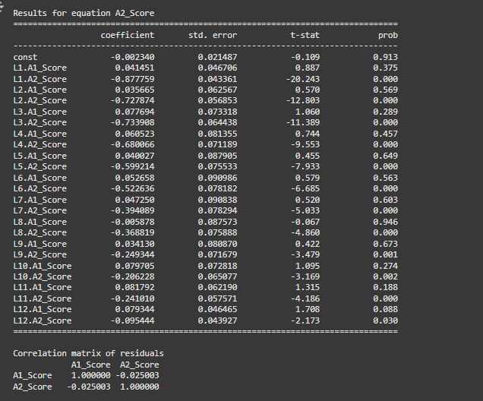

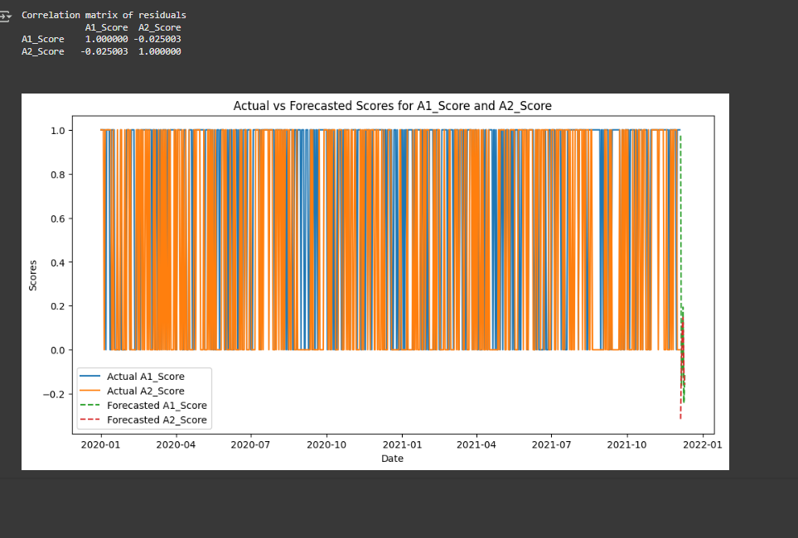

**Result:** This program t To Develop vector auto regression model for multivariate time series data forecasting using autism screening dataset was implemented and executed successfully

