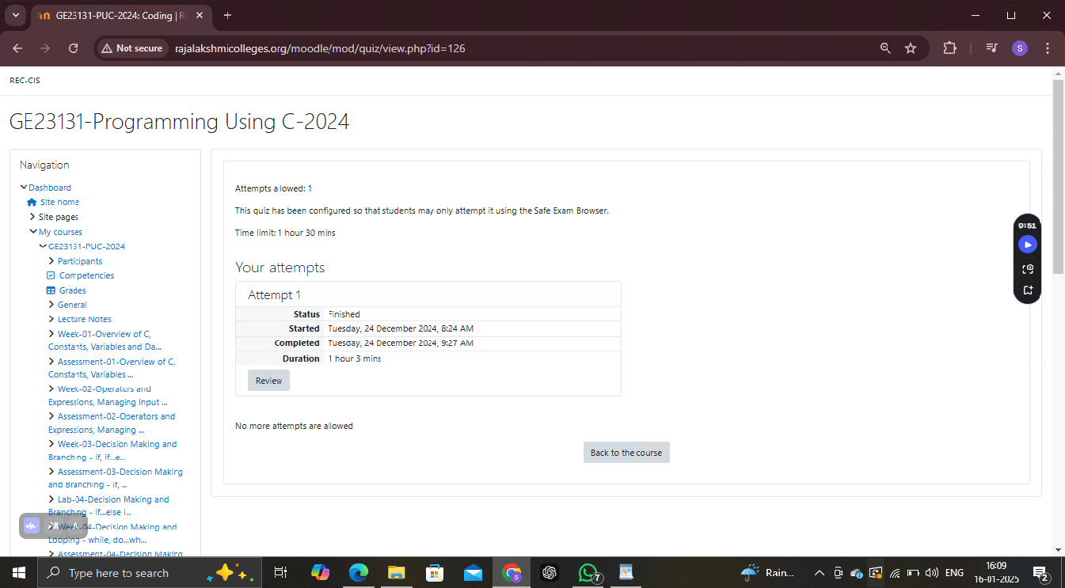

1.

Write a C program to count total number of digits of an Integer number (N).

Sample Test Cases

Test Case 1

Input

3456

Output

The number 3456 contains 4 digits.

Test Case 2

Input

30000

Output

The number 30000 contains 5 digits.

Test Case 3

Input

57

Output

The number 57 contains 2 digits.

Test Case 4

Input

909

Output

The number 909 contains 3 digits.

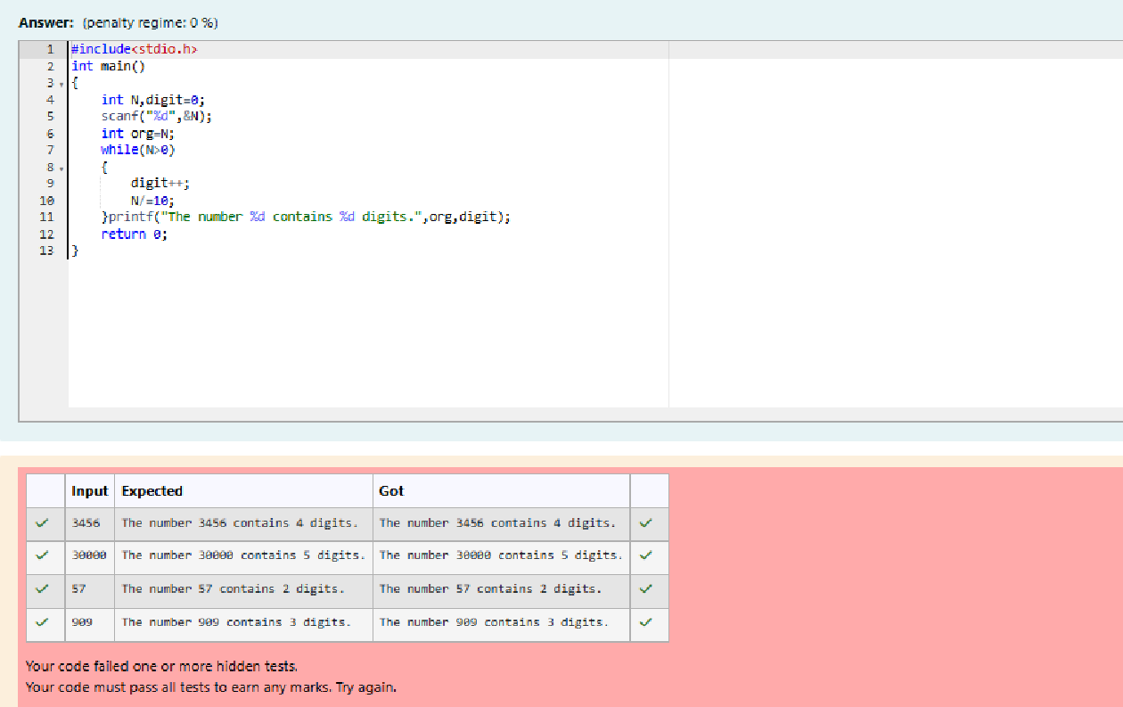

2.

Write a C program to check whether the given number(N) can be expressed as Power of Two (2) or not.

For example, 8 can be expressed as 2^3.

Sample Test Cases

Test Case 1

Input

8

Output

8 is a number that can be expressed as power of 2.

Test Case 2

Input

46

Output

46 cannot be expressed as power of 2.

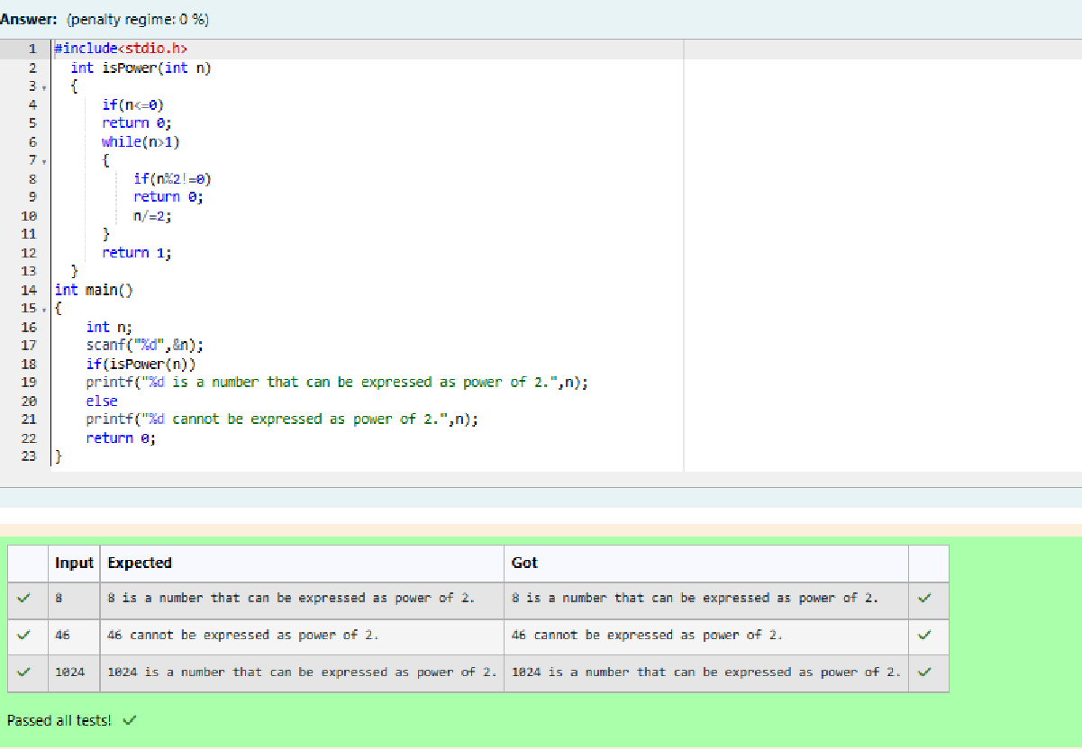

3.

Write a program in C to find the sum of the series 1 +11 + 111 + 1111 + . . . + n terms (n will be given as input from the user and sum will be the output)

Sample Test Cases

Test Case 1

Input

4

Output

1234

Test Case 2

Input

6

Output

123456

