BGM220P Blinky LED Implementation Report
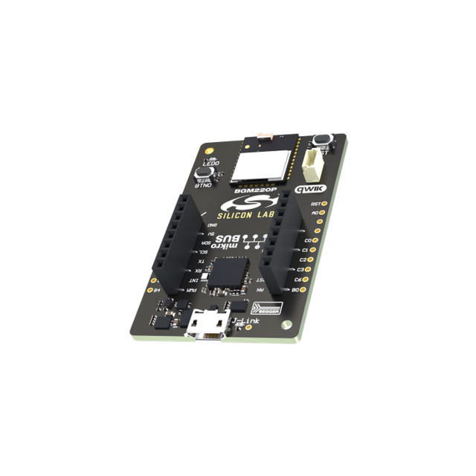

Executive Summary
This report outlines the implementation of a blinky LED project on the BGM220P Bluetooth module using Silicon Labs' Simplicity Studio development environment. The BGM220P is based on the EFR32BG22 SoC and provides an excellent platform for learning embedded development and Bluetooth Low Energy (BLE) applications.

Hardware Overview

BGM220P Module Specifications
- Core: ARM Cortex-M33 processor
- Bluetooth: 5.2 compliant with backward compatibility
- Power Consumption: Ultra-low power (3.6 mA TX at 0 dBm, 2.6 mA RX)
- Sleep Current: 1.2 µA
- Active Current: 27 µA/MHz
- Memory: Flash and RAM integrated
- Package: PCB module format for easy integration

Development Kit
- Kit: BGM220 Explorer Kit (BGM220-EK4314A)
- Onboard Components: LEDs, buttons, sensors
- Programming Interface: USB-based J-Link debugger
- Form Factor: Compact development board

Software Environment

Simplicity Studio 5.x IDE
- Platform: Cross-platform development environment
- SDK: Gecko Platform SDK with Bluetooth SDK
- Tools: Hardware configurator, energy profiler, project generator
- Debugging: Integrated J-Link debugger support

Required Components
- Simplicity Studio 5.x
- Gecko Platform SDK
- Bluetooth SDK (if BLE functionality needed)
- BGM220P device support package

Project Implementation

1. Project Setup
- Launch Simplicity Studio 5
- Create New Project:
  - Select "New Project" from File menu
  - Choose "Silicon Labs MCU Project"
  - Select BGM220P as target device
  - Choose "Empty C Project" template or "Blinky" example
- Hardware Configuration:
  - Open Hardware Configurator
  - Configure GPIO pins for LED control
  - Set up timer for blink timing
  - Generate source code

2. Hardware Configuration Details
GPIO Configuration
// LED GPIO Configuration
#define LED_PORT gpioPortA
#define LED_PIN 4
#define LED_ON 1
#define LED_OFF 0
Timer Configuration
- Timer: Use TIMER0 for blink timing
- Frequency: 1 Hz (1 second on, 1 second off)
- Mode: Periodic interrupt mode

3. Code Implementation
Main Application Structure
#include "em_device.h"
#include "em_chip.h"
#include "em_gpio.h"
#include "em_timer.h"
#include "em_cmu.h"

// Timer interrupt handler
void TIMER0_IRQHandler(void) {
// Clear interrupt flag
TIMER_IntClear(TIMER0, TIMER_IF_OF);

// Toggle LED
GPIO_PinOutToggle(LED_PORT, LED_PIN);
}

int main(void) {
// Initialize chip
CHIP_Init();

// Initialize GPIO and Timer
initGPIO();
initTimer();

// Main loop
while (1) {
// Enter low power mode
EMU_EnterEM1();
}
}
Note: initGPIO() and initTimer() functions are generated using the Hardware Configurator.

4. Build and Flash Process
Build Configuration
- Debug Configuration: For development and testing
- Release Configuration: Optimized for production
- Compiler Settings: ARM GCC with optimization flags
Programming Steps
- Connect Hardware: USB cable to Explorer Kit
- Build Project: Click build button or use Ctrl+B
- Flash Programming:
  - Right-click project → Run As → Silicon Labs ARM Program
  - Or use Debug configuration for step-by-step debugging

Conclusion
The BGM220P provides an excellent platform for blinky LED implementation with its ultra-low power consumption and robust development tools. The Simplicity Studio environment streamlines the development process with integrated tools for configuration, debugging, and power analysis.

Key Benefits
- Low Power: Industry-leading energy efficiency
- Development Tools: Comprehensive IDE and debugging support
- Scalability: Easy expansion to BLE applications
- Reliability: Proven hardware and software platform

References
- Silicon Labs BGM220P Data Sheet
- EFR32BG22 Reference Manual
- Simplicity Studio 5 User Guide
- Gecko Platform SDK Documentation
- Silicon Labs Community Forums
output:

