CRM APPLICATION FOR SCHOOL OR COLLEGE RECORDS

1 1 INTRODUCTION

* 1. Overview

To track alumni interactions, Send targeted communications, and Organise events.

* 1. Purpose

Customer relationship management (CRM) is a technology for managing all your company's relationships and interactions with customers and potential customers. The goal is simple: **Improve business relationships**. A CRM system helps companies stay connected to customers, streamline processes, and improve profitability.

**2 Problem Definition & Design Thinking**

2.1 Empathy Map

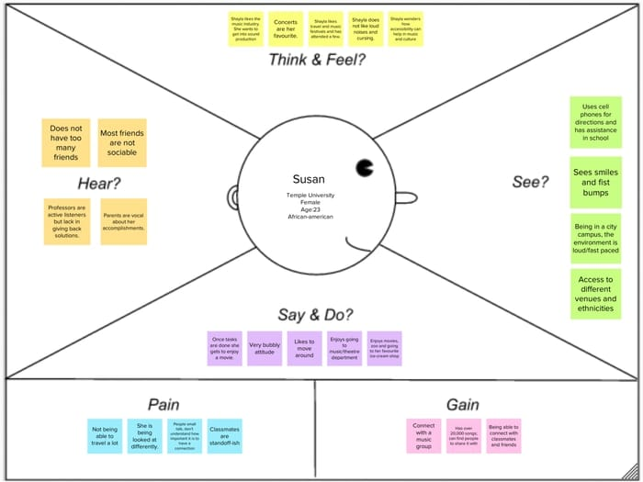

2.2 Ideation & Brainstorming Map

3 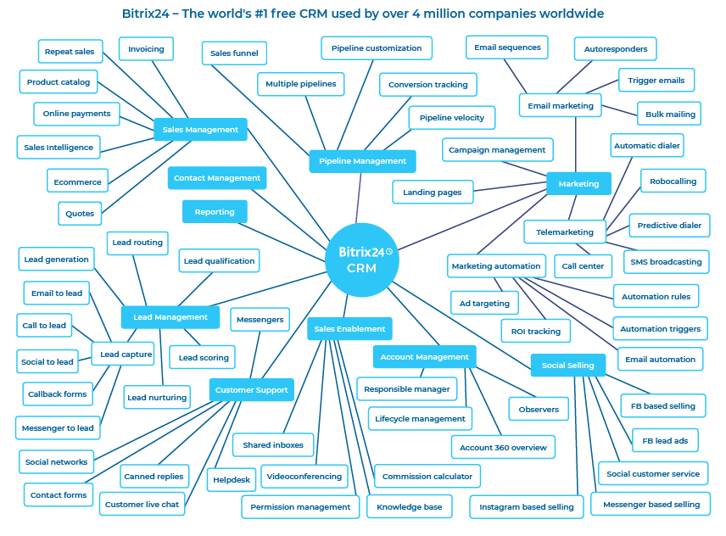 RESULT

* 1. Data Model:

|  |  |
| --- | --- |
| **Object name** | **Fields in the Object** |
| obj1 | |  |  | | --- | --- | | Field label | Data type | | School | Text | |  |  | |
| obj2 | |  |  | | --- | --- | | Field label Data type | Data type | | Student, parent Text |  | |  |  | |

* 1. **Activity & Screenshot**

Attach the screenshots of your project activity along with the description.

1. **Trailhead Profile Public URL**

**Team Lead - https://trailblazer.me/id/ssakthi78**

**Team Member 1 – https://trailblazer.me/id/amsha**

**Team Member 2 -** https://trailblazer.me/id/sangs45

**Team Member 3 – trailblazer.me/id/aishsice**

1. **ADVANTAGES & DISADVANTAGE**

|  |  |
| --- | --- |
| * It allows for the consolidation of customer data and the basis for deep insights. * It speeds up the sales conversion process. * It increases staff productivity, lowering time-cost. * It allows geographically dispersed teams to collaborate effectively. * Improves customer experience by allowing personalisation and improved query resolution. | * Customer experience may worsen due to staff over-reliance on the system. * Security and data protection issues with centralised data. * The excess initial time and productivity cost at the implementation. * Requires a process-driven sales organisation. * CRM may not suit all businesses. |

|  |  |
| --- | --- |
|  |  |

1. **APPLICATIONS**

As educational institutions strive to excel in a highly competitive landscape, the need for efficient management and organization has become paramount. From student admissions and enrollment to managing faculty and alumni relations, educational institutions face complex challenges that require a robust Customer Relationship Management (CRM) solution. Among the plethora of [CRM applications](https://solidperformers.com/best-crm-for-educational-institutions/) available, Solid Performers CRM has emerged as the top choice for schools and colleges seeking a [comprehensive solution](https://solidperformers.com/best-crm-for-educational-institutions/) to streamline operations and enhance productivity.

We have closely observed the evolution of CRM solutions and their impact on educational institutions. In this article, we will delve into the [unique features and benefits](https://solidperformers.com/solutions/) of Solid Performers CRM that make it the Best CRM Application for Schools and Colleges.

1. **CONCLUSION**

CRM for higher education plays an important role in the automation of the institute’s communication and processes. It helps them to connect with the interested and talented students who are seeking courses and programs based on their interests, affordability, and other parameters. Also, it reduces the manual tedious processes and improves the efficiency of the employees working there

1. **FUTURE SCOPE**

The education industry has witnessed various changes for several years like from pen and paper to phones, tablets, and laptops, for teaching and learning but there is still a big scope of change that can transform the level of education making all the operations simple, efficient, and relevant. I guess you may have understood what I am talking about? A Higher Education ERP – can transform the complete operations of the institution bringing automation and digital transformation of all the academic and administrative processes of the institution.

The future of education is changing rapidly and will change in the upcoming years, but having an [Education ERP Software](https://www.academiaerp.com/) you can make sure to adopt every change with the same consistency and flow and it will make all the processes easy and smooth providing access to every single thing from just one click. Let’s discuss how an ERP will help institutions to adopt any change in the education scenario easily.