Olist Marketplace Performance & Customer Satisfaction Analysis
Analysis Report
Prepared for: Olist Operations & Customer Experience Leadership
Prepared by: Data Analyst, Operations & Customer Experience Analytics
Data period covered: September 2016 – October 2018

1. Problem Understanding

Business Background
Olist is a Brazilian e-commerce platform that acts as a marketplace integrator: small and medium merchants across Brazil sign a single contract with Olist to sell through major marketplaces without negotiating each one individually. When a customer buys a product through an Olist-connected store, the responsible seller is notified to fulfill the order and ships it using Olist's logistics partners. Once an order is delivered — or once the estimated delivery date has passed — the customer receives a satisfaction survey by email where they can leave a 1-to-5-star review and, optionally, written comments.

The Business Challenge
Olist's leadership has approximately two years of order history (September 2016 to October 2018) covering orders, items, payments, products, sellers, customers, reviews, and geolocation data. Review scores, delivery timing, seller performance, and payment behavior all vary considerably across this period, across product categories, and across Brazil's states, but no single, consolidated analysis has connected these dimensions together. Leadership wants to understand what is actually shaping the customer experience on the platform, and where the clearest opportunities are to improve it as Olist continues to scale to more sellers and more regions of Brazil.

Objective
Determine how the marketplace has performed over the available time period, what factors are associated with customer satisfaction and dissatisfaction, where performance varies most across sellers, geography, categories, and payment behavior, and what Olist should prioritize as a result — using evidence from the data rather than assumptions.

2. Analytical Approach

Data
Nine linked tables were used: orders, order items, order payments, order reviews, customers, products, sellers, geolocation, and a product-category name translation table. These were joined into a single order-level master table (99,441 orders) carrying delivery timing, price, freight, payment, seller/customer geography, product category, and the matched review score.

Key Cleaning Decisions
- Reviews: 559 orders had more than one review row; the most recent review (by answer timestamp) was kept per order.
- Satisfaction and delivery-timing analysis was restricted to orders with status ‘delivered’ (96,478 of 99,441 orders), since only these have real delivery dates and a survey tied to an actual experience.
- September–December 2016 (4–324 orders/month) and September–October 2018 (4–16 orders/month) are onboarding and data-cutoff artifacts rather than real seasonal activity; time-trend analysis therefore uses the reliable window of January 2017 – August 2018.
- Missing or untranslated product categories were labeled ‘unknown’ rather than dropped, so those orders were not lost from volume and revenue totals.

Method
The analysis proceeds from descriptive trends (Q1–Q5) to a multivariate root-cause model (Q6): a Random Forest classifier (300 trees) predicting low reviews (≤2 stars) from delivery timing, order complexity, freight cost, geography, category, and payment features, with feature importances used to rank drivers. All findings below are supported by the accompanying Google Colab notebook, which runs top-to-bottom and reproduces every number and chart in this report.

3. Key Insights

3.1 Marketplace Performance Over Time
Order volume grew roughly 8x between January 2017 and August 2018 (750 to 6,351 orders/month), a steady and strong trend (correlation with time ≈ 0.89). Average review score, however, did not trend upward with it (correlation ≈ 0) — it stayed in a 4.0–4.3 band throughout, with sharp dips to 3.98 (Nov 2017) and 3.80–3.86 (Feb–Mar 2018) that coincide with spikes in the late-delivery rate (12–19%, versus a typical 3–6%).
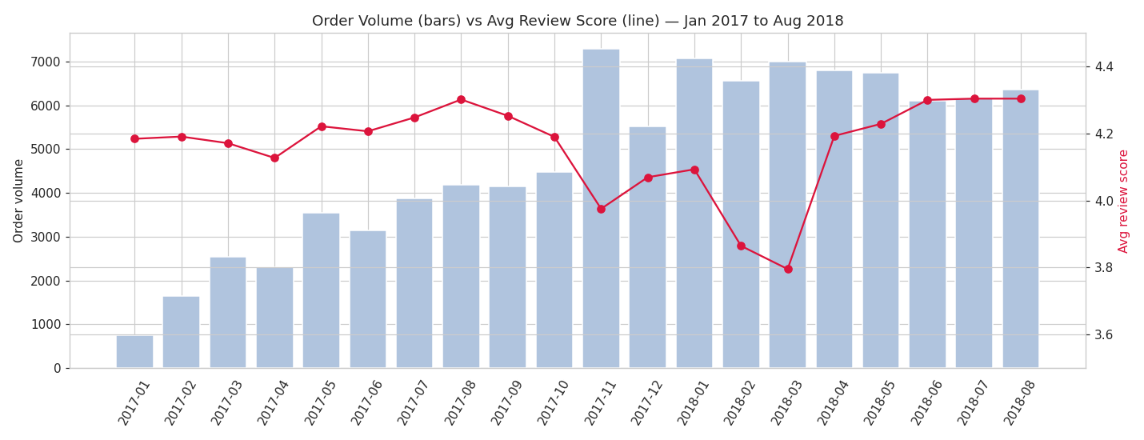
Figure 1. Order volume (bars) vs. average review score (line), Jan 2017–Aug 2018.
Finding: growth and satisfaction are decoupled. The platform is scaling order volume without a proportional improvement in experience, and satisfaction is fragile under demand surges.

3.2 Delivery Performance and Customer Satisfaction
This is the strongest single relationship in the dataset. Average review score falls sharply as deliveries run later relative to the estimated date:
Delivery timing | Avg. review score
7+ days early | 4.30
1–6 days early | 4.17
On time | 4.01
1–3 days late | 3.28
4–7 days late | 2.09
8+ days late | 1.69

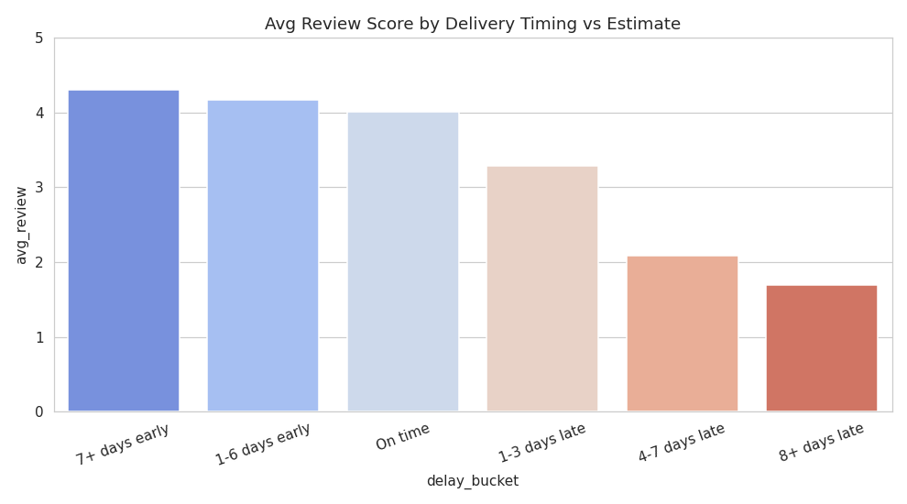
Figure 2. Average review score by delivery timing vs. estimate.
Only 6.8% of delivered orders arrive late, but late orders average 2.26 stars versus 4.28 for on-time orders — a roughly 2-star penalty. This penalty is not concentrated in any one place: it holds across every state and every product category tested (penalty range: 1.3–2.6 stars).
Finding: on-time delivery is the platform's single most important satisfaction lever, and it behaves consistently everywhere.

3.3 Seller and Geographic Patterns
Sellers are heavily concentrated in São Paulo state (≈60% of active sellers), while only ≈42% of customers are based there. Cross-state shipments take almost twice as long as same-state shipments (14.7 vs. 7.5 days average) and are roughly 80% more likely to be late (8.0% vs. 4.5%).
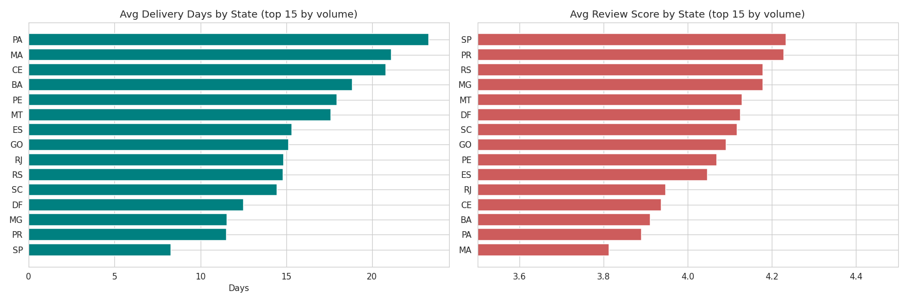
Figure 3. Average delivery days and average review score by state (top 15 states by order volume).
Northeastern and Northern states (Maranhão, Alagoas, Pará, Sergipe, Bahia, Ceará, Piauí) see late-delivery rates of 11–21%, average delivery times of 19–24 days, and freight costs consuming 20–26% of order value — compared to São Paulo's 4.5% late rate, 8.3-day average delivery, and 14% freight ratio. Review scores track this geography closely: São Paulo averages 4.23 stars versus roughly 3.8–3.9 in the most underserved states. Rio de Janeiro is a notable outlier — geographically close to São Paulo but still 12% late with a 3.95-star average, worth a closer operational look.
Finding: seller concentration in the Southeast creates a structural disadvantage for customers elsewhere in Brazil, compounding the delivery-satisfaction effect.

3.4 Product Category Performance
Across 52 categories with meaningful volume (platform average: 4.14 stars, $137 average order), books, food/drink, luggage, and stationery outperform (4.27–4.53 stars), while office furniture, audio, and men's fashion underperform (3.64–3.83 stars).
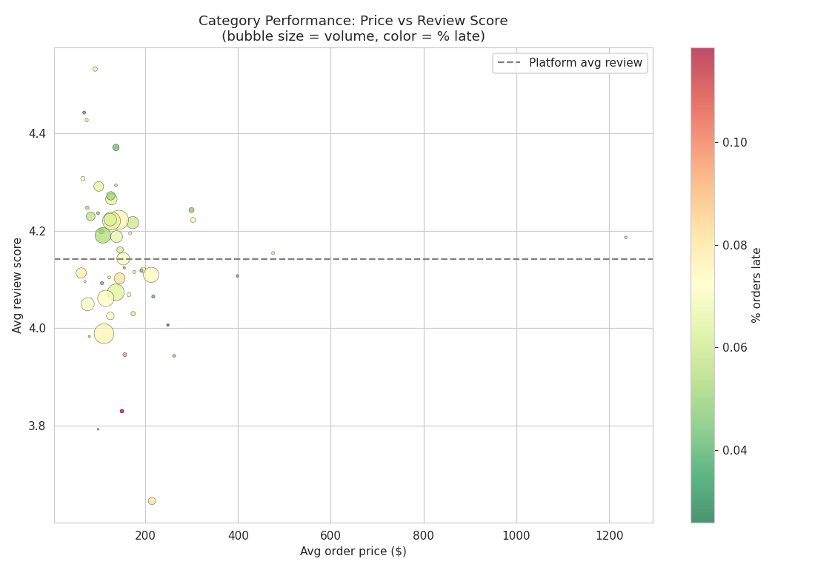
Figure 4. Category performance: average price vs. average review score (bubble size = order volume, color = % orders late).
Most of the gap in underperforming categories traces back to elevated late-delivery rates. The clear exception is office furniture, which scores 3.76 even on-time deliveries — below the platform's 4.28 on-time average — pointing to a product-fit or quality issue that is independent of shipping.
Finding: category performance mostly follows delivery performance, with office furniture standing out as a likely product-quality issue.

3.5 Payment Behavior
Payment type has almost no relationship with satisfaction (4.10–4.23 stars across credit card, boleto, debit, and voucher). Installment count correlates moderately with order value (r = 0.37, as expected — larger purchases are split into more installments) and shows a mild downward trend in review score at high installment counts (4.21 stars at 1 installment vs. 3.91 at 11+), which appears to reflect the slightly higher late-delivery rate on those larger orders rather than a distinct payment effect.
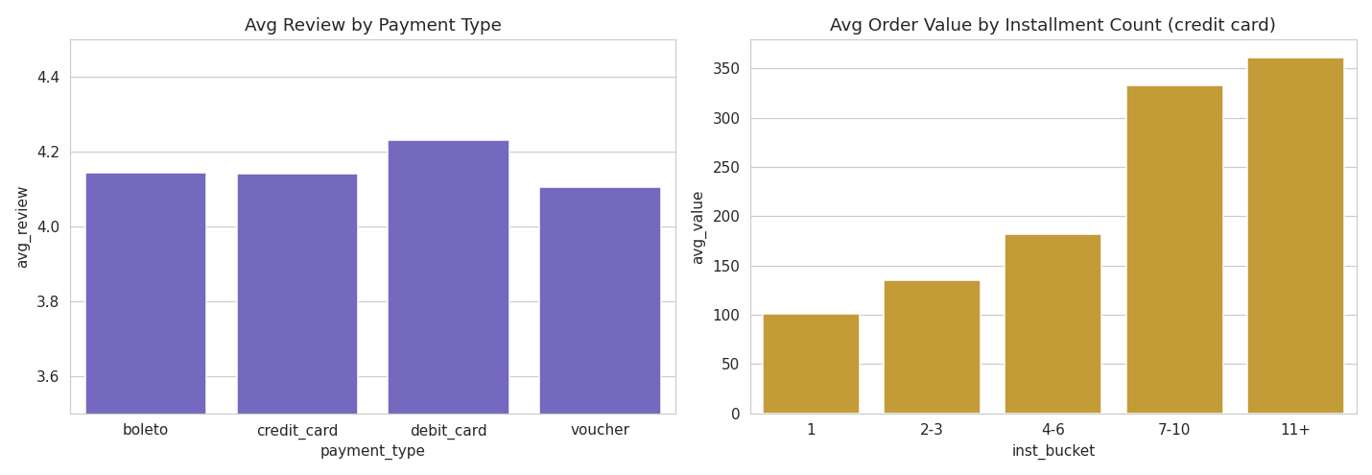
Figure 5. Average review score by payment type, and average order value by installment count.
Finding: payment behavior is a minor, secondary factor at most — not a meaningful satisfaction driver on its own.

3.6 Root Cause Analysis
A Random Forest model predicting low reviews (≤2 stars) from delivery timing, order complexity, freight, geography, category, and payment features ranks the drivers as follows:
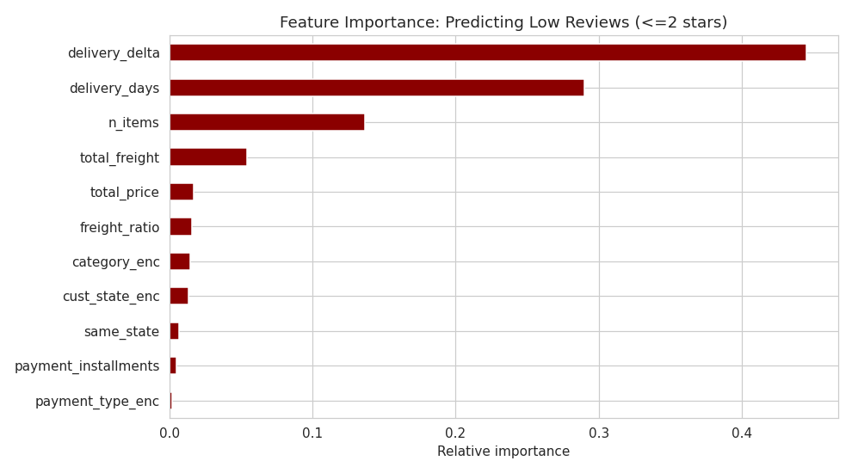
Figure 6. Feature importance for predicting low reviews (≤2 stars).
- Primary driver, by a wide margin: delivery timing (delivery delta and absolute delivery days together account for ≈73% of predictive importance).
- Secondary driver: order complexity. Multi-item orders average 3.67 stars versus 4.20 for single-item orders — and this is not explained by lateness, since multi-item orders are not more likely to be late. This points to partial-fulfillment issues or one weak item dragging down an otherwise good order.
- Contributing factors: freight cost and geography (customers in underserved regions pay more and wait longer, compounding the delivery effect), and category-specific quality issues (e.g., office furniture).
- Negligible: payment type and installment count, once delivery timing is controlled for.

3.7 Deep Dive: Seller Performance Scorecard
Among sellers with at least 20 delivered orders (who account for the large majority of platform volume), a specific subset combines high late-delivery rates (>15%) with low review scores (<3.8) — representing over $1,000,000 in combined revenue exposure.
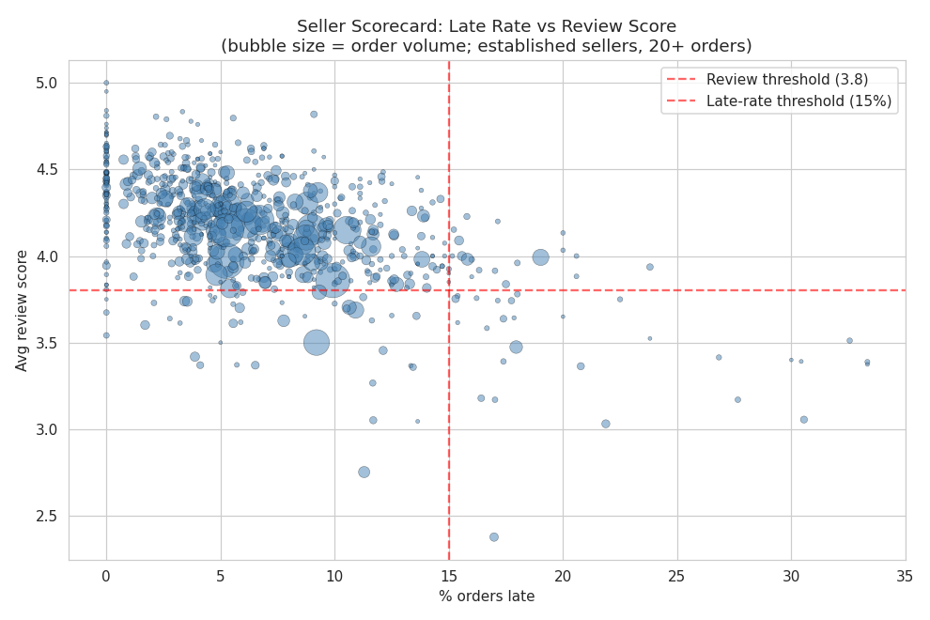
Figure 7. Seller scorecard — late-delivery rate vs. average review score (bubble size = order volume).
Finding: a concrete, actionable list of underperforming established sellers exists and can be targeted directly, rather than relying only on platform-wide fixes.

4. Business Findings Summary
- Growth and satisfaction are decoupled: order volume grew ~8x while average review score stayed flat, with sharp dips during demand surges.
- Delivery timing is the dominant driver of satisfaction, producing a consistent ~2-star swing between on-time and late orders across every state and category.
- Seller concentration in São Paulo creates a structural geographic penalty for the Northeast and North, compounding delivery delays with higher freight costs.
- Category performance mostly follows delivery performance, except for office furniture, which shows an independent product-quality signal.
- Payment type and installment behavior are minor factors with little independent effect on satisfaction.
- A specific, revenue-significant group of underperforming sellers can be identified and targeted directly.

5. Actionable Recommendations
1. Make on-time delivery the top operational KPI. Given the size and universality of the late-delivery penalty, even small reductions in the late-delivery rate should produce measurable satisfaction gains platform-wide.
2. Build logistics capacity in the Northeast and North. Recruit more regional sellers, negotiate improved regional freight/logistics partnerships, or set more conservative and achievable estimated delivery dates for these regions rather than overpromising.
3. Add demand-surge planning. Proactively scale logistics capacity or adjust delivery estimates ahead of known high-volume periods (e.g., Black Friday) to prevent satisfaction crashes like those seen in Nov 2017 and Feb–Mar 2018.
4. Investigate office furniture (and similarly flagged categories) for product and listing quality, separate from any delivery-focused fixes.
5. Launch a seller-performance program targeting the identified underperforming established sellers — logistics support, coaching, or performance-based offboarding.
6. Investigate multi-item order fulfillment, including partial shipments, mixed-seller orders, and quality-control processes for orders with two or more line items, since this effect is independent of delivery timing.

