PROBLEM STATEMENT:
Develop a machine learning classification model to predict whether a patient has Chronic Kidney Disease (CKD) or Not CKD based on the patient's clinical and laboratory parameters. The objective is to assist healthcare professionals in early diagnosis and decision-making.
Basic Information About the Dataset:
- Number of Rows: 399
- Number of Columns: 28
- Target Variable: classification (CKD / Not CKD)
Pre-processed methods used:
- Converted categorical (string) values into numerical values using encoding (such as Label Encoding).
- Split the dataset into training and testing sets.
- Applied feature scaling (e.g., StandardScaler) where required by the algorithm.
Confusion Matrix and accuracy values for every ML classification models
SVM:
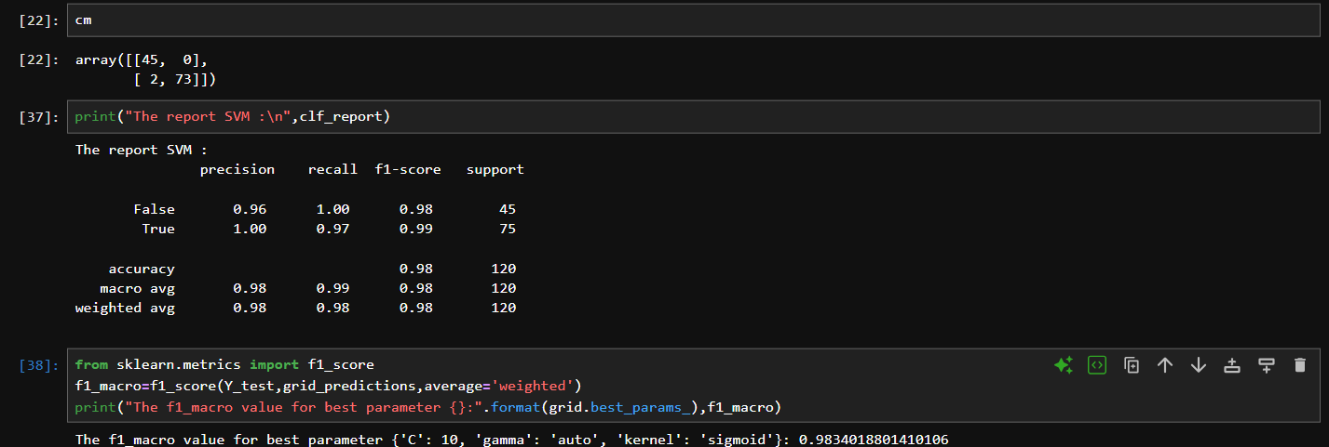
Accuracy: 0.98
Decision Tree:
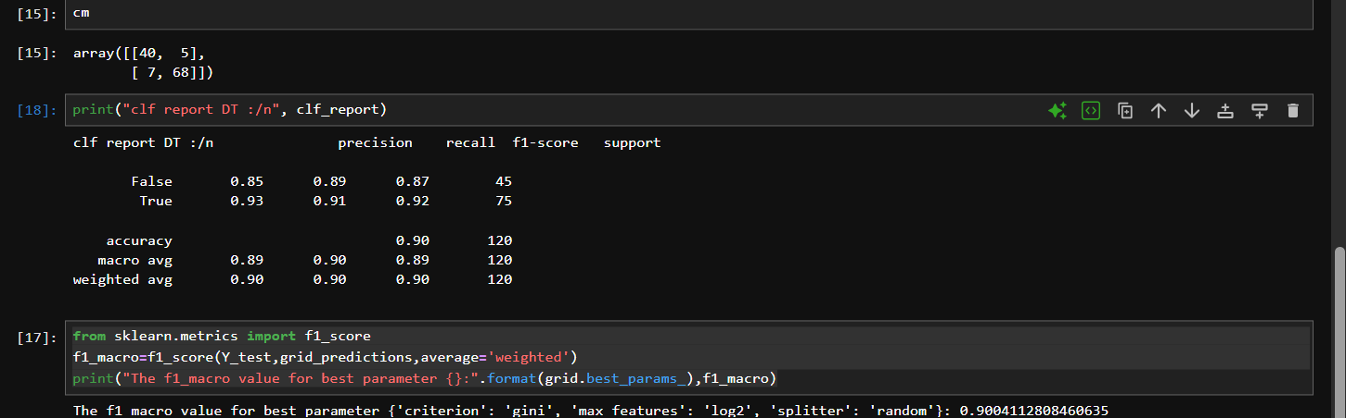
Accuracy: 0.90

Random Forest
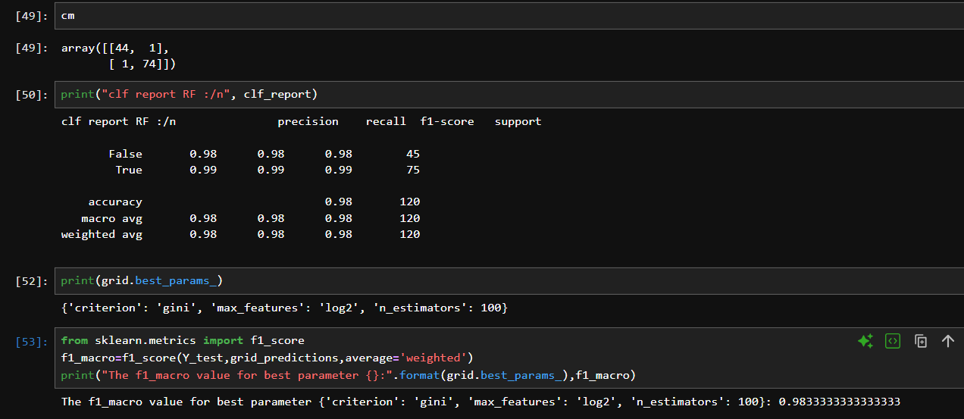
Accuracy: 0.98
Logistics Regression:
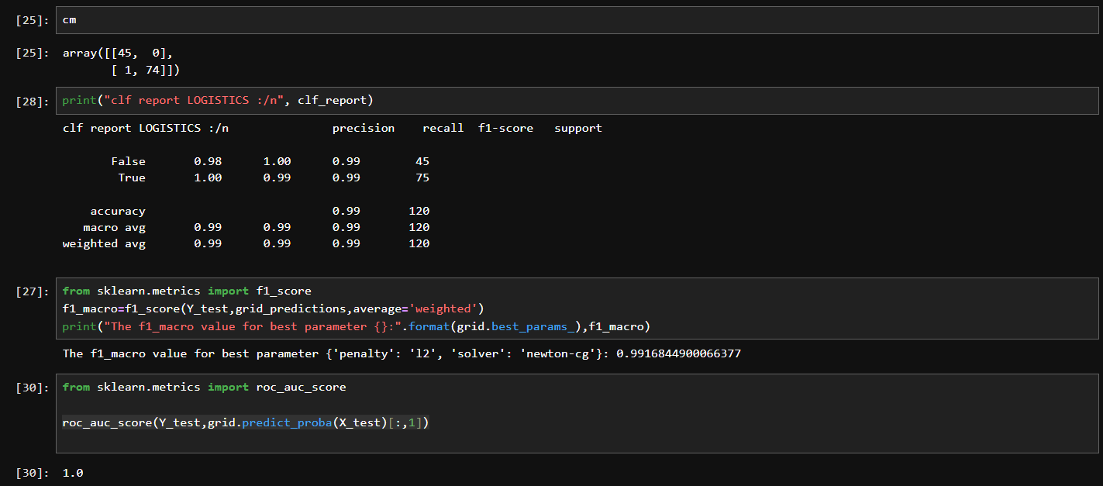
Accuracy: 0.99

KNN:
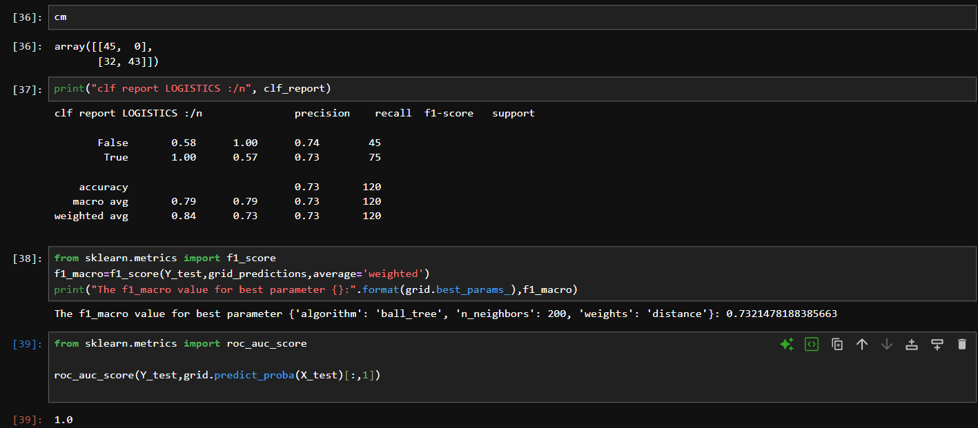
NB:
Multinomial NB:
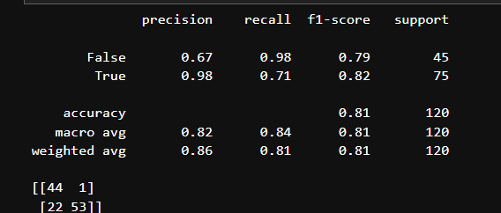
BernoulliNB:
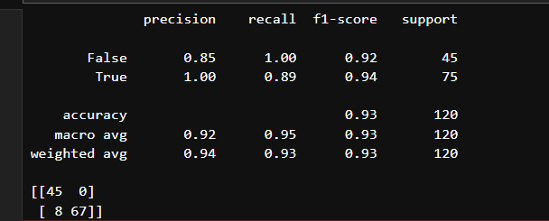

ComplementNB:
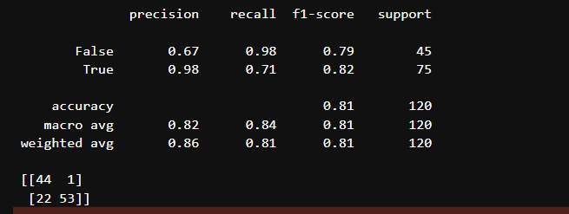
Final Model:
After evaluating multiple machine learning classification algorithms, Logistic Regression was selected as the final model for predicting Chronic Kidney Disease (CKD).
Logistic Regression was chosen because it achieved the best overall performance on the dataset based on the evaluation metrics. It provided high accuracy, precision, recall, F1-score, and ROC-AUC score, indicating that it can effectively distinguish between CKD and non-CKD patients.

