**Library Management System**

Type of applications – B to C

Target audience – Admins, User

Development time – 3 Days

Features:

**Admin :**

* Admin login - P1
* Set library on first time – P1
* Add books – P1
* Add users - P1
* View list of books - P1
* View search books – P1

**Candidate :**

* Candidate login - P1
* View list of books - P1
* View search books – P1
* Book borrow – P1
* Return book – P1
* View list of borrowed books – P1

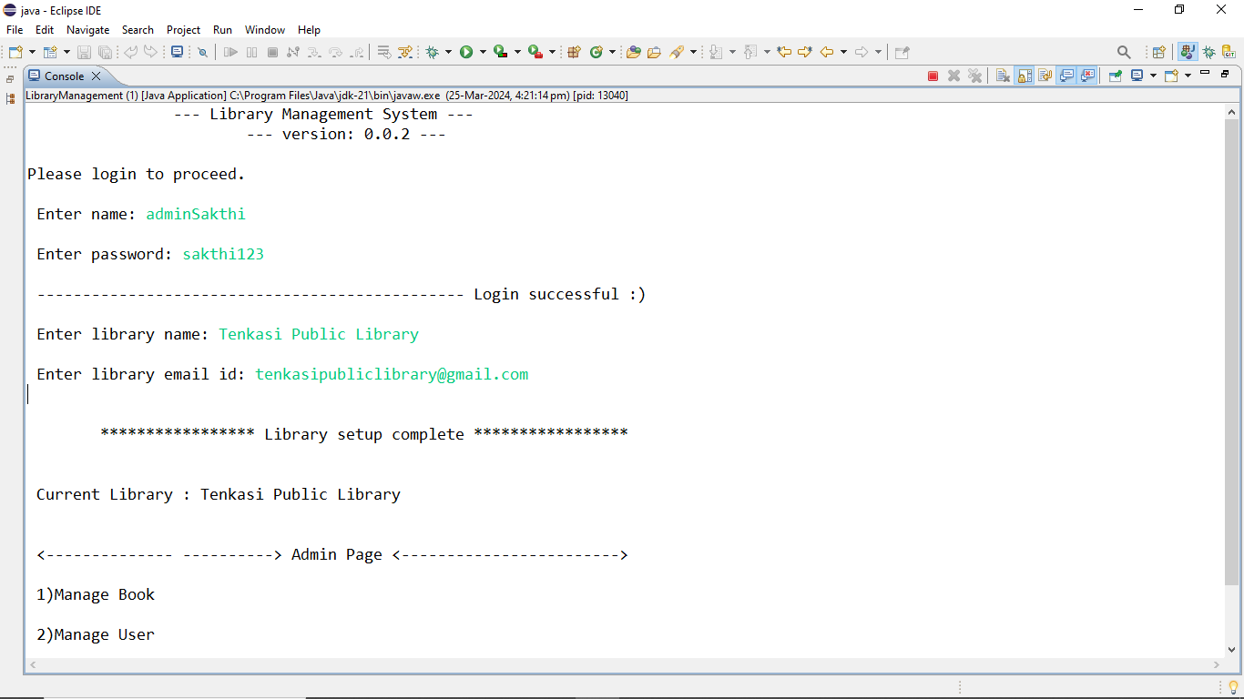

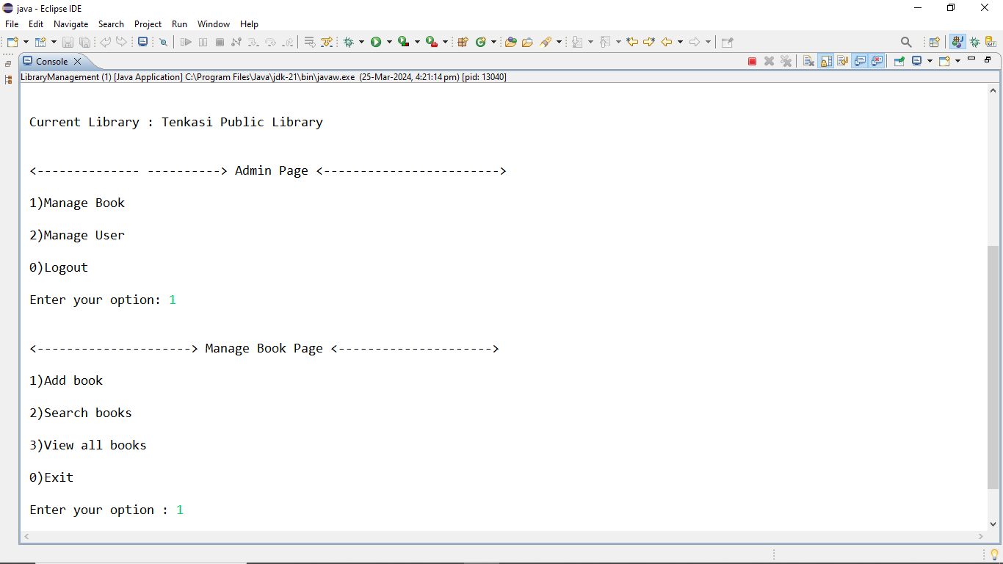

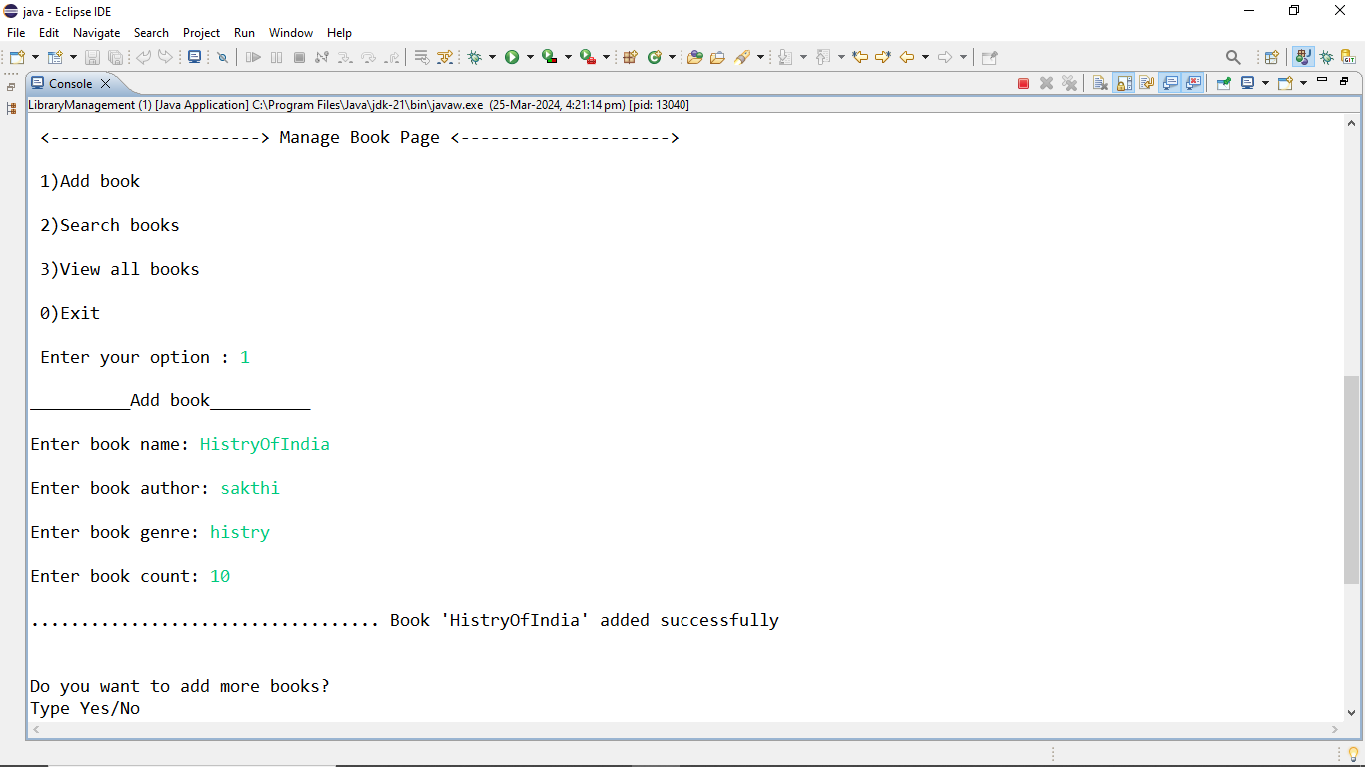

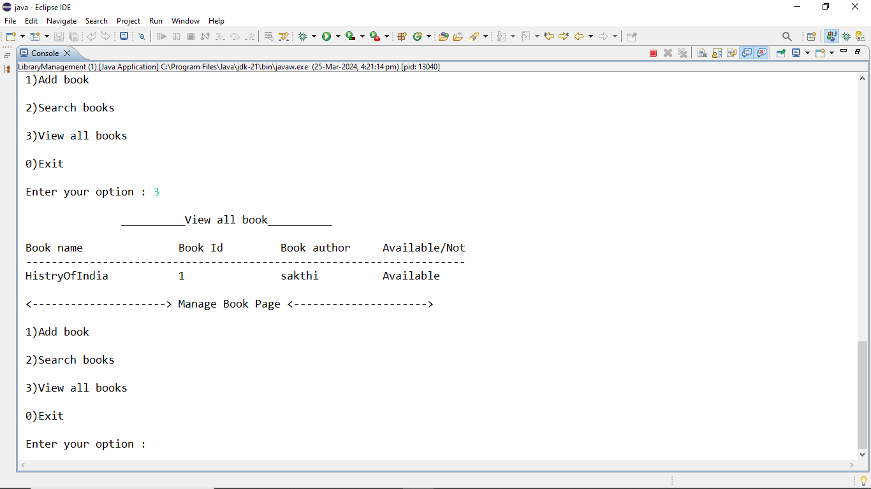

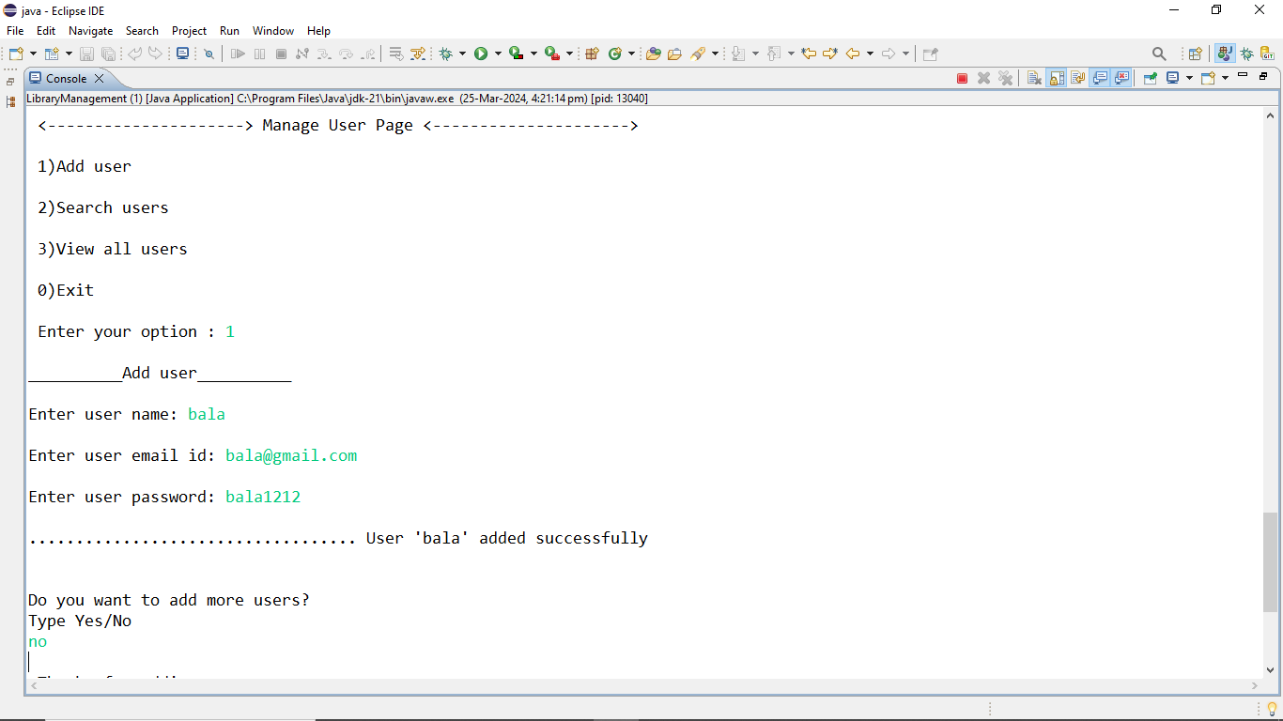

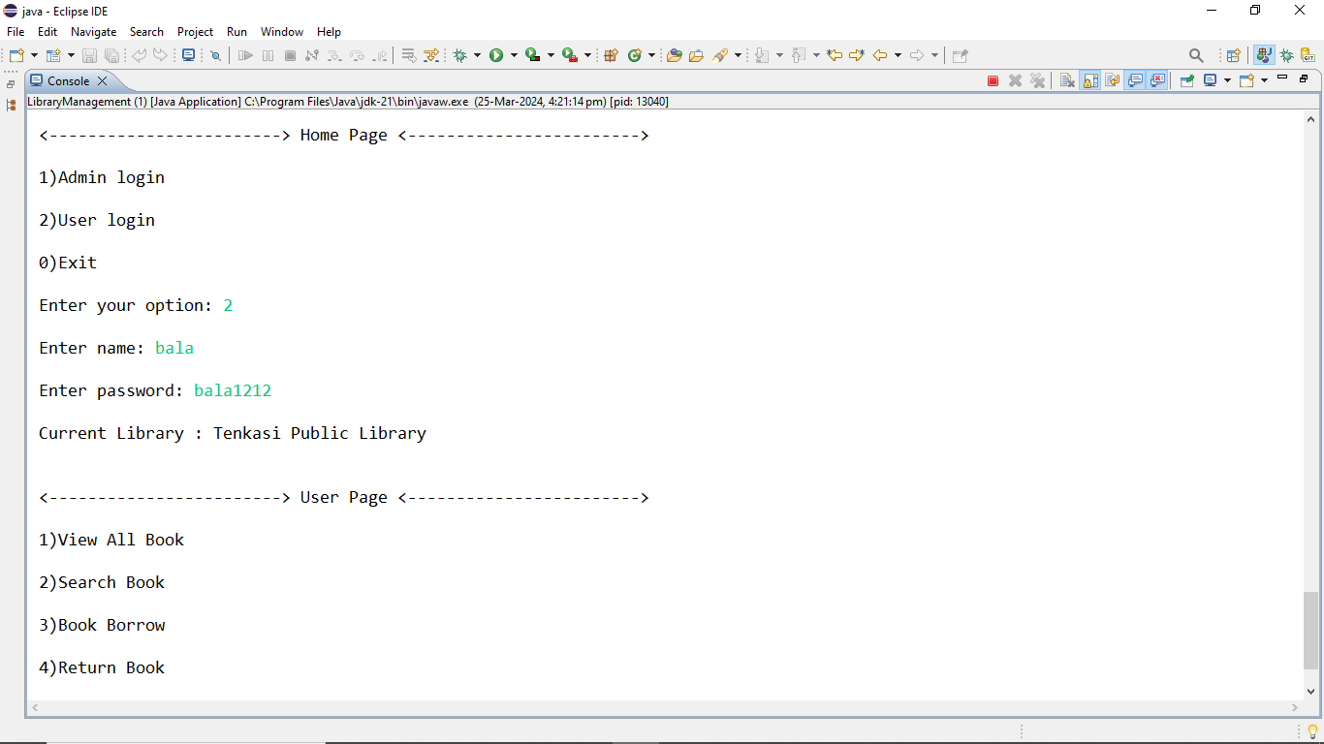

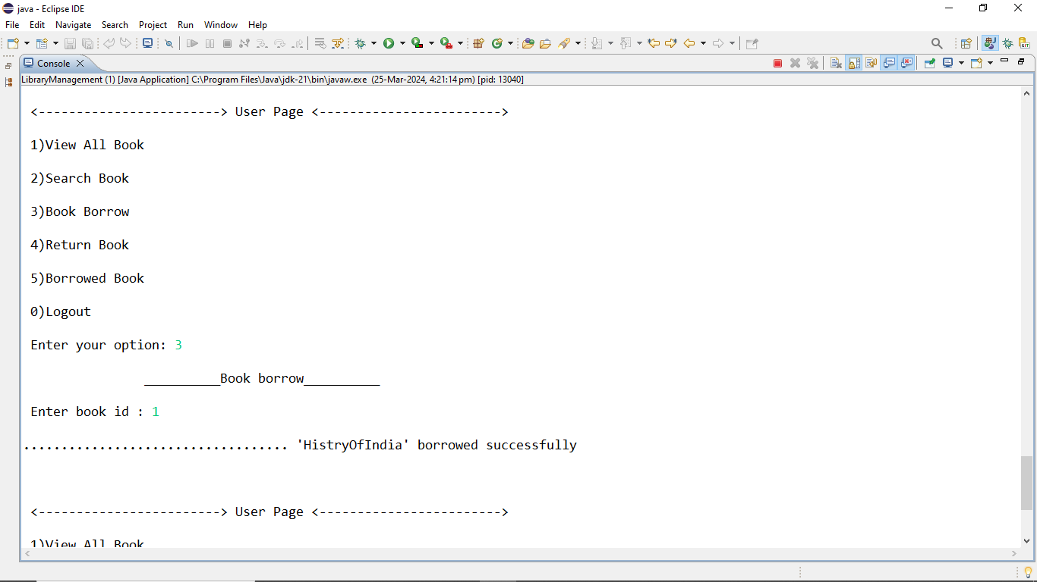

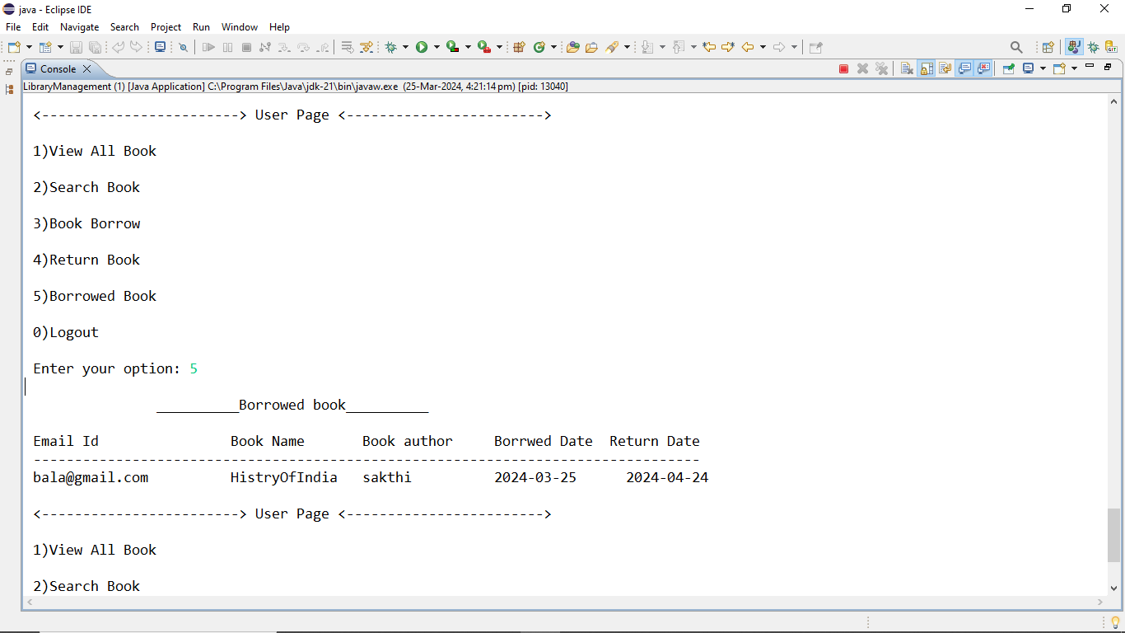

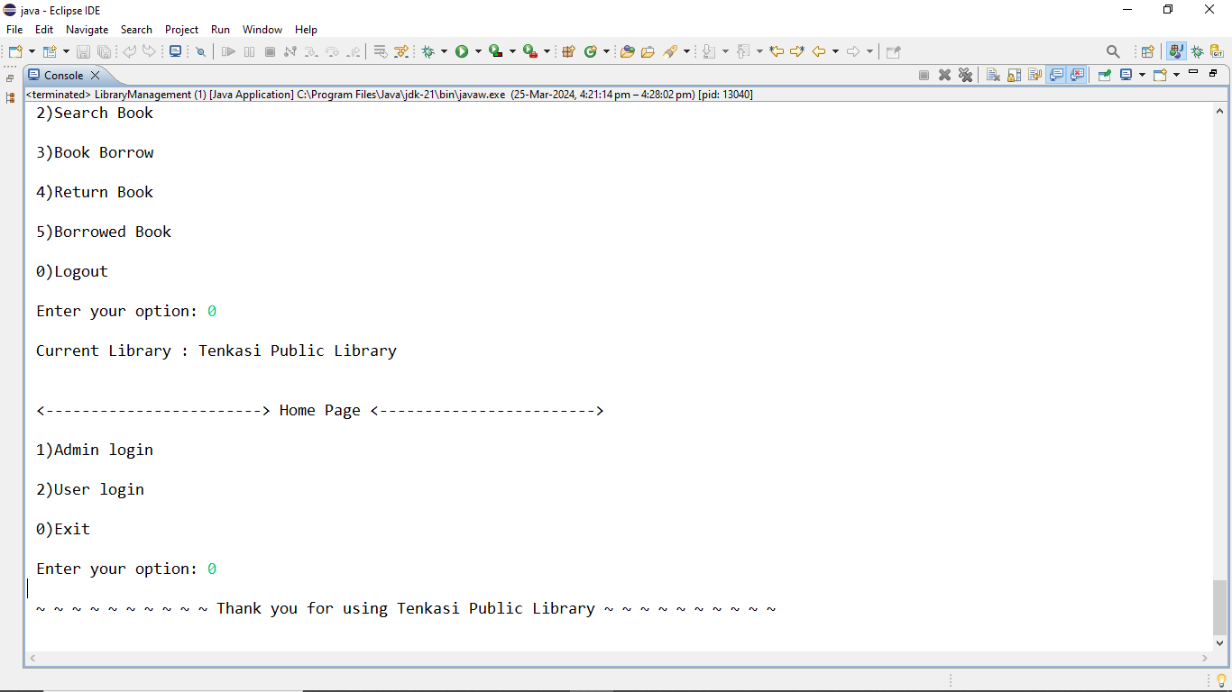

**Interview Panel**

Type of applications – B to B

Target audience – Admins

Development time – 2 Days

Features:

**Admin :**

* Admin login - P1
* Adding candidate - P1
* Update candidate – P1
* View list of candidate - P1
* View list of selected candidate - P1
* Delete candidate – P1
* Sending email to selected candidate - P1

