**Introduction:**

**Voyage vista: illuminating insights from uber expeditionary analysis**

**NM ID: A4015A0098FBBB281174DFDD89B648B7**

**Overview:**

As of my last knowledge update in September 2021, there is no specific information available regarding "Voyage Vista Illuminating Insights from Uber." It's possible that this is a project or initiative that was developed or announced after my last update, or it may be a term or concept that is not widely recognized.

If you have more specific information or context about "Voyage Vista Illuminating Insights from Uber," I'd be happy to try to provide more information or insights based on the details you can provide. Please provide additional context or specify any particular aspects of this topic you'd like to know more about.

**Purpose:**

Uber offers a range of services designed to meet different transportation and delivery needs. Here are some of the primary uses of Uber services:

1. **Ride-Sharing**: This is the most common and well-known use of Uber. Users can request a ride from a nearby driver using the Uber app. It's a convenient way to get from one location to another, whether you're traveling within a city or to an airport.
2. **UberPOOL**: This is a shared ride option where you can share your ride and the cost with other passengers traveling in the same direction. It's a more cost-effective option but may involve slight detours to pick up and drop off other passengers.
3. **UberX**: UberX offers a more affordable ride option than UberBLACK or UberSELECT, often using regular cars and not luxury vehicles.
4. **UberBLACK and UberSELECT**: These are premium services that offer higher-end vehicles and professional drivers. They are often used for business travel or when passengers want a more luxurious experience.

**Empathy map:**

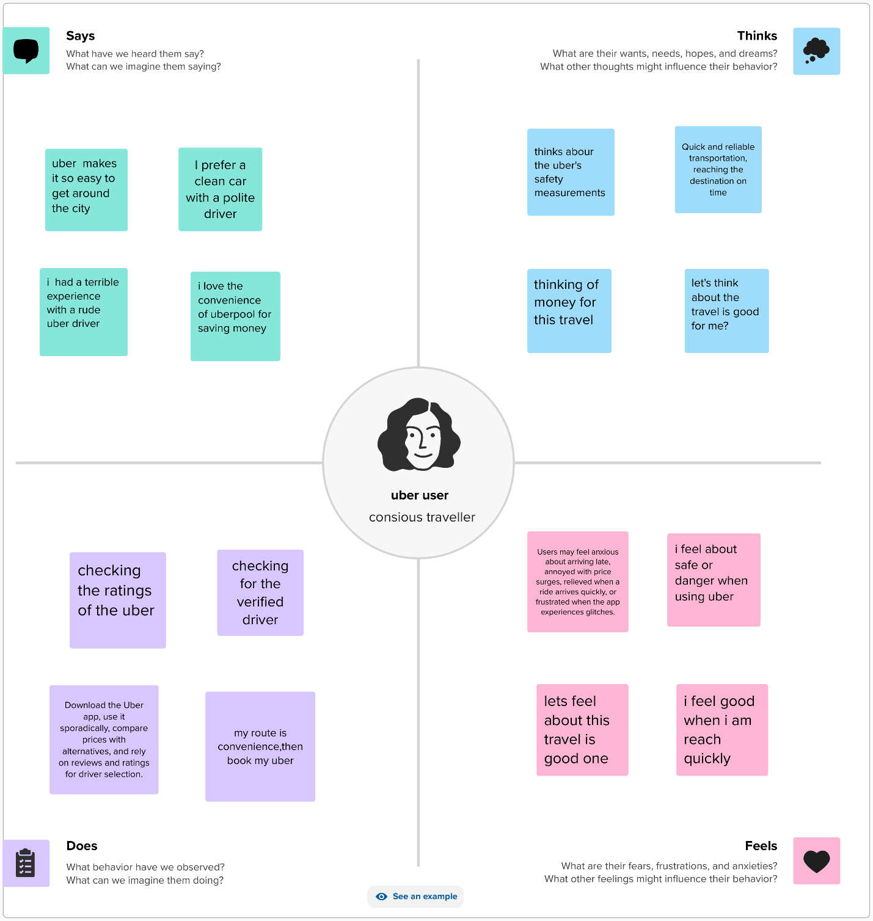

**Brianstroming map:**

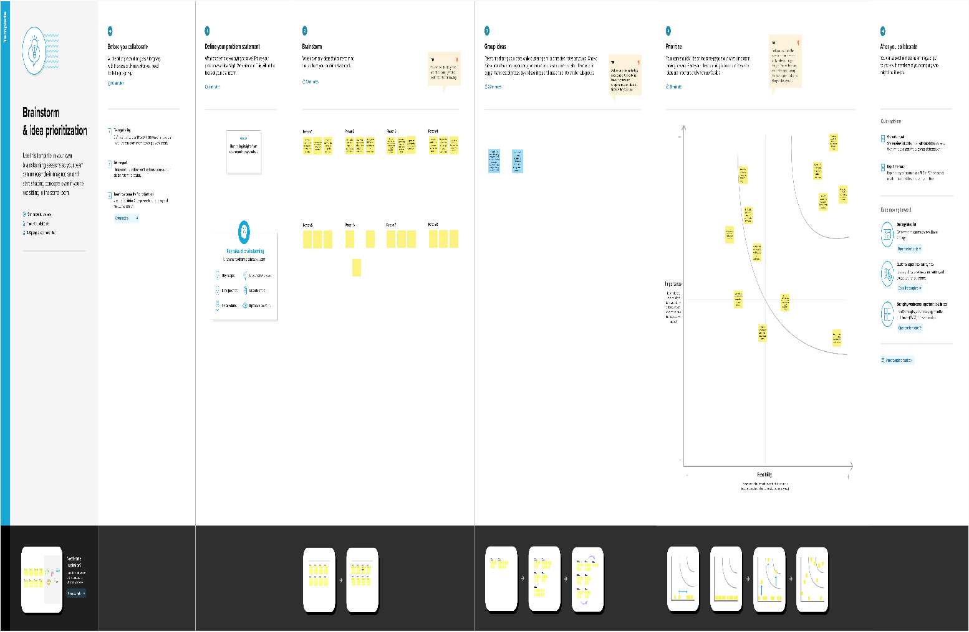

Uber, a popular ride-sharing service, has brought significant changes to the transportation industry worldwide. Like any technology-based service, it has its advantages and disadvantages:

**Advantages of Uber:**

1. Convenience: Uber offers a convenient way to request a ride through a smartphone app. Users can request a ride anytime, anywhere, making it easier to get around, especially in areas with limited taxi services.
2. Accessibility: Uber has increased transportation accessibility for individuals who may have difficulty hailing a taxi or using public transportation, such as people with disabilities.
3. Cost-Efficiency: Uber can be more cost-effective than traditional taxis in some cities. Surge pricing during peak hours can be a drawback, but at other times, it can offer competitive pricing.
4. Safety: Uber has implemented various safety features, such as driver background checks, real-time tracking, and the ability to share ride details with friends or family, which can enhance passenger safety.
5. Rating System: Both drivers and passengers rate each other, which can help maintain a level of accountability and ensure a better experience for all parties involved.
6. Income Opportunity: Uber provides an opportunity for individuals to earn money by becoming drivers, offering flexible work hours for those seeking additional income.
7. Reduced Drunk Driving: Uber has been credited with reducing the instances of drunk driving, as it provides a convenient and safe alternative to driving under the influence.
8. Ride Options: Uber offers various ride options, including UberX, Uber Pool, and Uber Black, catering to different preferences and budgets.

**Disadvantages:**

1. Surge Pricing: During peak hours or high-demand periods, Uber implements surge pricing, which can significantly increase the cost of rides. This can be frustrating for passengers.
2. Safety Concerns: Despite safety features, there have been incidents involving Uber drivers and passengers. Safety is an ongoing concern, and the company has faced criticism for its handling of some cases.
3. Employment Issues: Uber drivers are classified as independent contractors in many regions, which means they do not receive benefits like health insurance, and they are responsible for their own vehicle maintenance and expenses.
4. Regulatory Challenges: Uber has faced regulatory challenges and legal battles in many cities and countries, often related to issues of insurance, licensing, and competition with traditional taxi services.
5. Quality Control: While Uber maintains a rating system, the quality of service can vary widely, depending on the individual driver. Some passengers may have negative experiences due to unprofessional or inexperienced drivers.
6. Limited Service Areas: Uber is not available in all areas, particularly in rural or less densely populated regions where demand may be lower.
7. Impact on Traditional Taxis: The rise of Uber has disrupted the traditional taxi industry, leading to economic challenges and job losses for taxi drivers.
8. Environmental Concerns: Uber rides, like many other forms of transportation, contribute to traffic congestion and emissions, which can be harmful to the environment.

In summary, Uber offers numerous advantages, such as convenience, accessibility, and cost-efficiency, but it also comes with disadvantages, including safety concerns, regulatory challenges, and issues related to employment and pricing. The overall experience with Uber can vary depending on the location and individual circumstances.

Top of Form

**Applications:**

Uber, originally known for its ride-sharing service, has expanded its offerings over the years. Here are various applications of Uber:

1. **Ride-Sharing**: Uber's core service is ride-sharing. Users can request a ride through the Uber app, and a nearby driver will pick them up and take them to their destination. This service is available in numerous cities worldwide.
2. **Uber Eats**: Uber Eats is a food delivery service that allows users to order food from local restaurants through the Uber app. Uber drivers deliver the food to the customer's location.
3. **Uber Freight**: Uber Freight connects shippers and truck drivers, making it easier to arrange and manage freight shipments. It aims to streamline the logistics and transportation of goods.
4. **Uber for Business**: This application is designed for companies to manage their employees' transportation needs. It provides a convenient way for businesses to track and pay for employee rides, whether for commuting or business-related travel.
5. **Uber Health**: Uber Health is a platform for healthcare organizations to arrange non-emergency medical transportation for patients. It helps patients get to medical appointments conveniently.
6. **Uber Connect**: Uber Connect allows users to send packages or items to family and friends via an Uber driver. It's a convenient option for contactless deliveries.
7. **UberX for Commuting**: Some users use Uber for daily commuting to work or other regular destinations, especially in areas with limited public transportation options.
8. **UberPOOL**: UberPOOL is a ride-sharing option that allows

Top of Form

**Conclusion:**

In conclusion, Uber has had a significant impact on the transportation and technology industries, offering a range of services designed to enhance convenience and accessibility for users. Its innovative approach to transportation has introduced both advantages and disadvantages:

Advantages of Uber include its convenience, accessibility, cost-efficiency, safety features, and the potential for additional income opportunities for drivers. It has also contributed to reducing drunk driving incidents and offers various ride options to cater to diverse user preferences and budgets.

However, Uber has faced challenges such as surge pricing, safety concerns, employment issues, regulatory battles, and variability in the quality of service. Its disruptive nature has also had repercussions on the traditional taxi industry and raised environmental concerns due to increased congestion and emissions.

Ultimately, the experience with Uber can vary depending on the location and individual circumstances. While it has brought significant changes to the way people move around and access services, it continues to evolve and adapt to address the challenges and opportunities it encounters in the rapidly changing landscape of the transportation and technology sectors.

**Future scops:**

The future scope of Uber is likely to continue evolving and expanding in several directions, driven by advancements in technology, changing consumer preferences, and emerging trends in transportation and logistics. Here are some potential avenues for Uber's future growth and development:

1. **Autonomous Vehicles**: Uber has been investing in autonomous vehicle technology. In the future, self-driving cars could become a significant part of Uber's fleet, potentially reducing labor costs and increasing efficiency.
2. **Electric Vehicles (EVs)**: As the world moves toward a greener and more sustainable future, Uber may expand its electric vehicle offerings. This could include partnerships with electric vehicle manufacturers, incentives for drivers to switch to EVs, and the integration of EV charging infrastructure into the app.
3. **Urban Air Mobility (UAM)**: Uber has shown interest in the development of flying taxis and drones for urban air mobility. These technologies could revolutionize transportation in congested urban areas and may become a significant part of Uber's service in the future.
4. **Expansion into New Markets**: Uber may continue to expand into new markets and regions, especially in emerging economies where there is potential for rapid growth in transportation services.
5. **Diversification of Services**: Uber is likely to continue diversifying its services beyond ride-sharing and food delivery. This could include further expansion into areas like grocery delivery, pharmacy delivery, and other on-demand services.
6. **Subscription Services**: Uber has experimented with subscription services that offer various perks and discounts to regular users. Expanding and refining these subscription models could be part of Uber's future

Top of Form

Thank you