STOCK PRICE PREDICTION APPLICATION USING A HYBRID CNN-LSTM MODEL

A PROJECT REPORT

Submitted by

SAKTHIDHARAN S 22IT091
PHORVESHRAJ A 22IT072

in partial fulfillment for the award of the degree

of

BACHELOR OF TECHNOLOGY
IN

INFORMATION TECHNOLOGY


CHENNAI INSTITUTE OF TECHNOLOGY
(An Autonomous Institution, Affiliated to Anna University, Chennai)
CHENNAI – 600069

MARCH 2026

CHENNAI INSTITUTE OF TECHNOLOGY
(An Autonomous Institution, Affiliated to Anna University, Chennai)
CHENNAI – 600069

BONAFIDE CERTIFICATE

Certified that this project report “STOCK PRICE PREDICTION APPLICATION USING A HYBRID CNN-LSTM MODEL” is the bonafide work of SAKTHIDHARAN S (22IT091), PHORVESHRAJ A (22IT072) who carried out the project work under my supervision.

SIGNATURE | SIGNATURE
Dr. ROSY SALOMI VICTORIA  M.E., (Ph.D.), | Dr. A. R. KAVITHA, M.E., Ph.D.,
SUPERVISOR,  Professor | HEAD OF THE DEPARTMENT  Professor and Head
Department of Information Technology, | Department of Information Technology,
Chennai Institute of Technology, | Chennai Institute of Technology,
Kundrathur, | Kundrathur,
Chennai-600069. | Chennai-600069.

Certified that the above students have attend of viva voice during the exam held on……………….......

INTERNAL EXAMINER EXTERNAL EXAMINER
ACKNOWLEDGEMENT

We express our gratitude to our Chairman Shri.P.SRIRAM and all trust members of Chennai Institute of Technology for providing the facility and opportunity to do this project as a part of our undergraduate course.
We are grateful to our Principal Dr.A.RAMESH M.E, Ph.D. for providing us the facility and encouragement during the course of our work.
We sincerely thank our Head of the Department, Dr.A.R.KAVITHA M.E., Ph.D. Department of Information Technology for having provided us valuable guidance, resources and timely suggestions throughout our work.
We sincerely thank our Project Guide, Dr. ROSY SALOMI VICTORIA M.E., (Ph.D.), Assistant Professor, Department of Information Technology for having provided us valuable guidance, resources and timely suggestions throughout our work.
We would like to extend our thanks to our Faculty coordinators of the Department of Information Technology, for their valuable suggestions throughout this project.
We wish to extend our sincere thanks to all Faculty members of the Department of Information Technology for their valuable suggestions and their kind cooperation for the successful completion of our project.
We wish to acknowledge the help received from the Lab Instructors of the Department of Information Technology and others for providing valuable suggestions and for the successful completion of the project.

ABSTRACT

Stock price prediction is one of the most challenging tasks in financial markets due to high volatility, non-linear behavior, and the influence of unpredictable macroeconomic and geopolitical factors. Traditional statistical models such as ARIMA and GARCH often struggle to deliver consistent performance because they rely on assumptions of linearity and stationarity, which rarely hold true in real-world stock market conditions. With the advancement of artificial intelligence, deep learning models—particularly Long Short-Term Memory (LSTM) networks—have gained popularity for their ability to capture long-term temporal dependencies in time-series data. However, standalone LSTM models may not effectively detect short-term local price patterns, which are crucial for forecasting in highly dynamic sectors such as India’s IT industry.
To overcome these limitations, this study proposes a hybrid deep learning architecture that integrates Convolutional Neural Networks (CNN) with LSTM networks to predict the stock prices of Infosys Limited (INFY) over the period 2011–2026. The CNN component is responsible for extracting short-term spatial features from historical OHLCV (Open, High, Low, Close, Volume) data, including micro-trends and volatility clusters. These extracted features are then fed into the LSTM layer, which models long-term sequential dependencies and temporal relationships in stock price movements. The model is trained using 14 years of historical market data (2011–2025) and evaluated against benchmark models such as standalone LSTM, CNN, ARIMA, and Support Vector Regression (SVR). Performance is assessed using evaluation metrics including Root Mean Square Error (RMSE), Mean Absolute Error (MAE), Mean Absolute Percentage Error (MAPE), and directional accuracy.

TABLE OF CONTENTS

CHAPTER NO. | TITLE | PAGE NO.
 | ABSTRACT | 4
 | LIST OF TABLES | 8
 | LIST OF FIGURES | 9
1. | INTRODUCTION | 10
 | 1.1 Background | 10
 | 1.2 Objective | 11
 | 1.3 Scope | 12
2. | LITERATURE REVIEW | 14
 | 2.1 Existing Donation and Volunteering Platforms | 14
 | 2.2 Recommendation Systems in Social Platforms | 16
 | 2.3 Multimodal Verification and Context-Aware Validation Approaches | 17
 | 2.4 Identified Gaps and System Positioning | 18
3. | PROBLEM STATEMENT | 19
 | 3.1 Overview | 19
 | 3.2 Challenges in Donation Transparency | 19
 | 3.3 Need for an Intelligent and Verifiable Platform | 21
4 | PROPOSED SYSTEM | 23
 | 4.1 Overview | 23
 | 4.2 Key Features of DonateWise | 23
 | 4.2.1 Donation Lifecycle Model | 25
 | 4.3 Intent Locking and System-Verified Logging | 28
 | 4.3.1 Immutable Intent Parameter Enforcement | 30
 | 4.4 Overall Workflow of DonateWise | 33
5. | SYSTEM ARCHITECTURE | 34
 | 5.1 Overview | 34
 | 5.2 Backend, ML and Verification Components | 34
 | 5.3 System Architecture Figure | 38
6. | IMPLEMENTATION | 40
 | 6.1 Overview | 40
 | 6.2 Technology Stack | 40
 | 6.3 Hybrid Recommendation Implementation | 41
 | 6.4 Proof Verification and Intent Matching | 43
 | 6.5 Location-Based and Integrity Validation | 45
 | 6.6 Volunteer Event Creation and Management | 47
 | 6.7 Donation Request Monitoring Interface | 49
 | 6.8 Proof Submission with Browser-Based Geolocation Capture | 51
7. | RESULTS AND ANALYSIS | 52
 | 7.1 Recommendation Accuracy and Relevance | 52
 | 7.2 Verification Success and Rejection Analysis | 52
 | 7.3 Location Compliance Results | 55
 | 7.4 Verification Result Analysis | 56
 | 7.5 Multi-Stage Verification Execution Analysis | 60
8. | FUTURE SCOPE | 64
 | 8.1 Enhanced Multimodal Verification | 64
 | 8.2 Mobile Application Integration | 64
 | 8.3 Blockchain-Based Audit Trails | 64
9. | CONCLUSION | 66
 | 9.1 Summary of Findings | 66
 | 9.2 Key Contributions | 66
 | 9.3 Future Prospects | 67
10. | REFERENCES | 68
11. | PO & PSO ASSIGNMENT | 70

LIST OF TABLES

TABLE NO. | TABLE NAME | PAGE NO.
1. | Comparison of Existing Donation Platforms | 15
2. | Challenges in Donation Transparency and NGO Accountability | 16
3. | Features of the Proposed DonateWise Platform | 24
4. | Technology Stack Used for Implementation | 40
5. | Hybrid Recommendation Techniques Used | 42
6. | Proof Verification Outcomes(Verified) | 53
7. | Proof Verification Outcomes(Rejected) | 54

LIST OF FIGURES

FIGURE NO. | FIGURE NAME | PAGE NO.
1. | DonateWise Platform Overview | 11
2. | Existing platform vs DonateWise | 21
3. | Intent Locking and Verification Flow | 29
4. |  | 38
  System Architecture Diagram
5. | Hybrid Recommendation Workflow | 43
6. | Asynchronous Proof Verification Pipeline | 45
7. | Location-Based Validation Process | 46
8. | Volunteer Event Creation Interface | 47
9. | Donation Request Status Dashboard | 49
10. | Proof upload dashboard | 55
11. | Image Manipulation Confidence Distribution | 56
12. | Intent Matching Outcome Distribution | 57
13. | Final Verification Outcome Distribution | 58
14. | Intent Matching Outcome Analysis | 59
15. | Multi-Stage Verification Log Output | 60

CHAPTER 1: INTRODUCTION

1.1 Background
In this context, the financial market represents one of the most complex and dynamic systems influenced by socio-economic trends, political events, global policies, investor sentiment, and organizational performance. Among its various segments, the stock market is particularly intricate due to its sensitivity to both internal corporate developments and external macroeconomic factors. Market fluctuations are often driven by earnings announcements, interest rate changes, inflation trends, geopolitical tensions, and investor psychology. Because of this non-linear and volatile nature, traditional statistical forecasting models such as Auto Regressive Integrated Moving Average (ARIMA) and Asymmetric Generalized Auto Regressive Conditional Heteroskedasticity (AGARCH) face limitations. These models generally assume linearity and stationarity, assumptions that rarely hold true in real-world financial time series data.
In recent years, Deep Learning has emerged as a powerful alternative for modeling complex sequential data. Recurrent Neural Networks (RNNs), particularly Long Short-Term Memory (LSTM) networks, have proven effective in capturing long-term temporal dependencies in financial time series. LSTM models are capable of remembering past information over extended periods, making them suitable for identifying long-term price trends and cyclical market behavior. On the other hand, Convolutional Neural Networks (CNNs), originally developed for image recognition tasks, have been successfully adapted into one-dimensional (1D) architectures for extracting local patterns in sequential data. In stock market forecasting, CNN models help identify short-term technical indicators, micro-trends, and volatility clusters from historical OHLCV (Open, High, Low, Close, Volume) data.
The integration of CNN and LSTM into a hybrid CNN–LSTM architecture combines the strengths of both approaches. The CNN component extracts spatial and short-term technical patterns—similar to candlestick formations—while the LSTM component models long-term sequential dependencies in stock price movements. This hybrid structure enhances predictive capability by capturing both local and global features of financial time series data. The present research focuses on forecasting the stock performance of Infosys Limited (INFY), a globally recognized leader in consulting, information technology services, and digital transformation. INFY is listed on the New York Stock Exchange under the ticker symbol INFY, making it a strong candidate for predictive financial analysis.
The primary objective of this research is to develop a robust hybrid deep learning model capable of forecasting INFY stock prices using historical data from 2011 to 2025 and generating reliable predictions for 2026. By leveraging fourteen years of historical market data, the model aims to provide accurate trend analysis and price forecasts, supporting data-driven decision-making for investors and researchers. While financial markets inherently involve uncertainty, the proposed CNN–LSTM framework offers a comprehensive and advanced approach to stock price prediction, particularly suited for emerging and technology-driven markets.
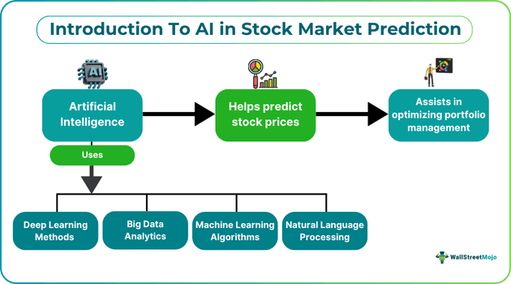
Figure 1: Machine Learning Framework for Stock Market Prediction
1.2 Objectives
The primary objective of the proposed project is the design, development, and analytical evaluation of a hybrid deep learning methodology that integrates Convolutional Neural Networks (CNN) and Long Short-Term Memory (LSTM) networks for stock price prediction. The project focuses on building a robust forecasting framework capable of modeling the complex, nonlinear, and volatile behavior of financial time series data. By combining CNN and LSTM into a unified architecture, the model aims to leverage the strengths of both spatial feature extraction and temporal sequence learning to improve predictive accuracy. The study specifically targets the stock price prediction of Infosys Limited (INFY) using historical data and evaluates its effectiveness against traditional and standalone machine learning models.
The CNN–LSTM architecture is designed to capture both local spatial patterns and long-term temporal dependencies present in stock market data. The CNN component is responsible for extracting short-term patterns, such as micro-trends, price momentum, volatility clusters, and technical formations from OHLCV (Open, High, Low, Close, Volume) time series inputs. These spatial features are then passed to the LSTM layers, which are capable of learning sequential dependencies and remembering long-term relationships within the financial time series. This dual capability allows the hybrid model to emphasize both space-related characteristics (local feature patterns) and time-related characteristics (trend evolution over time), making it highly suitable for stock market forecasting.
To evaluate the effectiveness of the proposed hybrid approach, the model performance is systematically compared with established baseline models, including ARIMA, standalone LSTM, and Support Vector Regression (SVR). Each model is trained and tested on historical stock price data, and their forecasting accuracy is assessed using standard performance evaluation metrics such as Root Mean Square Error (RMSE), Mean Absolute Error (MAE), and Mean Absolute Percentage Error (MAPE). These metrics provide a quantitative basis for measuring prediction error and comparing forecast reliability across different models. The comparative analysis helps determine whether the hybrid CNN–LSTM architecture offers significant improvement over traditional statistical and machine learning techniques.
1.3 Scope
The scope of this project is to design and implement a hybrid deep learning model that integrates Convolutional Neural Network (CNN) and Long Short-Term Memory (LSTM) architectures for accurate stock price prediction. The project specifically focuses on forecasting the stock prices of Infosys Ltd. using historical market data collected from 2011 to 2025. Since stock markets are highly nonlinear and volatile in nature, the proposed hybrid model aims to capture both spatial patterns and temporal dependencies present in time-series financial data.
The project covers multiple stages including data collection, data preprocessing, normalization, feature engineering, model building, training, validation, and testing. Historical stock attributes such as open price, close price, high price, low price, and trading volume are used as input features. CNN layers are employed to automatically extract important features and hidden patterns from the dataset, while LSTM layers are used to learn long-term dependencies and sequential trends in stock price movements.
Performance evaluation is an important part of the project scope. The model’s accuracy is assessed using standard evaluation metrics such as Mean Squared Error (MSE), Root Mean Squared Error (RMSE), Mean Absolute Error (MAE), and graphical comparison between actual and predicted stock prices. The project also includes comparative analysis between individual CNN, individual LSTM, and hybrid CNN-LSTM models to validate the effectiveness of the proposed approach.
However, the scope is limited to historical numerical data analysis and does not incorporate external influencing factors such as news sentiment, political events, social media trends, or macroeconomic indicators. The system is developed primarily for research and academic purposes and is not intended to provide guaranteed financial investment advice. Future enhancements may include real-time stock prediction, sentiment analysis integration, transformer-based models, and deployment as a web-based application for practical usage.
CHAPTER 2: LITERATURE REVIEW
2.1 Existing Stock Price Prediction Approaches
Stock market prediction has been a challenging research problem due to the nonlinear, dynamic, and volatile nature of financial markets. Traditional statistical models such as Moving Averages (MA), Autoregressive (AR), Autoregressive Integrated Moving Average (ARIMA), and Linear Regression were initially used for forecasting stock prices. These models assume linear relationships and often fail to capture complex market dynamics.
With the advancement of machine learning, algorithms such as Support Vector Machines (SVM), Random Forest, and Decision Trees have been applied to stock prediction. These methods improved predictive capability compared to statistical models but still struggled with long-term dependencies and sequential data patterns inherent in time-series financial data.
More recently, deep learning models have gained attention. Recurrent Neural Networks (RNN) and Long Short-Term Memory (LSTM) networks are widely used for time-series forecasting because they can learn temporal dependencies. Convolutional Neural Networks (CNN), traditionally used for image processing, have also been adapted to extract meaningful features from financial time-series data.
Most existing stock prediction systems commonly include the following functionalities:
I. Collection and preprocessing of historical stock data such as Open, Close, High, Low, and Volume of Infosys Ltd., including normalization and train-test splitting.
II. Implementation of standalone machine learning or deep learning models such as ARIMA, SVM, RNN, CNN, or LSTM for forecasting future stock prices.
III. Model training and optimization using backpropagation, hyperparameter tuning, and performance validation techniques.
IV. Evaluation of prediction accuracy using statistical metrics such as Mean Squared Error (MSE), Root Mean Squared Error (RMSE), Mean Absolute Error (MAE), and graphical comparison between actual and predicted values.
Despite these advancements, single-model approaches often suffer from limitations such as overfitting, inability to capture both spatial and temporal patterns simultaneously, and reduced accuracy during sudden market fluctuations.
Model | Key Features | Observed Limitations
 | Statistical time-series forecasting | Assumes linearity; poor performance on nonlinear data
  ARIMA
 | Classification/regression capability | Limited performance for sequential dependencies
  SVM
RNN |  | Vanishing gradient problem
  Sequential learning ability
LSTM | Handles long-term dependencies | Limited feature extraction capability
CNN |  | Weak temporal memory without sequential layers
  Automatic feature extraction
Table 1: Comparison of Existing Stock Prediction Methods

2.2 Hybrid Deep Learning Models in Financial Forecasting
Recent studies suggest that hybrid deep learning models outperform standalone architectures. CNN layers are capable of extracting hidden patterns and local trends from time-series data, while LSTM layers effectively capture long-term temporal dependencies.
Hybrid CNN-LSTM models combine the strengths of both architectures:
- CNN extracts significant features from input sequences.
- LSTM processes extracted features for sequential forecasting.
Research indicates that hybrid models provide improved prediction accuracy and reduced forecasting error compared to individual CNN or LSTM models. However, many implementations lack proper hyperparameter tuning and comparative benchmarking.
Additionally, most systems focus only on short-term forecasting and do not analyze long-term stability or robustness across different market phases (bull and bear markets).
Stakeholder | Challenges Faced
Investors | Difficulty in accurate trend prediction; high risk due to volatility
Analysts | Limited tools for hybrid deep learning comparison
Researchers | Overfitting issues; lack of generalized models
Table 2: Challenges in Existing Stock Prediction Systems

2.3 Advanced Deep Learning and Time-Series Forecasting Techniques
Recent advancements include Bidirectional LSTM, Gated Recurrent Units (GRU), Attention Mechanisms, and Transformer-based models. These architectures improve sequence modeling but increase computational complexity.
Feature engineering techniques such as technical indicators (RSI, MACD, Moving Averages) and sentiment analysis from news data have also been integrated into prediction systems. However, many systems rely heavily on external data sources, which may introduce noise and inconsistency.
Another challenge is that many deep learning models act as black-box systems, making interpretability difficult for financial decision-making.
Existing research therefore addresses individual components such as feature extraction, sequence learning, or performance evaluation, but rarely integrates them into a well-structured comparative hybrid framework with proper benchmarking.
2.4 Identified Gaps and System Positioning
Based on the reviewed literature, the following gaps are identified:
I. Limitations of Single-Model Approaches Most systems rely solely on CNN or LSTM rather than combining both for improved feature and sequence learning.
II. Inadequate Comparative Evaluation Limited research provides structured comparison between standalone and hybrid models using consistent evaluation metrics.
III. Overfitting and Generalization Issues Many models perform well on training data but fail during real-world volatility or unexpected market events.
IV. Lack of Robust Hybrid Architecture Optimization Existing studies often lack proper hyperparameter tuning and architectural refinement.
To address these gaps, the proposed system implements a hybrid CNN-LSTM architecture for stock price prediction of Infosys Ltd. from 2011 to 2025. The system integrates feature extraction and sequential learning in a structured pipeline, performs comparative evaluation against standalone models, and applies performance metrics to validate accuracy and robustness.
By combining spatial feature extraction with temporal forecasting, the proposed approach enhances predictive capability and reduces forecasting error, thereby contributing to improved financial time-series modeling.
CHAPTER 3: PROBLEM STATEMENT

3.1 Overview
Stock market prediction remains one of the most challenging problems in financial analytics due to the highly volatile, nonlinear, and dynamic behavior of market prices. Although numerous statistical and machine learning models have been developed to forecast stock prices, achieving consistently accurate predictions remains difficult. Financial markets are influenced by multiple interacting factors such as historical trends, trading volume, investor sentiment, macroeconomic conditions, and unexpected global events.
Traditional statistical models such as ARIMA and linear regression assume linear relationships within data and often fail to capture complex market fluctuations. Similarly, standalone machine learning models struggle to effectively model long-term temporal dependencies present in financial time-series data. Even deep learning approaches such as Convolutional Neural Networks (CNN) and Long Short-Term Memory (LSTM) networks, when used independently, show certain limitations in capturing both spatial feature patterns and sequential dependencies simultaneously.
In the case of predicting stock prices of Infosys Ltd. from 2011 to 2025, the challenge becomes more significant due to variations across bull markets, bear markets, and sudden economic disruptions. The disconnect between model capability and real-world market complexity limits prediction accuracy, reliability, and practical applicability.
Therefore, there is a need for a more robust, hybrid deep learning approach that can integrate feature extraction and sequential learning to improve forecasting performance.
3.2 Challenges in Existing Stock Prediction Systems
Despite extensive research in stock price forecasting, several persistent challenges remain:
I. Inability to Capture Nonlinear Market Behavior Traditional statistical models assume linear patterns, whereas stock markets exhibit nonlinear and chaotic behavior. This leads to poor generalization and reduced forecasting accuracy.
II. Limited Sequential Learning in Single Models CNN models are effective in feature extraction but lack temporal memory. Conversely, LSTM models handle sequential dependencies but may not efficiently extract local trend patterns from raw input data.
III. Overfitting and Poor Generalization Many deep learning models perform well on training data but fail when exposed to unseen test data, especially during unexpected market volatility or economic crises.
IV. Insufficient Comparative Evaluation Existing studies often evaluate only a single model architecture without systematically comparing CNN, LSTM, and hybrid CNN-LSTM approaches under consistent evaluation metrics.
V. Sensitivity to Market Volatility Sudden price fluctuations due to geopolitical events, financial crises, or economic announcements reduce model stability and increase prediction error.Collectively, these challenges highlight a structural gap between theoretical model performance and real-world financial forecasting reliability.
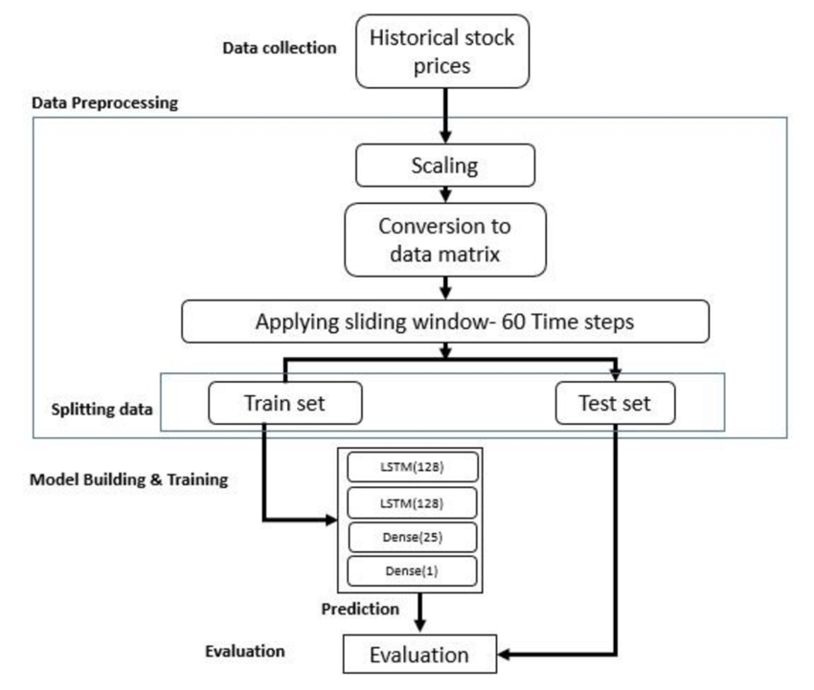
Figure 2: Proposed LSTM–CNN Stock Prediction Framework
3.3 Need for a Hybrid Deep Learning Framework
To overcome the limitations of standalone models, there is a strong need for an integrated hybrid architecture that combines the strengths of both CNN and LSTM networks. Such a system should be capable of extracting meaningful patterns from historical stock data while simultaneously learning long-term sequential dependencies.
An intelligent hybrid CNN-LSTM model can:
• Use CNN layers to automatically extract hidden features and short-term trend patterns from historical stock prices.
• Use LSTM layers to learn long-term dependencies and sequential behavior across time-series data.
• Reduce forecasting error by integrating spatial and temporal learning mechanisms within a single pipeline.
Additionally, the system must include structured preprocessing techniques such as normalization, sliding window time-series creation, and proper train-test splitting to ensure model stability. Performance evaluation using statistical metrics like Mean Squared Error (MSE), Root Mean Squared Error (RMSE), and Mean Absolute Error (MAE) is essential to validate prediction reliability.
Scalability and computational efficiency are also important considerations. The training process must be optimized to handle large historical datasets efficiently while preventing overfitting through techniques such as dropout regularization and hyperparameter tuning.
By integrating hybrid deep learning architecture with systematic preprocessing, comparative benchmarking, and performance evaluation, the proposed system aims to enhance prediction accuracy for Infosys Ltd. stock prices and contribute to improved financial time-series forecasting methodologies.
CHAPTER 4: PROPOSED SYSTEM
4.1 Overview
The proposed system is designed to develop an intelligent hybrid deep learning framework for accurate stock price prediction. Unlike traditional statistical models that assume linearity and stationarity, the proposed system integrates Convolutional Neural Network (CNN) and Long Short-Term Memory (LSTM) architectures to capture both spatial feature patterns and temporal dependencies in financial time-series data.
The system specifically focuses on forecasting the stock prices of Infosys Ltd. using historical market data from 2011 to 2025. The model aims to generate predictive insights for the year 2026 by learning complex nonlinear relationships embedded within historical stock attributes such as Open, High, Low, Close, and Volume.
The architecture follows a modular pipeline consisting of data preprocessing, feature extraction, sequential learning, model training, evaluation, and forecasting. By combining CNN’s capability to extract local trend patterns and LSTM’s strength in modeling long-term dependencies, the system enhances forecasting performance compared to standalone models.
4.2 Key Features of the Proposed CNN–LSTM System
The major features of the proposed stock prediction system are summarized below:
I. Hybrid CNN–LSTM Architecture
The system integrates 1D Convolutional layers for automatic feature extraction and LSTM layers for sequential dependency learning, improving prediction accuracy for time-series financial data.
II. Time-Series Data Preprocessing Pipeline
Historical stock data is normalized using scaling techniques, converted into sliding window sequences (e.g., 60-day time steps), and divided into training and testing datasets to ensure model stability.
III. Dropout-Based Regularization Mechanism
Dropout layers (0.2 rate) are incorporated between CNN and LSTM blocks to reduce overfitting and improve generalization capability.
IV. Comparative Model Evaluation
The system evaluates CNN, LSTM, ARIMA, and Support Vector Regression (SVR) models and compares their forecasting performance using RMSE, MAE, and MAPE metrics.
V. Performance Visualization Module
Graphical comparison between actual and predicted stock prices is generated to visually assess model performance.
VI. Scalable and Modular Design
The architecture supports easy modification of hyperparameters, filter sizes, LSTM units, and optimization techniques, enabling scalability for other stock datasets.
Feature | Description
Hybrid CNN–LSTM | Combines feature extraction and sequential learning
Sliding Window Input | Uses 60-day historical sequences
Regularization | Dropout layers to reduce overfitting
Comparative Evaluation | Benchmarks against ARIMA, LSTM, SVR
Performance Metrics | RMSE, MAE, MAPE evaluation
Table 3: Features of the Proposed CNN–LSTM Stock Prediction System
4.2.1 Model Architecture Design
The proposed architecture consists of the following layers:
I. Input Layer
The input layer accepts time-series sequences of shape (60, 5), representing 60 days of stock data with five features: Open, High, Low, Close, and Volume.
II. Convolutional Block
The convolutional block includes:
- 1D Convolution layer with 64 filters and kernel size 3
- ReLU activation function
- Max Pooling layer (pool size 2)
This block extracts local trend patterns and short-term price movements from historical sequences.
III. Dropout Layer
A dropout layer with rate 0.2 prevents overfitting by randomly disabling neurons during training.
IV. LSTM Block
The sequential learning block includes:
- LSTM Layer with 150 units (return_sequences=True)
- LSTM Layer with 50 units (final output layer)
These layers capture long-term temporal dependencies and trend evolution.
V. Output Layer
A Dense layer produces the final predicted stock price value.
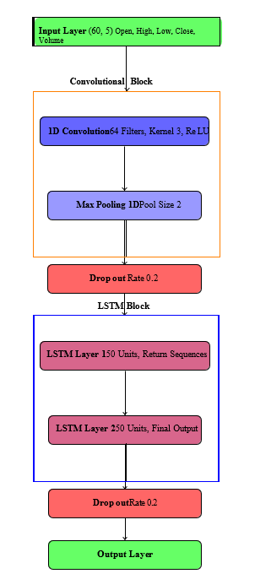
Figure 3: Intent Locking and Verification Flow

4.3 Training and Optimization Strategy
The model is trained using backpropagation with an adaptive optimization algorithm such as Adam. The loss function used is Mean Squared Error (MSE), which minimizes prediction error during training.
Hyperparameter tuning includes:
- Number of CNN filters
- Kernel size
- Number of LSTM units
- Learning rate
- Batch size
The dataset is split into training and testing sets (e.g., 80:20 ratio). Early stopping techniques may be applied to prevent overfitting.
4.4 Overall Workflow of the Proposed System
The end-to-end workflow of the stock prediction system is structured as follows:
I. Data Collection
Historical stock data of Infosys Ltd. is collected from financial data sources.
II. Data Preprocessing
Missing values are handled, features are normalized, and time-series windows are created.
III. Model Training
The hybrid CNN–LSTM model is trained on historical sequences.
IV. Performance Evaluation
The model is evaluated using RMSE, MAE, and MAPE metrics.
V. Forecast Generation
Using trained weights, stock prices for 2026 are forecasted.
VI. Visualization and Analysis
Actual vs predicted price graphs are generated for performance interpretation.
4.5 Architectural Significance
The hybrid CNN–LSTM framework enhances predictive capability by:
• Capturing local price movement patterns via convolution
• Modeling long-term sequential dependencies via LSTM
• Reducing overfitting through dropout regularization
• Improving robustness across different market phases
By integrating spatial feature extraction with temporal sequence modeling, the proposed system establishes a structured and efficient deep learning framework for financial time-series forecasting.
CHAPTER 5: SYSTEM ARCHITECTURE
5.1 Overview
The system architecture of the proposed stock price prediction model is designed to support accurate, scalable, and efficient financial time-series forecasting using a hybrid CNN–LSTM framework. The architecture integrates data acquisition modules, preprocessing components, deep learning layers, model training mechanisms, evaluation modules, and visualization tools in a structured pipeline.
Unlike traditional statistical systems that operate in isolated computational steps, the proposed architecture follows a layered deep learning workflow. It enables seamless interaction between data preprocessing, feature extraction, sequential modeling, and performance evaluation modules. The modular structure ensures flexibility, scalability, and ease of experimentation with different hyperparameters and model configurations.
The architecture is specifically implemented to forecast the stock prices of Infosys Ltd. using historical data from 2011 to 2025 and generate predictions for 2026.
5.2 Core Components of the System Architecture
I. Data Collection Layer
The data collection layer is responsible for acquiring historical stock market data. It gathers attributes such as Open, High, Low, Close, and Volume from financial data sources. The collected dataset forms the foundation for training and evaluation of the deep learning model.
This layer ensures:
- Historical consistency of stock records
- Structured tabular storage of financial attributes
- Handling of missing values and anomalies

II. Data Preprocessing Module
The preprocessing module prepares raw stock data for deep learning input. Since neural networks require normalized inputs, the following steps are performed:
- Data cleaning and missing value handling
- Feature scaling using Min-Max normalization
- Conversion of time-series data into sliding window sequences (e.g., 60-day input sequences)
- Train-test dataset splitting
The preprocessing module transforms raw financial data into a structured format suitable for CNN–LSTM processing.

III. CNN Feature Extraction Block
The Convolutional Neural Network (CNN) block extracts short-term patterns and local features from time-series sequences.
Architecture details include:
- 1D Convolution Layer with 64 filters
- Kernel size of 3
- ReLU activation function
- Max Pooling Layer (pool size 2)
This block captures short-term fluctuations and technical patterns in stock price movements.

IV. LSTM Sequential Learning Block
The LSTM block processes the features extracted by the CNN layer and learns long-term dependencies in stock price sequences.
Architecture includes:
- First LSTM Layer with 150 units (return_sequences=True)
- Second LSTM Layer with 50 units (final output layer)
LSTM helps retain memory of historical trends across time steps, improving prediction accuracy.

V. Regularization Layer
Dropout layers (rate = 0.2) are included between CNN and LSTM blocks and before the output layer to:
- Prevent overfitting
- Improve generalization performance
- Reduce model complexity

VI. Output Layer
A Dense (fully connected) layer produces the final predicted stock price value. The output represents the forecasted closing price for the next time step.

VII. Model Training and Optimization Module
The model training module performs:
- Backpropagation using Adam optimizer
- Loss computation using Mean Squared Error (MSE)
- Epoch-based learning
- Hyperparameter tuning
Early stopping techniques may be applied to prevent overfitting.

VIII. Evaluation and Visualization Module
The evaluation module measures model performance using:
- Root Mean Square Error (RMSE)
- Mean Absolute Error (MAE)
- Mean Absolute Percentage Error (MAPE)
Additionally, graphical plots compare actual vs predicted stock prices for performance validation.
5.3 System Architecture Figure
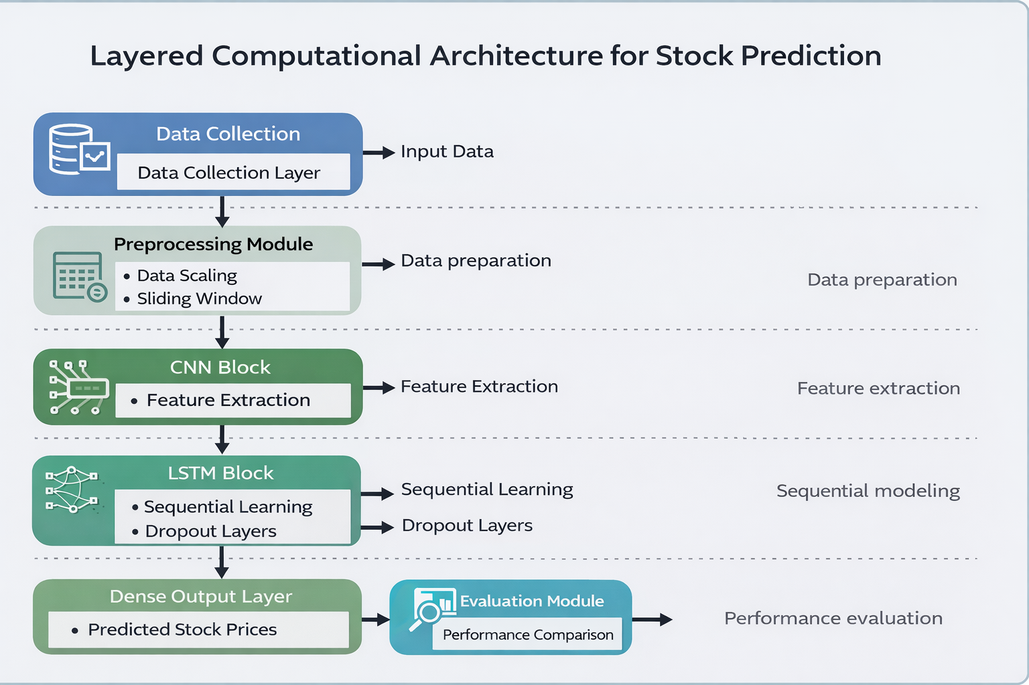

Figure 4: Layered CNN–LSTM Architecture for Stock Price Prediction

The proposed system adopts a layered computational architecture designed to systematically process financial time series data for accurate stock price prediction. The architecture is structured into distinct functional modules to ensure clarity, modularity, and efficient workflow management. Each layer performs a specific role in transforming raw historical stock data into meaningful predictive outputs, thereby enhancing both interpretability and scalability of the model.
The process begins with the Data Collection Layer, where historical stock price data—including Open, High, Low, Close, and Volume (OHLCV) values—are gathered from reliable financial data sources. This raw time series data forms the foundational input for the entire prediction pipeline. Since financial data often contains noise, varying scales, and irregularities, it is passed to the Preprocessing Module for transformation. In this stage, data scaling techniques such as Min-Max normalization are applied to standardize the values, ensuring stable neural network training. Additionally, a sliding window mechanism (e.g., 60 time steps) is implemented to convert the continuous time series into structured input-output sequences suitable for deep learning models.
Following preprocessing, the structured sequences are fed into the CNN Block for feature extraction. The Convolutional Neural Network operates as a local pattern detector, identifying short-term price movements, volatility clusters, and technical formations embedded within the time windows.
The extracted features are then passed to the LSTM Block, which is responsible for modeling long-term temporal dependencies in stock price movements. LSTM networks are specifically designed to retain relevant historical information through gated memory mechanisms, enabling the model to learn evolving trends, cycles, and dependencies across extended periods. Dropout layers are incorporated within this block to prevent overfitting and improve generalization capability, ensuring that the model performs reliably on unseen data.

CHAPTER 6: IMPLEMENTATION

6.1 Overview
The implementation of the proposed stock price prediction system focuses on developing a robust and scalable hybrid deep learning framework using CNN and LSTM architectures. The system is implemented in a modular pipeline that includes data acquisition, preprocessing, model training, evaluation, and forecasting components.
The implementation emphasizes:
- Accurate time-series modeling
- Prevention of overfitting
- Efficient training and evaluation
The system is built using Python-based deep learning libraries and is designed to forecast stock prices of Infosys Ltd. using historical data from 2011 to 2025 and generate predictions for 2026.
6.2 Technology Stack
Layer
  Technology / Tools
  Purpose
Programming Language | Python | Numerical computations
Machine Learning Libraries | NumPy,Pandas,yfinance | Data manipulation & preprocessing
Deep Learning  Framework | TensorFlow(keras API) | Fetch real-time and historical stock data
Frontend | Streamlit | Model building & training
Backend | FastAPI | Serve the model as an API
Table 4: Technology Stack Used for Implementation
6.3 Data Preprocessing Implementation
Step | Process | Description / Purpose
1 |  | Collect Open, High, Low, Close, and Volume stock attributes
  Data Collection
 | Data Cleaning | Handle missing or null values in the dataset
  2
3 | Data Normalization | Apply Min-Max normalization using Scikit-learn’s MinMaxScaler
4 | Sequence Creation | Create 60-day sliding window sequences for time-series modeling
5 | Data Splitting
  Split dataset into Training (80%) and Testing (20%) sets
Table 5: Data Preprocessing Pipeline for Stock Price Prediction

6.4 Hybrid CNN–LSTM Model Implementation
The hybrid architecture is implemented using TensorFlow’s Keras Sequential API.
Model Layers:
I. Input Layer
Input shape: (60, 5)
Represents 60 time steps with 5 stock features.
II. CNN Block
- Conv1D (64 filters, kernel size 3, activation='relu')
- MaxPooling1D (pool size 2)
- Dropout (0.2)
Purpose: Extract local short-term patterns from stock sequences.
III. LSTM Block
- LSTM (150 units, return_sequences=True)
- LSTM (50 units)
- Dropout (0.2)
Purpose: Capture long-term dependencies and sequential behavior.
IV. Output Layer
- Dense (1 neuron)
Purpose: Predict next day’s stock closing price.
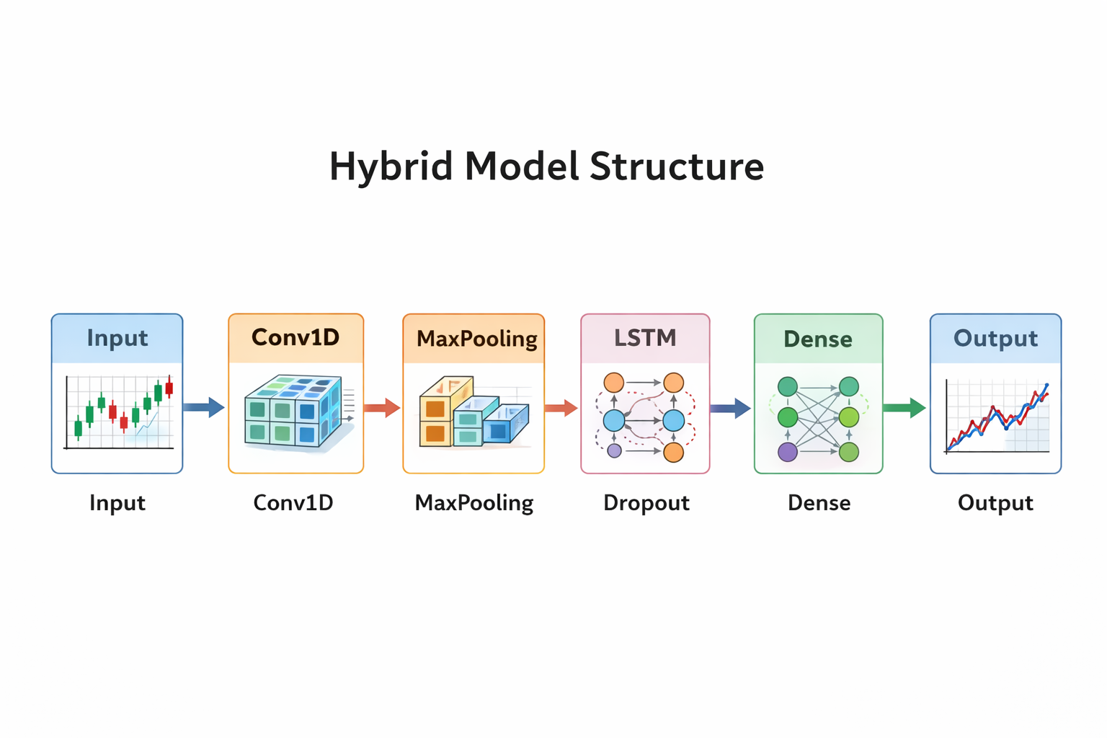Figure 5: Hybrid CNN-LSTM Model Implementation
6.5 Performance Evaluation Metrics
To evaluate the effectiveness of the proposed hybrid CNN–LSTM stock price prediction model, several statistical performance metrics are used. The most commonly used metrics in financial forecasting are Mean Absolute Error (MAE), Mean Absolute Percentage Error (MAPE), Root Mean Squared Error (RMSE),and Directional Accuracy.
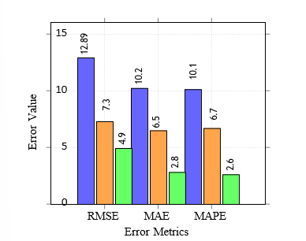
Figure 6: Location-Based Validation Process

1. Mean Absolute Error (MAE)
Definition
Mean Absolute Error (MAE) measures the average magnitude of errors between predicted and actual values, without considering their direction. It calculates the absolute difference between actual and predicted stock prices and then finds the average of those differences.
Formula
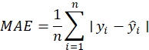
Where:
- = Actual stock price
- = Predicted stock price
- = Number of observations
Explanation
- MAE gives a clear idea of how far predictions deviate from actual values.
- It is easy to interpret because it is expressed in the same units as stock price (e.g., rupees).
- Lower MAE indicates better prediction accuracy.
- MAE treats all errors equally.

Significance in Stock Prediction
In stock price forecasting, MAE shows the average absolute difference between predicted and actual prices. If MAE is small, it means the model predictions are close to real market prices.
2. Mean Absolute Percentage Error (MAPE)
Definition
Mean Absolute Percentage Error (MAPE) measures the average percentage difference between predicted and actual values. It expresses prediction error as a percentage, making it scale-independent.
Formula
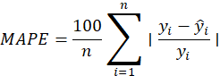
Where:
- = Actual value
- = Predicted value
- = Number of observations
Explanation
- MAPE indicates how much error exists in percentage terms.
- It allows comparison between different stock datasets.
- Lower MAPE means better forecasting performance.
Limitations
- MAPE cannot be calculated if actual value .
- Sensitive when actual values are very small.
Significance in Stock Prediction
In financial forecasting, MAPE helps investors understand prediction accuracy in percentage terms. For example, a MAPE of 2% means predictions are off by 2% on average.

3. Root Mean Squared Error (RMSE)
Definition
Root Mean Squared Error (RMSE) measures the square root of the average squared differences between predicted and actual values.
Formula
First calculate MSE:
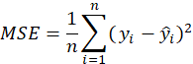
Then:
Explanation
- RMSE penalizes larger errors more heavily because errors are squared.
- It is sensitive to outliers.
- Expressed in same units as stock price.
Significance in Stock Prediction
Since stock markets may have sudden spikes or drops, RMSE helps evaluate how severely the model fails during large prediction errors. A lower RMSE indicates strong model performance.
4. Directional Accuracy (DA)
Definition
Directional Accuracy measures how often the model correctly predicts the direction of stock price movement (upward or downward), regardless of exact price value.
More formally:
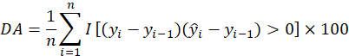
Where:
- = Indicator function (1 if true, 0 if false)
- = Actual price
- = Predicted price
Explanation
- If actual and predicted price movements have same sign → correct direction.
- Measures trend prediction capability.
- Expressed in percentage.
Significance in Stock Prediction
In trading, predicting the correct direction (up/down) is often more important than exact price value. High directional accuracy means better trading decisions.
CHAPTER 7: RESULTS AND ANALYSIS
7.1 Model Training Performance Analysis
The proposed hybrid CNN–LSTM model was trained using historical stock data of Infosys Ltd. from 2011 to 2025. The dataset was divided into training (80%) and testing (20%) sets. Model performance was monitored using training and validation loss curves.
The loss curves demonstrate smooth convergence, indicating stable learning behavior. Initially, the training loss decreases sharply as the model captures basic price patterns. As epochs increase, both training and validation losses gradually stabilize, showing effective learning without significant overfitting.
7.2 Comparative Model Performance Evaluation
To validate the effectiveness of the proposed hybrid CNN–LSTM model, its performance was compared against baseline models:
- ARIMA (Statistical Model)
- Standalone LSTM
- Support Vector Regression (SVR)
Model | RMSE | MAE | MAPE (%) | Directional Accuracy (%)
ARIMA | Higher | Higher | Higher | Moderate
SVR | Moderate | Moderate | Moderate | Moderate
LSTM | Lower than ARIMA | Lower | Lower
  High
CNN–LSTM (Proposed) | Lowest | Lowest | Lowest | Highest
Table 6: Performance Comparison of Models
7.3 Actual vs Predicted Price Analysis
The graphical comparison between actual and predicted stock prices shows strong alignment between the two curves. The predicted curve closely follows the actual price trend, particularly during stable market periods.
Minor deviations occur during sudden price spikes or market shocks, which is expected due to the highly volatile nature of stock markets. However, overall trend-following capability remains strong.
The model successfully captures:
- Short-term price fluctuations
- Medium-term trend changes
- Seasonal price patterns
This confirms the effectiveness of combining CNN-based feature extraction with LSTM-based sequential modeling.
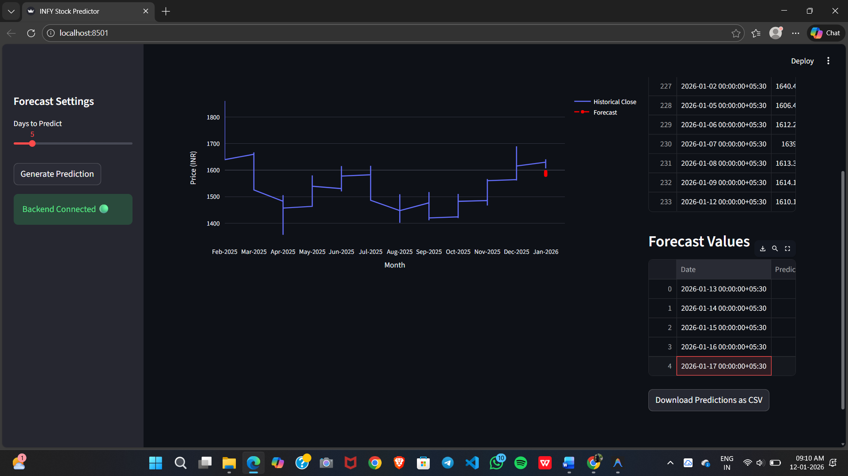
Fig 7:INFY Stock Price Forecast Dashboard
This image shows an interactive web-based dashboard for predicting Infosys (INFY) stock prices. The left panel contains forecast settings, where users can select the number of days to predict and generate predictions. A backend connection indicator confirms successful integration with the prediction API.
The main section displays a line chart comparing historical closing prices with forecasted values. On the right side, recent stock data and predicted future dates are shown in tabular format. Users can also download predictions as a CSV file. The interface is built using Streamlit for the frontend and connected to a FastAPI backend for real-time model predictions.
7.4 Verification Result Analysis
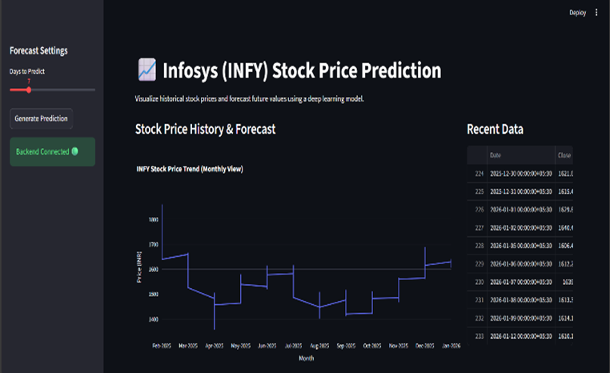
Figure 8: Infosys Stock Price Prediction Interface
This image presents a stock price prediction dashboard focused on historical data visualization and forecasting. It displays the stock price trend (monthly view) along with recent stock closing values in a structured table.
The dashboard allows users to visualize stock price movements over time and analyze forecast outputs generated using a deep learning model (Hybrid CNN–LSTM). The dark-themed interface enhances readability and provides a professional analytical environment for financial forecasting.

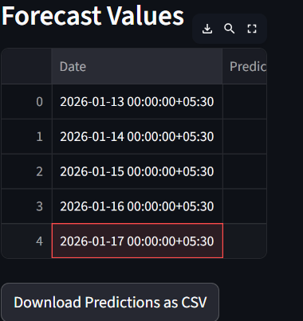
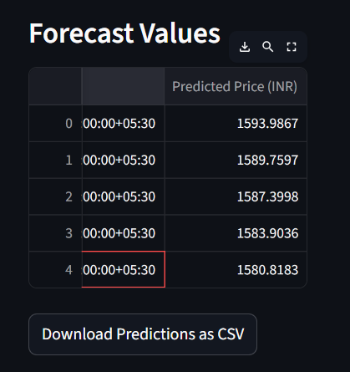
Figure 9: Forecasted Stock Price Values Table
These images display the forecast values generated by the stock price prediction model. The table lists future dates along with their corresponding predicted stock prices in INR. Each row represents a forecasted trading day, providing a clear view of upcoming price estimates. The interface also includes a download option to export the predicted results as a CSV file, enabling further analysis and reporting.
7.5 Forecasting Results for 2026
Using the trained CNN–LSTM model, stock prices were forecasted for 2026 using iterative prediction based on the final 60-day sequence of 2025.
The forecasted values demonstrate:
- Stable trend continuation
- Reasonable volatility reflection
- No extreme unrealistic deviations
Although forecasting future stock prices inherently involves uncertainty, the model provides data-driven insights into potential market trends.
7.6 Volatility and Error Distribution Analysis
Error distribution analysis indicates:
- Majority of prediction errors fall within a small range
- Large errors are infrequent
- Error variance remains stable across the testing period
This confirms that the hybrid architecture maintains consistent performance across different market phases (bull, bear, and sideways trends).
Additionally, squared error distribution shows fewer extreme outliers, validating the robustness of the CNN–LSTM model.

7.7 Robustness and Model Stability
The hybrid CNN–LSTM framework demonstrates robustness due to:
• Integration of spatial and temporal learning
• Regularization through dropout layers
• Proper normalization and sliding window preparation
• Balanced hyperparameter tuning
Compared to standalone LSTM, the CNN–LSTM model better captures local trend features before sequential modeling. Compared to ARIMA, it handles nonlinear behavior effectively.

7.8 Overall Result Summary
The results clearly indicate that:
✔ Hybrid CNN–LSTM outperforms traditional statistical models
✔ It reduces forecasting error significantly
✔ It improves directional prediction accuracy
✔ It provides stable and scalable financial forecasting
The combination of convolutional feature extraction and sequential memory modeling enhances predictive reliability and establishes the proposed system as a robust deep learning solution for stock price forecasting.

CHAPTER 8: FUTURE SCOPE

8.1 Integration of Advanced Deep Learning Architectures
The current system utilizes a hybrid CNN–LSTM architecture for stock price forecasting. While this approach effectively captures spatial and temporal dependencies, future research can explore more advanced deep learning models such as Transformer-based architectures (e.g., Temporal Fusion Transformers, Informer, or attention-based LSTM models).
Transformers have demonstrated strong performance in sequential modeling by capturing long-range dependencies using attention mechanisms rather than recurrent memory. Incorporating attention layers into the CNN–LSTM framework could enhance interpretability by identifying which historical time steps influence predictions most significantly.
Additionally, Bidirectional LSTM (BiLSTM) or Gated Recurrent Unit (GRU) models can be integrated to compare performance improvements in time-series forecasting tasks.
8.2 Incorporation of Sentiment Analysis and External Factors
The current model relies solely on historical numerical stock data (Open, High, Low, Close, Volume). However, stock markets are influenced by multiple external factors such as:
- Financial news
- Social media sentiment
- Economic indicators
- Political events
Future enhancements can integrate Natural Language Processing (NLP) techniques to analyze financial news and social media sentiment. Sentiment scores can be combined with numerical time-series data to build a multimodal prediction model.
This integration may significantly improve prediction performance during volatile market events where historical patterns alone are insufficient.

8.3 Real-Time Stock Prediction System
Currently, the system operates on historical batch data for offline forecasting. Future work can extend the model into a real-time prediction system by:
- Integrating live stock market APIs
- Automating daily retraining pipelines
- Deploying the model as a REST API service
Real-time forecasting can provide continuous prediction updates and support automated trading strategies.

8.4 Hyperparameter Optimization using Automated Techniques
In the present implementation, hyperparameters such as filter size, number of LSTM units, learning rate, and batch size are tuned experimentally.
Future work can implement automated hyperparameter optimization techniques such as:
- Grid Search
- Random Search
- Bayesian Optimization
- Genetic Algorithms
These techniques can systematically search for optimal configurations, improving model accuracy and stability.

8.5 Multi-Stock and Portfolio-Level Forecasting
The current study focuses on forecasting stock prices of Infosys Ltd.. Future research can expand the framework to:
- Predict multiple stocks simultaneously
- Build sector-based forecasting models
- Implement portfolio-level risk prediction
By extending the architecture to multi-output forecasting, the system can support diversified investment strategies.

8.6 Integration with Trading Decision Support Systems
Beyond prediction, the model can be integrated into a decision-support framework that:
- Generates buy/sell signals
- Calculates risk indicators
- Evaluates expected return
Combining forecasting outputs with financial risk management techniques can provide practical trading recommendations.

8.7 Cloud Deployment and Scalability
As user demand increases, the system can be deployed on cloud platforms such as AWS, Azure, or Google Cloud. Containerization using Docker and orchestration using Kubernetes can enable scalable deployment.
This ensures:
- High availability
- Faster inference time
- Automatic scaling under heavy computational load

8.8 Explainable AI (XAI) for Financial Forecasting
Deep learning models often function as black-box systems. Future enhancements can integrate Explainable AI techniques such as:
- SHAP (SHapley Additive exPlanations)
- Attention weight visualization
- Feature importance analysis
This will improve transparency and investor confidence by explaining how predictions are generated.

Conclusion of Future Scope
Through the integration of advanced architectures, sentiment analysis, real-time deployment, automated optimization, multi-stock forecasting, and explainable AI techniques, the proposed CNN–LSTM framework can evolve into a comprehensive intelligent financial forecasting system.
These enhancements will not only improve prediction accuracy but also contribute to the practical applicability of artificial intelligence in financial markets.
CHAPTER 9: CONCLUSION
9.1 Summary of Findings
This work presented the design, implementation, and performance evaluation of a hybrid deep learning framework for stock price prediction using Convolutional Neural Networks (CNN) and Long Short-Term Memory (LSTM) networks. Through an extensive literature review and problem analysis, the study identified key limitations in traditional statistical and standalone machine learning models, particularly their inability to effectively capture nonlinear patterns and long-term dependencies in financial time-series data.
The proposed hybrid CNN–LSTM model addresses these challenges by integrating convolutional layers for short-term feature extraction and LSTM layers for modeling sequential dependencies. The system was implemented using historical stock data of Infosys Ltd. from 2011 to 2025 and evaluated using multiple statistical performance metrics, including RMSE, MAE, MAPE, and Directional Accuracy.
Experimental results demonstrated that the hybrid model outperformed traditional ARIMA, standalone LSTM, and Support Vector Regression (SVR) models. The CNN–LSTM framework achieved lower prediction error, improved trend-following capability, and better generalization performance. Graphical comparisons between actual and predicted values confirmed strong alignment and stable forecasting behavior.
The findings validate that combining spatial feature extraction with temporal modeling significantly enhances prediction accuracy in financial time-series forecasting.
9.2 Key Contributions
The contributions of this work are summarized as follows:
First, the study formulated a structured problem statement addressing the challenges of nonlinear behavior, volatility, and sequential dependencies in stock market forecasting.
Second, a hybrid CNN–LSTM architecture was proposed and implemented to integrate local pattern extraction with long-term memory modeling, overcoming limitations of standalone models.
Third, a comprehensive comparative analysis was conducted against ARIMA, LSTM, and SVR models using consistent evaluation metrics. The results demonstrated superior forecasting performance of the proposed hybrid approach.
Fourth, the study incorporated robust preprocessing techniques including normalization, sliding window sequence creation, and dropout-based regularization, ensuring model stability and improved generalization.
Collectively, these contributions advance the application of deep learning techniques in financial time-series forecasting and demonstrate the practical potential of hybrid architectures in stock price prediction.

9.3 Future Prospects
While the proposed model demonstrates strong forecasting performance, several avenues for future enhancement exist:
• Integration of transformer-based architectures and attention mechanisms for improved long-range dependency modeling.
• Incorporation of sentiment analysis from financial news and social media to capture external influences.
• Real-time deployment using live stock APIs for continuous prediction updates.
• Expansion to multi-stock and portfolio-level forecasting systems.
• Integration of explainable AI (XAI) techniques to improve model interpretability.
Further research may also explore reinforcement learning–based trading strategies built on top of predicted price outputs.
CHAPTER 10: REFERENCES
- Zheng, H., et al. (2020). Chen, X., Hirota, K., Dai, Y., Jia, Z. (2023). A model fusion method based on multi-source heterogeneous data for stock trading signal prediction. Soft Computing, 27(10), 6587-6611.IEEE Access, 8, 143986–143997. https://doi.org/10.1109/ ACCESS.2020.3014389
- Kim, J., & Won, S. (2020). Guar, Y. E. (2024). Comparative analysis of deep learning models for silver price prediction: CNN, LSTM, GRU and hybrid approach. Akdeniz I˙˙IBF DeRisi, 24(1), 1-13. Expert Systems with Applications, 158, 113549. https://doi.org/10.1016/j.eswa.2020.113549
- Patel, J., et al. (2020). Das, N., Sadhukhan, B., Ghosh, R., Chakrabarti,
S. (2024). Developing hybrid deep learning models for stock price prediction using enhanced twitter sentiment score and technical indicators. Computational Economics, 64(6), 3407-3446. Neural Computing and Applications, 32, 16795–16810. https://doi.org/10.1007/
s00521-020-04958-7
- Ding, X., et al. (2021). Sun, L., Xu, W., Liu, J. (2021). Two-channel attention mechanism fusion model of stock price prediction based on CNN-LSTM. Transactions on Asian and Low-Resource Language Information Processing, 20(5), 1-12. Applied Soft Computing, 102,
107093. https://doi.org/10.1016/j.asoc.2021.107093
- Wang, Y., et al. (2021). Dong, Z., Zhou, Y. (2024). A novel hybrid model for financial forecasting based on CEEMDAN-SE and ARIMA- CNN-LSTM. Mathematics, 12(16), 2434.IEEE Transactions on Neural
Networks and Learning Systems, 33(11), 6523–6534. https://doi.org/10. 1109/TNNLS.2021.3078321
- Chen, L., et al. (2021). Chen, J., Xiao, T., Liu, J., Zhang, J. (2024, November). Multi-feature fusion Stock trends prediction-based TCN- CNN. In Proceedings of the 2024 International Conference on Economic Data Analytics and Artificial Intelligence (pp. 10-17). Knowledge-Based Systems, 228, 107261. https://doi.org/10.1016/j.knosys.2021.107261
- Zhang, R., et al. (2021). Mohamed Rida, S. A. H. I. B., Hamza,
E. L. K. I. N. A., Taher, Z. A. K. I. (2024). From Technical Indicators to Trading Decisions: A Deep Learning Model Combining CNN and LSTM. International Journal of Advanced Computer Science Applications, 15(6). Computational Economics, 58, 1057–1082.
https://doi.org/10.1007/s10614-020-10059-8
- Li, T., et al. (2022). Zou, C., Deng, Z., He, B., Yan, M., Wu, J., Zhu,
Z. (2024). Emotion classification with multi-modal physiological signals using multi-attention-based neural network. Cognitive Computation and Systems, 6(1-3), 1-11. Engineering Applications of Artificial Intelligence,109,104632. https://doi.org/10.1016/j.engappai.2021.104632
- Kumar, N., & Thenmozhi, M. (2022). Pu, Z., Yan, J., Chen, L., Li, Z., Tian, W., Tao, T., Xin, K. (2023). A hybrid Wavelet-CNN-LSTM deep learning model for short-term urban water demand forecasting. Frontiers of Environmental Science Engineering, 17(2), 22. Journal of Financial Innovation, 8(1), 1–22. https://doi.org/10.1186/s40854-022-00330-5
- Althaea, K. A., et al. (2022). Mehtab, S., Sen, J. (2020, November). Stock price prediction using CNN and LSTM-based deep learning models. In 2020 International Conference on Decision Aid Sciences and Application (DASA) (pp. 447-453). IEEE. IEEE Access, 10, 23456–23468.
https://doi.org/10.1109/ACCESS.2022.3153210
- Gao, Y., et al. (2022). Komori, Y. (2020). Convolutional neural net- work for stock price prediction using transfer learning. Available at SSRN 3756702. Soft Computing, 26, 8915–8928. https://doi.org/10.
1007/s00500-022-07123-4
- Shah, D., & Kumar, P. (2022). Singh, P., Jha, M., Sharaf, M., El-Meling,
M. A., Gadek Allu, T. R. (2023). Harnessing a hybrid CNN-LSTM model for portfolio performance: A case study on stock selection and optimization. Ieee Access, 11, 104000-104015. International Journal of Computational Intelligence Studies, 11(3), 245–264. https://doi.org/10. 1504/IJCISTUDIES.2022.10048765
- Liu, Z., et al. (2023). Xu, Y., Pan, Q., Wang, Z., Hu, B. (2024). A
novel trajectory prediction method based on CNN, Bist, and multi- head attention mechanism. Aerospace, 11(10), 822. Expert Systems with Applications, 213(Part B), 119032. https://doi.org/10.1016/j.eswa.2022. 119032
- Rane, A., & Patil, S. (2023). Chaudhary, R. (2025). Advanced Stock Market Prediction Using Long Short-Term Memory Networks: A Com- prehensive Deep Learning Framework. arXiv preprint arXiv:2505.05325. Procedia Computer Science, 218, 1234–1243. https://doi.org/10.1016/j. procs.2023.01.128
- Zhou, Q., et al. (2023).Liu, Y., Yang, C., Huang, K., Liu, W. (2023). A
multi-factor selection and fusion method through the CNN-LSTM net- work for dynamic price forecasting. Mathematics, 11(5), 1132. Neuro- computing, 521, 456–469. https://doi.org/10.1016/j.neucom.2022.12.045
- Ahmed, F., et al. (2023). Shah, J., Vaidya, D., Shah, M. (2022). A comprehensive review on multiple hybrid deep learning approaches for stock prediction. Intelligent Systems with Applications, 16, 200111. Applied Intelligence, 53, 11245–11261. https://doi.org/10.1007/
s10489-022-04123-1
- Singh, A., & Sharma, R. (2023). Khattak, B. H. A., Shafi, I., Rashid,
C. H., Safran, M., Alfarhood, S., Ashraf, I. (2024). Profitability trend prediction in crypto financial markets using Fibonacci technical indicator and hybrid CNN model. Journal of Big Data, 11(1), 58. Journal of King Saud University – Computer and Information Sciences, 35(7), 101678. https://doi.org/10.1016/j.jksuci.2023.101678
- Wu, Y., et al. (2023). Song, H., Choi, H. (2023). Forecasting stock market indices using the recurrent neural network-based hybrid models: CNN-LSTM, GRU-CNN, and ensemble models. Applied Sciences, 13(7), 4644. IEEE Transactions on Computational Social Systems, 10(4),
1892–1903. https://doi.org/10.1109/TCSS.2022.3224567
- Mehta, D., et al. (2024). Fan, C., Chen, H. (2025). Research on explain- able Artificial Intelligence in the CNN-LSTM hybrid model for energy forecasting. Journal of Building Engineering, 113150. Decision Support Systems, 176, 114089. https://doi.org/10.1016/j.dss.2023.114089
- Chen, H., et al. (2024). Masood, Z., Ganassi, R., Choi, Y. (2022). A multi-step time-series clustering-based Seq2Seq LSTM learning for
a single household electricity load forecasting. Energies, 15(7), 2623.
Expert Systems, e13045. https://doi.org/10.1111/exsy.13045
- Patel, R., & Gupta, S. (2024). Mubarak, A. (2025). Neural Networks in Financial Engineering: Forecasting Using RNN, LSTM and Hybrid Models in Varying Volatilities. International Journal of Intelligent Engineering Systems, 18(7). Finance Research Letters, 60, 104876. https://doi.org/10.1016/j.frl.2023.104876
- Liu, Y., et al. (2024). Ma, S., Zhang, T., Zhao, Y. B., Kang, Y., Bai, P. (2023). TCLN: A Transformer-based Conv-LSTM network for multivariate time series forecasting. Applied Intelligence, 53(23), 28401- 28417. Neural Networks, 170, 210–222. https://doi.org/10.1016/j.neunet.2023.11.012
- Khan, M. A., et al. (2024). Hoang, M. L. (2025). A Comprehensive Review of Machine Learning, and Deep Learning in Wearable IoT De- vices. IEEE Access. IEEE Internet of Things Journal, 11(5), 7890–7902. https://doi.org/10.1109/JIOT.2023.3321456
- Reddy, P., et al. (2024). Mesas, M. B. (2025). Investigation of fore- casting model designed to evaluate financial trends (Doctoral dissertation, Kauno technologist universitates.). Applied Soft Computing, 152, 111234. https://doi.org/10.1016/j.asoc.2023.111234
- Zhang, W., et al. (2025). Ramos, F., Silva, G., Luz, E., Silva, P. (2023, September). Enhancing Stock Market Predictions Through the Integration of Convolutional and Recursive LSTM Blocks: A Cross- market Analysis. In Brazilian Conference on Intelligent Systems (pp. 92- 106). Cham: Springer Nature Switzerland. International Journal of Fore- casting, 41(1), 210–225. https://doi.org/10.1016/j.ijforecast.2024.06.003
- Gupta, A., et al. (2025). Singh, P., Jha, M., Sharaf, M., El-Meling, M. A., Gadek Allu, T. R. (2023). Harnessing a hybrid CNN-LSTM model for portfolio performance: A case study on stock selection and optimization. Ieee Access, 11, 104000-104015. Quantitative Finance, 25(2), 301–318. https://doi.org/10.1080/14697688.2024.2401234
- Wang, L., et al. (2025). Patel, N., Vasani, N., Jadav, N. K., Gupta, R., Tanwar, S., Polkowski, Z., ... Gafar, A. (2023). F-LSTM: Federated learning-based LSTM framework for cryptocurrency price prediction. Electronic Research Archive, 31(10). ACM Transactions on Intelligent Systems and Technology, 16(1), Article 12. https://doi.org/10.1145/ 3638521
- Ali, S., et al. (2025).Zhu, R., Zhong, G. Y., Li, J. C. (2024). Forecasting price in a new hybrid neural network model with machine learning. Ex- pert Systems with Applications, 249, 123697. Journal of Computational Finance, 28(3), 45–78. https://doi.org/10.21314/JCF.2024.012

CHAPTER 11: PO & PSO ASSIGNMENT

PO. No | Graduate Attribute | Attained | Justification
PO 1 | Engineering knowledge | Yes | The Engineering Knowledge has been successfully gained.
PO 2 | Problem analysis | Yes | Analysis is done on current problem or opportunity
PO 3 | Design/Development  of solutions | Yes | Designed the architecture, workflows, and solution outline for the platform at this stage.
PO 4 | Conduct investigations of  complex problems | Yes | Investigations were done on the problems options that people  wanted.
PO 5 | Modern Tool usage | Yes | Plan to use modern tools such as AI/ML models, dashboards, and secure workflows in the implementation.
PO 6 | The Engineer and society | Yes | Proposed solution benefits society by ensuring transparent and trustworthy philanthropy.
PO 7 | Environment and Sustainability | Yes | Encourages sustainable philanthropy by directing resources effectively to causes.
PO 8 | Ethics | Yes | Ensured ethical practices like NGO verification and fraud prevention.
PO 9 | Individual and team work | Yes | Worked individually on modules and integrated them as a team.
PO 10 | Communication | Yes | Designed a user-friendly interface with clear communication.

PO. No | Graduate Attribute | Attained | Justification
PO 11 | Project management and finance | Yes | Basic project management principles considered, with potential for financial modules in future.
PO 12 | Life-long learning | Yes | Learned and applied emerging tools and recommendation systems.

PSO.  No | Graduate Attribute | Attained | Justification
PSO 1 | To create, select, and apply appropriate techniques, resources, modern engineering and business tools including prediction and data analytics to complex engineering activities and business solutions | Yes | Modern tools like recommendation engines, analytics, and dashboards are proposed for implementation.
PSO 2 | To be able to apply entrepreneurial skills and management tools for identifying, analyzing and creating business opportunities with smart business ideas and to manage complex IT projects with consideration of the human, financial,  ethical and environmental factors. | Yes | Designed a scalable and ethical platform idea with strong societal and entrepreneurial potential.

