Resignation Confirmation Mail Screenshot:

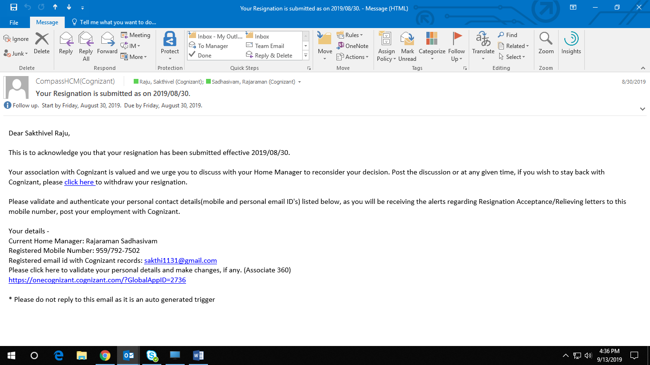

Below screenshot is for my project billing and allocation ends by 30th September 2019

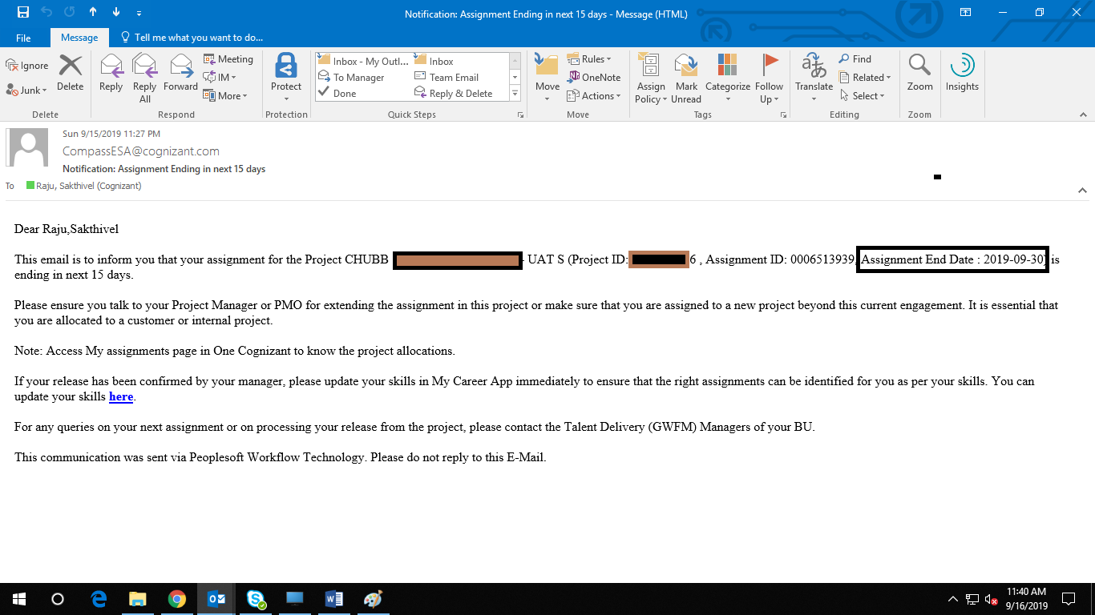

As informed over mobile the below mail screenshot is only the **Auto-approved** Last Working Date mail screenshot (received on 9th Sep 2019). **As confirmed by my supervisor the updated final mail for my Last Working Date (i.e. 15th Oct 2019) will be shared to me within this week.** I shall send the screenshot of the same within end of this week (19th Sep 2019) for sure.

