The code is placed in

C:\Sakthi\WCF\HelloService

C:\Sakthi\WCF\ MVC_Client

C:\Sakthi\WCF\MathsService\MathService

C:\Sakthi\WCF\MathsService\MathServiceClient\MathServiceClient

Service self-hosting

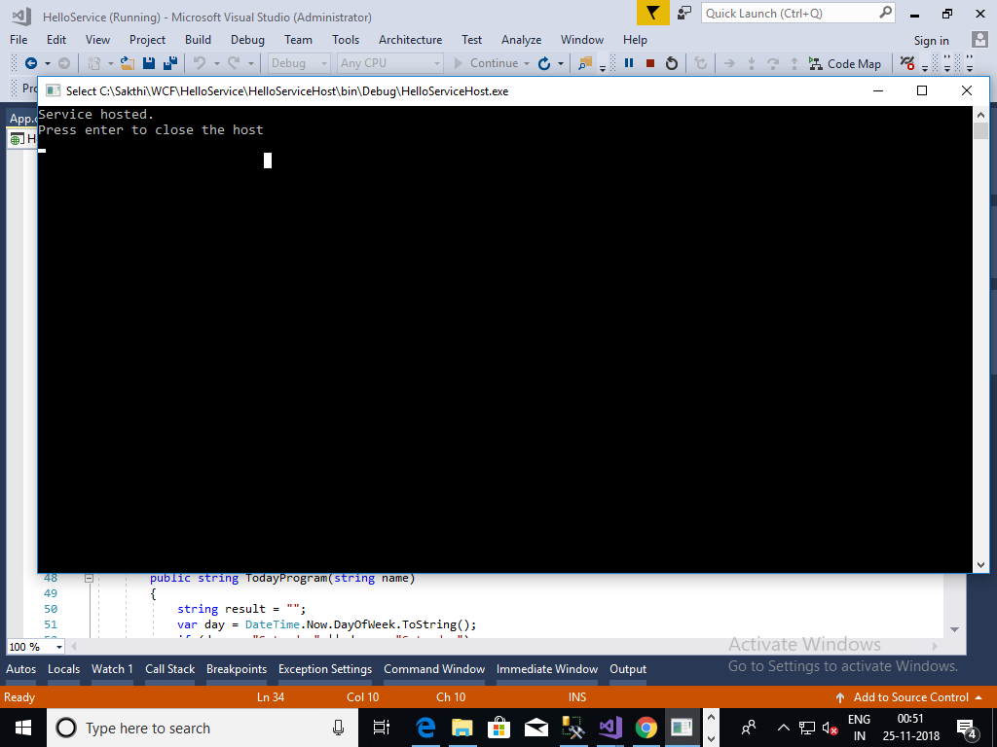

Basic http binding

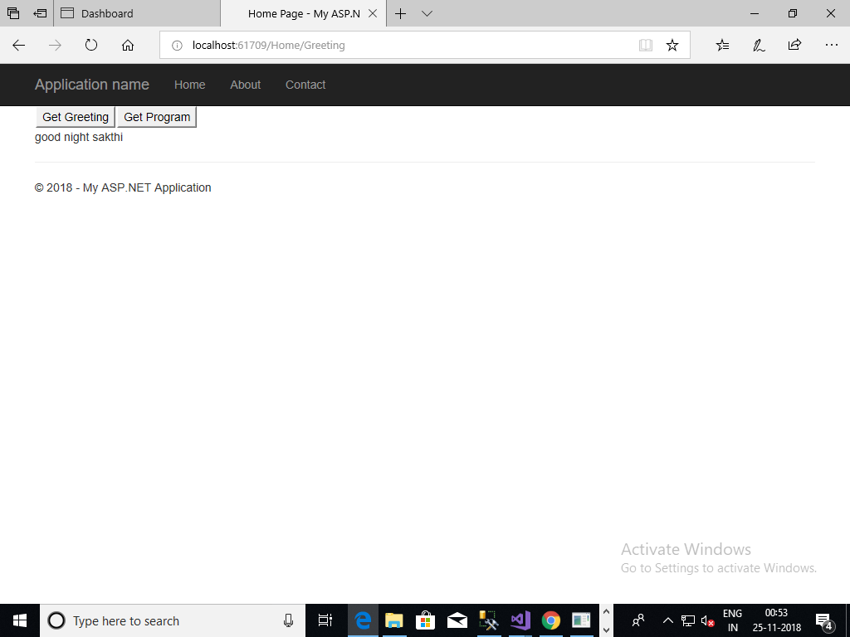

Net tcp binding

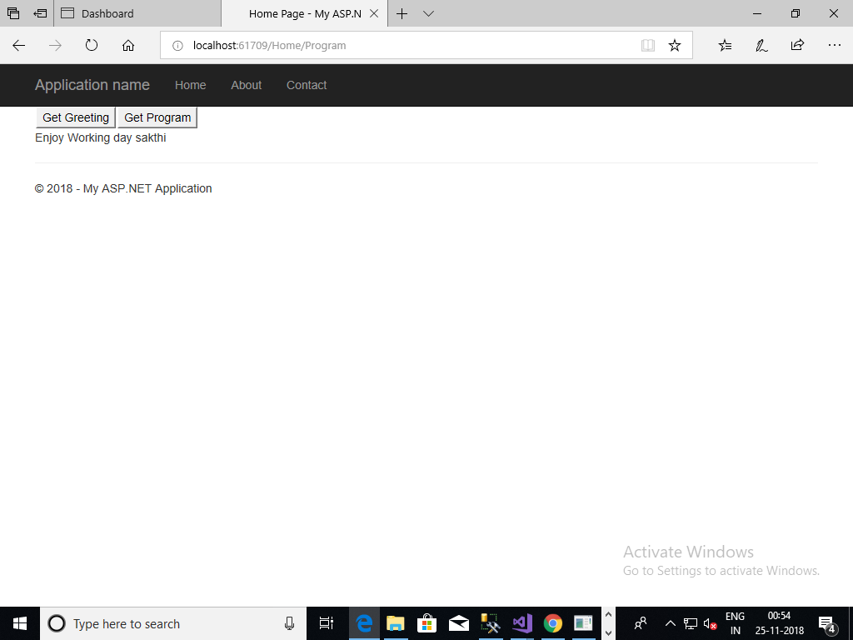

IIS hosting

