SECTION -5.1

5.Write a Java program that will decide if a student gets into Mountville University. Students must have one of the following criteria:

• been a valedictorian or salutatorian of a school of 1400 or more

• had a gpa of 4.0 or better and a SAT score of 1100 or more

• had a gpa of 3.5 or better and an SAT score of 1300 or more

• had a gpa of 3.0 or better and an SAT score of 1500 or more

Code;

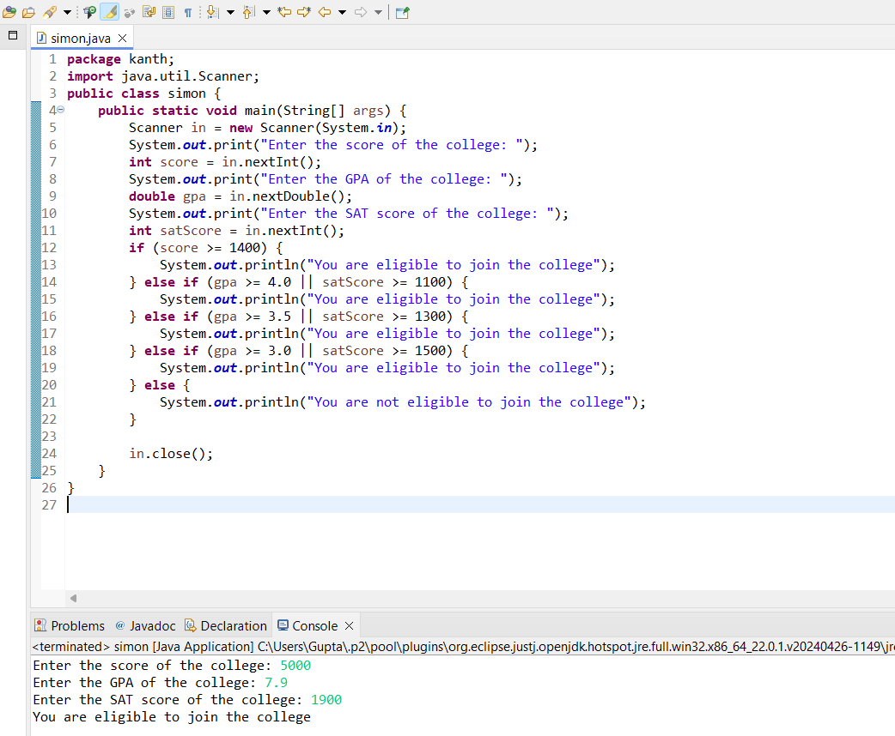

6.A professor in college will allow a student to be excused from the final exam if either of the following is true:

• They have a 90% average or higher in the class and have missed 3 or less class lectures.

• They have a 80% average or higher in the class and have not missed any class lectures.

• The program below will determine whether a student can get out of the exam or not.

• Rewrite the program so only one if statement is used.

import java.util.Scanner;

public class FinalExam{

public static void main(String[] args) {

double average;

int daysAbsent;

boolean exempt=false;

Scanner reader= new Scanner(System.in);

System.out.println("This program will determine if you can get out of the final exam."); System.out.println("Please answer the following questions.");

System.out.println("What is your average in the class?");

average=reader.nextDouble();

System.out.println("How class lectures have you missed?"

daysAbsent=reader.nextInt();

if(average>=90) {

if(daysAbsent<=3)

exempt=true;

} else if(average>=80) {

if(daysAbsent<=0)

exempt=true;

}

if(exempt)

System.out.println("Congratulations! You are exempt from the final exam.");

Else

System.out.println("You are not exempt from the final exam.");

}

}

PROGRAM

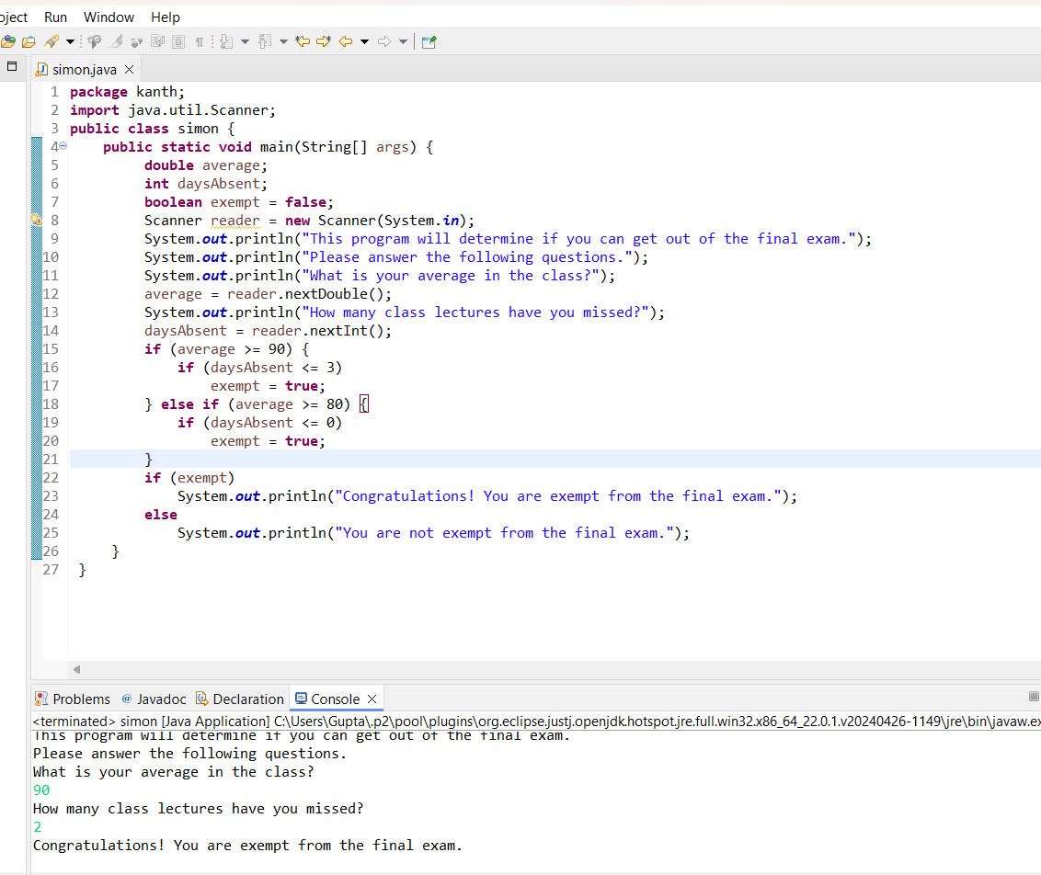

7. Write a program that calculates the number of buckets of paint to use for a room and the optimal number of cans to purchase. You need to ask the height of the room and the length and width of the room. The room is rectangular. You must paint the walls and the ceiling but not the floor. There are no windows or skylights.

You can purchase the following size buckets of paint.

• 5-liter bucket costs $15 each and covers 1500 square feet.

• 1-liter bucket costs $4 and covers 300 square feet.