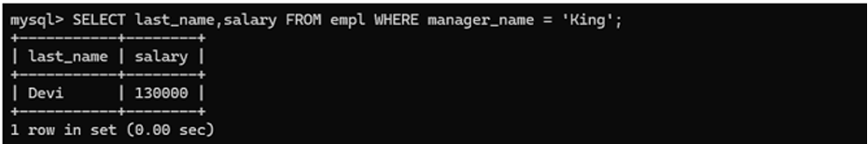

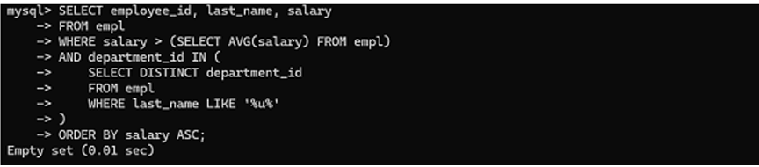

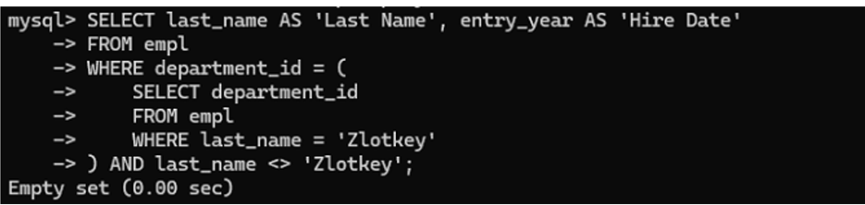

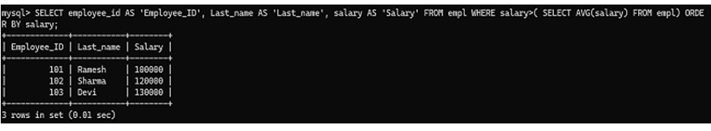

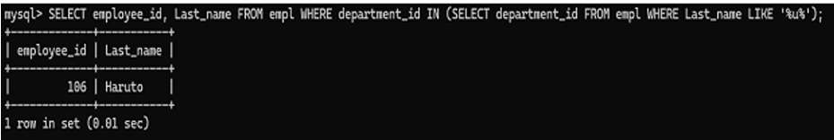

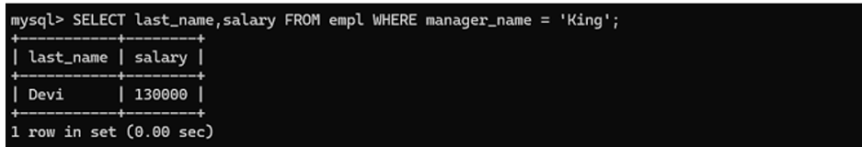

EXPERIMENT NO:9

ROLL NUMBER:231801153