**MQTT**

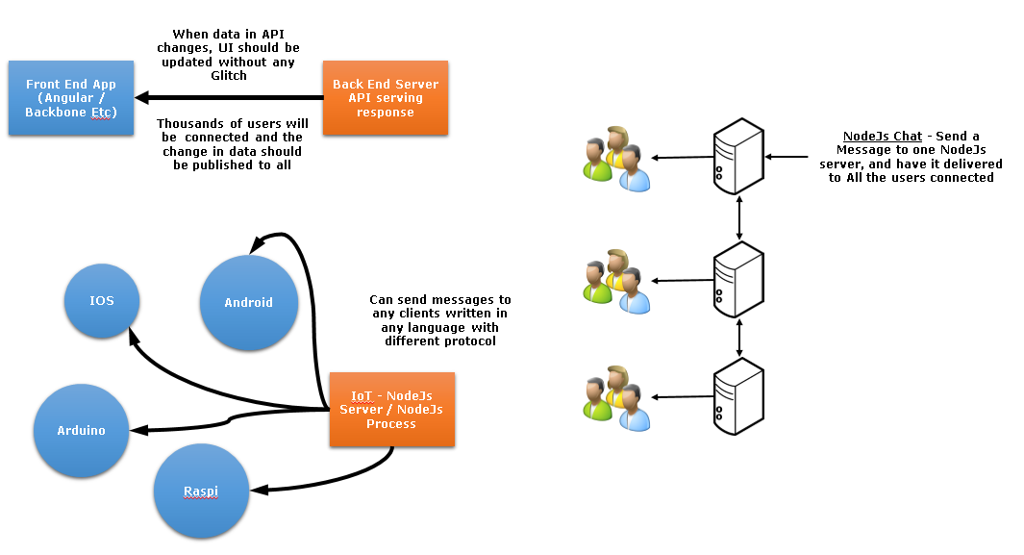

**What is MQTT?**

* MQTT is a publish/subscribe messaging protocol. It stands for MQ Telemetry Transport.
* It has been designed to be an extremely simple and lightweight protocol.
* The targeted systems for this protocol are devices with extremely constrained network bandwidth and places where networks are unreliable with high-latency.
* The protocol standards are to use minimal network bandwidth and reduce battery power of devices while ensuring reliability and assurance in delivery to an extent.
* MQTT protocol is ideal for machine-to-machine or Internet of Things (IoT) world of connected devices.
* It is used on top of TCP/IP protocol.

**Security in MQTT**

* Passing user name and password is feasible with an MQTT packet in V3.1 of the protocol.
* Network encryption should be handled with SSL which is independent of the MQTT protocol.
* Encryption is not built into MQTT protocol as the sole purpose of the protocol was to make it lightweight and simple.
* It is worth noting that SSL adds network overhead as it is not a simple protocol.
* Additional encryption of messages can be applied by a separate service / application.

**Topic**

* Messages are published to a logical channel called as “topics”.
* A subscriber can subscribe to a specific topic. All the subscribers for a topic will receive the same message published.

**MQTT Specification**

<https://www.oasis-open.org/committees/tc_home.php?wg_abbrev=mqtt>

**StrongLoop – NodeJs Publish/Subscribe**

strong-pubsub is a library of modules which implement a basic publish/subscribe model. It has no dependency over a specific transport mechanism (websockets, HTTP, etc.) or protocol (e.g. MQTT, STOMP, AMQP, Redis, etc.). It has the advantage of swapping an underlying adapter that implements a publish/subscribe protocol instead of restricting towards a specific transport.

**Terminologies**

1. Client

A unified client class (Can be used as a publisher or subscriber) which supports subscribing to topics. It can connect to broker or a bridge which supports the same protocol used by the current client’s adaptor.

1. Broker

A [broker](http://en.wikipedia.org/wiki/Message_broker) is a server that acts as a routing system for messages. It routes the messages published to all the subscribed clients.

[Mosquito](http://mosquitto.org/) is commonly used message broker.

1. Bridge

A bridge creates a connection between two MQTT brokers. Bridge can be used in cases where a client should not connect directly to a Broker.

It helps us to include logic for verifying authenticity of messages and clients.

1. Adapter

An Adapter to specify the type of transport and protocol.

**References**

<http://mqtt.org/>

<http://mqtt.org/faq>

<https://en.wikipedia.org/wiki/MQTT>

https://strongloop.com/strongblog/introducing-strongloops-unopinionated-pubsub/