SERVICENOW PROJECT REPORT
Import Data using Transform Maps (Spreadsheet)
Import Sets · Transform Maps · Coalesce · Reports · Dashboard
Date | 01 October 2026
Team ID | SWTID-2026-9663
Project Name | Import Data using Transform Maps (Spreadsheet) – ServiceNow
Maximum Marks | As per each phase template

Contents
1. Introduction
2. Ideation Phase (Problem Statement · Empathy Map · Brainstorming)
3. Requirement Analysis (Journey Map · Solution Requirements · DFD & User Stories · Technology Stack)
4. Project Design (Problem-Solution Fit · Proposed Solution · Solution Architecture)
5. Project Planning & Scheduling
6. Functional and Performance Testing (Performance · UAT)
7. Results (Output Screenshots)
8. Advantages & Disadvantages
9. Conclusion
10. Future Scope
11. Appendix

1. INTRODUCTION

1.1 Project Overview
This micro project imports structured employee data from an external spreadsheet into the ServiceNow platform using Import Sets and Transform Maps. It simulates a real-world scenario in which bulk employee data is received in Excel format and must be migrated into ServiceNow efficiently and accurately.
The spreadsheet is first loaded into an Import Set table, which acts as a staging area. A Transform Map then maps the source fields to the target table fields. Running the transformation creates records in the target table, which are then validated to confirm data integrity.
The project was later extended with Coalesce (to prevent duplicate records on repeated imports), three Reports and an Employee Analytics Dashboards dashboard. Together these give administrators and HR teams a single view of employee data and import activity.
Item | Details
Platform | ServiceNow
Source data | Sample Spreadsheet.xlsx (Employee ID, Name, Email, Department, Location)
Staging table | Employee Import (u_employee_import)
Target table | Employee Test (u_employee_test)
Transform Map | Sample Spreadsheet Import (Coalesce on Employee ID)
Reports | Employees by Department (Pie), Employees by Location (Bar), Employee List Report (List)
Dashboard | Employee Analytics Dashboards

1.2 Purpose
- Help beginners understand the end-to-end data import process in ServiceNow: data loading, field mapping, transformation execution and result verification.
- Replace manual record entry with a repeatable, accurate bulk import from Excel.
- Use Coalesce so that repeated imports update existing employees instead of creating duplicates.
- Provide visibility into employee data (department-wise and location-wise distribution) through reports and a dashboard.

2. IDEATION PHASE

2.1 Problem Statement
Ideation Phase
Define the Problem Statements
Date | 01 October 2026
Team ID | [Enter Team ID]
Project Name | Import Data using Transform Maps (Spreadsheet) – ServiceNow
Maximum Marks | 2 Marks

Customer Problem Statement
A customer problem statement keeps the team focused on the user's point of view. Two problem statements were identified for this project.
Problem Statement (PS) | I am (Customer) | I'm trying to | But | Because | Which makes me feel
PS-1 | A ServiceNow administrator / HR data owner | Load bulk employee records received in an Excel sheet into ServiceNow | Manual entry is slow, mistakes creep in, and re-uploading the same sheet creates duplicate records | There is no staging area, field mapping or duplicate control in place | Frustrated and worried about data accuracy
PS-2 | An HR manager / reporting stakeholder | See the department-wise and location-wise employee distribution and the import results at a glance | The data sits in spreadsheets and has to be analysed by hand | There are no reports or dashboards built on the imported data | Uninformed and slow to make decisions

2.2 Empathy Map Canvas
Ideation Phase
Empathize & Discover
Date | 01 October 2026
Team ID | [Enter Team ID]
Project Name | Import Data using Transform Maps (Spreadsheet) – ServiceNow
Maximum Marks | 4 Marks

Empathy Map Canvas – ServiceNow Administrator / HR Data Owner
The empathy map captures what the user says, thinks, does and feels while importing employee data, together with their pains and gains.
SAYS | THINKS
“I receive employee data in Excel every time.”  “Entering hundreds of rows by hand takes too long.”  “I can't have duplicate employee records.” | “Will this import overwrite or duplicate my data?”  “If a field is mapped wrongly, the data will be wrong.”  “I need proof that every row was loaded.”
DOES | FEELS
Prepares the sample sheet in Google Sheets and downloads it as .xlsx  Loads the file through Load Data and runs the Transform Map  Checks the Employee Test table and Transform History | Frustrated by repeated manual work  Anxious about duplicates and data accuracy  Relieved and confident when the import succeeds
PAINS | GAINS
Manual data entry errors  Duplicate records after repeated uploads  No quick way to see what was inserted, updated or ignored  No visual summary of employee data | Fast, accurate bulk import  Clean data with no duplicates (Coalesce)  Clear Transform History (inserted / updated / ignored)  Reports and a dashboard for quick decisions

2.3 Brainstorming
Ideation Phase
Brainstorm & Idea Prioritization Template
Date | 01 October 2026
Team ID | [Enter Team ID]
Project Name | Import Data using Transform Maps (Spreadsheet) – ServiceNow
Maximum Marks | 4 Marks

Step-1: Team Gathering, Collaboration and Select the Problem Statement
The team met to discuss how employee data from Excel can be brought into ServiceNow reliably. Selected problem statement: PS-1 – bulk-loading employee records from a spreadsheet without errors or duplicates, with PS-2 (reporting) as an extension.
Step-2: Brainstorm, Idea Listing and Grouping
Group | Ideas listed
A. Getting data in | Enter records manually through the form · Import the Excel file with Import Sets and a Transform Map · Pull data through a REST API · Scheduled import from a data source
B. Keeping data clean | Coalesce on Employee ID · Validate rows in the Import Set staging table · Transform scripts for clean-up · Review Transform History after each run
C. Getting insight | Pie chart by department · Bar chart by location · Employee list report · One dashboard for all reports · Share dashboard by user, group or role

Step-3: Idea Prioritization
Idea | Impact | Effort | Decision
Excel import with Import Set + Transform Map | High | Low | Selected (core solution)
Coalesce on Employee ID | High | Low | Selected (data integrity)
Reports (Pie, Bar, List) | Medium | Low | Selected
Employee Analytics Dashboards | Medium | Medium | Selected
Manual entry through forms | Low | High | Rejected – slow and error-prone
REST API / scheduled import | High | High | Deferred to Future Scope

3. REQUIREMENT ANALYSIS

3.1 Customer Journey Map
The journey below follows the administrator from receiving the spreadsheet to monitoring the imported data.
Stage | Prepare | Create tables | Import | Transform | Validate | Monitor
Actions | Create sample sheet; download as .xlsx | Create Employee Test and five fields | Load Data into Employee Import | Create Transform Map, auto map, run Transform | Open Employee Test; check Transform History | Open reports and the dashboard
Touchpoints | Google Sheets | Tables > Create New; Form Layout | Load Data | Transform Map; Mapping Assist | Employee Test list; Transform Histories | Reports; Dashboards
Emotion | Neutral | Focused | Hopeful | Cautious | Relieved | Confident
Pain points | Header names must match the fields | Missing fields cause mapping gaps | Wrong sheet / header row | Duplicates on re-import | Hard to see what changed | Data scattered across sheets
Opportunities | Fix a standard sheet format | Create all five fields up front | Sheet 1, header row 1 | Enable Coalesce | Use inserted / updated / ignored counts | Add reports to one dashboard

3.2 Solution Requirements
Project Design Phase-II
Solution Requirements (Functional & Non-functional)
Date | 01 October 2026
Team ID | [Enter Team ID]
Project Name | Import Data using Transform Maps (Spreadsheet) – ServiceNow
Maximum Marks | 4 Marks

Functional Requirements
FR No. | Functional Requirement (Epic) | Sub Requirement (Story / Sub-Task)
FR-1 | Spreadsheet Preparation | Create sample data in Google Sheets (Employee ID, Name, Email, Department, Location) · Download as Sample Spreadsheet.xlsx
FR-2 | Custom Table Creation | Create Employee Test (u_employee_test) · Add Employee ID, Employee Name, Email, Department, Location as String fields through Form Layout
FR-3 | Import Set Loading | Create Employee Import (u_employee_import) through Load Data · Load the .xlsx file (sheet 1, header row 1)
FR-4 | Transform Map and Execution | Create Sample Spreadsheet Import map · Auto Map Matching fields and Mapping Assist · Run Transform
FR-5 | Duplicate Prevention (Coalesce) | Set Coalesce true on Employee ID · New IDs are inserted, changed rows are updated, unchanged rows are ignored
FR-6 | Validation | Verify records in Employee Test · Personalise list columns · Review Transform History
FR-7 | Reporting | Employees by Department (Pie) · Employees by Location (Bar) · Employee List Report (List)
FR-8 | Dashboard | Create Employee Analytics Dashboards · Add the three reports · Restrict sharing by users, groups and roles

Non-functional Requirements
NFR No. | Non-Functional Requirement | Description
NFR-1 | Usability | Standard ServiceNow modules (Load Data, Transform Map, Reports) with no custom code; beginners can follow the steps.
NFR-2 | Security | Access to pa_dashboards creation is controlled by ACL (Admin Overrides); reports and dashboards can be shared only with chosen users, groups and roles.
NFR-3 | Reliability | Staging in an Import Set table plus Transform History lets every run be checked; Coalesce keeps repeated imports consistent.
NFR-4 | Performance | The 4-row transform run completed in 1 second (see Transform History).
NFR-5 | Availability | Runs on the ServiceNow cloud platform; no local server is needed.
NFR-6 | Scalability | The same Import Set and Transform Map pattern can be reused for larger files and for other tables.

3.3 Data Flow Diagram & User Stories
Project Design Phase-II
Data Flow Diagram & User Stories
Date | 01 October 2026
Team ID | [Enter Team ID]
Project Name | Import Data using Transform Maps (Spreadsheet) – ServiceNow
Maximum Marks | 4 Marks

Data Flow Diagram
The DFD shows how the spreadsheet data enters ServiceNow, how it is stored in the staging table, what changes it during the transform, and where the results are kept.
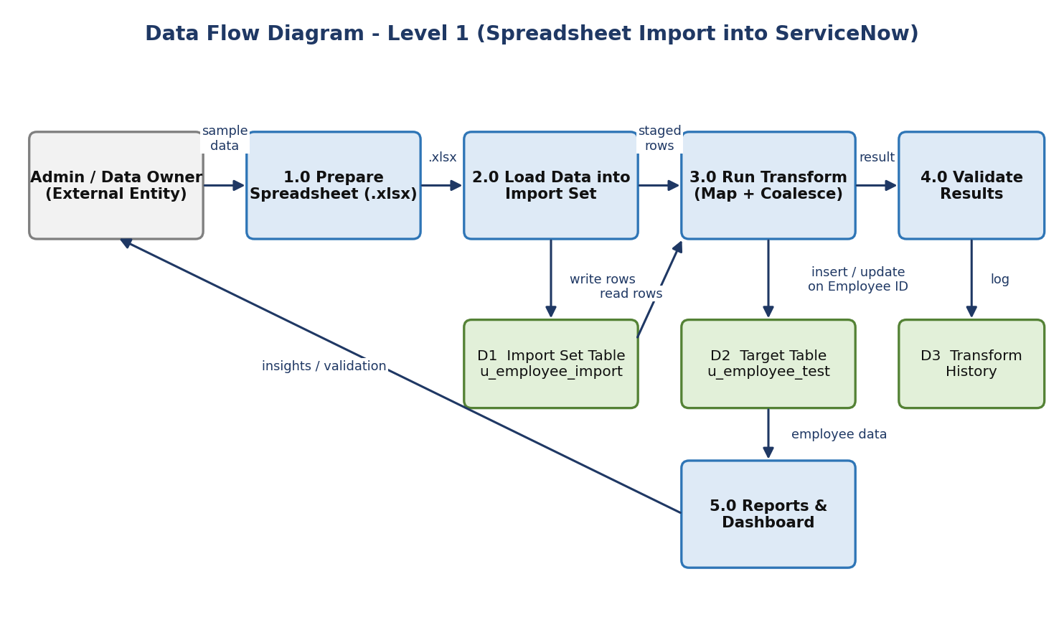
Figure 3.1 – Level-1 Data Flow Diagram
User Stories
User Type | Functional Requirement (Epic) | User Story Number | User Story / Task | Acceptance criteria | Priority | Release
Data Owner | Data Preparation | USN-1 | As a data owner, I can prepare a spreadsheet of employee records in Google Sheets | Sheet has Employee ID, Name, Email, Department, Location | High | Sprint-1
 |  | USN-2 | As a data owner, I can download the sheet as Sample Spreadsheet.xlsx | An .xlsx file is available for upload | High | Sprint-1
Administrator | Custom Table | USN-3 | As an administrator, I can create the Employee Test table | u_employee_test is created and saved | High | Sprint-1
 |  | USN-4 | As an administrator, I can add five String fields through Form Layout | All five fields appear on the Employee Test form | High | Sprint-1
 | Import Set | USN-5 | As an administrator, I can load the .xlsx into Employee Import | Load Data finishes with a success message | High | Sprint-1
 | Transform Map | USN-6 | As an administrator, I can create a Transform Map with auto-mapped fields | Source and target fields are mapped and saved | High | Sprint-1
 |  | USN-7 | As an administrator, I can run the Transform and verify the records | Records appear in Employee Test | High | Sprint-1
 | Duplicate Prevention | USN-8 | As an administrator, I can enable Coalesce on Employee ID | Coalesce shows true on the Employee ID field map | High | Sprint-2
 |  | USN-9 | As an administrator, I can re-import changed data and check the result | Transform History shows inserted, updated and ignored counts | High | Sprint-2
HR Manager | Reporting | USN-10 | As an HR manager, I can view employees by department as a pie chart | Pie chart groups by Department with a Count | Medium | Sprint-2
 |  | USN-11 | As an HR manager, I can view employees by location as a bar chart | Bar chart groups by Location with a Count | Medium | Sprint-2
 |  | USN-12 | As an HR manager, I can view a list of all employees | List shows all five columns | Medium | Sprint-2
 | Dashboard | USN-13 | As an administrator, I can create the Employee Analytics Dashboards dashboard | Dashboard is saved | Medium | Sprint-2
 |  | USN-14 | As an HR manager, I can see all three reports on one dashboard | Three reports are visible on the dashboard | Medium | Sprint-2

3.4 Technology Stack
Project Design Phase-II
Technology Stack (Architecture & Stack)
Date | 01 October 2026
Team ID | [Enter Team ID]
Project Name | Import Data using Transform Maps (Spreadsheet) – ServiceNow
Maximum Marks | 4 Marks

Technical Architecture
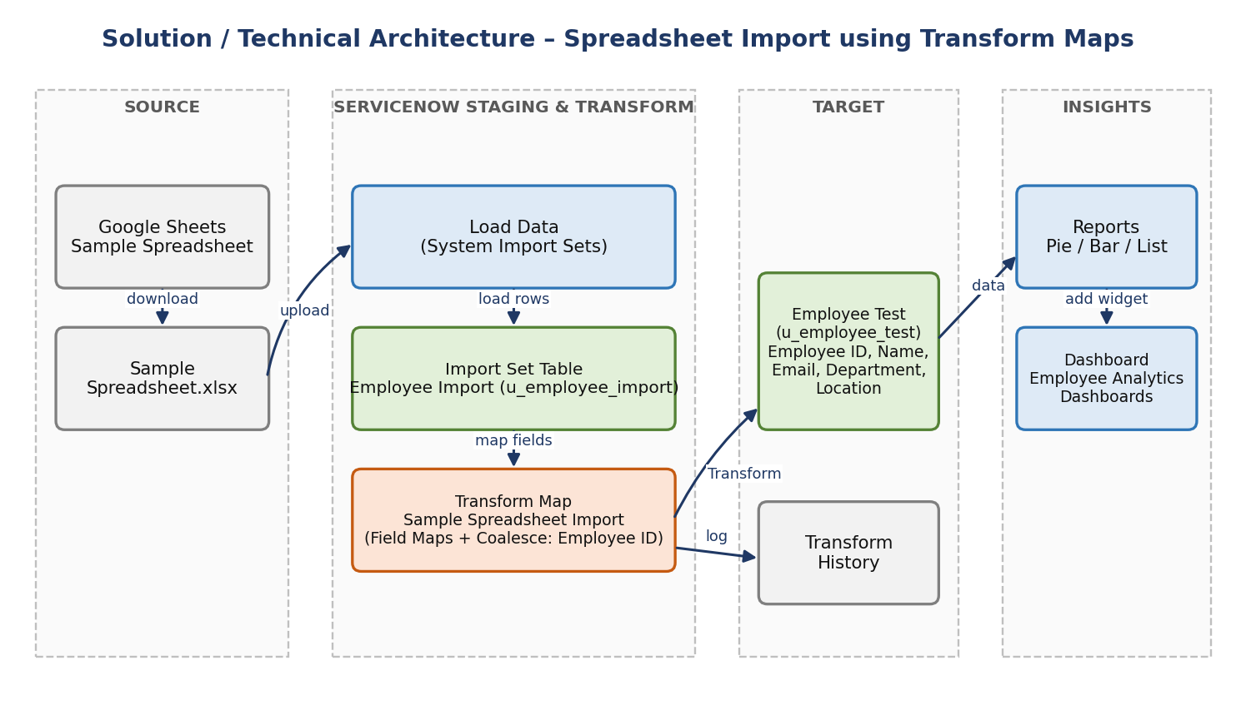
Figure 3.2 – Technical architecture
Table-1: Components & Technologies
S.No | Component | Description | Technology
1 | User Interface | Administrators work in the ServiceNow web UI: Application Navigator, Load Data, table forms, Transform Map, Reports and Dashboards | ServiceNow Platform UI
2 | Application Logic-1 | Source file is prepared and exported | Google Sheets, Microsoft Excel (.xlsx)
3 | Application Logic-2 | Field mapping and transformation of staged rows into the target table | Import Sets, Transform Map (Auto Map, Mapping Assist)
4 | Application Logic-3 | Duplicate prevention on Employee ID | Coalesce in Transform Map field maps
5 | Database | Staging table u_employee_import and target table u_employee_test | ServiceNow platform database
6 | Cloud Database | Tables are hosted with the ServiceNow instance | ServiceNow cloud instance
7 | File Storage | The .xlsx file is uploaded through Load Data (Source of import: File) | ServiceNow import file handling
8 | External API | Not used – data arrives as a file | N/A
9 | Machine Learning Model | Not used | N/A
10 | Infrastructure (Server / Cloud) | Application is configured directly on a ServiceNow instance | ServiceNow cloud

Table-2: Application Characteristics
S.No | Characteristics | Description | Technology
1 | Open-Source Frameworks | None; the solution uses out-of-the-box ServiceNow modules | ServiceNow Import Sets / Transform Maps
2 | Security Implementations | Access control on dashboard creation (pa_dashboards ACL – Admin Overrides); sharing restricted by users, groups and roles | ServiceNow ACLs, roles
3 | Scalable Architecture | Staging in an Import Set table; the same map can be reused for repeated or larger loads | Import Set + Transform Map
4 | Availability | Hosted on the ServiceNow cloud platform | ServiceNow cloud
5 | Performance | Rows are staged first and transformed in one run; the 4-row run took 1 second | Import Set staging, Transform History

4. PROJECT DESIGN

4.1 Problem Solution Fit
Project Design Phase
Problem – Solution Fit Template
Date | 01 October 2026
Team ID | [Enter Team ID]
Project Name | Import Data using Transform Maps (Spreadsheet) – ServiceNow
Maximum Marks | 2 Marks

Problem-Solution Fit confirms that the solution actually solves the customer's problem. The canvas below follows the template's numbered boxes.
Canvas box | Content
1. Customer Segment(s) – CS | ServiceNow administrators, HR / data owners and HR managers who receive employee data in Excel format.
2. Jobs-to-be-Done / Problems – J&P | Bulk-load employee records accurately; avoid duplicates on repeated imports; see department and location distribution quickly.
3. Triggers – TR | A new batch of employee data arrives in a spreadsheet; the same file or an updated file has to be uploaded again; management asks for employee numbers.
4. Emotions: Before / After – EM | Before: frustrated, worried about errors and duplicates. After: confident and in control, because every run shows inserted, updated and ignored rows.
5. Available Solutions – AS | Manual entry through forms (slow, error-prone); copy-paste into lists; custom scripts (need coding skills).
6. Customer Constraints – CC | No coding skills assumed; data must stay accurate and duplicate-free; access limited by roles and ACLs.
7. Behaviour – BE | Keeps employee data in Excel / Google Sheets, uploads files, and checks the target table by hand.
8. Channels of Behaviour – CH | Online: Google Sheets, ServiceNow Load Data, Transform History, Reports and Dashboards. Offline: Excel files shared by HR / teams.
9. Problem Root Cause – RC | No staging area, field mapping or Coalesce rule, so data is typed or pasted by hand and repeated uploads create duplicates.
10. Your Solution – SL | Import Set (staging) + Transform Map (field mapping) + Coalesce on Employee ID, with reports and a dashboard on top.

4.2 Proposed Solution
Project Design Phase
Proposed Solution Template
Date | 01 October 2026
Team ID | [Enter Team ID]
Project Name | Import Data using Transform Maps (Spreadsheet) – ServiceNow
Maximum Marks | 2 Marks

S.No. | Parameter | Description
1 | Problem Statement (Problem to be solved) | Employee data arrives in Excel and must be moved into ServiceNow quickly, accurately and without duplicate records, then made visible to HR and administrators.
2 | Idea / Solution description | Load the spreadsheet into the Import Set table Employee Import, map it to Employee Test with the Sample Spreadsheet Import Transform Map, run the Transform, and verify the result. Coalesce on Employee ID updates existing employees and inserts only new ones. Three reports are combined on the Employee Analytics Dashboards dashboard.
3 | Novelty / Uniqueness | Re-importing the same file is safe: unchanged rows are ignored, changed rows are updated and new IDs are inserted. The import is also tied to reporting, so the data can be analysed straight away.
4 | Social Impact / Customer Satisfaction | Less manual effort and fewer errors for HR and admin teams; reliable employee data and instant visual insight improve decisions.
5 | Business Model (Revenue Model) | Internal efficiency solution built on existing ServiceNow modules (no extra licences or code); the value is saved effort and cleaner data. It can be reused as an import accelerator for other teams.
6 | Scalability of the Solution | The Import Set / Transform Map pattern works for larger files and for other tables; further maps can be added and imports can later be scheduled.

4.3 Solution Architecture
Project Design Phase
Solution Architecture
Date | 01 October 2026
Team ID | [Enter Team ID]
Project Name | Import Data using Transform Maps (Spreadsheet) – ServiceNow
Maximum Marks | 4 Marks

The solution architecture bridges the business problem (moving Excel data into ServiceNow cleanly) and the technology that solves it. It describes the structure, data flow and components so that stakeholders can understand how the solution is delivered.
Figure 4.1 – Solution architecture and data flow
Data flow
- The data owner prepares the sample data in Google Sheets and downloads it as Sample Spreadsheet.xlsx.
- Load Data uploads the file into the Import Set table Employee Import (u_employee_import), which is the staging area.
- The Transform Map Sample Spreadsheet Import maps source fields to the Employee Test (u_employee_test) fields.
- Running Transform inserts new records and, because Coalesce is on Employee ID, updates matching ones or ignores unchanged rows.
- Transform History records total, inserted, updated, ignored, skipped and error counts for every run.
- Reports read from Employee Test and are shown together on the Employee Analytics Dashboards dashboard.

5. PROJECT PLANNING & SCHEDULING

5.1 Project Planning
Project Planning Phase
Project Planning Template (Product Backlog, Sprint Planning, Stories, Story points)
Date | 01 October 2026
Team ID | [Enter Team ID]
Project Name | Import Data using Transform Maps (Spreadsheet) – ServiceNow
Maximum Marks | 5 Marks

Work was organised into two sprints. Story points follow the Fibonacci-style scale (1, 2, 3, 5): 1 = very easy, 2 = normal, 3 = moderate, 5 = difficult.
Product Backlog, Sprint Schedule, and Estimation (4 Marks)
Sprint | Functional Requirement (Epic) | User Story Number | User Story / Task | Story Points | Priority | Team Members
Sprint-1 | Data Preparation | USN-1 | Prepare the employee spreadsheet in Google Sheets | 2 | High | [Team member]
Sprint-1 |  | USN-2 | Download it as Sample Spreadsheet.xlsx | 1 | High | [Team member]
Sprint-1 | Custom Table | USN-3 | Create the Employee Test table (u_employee_test) | 2 | High | [Team member]
Sprint-1 |  | USN-4 | Add the five String fields through Form Layout | 3 | High | [Team member]
Sprint-1 | Import Set | USN-5 | Load the .xlsx into Employee Import (u_employee_import) | 2 | High | [Team member]
Sprint-1 | Transform Map | USN-6 | Create Sample Spreadsheet Import with auto map and Mapping Assist | 3 | High | [Team member]
Sprint-1 |  | USN-7 | Run Transform and verify records in Employee Test | 2 | High | [Team member]
Sprint-2 | Duplicate Prevention | USN-8 | Enable Coalesce on Employee ID | 2 | High | [Team member]
Sprint-2 |  | USN-9 | Re-import changed data and verify inserted / updated / ignored counts | 3 | High | [Team member]
Sprint-2 | Reporting | USN-10 | Create the Employees by Department pie report | 2 | Medium | [Team member]
Sprint-2 |  | USN-11 | Create the Employees by Location bar report | 2 | Medium | [Team member]
Sprint-2 |  | USN-12 | Create the Employee List Report | 1 | Medium | [Team member]
Sprint-2 | Dashboard | USN-13 | Create Employee Analytics Dashboards (enable Admin Overrides on the create ACL) | 3 | Medium | [Team member]
Sprint-2 |  | USN-14 | Add the three reports to the dashboard | 2 | Medium | [Team member]

Sprint totals (planning logic)
Sprint-1 = 2 + 1 + 2 + 3 + 2 + 3 + 2 = 15 story points. Sprint-2 = 2 + 3 + 2 + 2 + 1 + 3 + 2 = 15 story points. Total = 30 story points.
Project Tracker, Velocity & Burndown Chart (4 Marks)
Sprint | Total Story Points | Duration | Sprint Start Date | Sprint End Date (Planned) | Story Points Completed (as on Planned End Date) | Sprint Release Date (Actual)
Sprint-1 | 15 | 6 Days | [Enter date] | [Enter date] | 15 | [Enter date]
Sprint-2 | 15 | 6 Days | [Enter date] | [Enter date] | 15 | [Enter date]

Velocity
Velocity = Total story points completed ÷ Number of sprints = 30 ÷ 2 = 15 story points per sprint.
With a 6-day sprint, the average velocity per day is 15 ÷ 6 = 2.5 story points per day.
Burndown Chart
A burndown chart shows the work left to do against time. The chart below plots the planned (ideal) burndown for 30 story points over two 6-day sprints; the team can overlay actual daily remaining points on it.
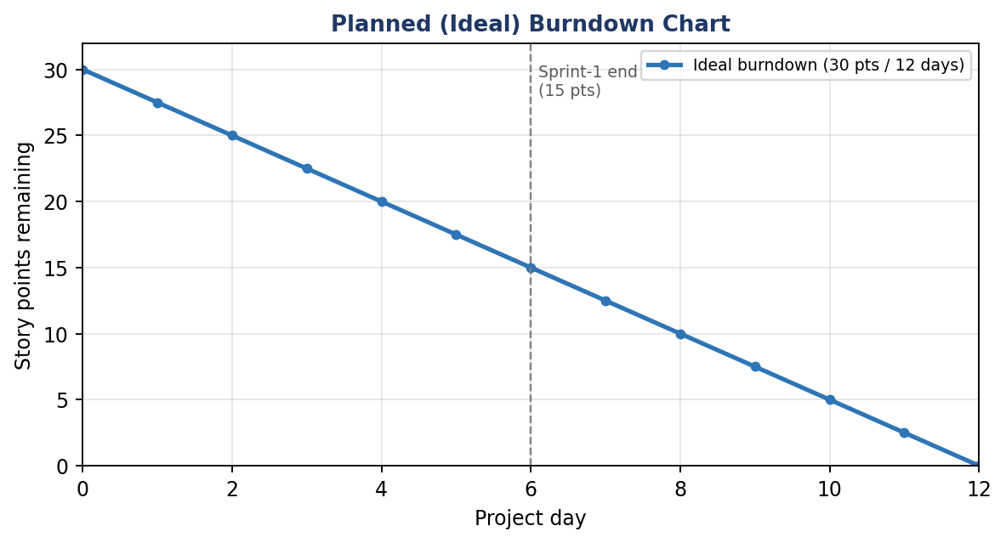
Figure 5.1 – Planned burndown chart

6. FUNCTIONAL AND PERFORMANCE TESTING

6.1 Performance Testing
Project Development Phase
Model Performance Test
Date | 01 October 2026
Team ID | [Enter Team ID]
Project Name | Import Data using Transform Maps (Spreadsheet) – ServiceNow
Maximum Marks | [Enter marks]

Performance Testing
The following table records the performance of the data-management automation (import, transform and reporting). Records are created only when the source data matches the mapped fields correctly.
S.No. | Parameter | Values | Screenshot
1 | Project Summary | ServiceNow automation for employee data management using Import Sets, Transform Maps (with Coalesce), Reports and a Dashboard. Records are created when source columns map correctly to the target fields. | 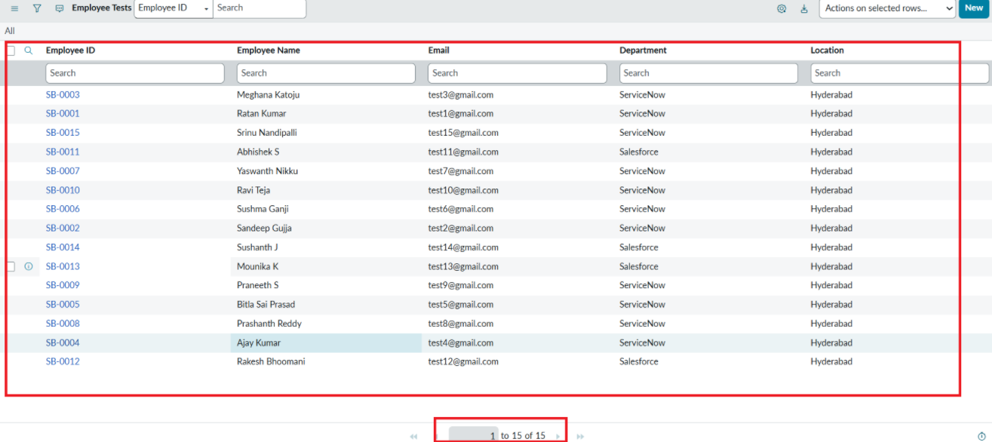
2 | Import Accuracy | First load: 15 rows processed, 15 inserts, 0 errors – all sample records imported into Employee Test. Second load (4 rows): Total 4, Inserts 2, Updates 2, Ignored 0, Skipped 0, Errors 0. Run time: 1 second. | 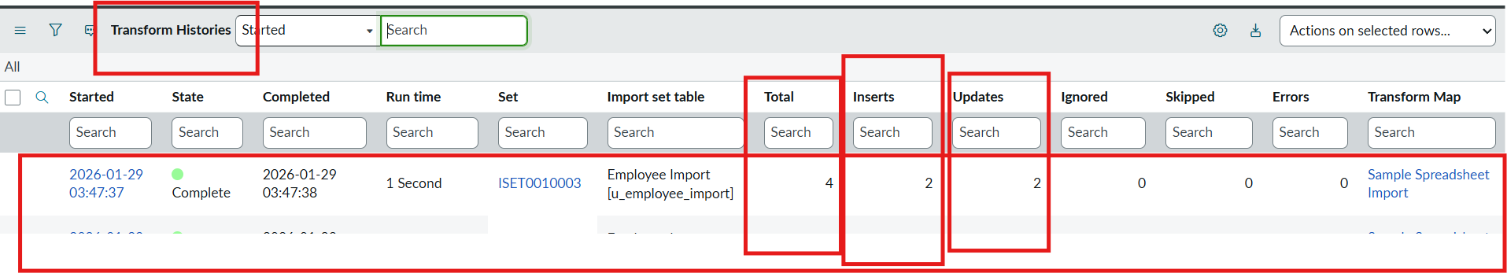
3 | Duplicate Control (Coalesce) | Same sheet loaded again: Total 4, Inserts 0, Updates 0, Ignored 4 – no duplicate records created. | 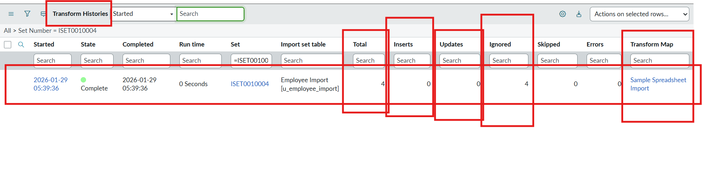
4 | Reports & Dashboard | 3 reports created (Pie, Bar, List) and added to Employee Analytics Dashboards. | 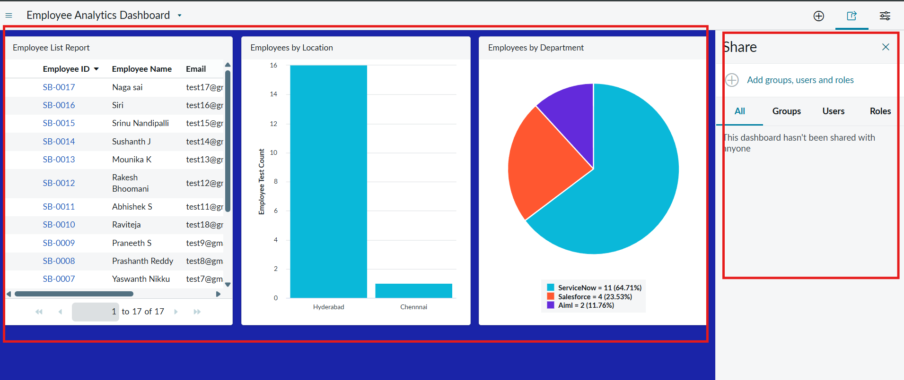

6.2 Functional Testing & User Acceptance Testing
Project Development Phase
User Acceptance Testing (UAT) Template
Date | 01 October 2026
Team ID | [Enter Team ID]
Project Name | Import Data using Transform Maps (Spreadsheet) – ServiceNow
Maximum Marks | [Enter marks]

Project Overview
Project Name: Import Data using Transform Maps (Spreadsheet)
Project Description: Import employee data from an Excel spreadsheet into ServiceNow using Import Sets and Transform Maps, prevent duplicates with Coalesce, and report on the data through a dashboard.
Project Version: 1.0 Testing Period: [Start Date] to [End Date]
Testing Scope
- Custom table and field creation (Employee Test).
- Import Set loading, Transform Map execution and validation.
- Coalesce behaviour on repeated imports.
- Reports and dashboard (USN-1 to USN-14).
Testing Environment
URL / Location: [ServiceNow instance URL] Credentials: Administrator account (not recorded in this document)
Test Cases
Test Case ID | Test Scenario | Test Steps | Expected Result | Actual Result | Pass/Fail
TC-001 | Create the Employee Test table and fields | Tables > Create New; label Employee Test; add five String fields in Form Layout | Table u_employee_test and the five fields exist on the form | Table and fields created and shown on the form | Pass
TC-002 | Load spreadsheet into the Import Set table | Load Data > create table Employee Import (u_employee_import) > Submit | Import completes successfully | Import completed: 15 rows processed, 15 inserts, 0 errors | Pass
TC-003 | Create the Transform Map and run it | Create Transform Map; Auto Map Matching fields; Mapping Assist; Save; Transform | Records are created in Employee Test | Transform succeeded; all records appear in Employee Test | Pass
TC-004 | Re-import changed data with Coalesce on Employee ID | Load Data (existing table, sheet 1, header row 1) > Run Transform > open Transform History | 2 new IDs inserted, 2 changed rows updated | Total 4, Inserts 2, Updates 2, Errors 0 | Pass
TC-005 | Re-import the same sheet | Repeat TC-004 with the same file | No inserts or updates | Total 4, Inserts 0, Updates 0, Ignored 4 | Pass
TC-006 | Create the three reports | Reports > New: Pie (Department), Bar (Location), List (five columns); Run; Save | Each report renders and saves | All three reports rendered and saved | Pass
TC-007 | Create the dashboard | Open pa_dashboards.form; name it Employee Analytics Dashboards; Save | Dashboard is created | Form opened after Admin Overrides was enabled on the create ACL; dashboard saved | Pass
TC-008 | Add reports to the dashboard | Report > Share > Add to Dashboards > select dashboard > Add (for each report) | Three reports appear on the dashboard | Three reports displayed | Pass
PT-01 | Transform run time | Run Transform on the 4-row import and read Transform History | Completes quickly | Run time: 1 second | Pass

Bug Tracking
Bug ID | Bug Description | Steps to reproduce | Severity | Status | Additional feedback
BG-001 | Dashboard create form (pa_dashboards.form) would not open by its backend name | Open pa_dashboards.form directly before changing the ACL | Low | Closed | Fixed by opening the pa_dashboards Create ACL and setting Admin Overrides to true, then updating the form.

UAT Execution & Report Submission
Purpose of Document: to explain the test coverage and open issues of the Import Data using Transform Maps project at the time of release to UAT.
Defect Analysis – resolved / closed bugs by severity and how they were resolved:
Resolution | Severity 1 | Severity 2 | Severity 3 | Severity 4 | Subtotal
By Design | 0 | 0 | 0 | 0 | 0
Duplicate | 0 | 0 | 0 | 0 | 0
External | 0 | 0 | 0 | 0 | 0
Fixed | 0 | 0 | 0 | 1 | 1
Not Reproduced | 0 | 0 | 0 | 0 | 0
Skipped | 0 | 0 | 0 | 0 | 0
Won't Fix | 0 | 0 | 0 | 0 | 0
Totals | 0 | 0 | 0 | 1 | 1

Test Case Analysis – test cases that passed, failed and are untested:
Section | Total Cases | Not Tested | Fail | Pass
Custom Table (TC-001) | 1 | 0 | 0 | 1
Import Set (TC-002) | 1 | 0 | 0 | 1
Transform Map (TC-003) | 1 | 0 | 0 | 1
Coalesce / Re-import (TC-004, TC-005) | 2 | 0 | 0 | 2
Reports (TC-006) | 1 | 0 | 0 | 1
Dashboard (TC-007, TC-008) | 2 | 0 | 0 | 2
Performance (PT-01) | 1 | 0 | 0 | 1
Total | 9 | 0 | 0 | 9

Sign-off
Tester Name: [Name of Tester] Date: [Date of Test Completion] Signature: ______________________

7. RESULTS

7.1 Output Screenshots
The screenshots below show the result of each phase of the project.
Phase 1 – Prepare the sheet
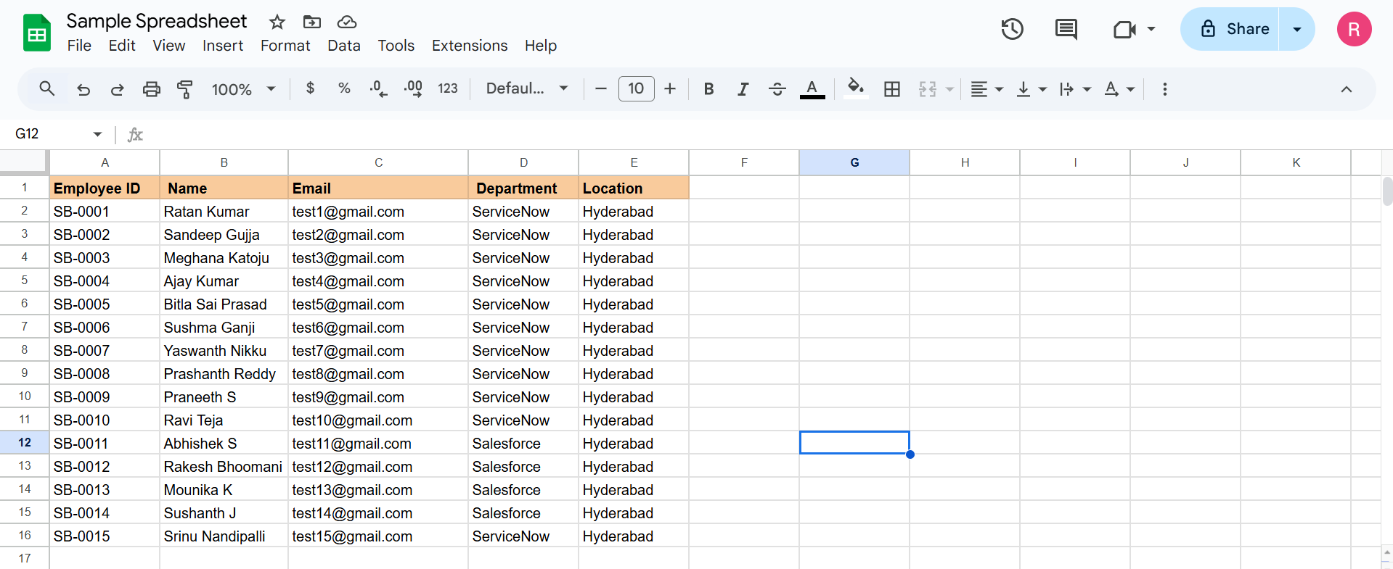
Sample spreadsheet with employee records (Google Sheets)
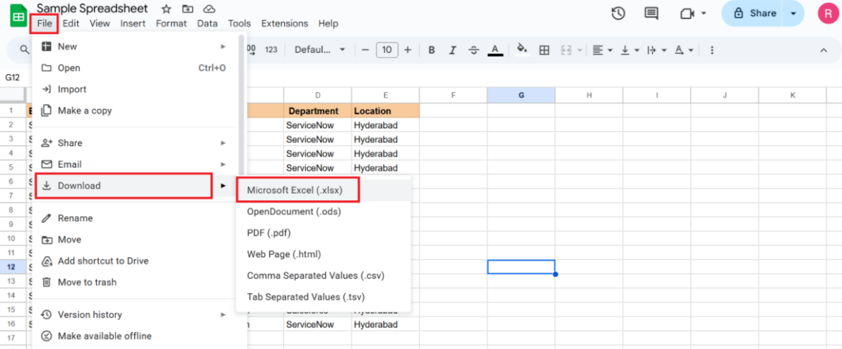
Downloading the sheet in Microsoft Excel (.xlsx) format
Phase 2 – Create the custom table
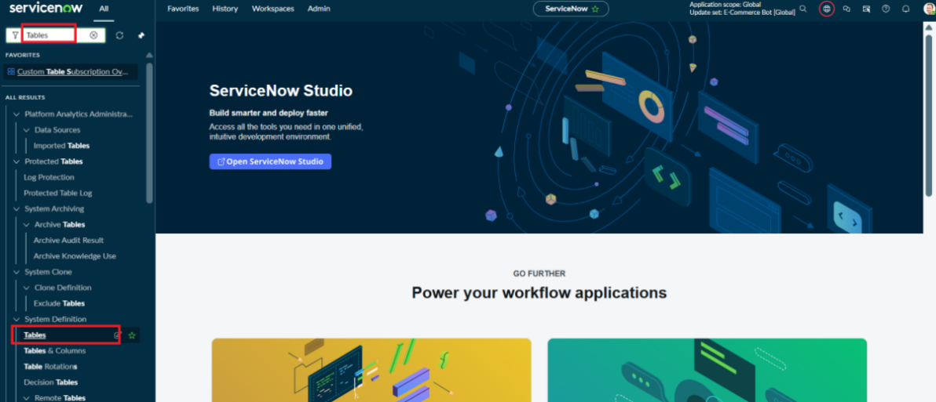
Opening Tables from the Application Navigator to create the Employee Test table (u_employee_test)
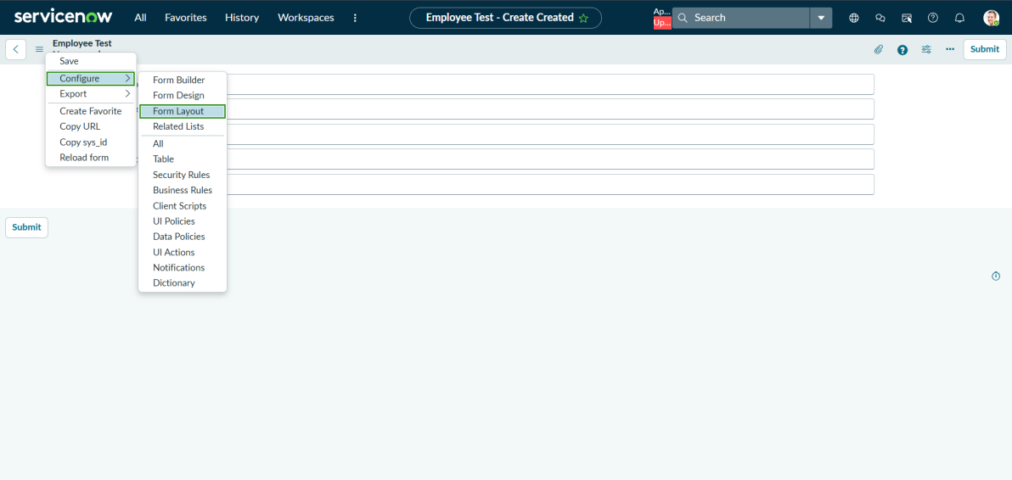
Form context menu > Configure > Form Layout
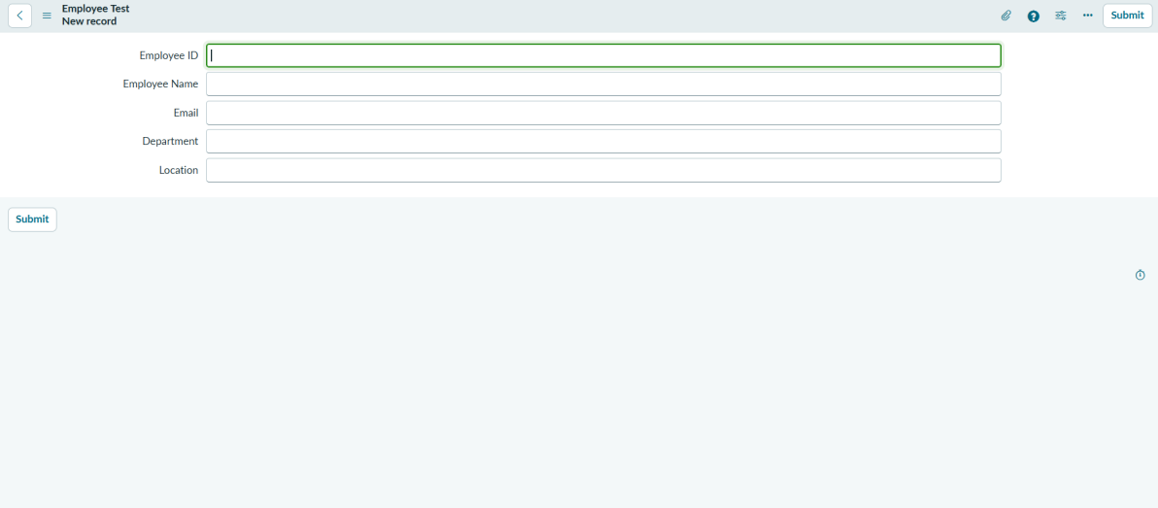
Employee Test form showing Employee ID, Employee Name, Email, Department and Location
Phase 3 – Import Set table
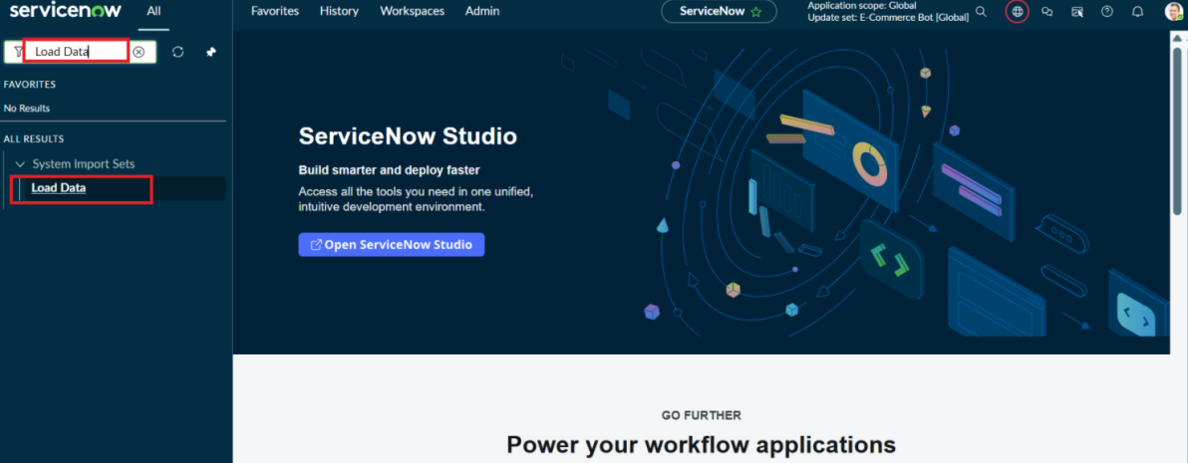
Load Data under System Import Sets
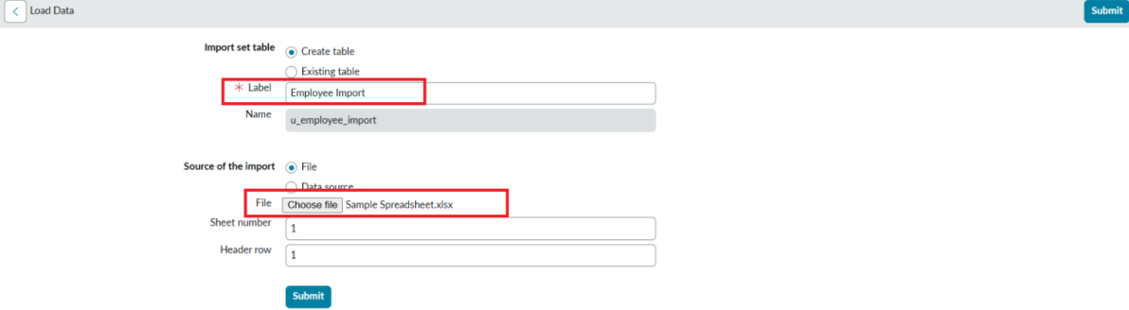
Load Data form – label Employee Import, file Sample Spreadsheet.xlsx, sheet 1, header row 1
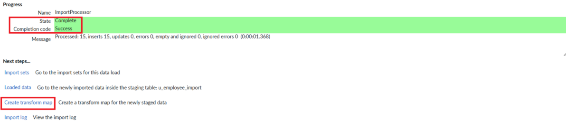
Import completed – 15 rows processed, 15 inserts, 0 errors; Create transform map link
Phase 4 – Create the Transform Map
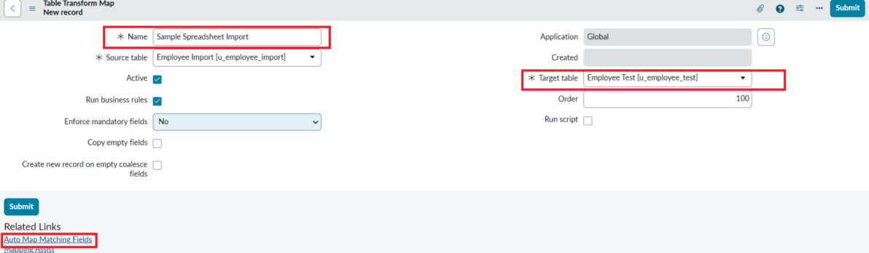
New Transform Map – Sample Spreadsheet Import, source Employee Import, target Employee Test
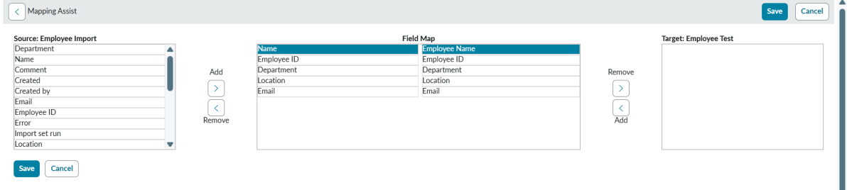
Mapping Assist – mapping source and target fields
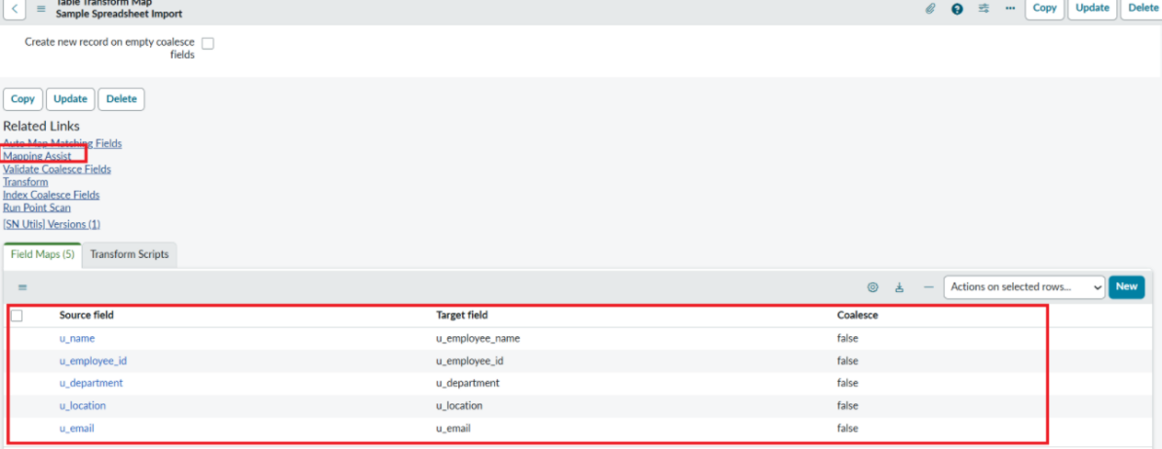
Source and target fields mapped
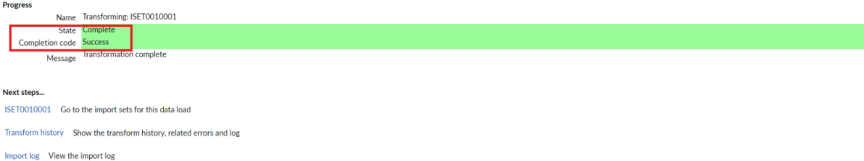
Transform completed successfully
Phase 5 – Transform data & validate
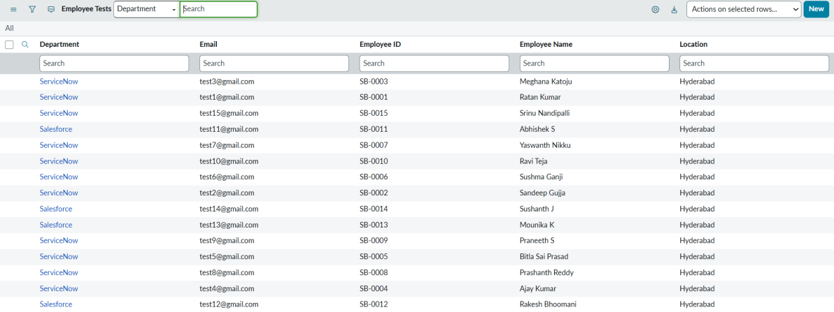
Records created in the Employee Test table
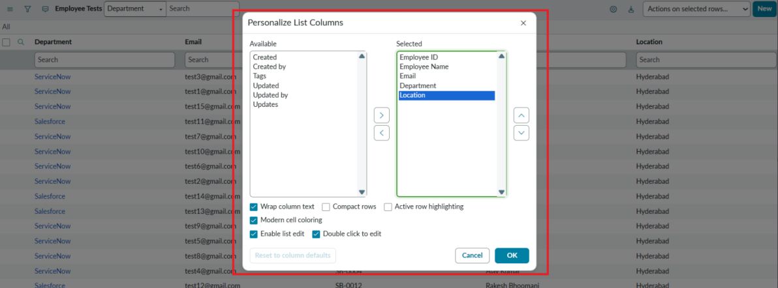
Personalize List Columns
Final result – imported employee records
Phase 6 – Coalesce
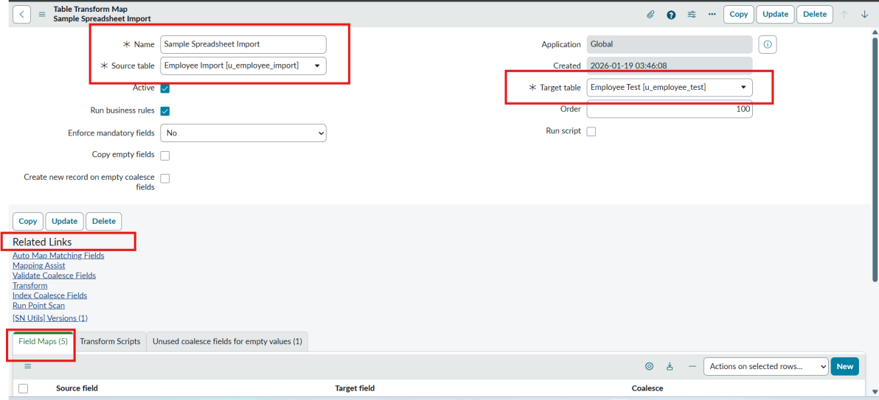
Transform Map form (source Employee Import, target Employee Test) with the Field Maps list
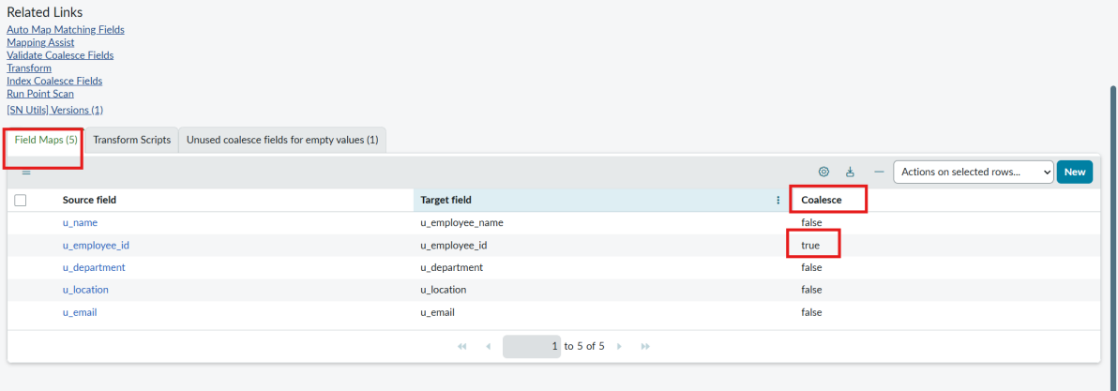
Field maps – Coalesce set to true on u_employee_id
Phase 7 – Inserting new data
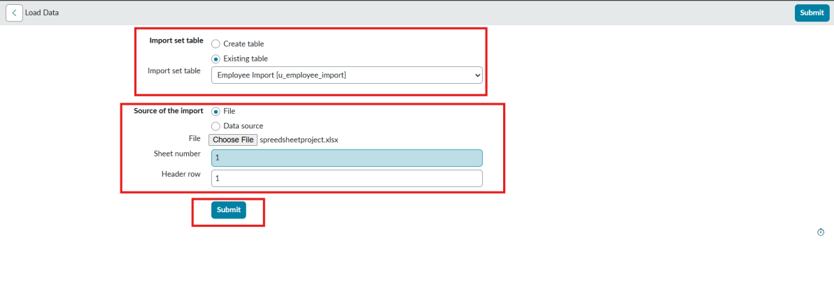
Load Data – existing table, file source, sheet 1, header row 1
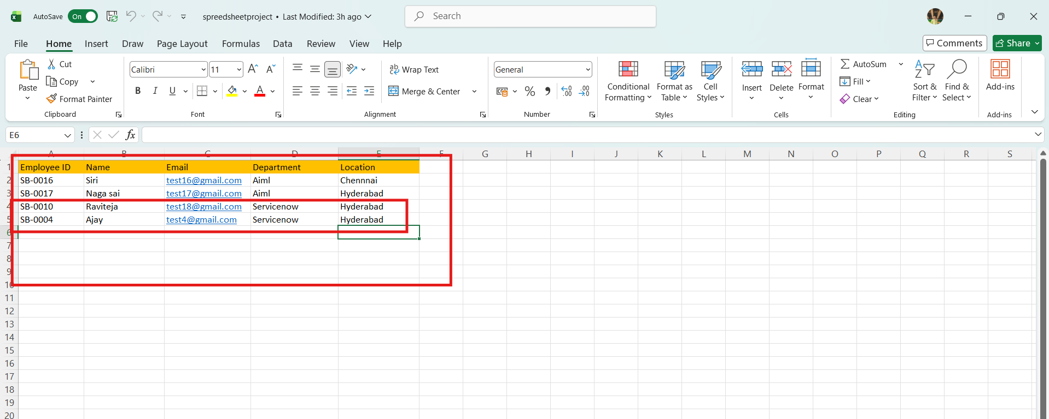
Updated spreadsheet with changed and new rows
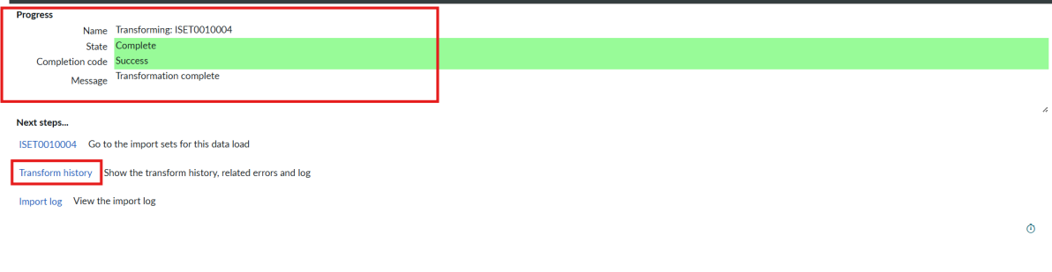
Transform completed
Transform History – Total 4, Inserts 2, Updates 2
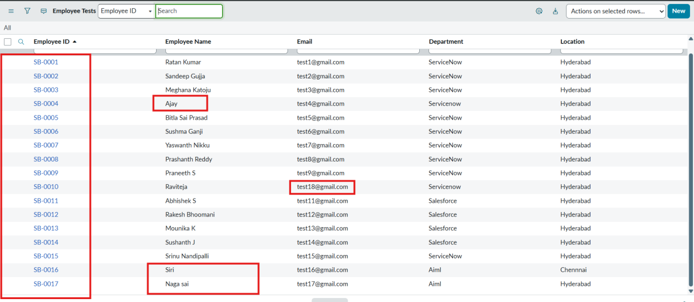
Employee Test showing updated and inserted rows
Transform History after the same sheet is loaded again – 4 ignored
Phase 8 – Reports
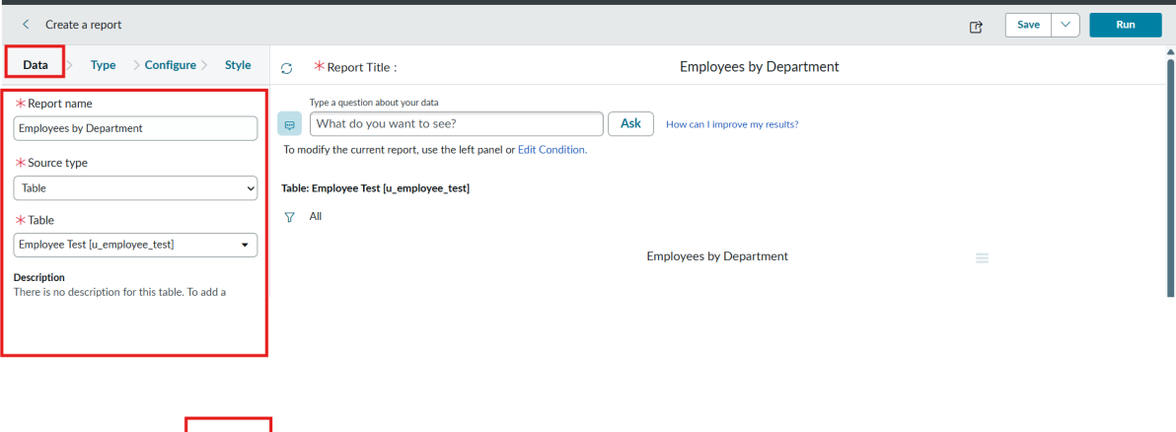
Report data: name, source type (Table) and table
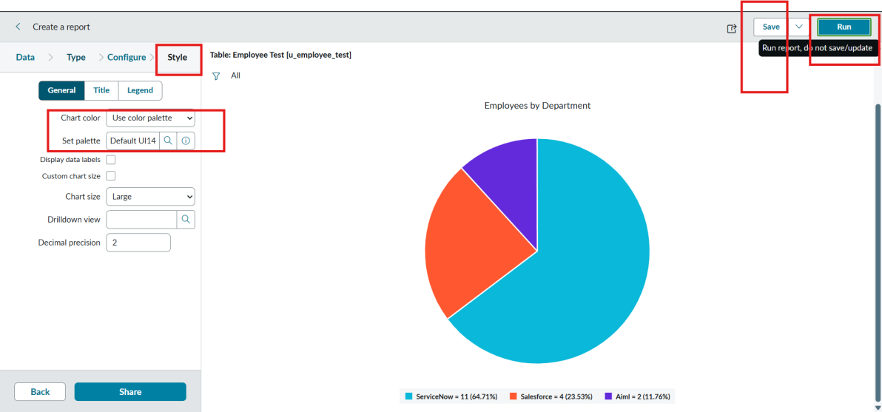
Employees by Department – pie chart
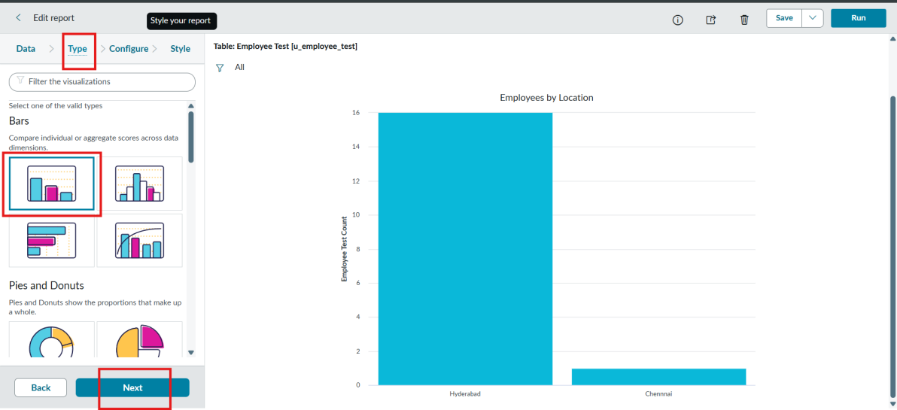
Employees by Location – bar chart type
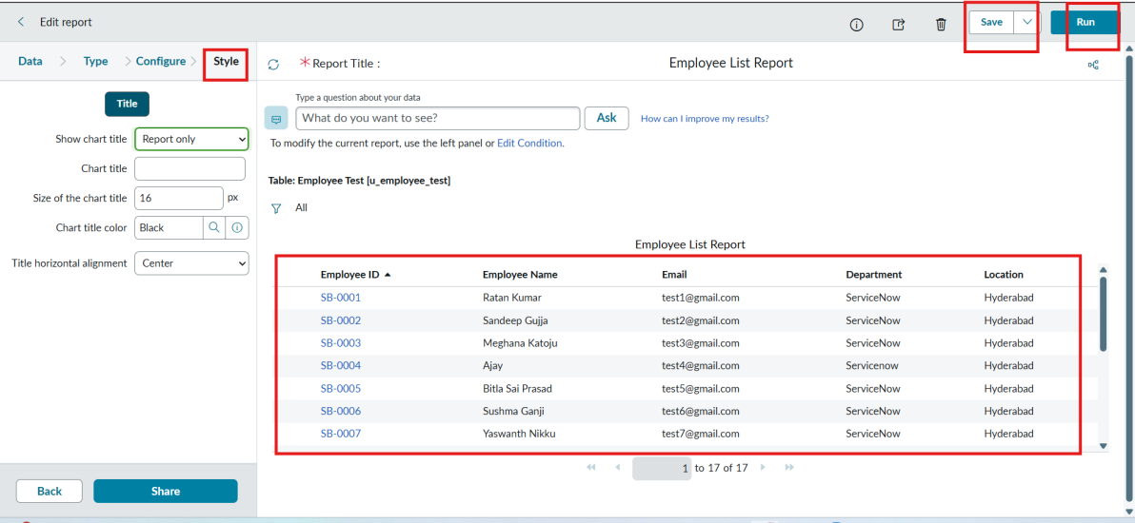
Employee List Report
Phase 9 – Dashboard
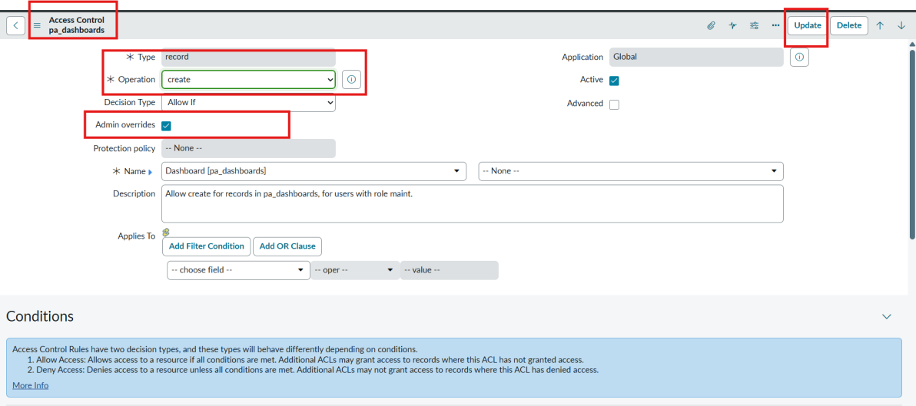
pa_dashboards Create ACL with Admin Overrides
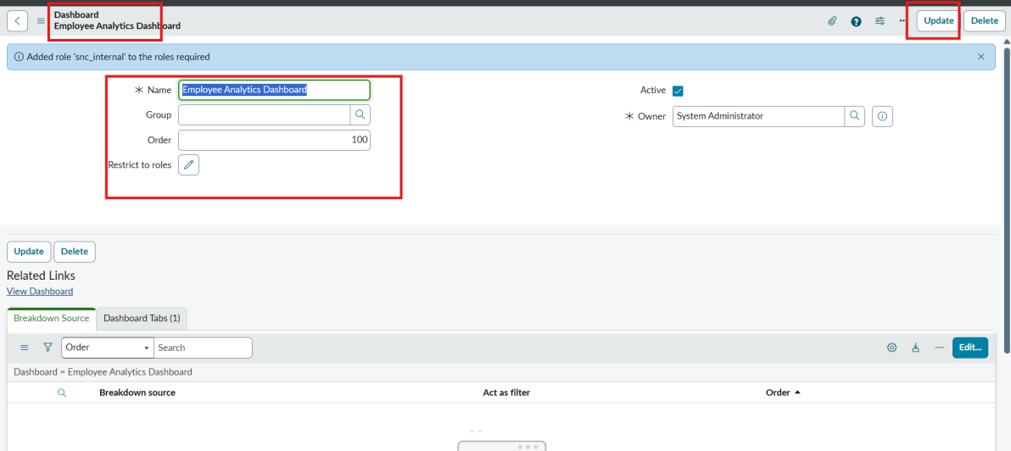
Dashboard form – Employee Analytics Dashboards
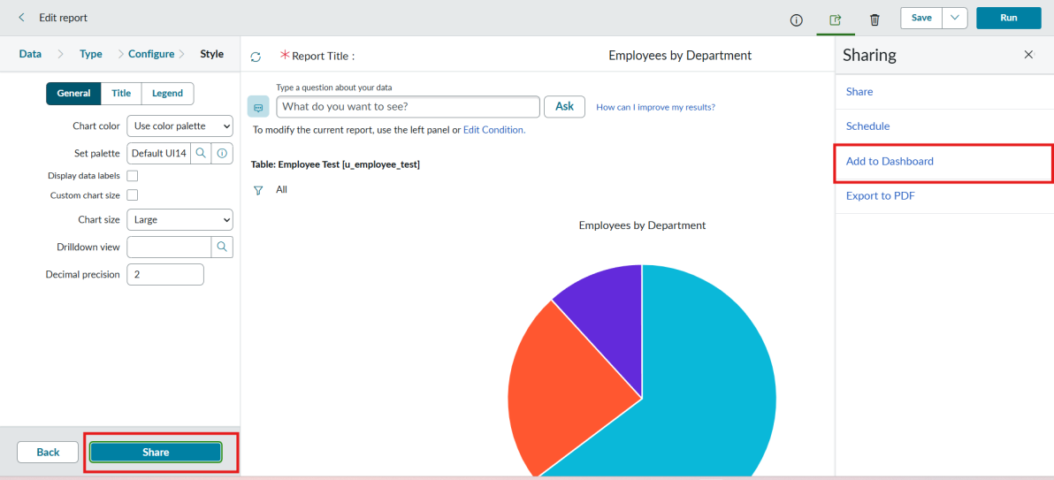
Report > Share > Add to Dashboards
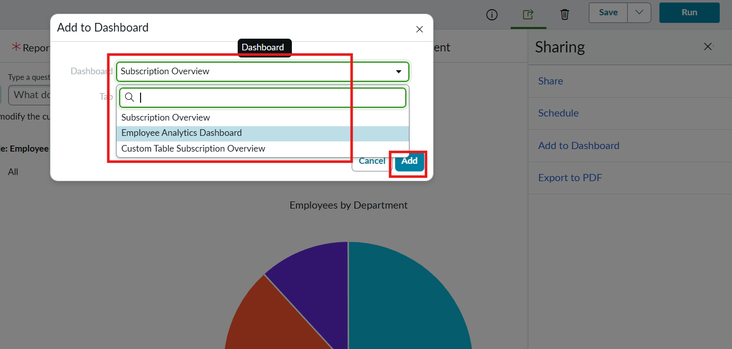
Add to Dashboard dialog
Employee Analytics Dashboards with the three reports

8. ADVANTAGES & DISADVANTAGES

Advantages
- Bulk employee data is loaded without coding, using standard ServiceNow modules.
- The Import Set staging table lets data be checked before it reaches the target table.
- Coalesce on Employee ID prevents duplicates and updates existing records on repeated imports.
- Transform History shows inserted, updated, ignored, skipped and error counts for every run.
- Reports and the dashboard give HR and administrators a single visual view of the data.

Disadvantages
- The file must be uploaded manually each time; there is no automatic refresh.
- Column headers, sheet number and header row must be consistent, otherwise mapping fails.
- Coalesce depends on the chosen field: a wrong or changed Employee ID will create a new record instead of updating.
- Creating the dashboard through its backend form needs an ACL change (Admin Overrides), so administrator access is required.
- Department and Location are stored as plain String fields, so spelling differences can split report groups.

9. CONCLUSION
This project successfully implemented an automated employee data management solution using ServiceNow Import Sets and Transform Maps, ensuring accuracy, efficiency and data integrity throughout employee onboarding and update.
A key enhancement was the use of Coalesce in the Transform Map. By enabling Coalesce on the Employee ID field, the system identifies existing employee records during every import. This prevents duplicate records and makes repeated imports update existing data instead of inserting redundant entries. The employee database therefore stays clean, reliable and consistent, which matters in enterprise environments where data may be imported many times from external systems.
The project was also extended with Reports and a Dashboard to give real-time visibility into employee data and import activity. Reports and views were created to track:
- Total employee records.
- Newly added employees.
- Updated employee records.
- Department-wise employee distribution.
- Import success and error counts.
These were consolidated into a dashboard so administrators and HR teams can monitor employee data trends, import performance and data quality from one place. Presenting the data in charts and graphs improves decision-making and reduces manual analysis.

10. FUTURE SCOPE
- Automate the import with a Data Source and a Scheduled Import instead of manual file uploads.
- Integrate with HR systems through REST / API so that data arrives without spreadsheets.
- Add transform scripts and validation rules (for example email format and mandatory fields).
- Convert Department and Location into reference fields or choice lists to avoid spelling differences.
- Send notifications when an import finishes with errors or ignored rows.
- Add Performance Analytics indicators for import success and error counts and share dashboards by role.

11. APPENDIX

Source Code
Not applicable – the solution is configured with out-of-the-box ServiceNow features (tables, Import Set, Transform Map, Reports and Dashboard); no custom code was written.

Dataset
Sample Spreadsheet.xlsx – sheet 1, header row 1. Columns: Employee ID, Name, Email, Department, Location.
Employee ID | Name | Email | Department | Location
SB-0001 | Ratan Kumar | test1@gmail.com | ServiceNow | Hyderabad
SB-0002 | Sandeep Gujja | test2@gmail.com | ServiceNow | Hyderabad
SB-0003 | Meghana Katoju | test3@gmail.com | ServiceNow | Hyderabad
SB-0004 | Ajay Kumar | test4@gmail.com | ServiceNow | Hyderabad
SB-0005 | Bitla Sai Prasad | test5@gmail.com | ServiceNow | Hyderabad
SB-0006 | Sushma Ganji | test6@gmail.com | ServiceNow | Hyderabad
SB-0007 | Yaswanth Nikku | test7@gmail.com | ServiceNow | Hyderabad
SB-0008 | Prashanth Reddy | test8@gmail.com | ServiceNow | Hyderabad
SB-0009 | Praneeth S | test9@gmail.com | ServiceNow | Hyderabad
SB-0010 | Ravi Teja | test10@gmail.com | ServiceNow | Hyderabad
SB-0011 | Abhishek S | test11@gmail.com | Salesforce | Hyderabad
SB-0012 | Rakesh Bhoomani | test12@gmail.com | Salesforce | Hyderabad
SB-0013 | Mounika K | test13@gmail.com | Salesforce | Hyderabad
SB-0014 | Sushanth J | test14@gmail.com | Salesforce | Hyderabad
SB-0015 | Srinu Nandipalli | test15@gmail.com | ServiceNow | Hyderabad

Changes in the second sheet: the email of SB-0010 was changed from test10@gmail.com to test18@gmail.com; the name of SB-0004 was changed from Ajay Kumar to Ajay; and two new employee IDs were added (4 rows loaded: 2 inserted, 2 updated).

GitHub & Project Demo Link
[Add GitHub repository / demo video link here]

