**COURSE: ARTIFICIAL INTELLIGENCE**

**TITLE: EARTHQUAKE PREDICTION MODEL USING PYTHON**

**PHASE 2 SUBMISSION**

**Team members:**

**Shravya. G. P (au 311521106091)**

**Sakthi Sowmiya. S (au311521106083)**

**Rekha Sekar (au 311521106075)**

**Saali Deivanai. L (au 311521106080)**

**INTRODUCTION:**

Predicting earthquakes using Python, or any other programming language, is a challenging scientific problem because short-term earthquake prediction remains uncertain and not currently feasible with high accuracy. Earthquake prediction often involves making forecasts about the occurrence, timing, and location of future seismic events, which is a complex task due to the unpredictable nature of earthquakes. Nevertheless, researchers use Python and various data analysis and machine learning techniques to work on related tasks like earthquake forecasting and seismic hazard assessment.

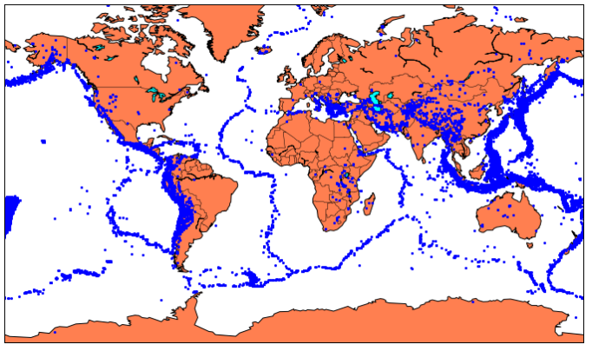

**DATA SET LINK:** [**https://www.kaggle.com/datasets/usgs/earthquake-database**](https://www.kaggle.com/datasets/usgs/earthquake-database)

**DATA SET:**

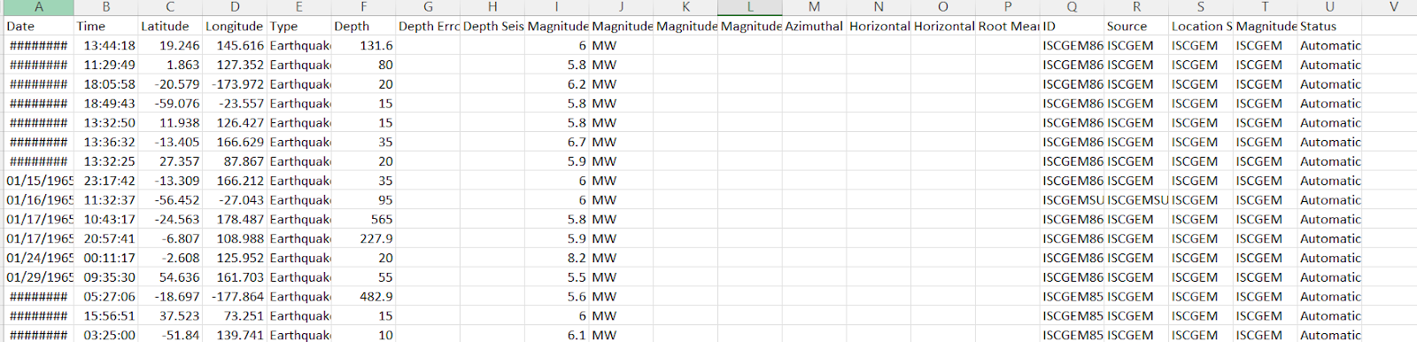

**PROGRAM:**

from learntools.core import binder

binder.bind(globals())

from learntools.data_cleaning.ex3 import *

print("Setup Complete")

# modules we'll use

import pandas as pd

import numpy as np

import seaborn as sns

import datetime

# read in our data

earthquakes = pd.read_csv("../input/earthquake-database/database.csv")

# set seed for reproducibility

np.random.seed(0)

# TODO: Your code here!

earthquakes['Date'].head()

# Check your answer (Run this code cell to receive credit!)

q1.check()

# Line below will give you a hint

#q1.hint()

Earthquakes[3378:3383]

date_lengths = earthquakes.Date.str.len()

date_lengths.value_counts()

indices = np.where([date_lengths == 24])[1]

print('Indices with corrupted data:', indices)

earthquakes.loc[indices]

# TODO: Your code here

earthquakes.loc[3378, "Date"] = "02/23/1975"

earthquakes.loc[7512, "Date"] = "04/28/1985"

earthquakes.loc[20650, "Date"] = "03/13/2011"

earthquakes['date_parsed'] = pd.to_datetime(earthquakes['Date'], format="%m/%d/%Y")

# Check your answer

q2.check()

# try to get the day of the month from the date column

day_of_month_earthquakes = earthquakes['date_parsed'].dt.day

# Check your answer

q3.check()

# TODO: Your code here!

sns.distplot(day_of_month_earthquakes, kde=False, bins=31)

# Check your answer (Run this code cell to receive credit!)

q4.check()

**OUTPUT:**

0    01/02/1965

1    01/04/1965

2    01/05/1965

3    01/08/1965

4    01/09/1965

Date

10    23409

24        3

Name: count, dtype: int64

