**COURSE: ARTIFICIAL INTELLIGENCE**

**TITLE: EARTHQUAKE PREDICTION MODEL USING PYTHON**

**PHASE 3 SUBMISSION : DEVELOPMENT PART 1**

**Team members:**

**Shravya. G. P (au 311521106091)**

**Sakthi Sowmiya. S (au311521106083)** **Rekha Sekar (au311521106075)**

**Saali Deivanai.L (au 311521106080)**

**INTRODUCTION:**

Predicting earthquakes using Python, or any other programming language, is a challenging scientific problem because short-term earthquake prediction remains uncertain and not currently feasible with high accuracy. Earthquake prediction often involves making forecasts about the occurrence, timing, and location of future seismic events, which is a complex task due to the unpredictable nature of earthquakes. Nevertheless, researchers use Python and various data analysis and machine learning techniques to work on related tasks like earthquake forecasting and seismic hazard assessment.

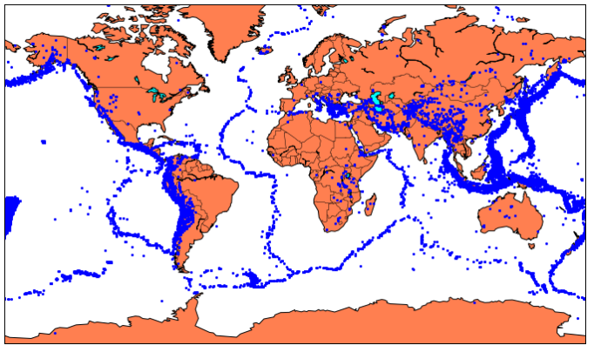

**DATA SET LINK:** [**https://www.kaggle.com/datasets/usgs/earthquake*database**](https://www.kaggle.com/datasets/usgs/earthquake-database)

**DATA SET:**

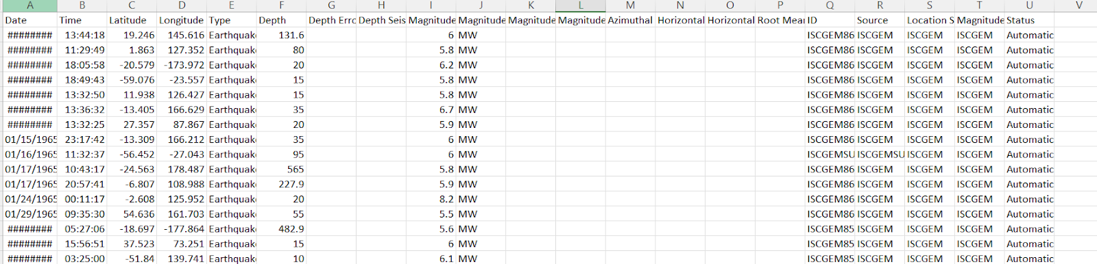

**DATA PRE-PROCESSING:**

Data preprocessing is a critical step in earthquake prediction or any data*driven task. It involves cleaning, organizing, and transforming the raw data into a format that can be effectively used for analysis and modeling. Here are the steps involved in data preprocessing for earthquake prediction:

1. Data Collection: Gather data from various sources, including seismometers, satellite imagery, and geological surveys. Ensure that the data is representative of the area of interest.

2. Data Cleaning:

* Missing Data: Check for missing values and decide on an appropriate strategy for dealing with them, such as imputation or removal.

* Outliers: Identify and handle outliers, as they can distort the analysis. Outliers may indicate sensor malfunctions or unusual seismic activity.

3. Data Integration: If you have data from multiple sources, merge them into a single dataset, making sure that the data formats are compatible.

4. Feature Selection:

* Identify the most relevant features (variables) for earthquake prediction. These could include seismic activity data, geological features, and meteorological data.

* Remove redundant or irrelevant features to simplify the dataset and improve model performance.

5. Feature Engineering: Create new features that can provide additional insights or improve model performance. For earthquake prediction, this might involve calculating seismic activity trends, Fourier transforms, or time*based aggregations.

6. Data Scaling: Standardize or normalize the data to ensure that all features have the same scale. Common techniques include min*max scaling or z*score normalization.

7. Temporal Data Handling: Earthquake prediction often involves time*series data. Consider techniques like resampling, smoothing, or windowing to extract relevant patterns from the temporal data.

8. Dimensionality Reduction: Use dimensionality reduction techniques such as Principal Component Analysis (PCA) to reduce the number of features while preserving important information.

9. Data Splitting: Divide the dataset into training, validation, and test sets. The training set is used to train the model, the validation set is used to tune hyperparameters, and the test set is used to evaluate the model's performance.

10. Data Imbalance: Check for class imbalances if you're working with a classification problem (e.g., predicting earthquake occurrence vs. non*occurrence). You may need to apply techniques like oversampling, undersampling, or Synthetic Minority Over*sampling Technique (SMOTE) to balance the dataset.

11. Time Series Data Preprocessing:

* Ensure that time series data is in a suitable format for modeling, which may include creating lag features or rolling statistics.

* Handling time gaps and irregularities in data collection.

12. Encoding Categorical Data: If your data includes categorical variables, encode them into numerical values using techniques like one*hot encoding or label encoding.

13. Data Splitting: Split your dataset into training, validation, and test sets. Ensure that the data splitting maintains the temporal order of the data.

14. Data Normalization: Normalize your data, especially if you are using neural networks or other algorithms sensitive to input scale.

15. Data Augmentation: If you have limited earthquake data, consider data augmentation techniques like adding noise, jitter, or applying transformations to generate synthetic samples.

16. Data Preprocessing Pipeline: Create a preprocessing pipeline that includes all the necessary transformations, which can be easily applied to new data.

17. Documentation: Keep thorough documentation of all the preprocessing steps and the reasoning behind each step, as this is essential for reproducibility and troubleshooting.

**DATA CLEANING:**

Data cleaning is a crucial step in preparing your data for earthquake prediction using Python. Here are the steps and Python code examples to help you clean and preprocess your earthquake data:

1. Import Libraries:

Start by importing the necessary libraries, such as pandas and NumPy, which are commonly used for data cleaning and preprocessing.

import pandas as pd

import numpy as np

2. Load the Data:

Load your earthquake data into a Pandas DataFrame. Replace 'your_data.csv' with the actual filename or data source.

df = pd.read_csv('your_data.csv')

3. Handling Missing Data:

Check for missing values and decide how to handle them. You can either remove rows with missing values or impute them with a reasonable value.

To remove rows with missing values:

df = df.dropna()

To impute missing values with the mean of the column:

df = df.fillna(df.mean())

4. Handling Duplicates:

Check for and remove duplicate rows in your dataset.

df = df.drop_duplicates()

5. Outlier Detection and Handling:

Identify and deal with outliers in your dataset. You can use statistical methods or visualization techniques to detect outliers.

To remove outliers based on z-scores:

from scipy import stats

z_scores = np.abs(stats.zscore(df))

df = df[(z_scores < 3).all(axis=1)]

Replace outliers with the median:

median = df['column_name'].median()

df['column_name'] = np.where((df['column_name'] > 3 * median), median, df['column_name'])

6. Data Transformation and Feature Engineering:

Perform any necessary data transformations and feature engineering. This could involve creating new features, scaling, or encoding categorical variables.

To scale features using Min-Max scaling:

from sklearn.preprocessing import MinMaxScaler

scaler = MinMaxScaler()

df['scaled_feature'] = scaler.fit_transform(df[['feature']])

To one-hot encode categorical variables:

df = pd.get_dummies(df, columns=['categorical_feature'])

7. Data Splitting:

Split your data into training, validation, and test sets.

from sklearn.model_selection import train_test_split

X = df.drop(columns=['target_column'])

y = df['target_column']

X_train, X_temp, y_train, y_temp = train_test_split(X, y, test_size=0.3, random_state=42)

X_valid, X_test, y_valid, y_test = train_test_split(X_temp, y_temp, test_size=0.5, random_state=42)

8. Save Cleaned Data:

Save the cleaned data to a new CSV file for future use.

df.to_csv('cleaned_data.csv', index=False)

9. Documentation:

Keep track of all the steps you've taken during data cleaning for reproducibility.

**DATA INTEGRATION:**

Data integration is the process of merging data from various sources and organizing it into a single dataset for earthquake prediction. This can involve combining data from different sensors, geological surveys, meteorological sources, and other relevant sources. Here's how you can perform data integration for earthquake prediction using Python:

1. Import Libraries:

Start by importing the necessary libraries, including pandas, which is a powerful tool for data manipulation and integration.

import pandas as pd

2. Load Data from Different Sources:

Load data from various sources, such as seismometers, geological surveys, and meteorological stations, into separate Pandas DataFrames. Ensure that each dataset has a common identifier (e.g., time or location) that can be used to merge them.

seismometer_data = pd.read_csv('seismometer_data.csv')

geological_data = pd.read_csv('geological_data.csv')

meteorological_data = pd.read_csv('meteorological_data.csv')

3. Data Exploration:

Explore each dataset to understand its structure, features, and the common identifier that can be used for merging.

4. Data Preprocessing:

Perform data cleaning and preprocessing on each dataset individually, following the steps mentioned in the previous response on data cleaning. This ensures that each source's data is in good shape before integration.

5. Merge Data:

Merge the data from different sources based on the common identifier. You can use the `merge` function in Pandas to join the dataframes. For example, if you're using a common "timestamp" column:

integrated_data = seismometer_data.merge(geological_data, on='timestamp', how='inner')

integrated_data = integrated_data.merge(meteorological_data, on='timestamp', how='inner')

Adjust the 'on' parameter and the 'how' parameter as needed based on your specific dataset.

6. Data Transformation and Feature Engineering:

Perform any necessary data transformations and feature engineering on the integrated dataset, as mentioned in the previous response. This may involve scaling, encoding, and creating new features.

7. Data Splitting:

Split your integrated dataset into training, validation, and test sets as needed for earthquake prediction, as explained earlier.

8. Save Integrated Data:

Save the integrated data to a new CSV file for future use. integrated_data.to_csv('integrated_data.csv', index=False)

9. Documentation:

Document the entire data integration process, including the sources of data, the merging strategy, and any decisions made during the integration.

**DATA TRANSFORMATION:**

Data transformation is a crucial step in preparing your data for earthquake prediction using Python. This process involves converting, scaling, and engineering features to make the data suitable for machine learning models. Here's how you can perform data transformation for earthquake prediction:

1. Import Libraries:

Start by importing the necessary libraries, including pandas and scikit*learn for data transformation.

import pandas as pd

from sklearn.preprocessing import StandardScaler, MinMaxScaler

2. Load the Data:

Load your earthquake prediction dataset into a Pandas DataFrame.

df = pd.read_csv('earthquake_data.csv')

3. Feature Scaling:

Scaling is often necessary to ensure that all features are on the same scale, which can improve the performance of many machine learning algorithms.

a. Standardization (Z-score normalization):

Standardize your features by subtracting the mean and dividing by the standard deviation:

scaler = StandardScaler()

df[['feature1', 'feature2']] = scaler.fit_transform(df[['feature1', 'feature2']])

b. Min-Max Scaling:

Scale features to a specific range (e.g., 0 to 1) using Min-Max scaling:

scaler = MinMaxScaler()

df[['feature1', 'feature2']] = scaler.fit_transform(df[['feature1', 'feature2']])

4. Log Transformation:

In some cases, taking the logarithm of a feature can help normalize its distribution:

df['log_feature'] = np.log(df['feature'])

5. Encoding Categorical Data:

If your dataset contains categorical variables, you should encode them into numerical values. Common encoding methods include one*hot encoding or label encoding:

a. One*Hot Encoding:

df = pd.get_dummies(df, columns=['categorical_feature'])

b. Label Encoding:

from sklearn.preprocessing import LabelEncoder

le = LabelEncoder()

df['categorical_feature'] = le.fit_transform(df['categorical_feature'])

6. Creating New Features:

Feature engineering is an essential part of data transformation. You can create new features that may capture important patterns related to earthquake prediction. This can involve mathematical transformations, aggregations, or interactions between existing features.

For example, you might create a feature that represents the time difference between the current data point and the previous data point.

df['time_difference'] = df['timestamp'].diff()

7. Handling Time Series Data:

If you're working with time series data, you may want to extract features related to time patterns, such as rolling statistics, moving averages, or time*based aggregations.

df['rolling_mean'] = df['feature'].rolling(window=5).mean()

8. Data Splitting:

Split your transformed data into training, validation, and test sets as needed for machine learning model training and evaluation.

9. Save Transformed Data:

Save the transformed data to a new CSV file for future use.

df.to_csv('transformed_data.csv', index=False)

10. Documentation:

Keep thorough documentation of all the transformations and feature engineering steps, as this is essential for reproducibility and model evaluation.

Data transformation is a critical step in earthquake prediction, as it can significantly impact the performance of your machine learning models. Customize these steps according to your specific dataset and needs, and consult with domain experts if necessary for accurate feature engineering.

**DATA REDUCTION:**

Data reduction, often referred to as dimensionality reduction, is a technique used to reduce the number of features (variables) in your dataset while preserving the essential information. This can be beneficial for earthquake prediction to reduce computational complexity and potentially improve model performance. One common method for dimensionality reduction is Principal Component Analysis (PCA). Here's how to perform data reduction for earthquake prediction using PCA in Python:

1. Import Libraries:

Begin by importing the necessary libraries, including pandas, scikit*learn for PCA, and any other libraries you might need.

import pandas as pd

from sklearn.decomposition import PCA

from sklearn.preprocessing import StandardScaler

2. Load and Prepare the Data:

Load your earthquake prediction dataset into a Pandas DataFrame and prepare the data, including any necessary data cleaning and transformation.

df = pd.read_csv('earthquake_data.csv')

3. Standardize the Data:

PCA is sensitive to the scale of your data, so it's recommended to standardize your features using z*score normalization.

scaler = StandardScaler()

standardized_data = scaler.fit_transform(df)

4. Apply PCA:

Apply PCA to the standardized data. You can specify the number of principal components you want to keep.

n_components = 2 # Choose the number of principal components to retain

pca = PCA(n_components=n_components)

reduced_data = pca.fit_transform(standardized_data)

5. Explained Variance:

After applying PCA, it's essential to check the explained variance to understand how much of the variance in the original data is retained by the selected number of principal components. This can help you decide on the appropriate number of components to retain.

explained_variance = pca.explained_variance_ratio_

6. Interpretation:

Analyze the results to understand which principal components are the most informative for your earthquake prediction task. You can examine the loadings of each component to interpret their meaning.

component_loadings = pca.components_

7. Incorporate Reduced Data into Your Model:

Use the reduced data as input for your earthquake prediction model. Depending on the algorithm you're using, you may need to retrain your model using the reduced feature set.

8. Save the Reduced Data:

If you want to save the reduced data for later use, you can create a new DataFrame and store it in a CSV file.

reduced_df = pd.DataFrame(data=reduced_data, columns=['PC1', 'PC2']) # Adjust column names as needed

reduced_df.to_csv('reduced_data.csv', index=False)

9. Documentation:

Document the entire process, including the number of principal components retained and any insights gained from the PCA analysis.