**SOFTWARE**

**REQUIREMENTS SPECIFICATION**

**For**

**STOCK INVENTORY APPLICATION**

## Prepared by:-

*SAKTHIVEL S*

*SUGUMAR S*

*SRIRAM K*

*RAMANATHAN D*

**Academic Year:** *2020-2024*

### 1. Introduction

#### 1.1 Purpose

Our Stock Maintenance system provides online internet sales for direct/ indirect customers, agents, and trade partners. Stock maintenance system is used to records the products sales details very easy and effective.

.

#### 1.2 Document Conventions

* Entire document should be justified.
* Convention for Main title

Font face: Times New Roman



Font style: Bold

Font Size: 14

* Convention for Sub title

Font face: Times New Roman



Font style: Bold

Font Size: 12

* Convention for body

Font face: Times New Roman



Font Size: 12

#### 1.3 Scope of Development Project

The Stock Management System and Control (SMSC) is designed to maintain the stock details; effective handling in avoid shortage of stocks. This allows user to purchase an item, more effectively, consistently. The data will be held in an Access database.

#### 1.4 Definitions, Acronyms and Abbreviations

JAVA -> platform independence

SQL-> Structured query Language

ER-> Entity Relationship

UML -> Unified Modeling Language

IDE-> Integrated Development Environment

SRS-> Software Requirement Specification

ISBN -> International Standard Book Number

IEEE ->Institute of Electrical and Electronics Engineers

#### 1.5 References

[IEEE] The applicable IEEE standards are published in “IEEE APPLINY UML AND PATTERNS” by CRAIG LARMAN (2001 edition).

1. Mike Docherty, “Object-Oriented Analysis & Design: Understanding System

Development with UML 2.0”, John Wiley & Sons, 2005.

2. James W- Cooper, Addison-Wesley, “Java Design Patterns – A Tutorial”, 2000.

3. Micheal Blaha, James Ram Baugh, “Object-Oriented Modeling and Design with UML”,

Second Edition, Prentice Hall of India Private Limited, 2007

4. Erich Gamma, Richard Helm, Ralph Johnson, John Vlassises, **“**Design patterns:

Elements of Reusable object-oriented software”, Addison-Wesley, 1995.

### 2. Overall Descriptions

#### 2.1 Product Perspective

Use cases are text stories, widely used to discover and record requirements. They emphasize the user goals and perspective. The use case name starts with verb.

The use cases used in this system are

* Make sale
* Purchase item
* Maintain account

**Use Case Diagram of stock maintenance System**

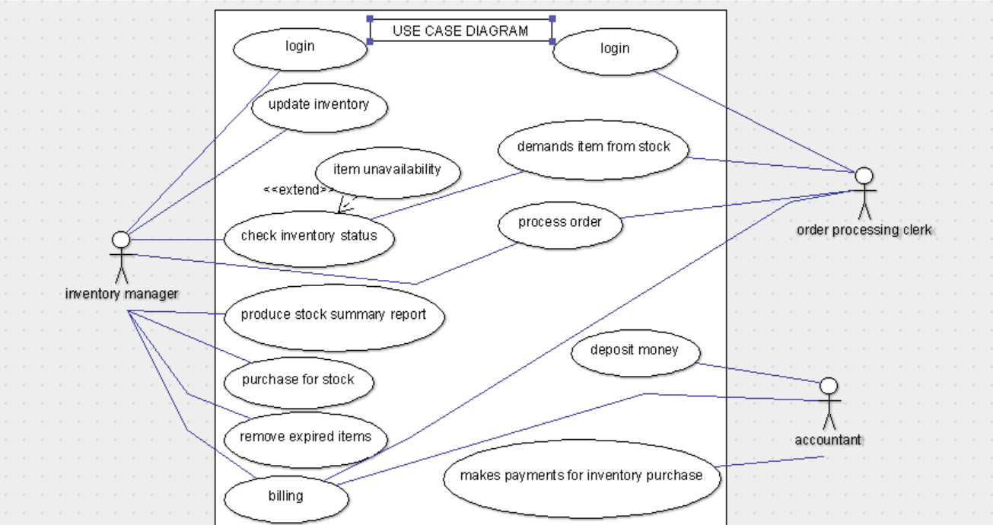

#### 2.2 Product Function

Entity Relationship Diagram of stock Maintenance System.

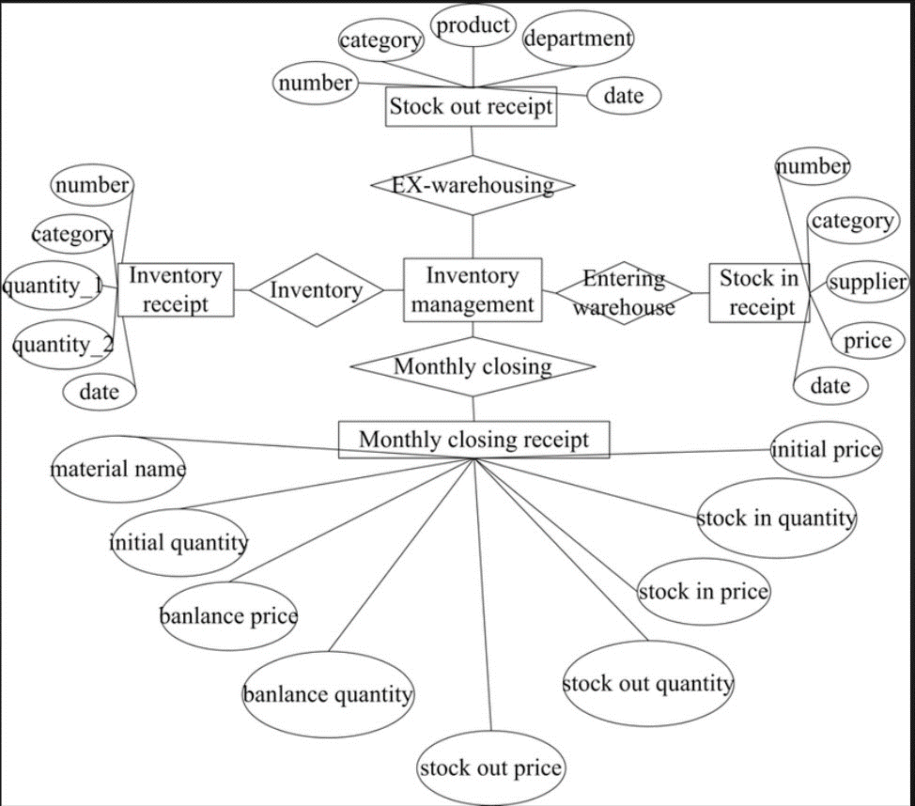

The Stock inventory System provides online real time information about the stock available in the inventory and the user information. The main purpose of this project is to reduce the manual work. This software is capable of managing stocks Issues, Generating various Reports for Record-Keeping according to end user requirements. The stock manager will act as the administrator to control members and manage stocks. The member’s status of issue/return is maintained in the inventory database. The member’s details can be fetched by the stock manager from the database as and when required.

#### 2.3 User Classes and Characteristics

The application will have three main user roles:

1. Administrator: Can perform all functions, including user management.

2. Manager: Can manage products, inventory, orders, and generate reports.

3. Employee: Can view and modify product details, track stock levels, and process orders.

#### 2.4 Operating Environment

The product will be operating in windows environment. The stock Maintenance System is a website and shall operate in all famous browsers, for a model we are taking Microsoft Internet Explorer, Google Chrome, and Mozilla Firefox. Also it will be compatible with the IE 6.0. Most of the features will be compatible with the Mozilla Firefox & Opera 7.0 or higher version. The only requirement to use this online product would be the internet connection.

The hardware configuration include are

Hard Disk: 40 GB,

Monitor: 15” Color monitor,

Keyboard: 122 keys.

The basic input devices required are keyboard, mouse and output devices are monitor, printer etc.

#### 2.5 Assumptions and Dependencies

The assumptions are:-

* The coding should be error free
* The system should be user-friendly so that it is easy to use for the users
* The information of all users, stocks and stock manager must be stored in a database that is accessible by the website
* The system should have more storage capacity and provide fast access to the database
* The system should provide search facility and support quick transactions
* The stock inventory System is running 24 hours a day
* Users may access from any computer that has Internet browsing capabilities and an Internet connection
* Users must have their correct usernames and passwords to enter into their online accounts and do actions

The dependencies are:-

* The specific hardware and software due to which the product will be run.
* On the basis of listing requirements and specification the project will be developed and run.
* The end users (admin) should have proper understanding of the product.
* The system should have the general report stored.
* The information of all the users must be stored in a database that is accessible by the stock System.
* Any update regarding the stocks from the inventory is to be recorded to the database and the data entered should be correct.

#### 2.6 Requirement

**Software Configuration**:-

This software package is developed using java as front end which is supported by sun micro system. Microsoft SQL Server as the back end to store the database.

Operating System: Windows NT, windows 98, Windows XP

Language: Java Runtime Environment, Net beans 7.0.1 (front end)

Database: MS SQL Server (back end)

**Hardware Configuration**:-

Processor: Pentium(R)Dual-core CPU

Hard Disk: 40GB

RAM: 256 MB or more

#### 2.7 Data Requirement

The inputs consist of the query to the database and the output consists of the solutions for the query. The output also includes the user receiving the details of their accounts. In this project the inputs will be the queries as fired by the users like create an account, selecting stocks and putting into account. Now the output will be visible when the user requests the server to get details of their account in the form of time, date and which stocks are currently in the account.

### 3. External Interface Requirement

#### 3.1 GUI

The software provides good graphical interface for the user and the administrator can operate on the system, performing the required task such as create, update, viewing the details of the stock.

* It allows user to view quick reports like stock Issued.
* It provides stock verification and search facility based on different criteria.
* The user interface must be customizable by the administrator
* All the modules provided with the software must fit into this graphical user interface and accomplish to the standard defined.
* The design should be simple and all the different interfaces should follow a standard template.
* The user interface should be able to interact with the user management module and a part of the interface must be dedicated to the login/logout module.

**Login Interface: -**

In case the user is not yet registered, he can enter the details and register to create his account. Once his account is created, he can ‘Login’ which asks the user to type his username and password. If the user entered either his username or password incorrectly then an error message appears.

**Search**: -

The member or stock manager can enter the type of stock he is looking for and the title he is interested in, then he can search for the required stock by entering the stock name.

**Categories View**: -

Category’s view shows the categories of stocks available and provides ability to the stock manager to add/edit or delete category from the list.

Inventory manager’s Control Panel: -

This control panel will allow manager to add/remove users; add, edit, or remove a resource. And manage lending options.

### 4. System Features

The users of the system should be provided the surety that their account is secure. This is possible by providing: -

* User authentication and validation of members using their unique member ID
* Proper monitoring by the administrator which includes updating account status, showing a popup if the member attempts to issue number of stocks that exceed the limit provided by the inventory policy.
* Proper accountability which includes not allowing a member to see other member’s account. Only administrator will see and manage all member accounts.

### 5. Other Non-functional Requirements

#### 5.1 Performance Requirement

The proposed system that we are going to develop will be used as the Chief performance system within the different campuses of the company which interacts with the company customers. Therefore, it is expected that the database would perform functionally all the requirements that are specified by the university.

* The performance of the system should be fast and accurate.
* Stock inventory System shall handle expected and non-expected errors in ways that prevent loss in information and long downtime period. Thus, it should have inbuilt error testing to identify invalid username/password
* The system should be able to handle large amount of data. Thus, it should accommodate high number of stocks and users without any fault

#### 5.2 Safety Requirement

The database may get crashed at any certain time due to virus or operating system failure. Therefore, it is required to take the database backup so that the database is not lost. Proper UPS/inverter facility should be there in case of power supply failure.

#### 5.3 Security Requirement

* System will use secured database.
* Normal users can just read information but they cannot edit or modify anything except their personal and some other information.
* System will have different types of users and every user has access constraints
* Proper user authentication should be provided

➢ No one should be able to hack users’ password

* There should be separate accounts for admin and members such that no member can access the database and only admin has the rights to update the database.

#### 5.4 Requirement attributes

* There may be multiple admins creating the project, all of them will have the right to create changes to the system. But the members or other users cannot do changes
* The project should be open source
* The Quality of the database is maintained in such a way so that it can be very user friendly to all the users of the database
* The user be able to easily download and install the system.

#### 5.5 Business Rules

A business rule is anything that captures and implements business policies and practices. A rule can enforce business policy, make a decision, or infer new data from existing data. This includes the rules and regulations that the System users should abide by. This includes the cost of the project and the discount offers provided. The users should avoid illegal rules and protocols. Neither admin nor member should cross the rules and regulations.

#### 5.6 User Requirement

The users of the system are customer and stock person of the company who act as administrator to maintain the system. The members are assumed to have basic knowledge of the computers and internet browsing. The administrators of the system should have more knowledge of the internals of the system and is able to rectify the small problems that may arise due to disk crashes, power failures and other catastrophes to maintain the system. The proper user interface, user manual, online help, and the guide to install and maintain the system must be sufficient to educate the users on how to use the system without any problems.

**The admin provides certain facilities to the users in the form of**: ➢ Backup and Recovery

* Forgot Password.
* Data migration i.e., whenever user registers for the first time then the data is stored in the server
* Data replication i.e., if the data is lost in one branch, it is still stored with the server
* Auto Recovery i.e., frequently auto saving the information
* Maintaining files i.e., File Organization
* The server must be maintained regularly and it must be updated from time to time

### 6. Other Requirements

#### 6.1 Data and Category Requirement

There are different categories of users namely customer, cashier, etc. Depending upon the category of user the access rights are decided. It means if the user is an administrator, then he can be able to modify the data, delete, append etc. All other users except the stock person only have the rights to retrieve the information about database. Similarly, there will be different categories of stock available. According to the categories of stock their relevant data should be displayed. The categories and the data related to each category should be coded in the particular format.

#### 6.2 Appendix

A: Admin, Abbreviation, Acronym, Assumptions; S: Stock; C: Class, Client, Conventions; D: Data requirement, Dependencies; G: GUI; K: Key; M: Member; N:Non-functional Requirement;

O: Operating environment; P: Performance, Perspective, Purpose; R: Requirement, Requirement attributes; S: Safety, Scope, Security, System features; U: User, User class and characteristics, User requirement;

#### 6.3 Glossary

The following are the list of conventions and acronyms used in this document and the project as well:

|  |  |
| --- | --- |
| Term | Definition |
| Customers | Who tried to purchase the Item? |
| CI | Configuration Item |
| SMSC | Stock Management System and Control |
| Entry | Item stored in the Access Database |
| IEEE | Institute of Electrical and Electronic Engineers |
| QA | Quality assurance |
| SCMP | Software Configuration Management Plan |

#### 6.4 Class Diagram

A class is an abstract, user-defined description of a type of data. It identifies the attributes of the data and the operations that can be performed on instances (i.e. objects) of the data. A class of data has a name, a set of attributes that describes its characteristics, and a set of operations that can be performed on the objects of that class. The classes’ structure and their relationships to each other frozen in time represent the static model. In this project there are certain main classes which are related to other classes required for their working. There are different kinds of relationships between the classes as shown in the diagram like normal association, aggregation, and generalization. The relationships are depicted using a role name and multiplicities. Here ‘cashier’, ‘customer’ and ‘stocks’ are the most important classes which are related to other classes.

