Co-1 _Assessment_Tool_2 - Flowgorithm

1. Read the coordinates (x, y) of a point and identify the quadrant or axis on which the point lies.

Answer:

Function Main
Declare Real x
Declare Real y

Input x
Input y
If x>0 and y>0
Output "Quadrant I"
Else
If x < 0 and y > 0
Output "Quadrant II"
Else
If x < 0 and y < 0
Output "Quadrant III"
Else
If x > 0 and y < 0
Output "Quadrant IV"
Else
If x = 0 and y = 0
Output "Origin"
Else
If x = 0
Output "Y-Axis"
Else
Output "X-Axis"
End
End
End
End
End
End
End

FLOWCHART:

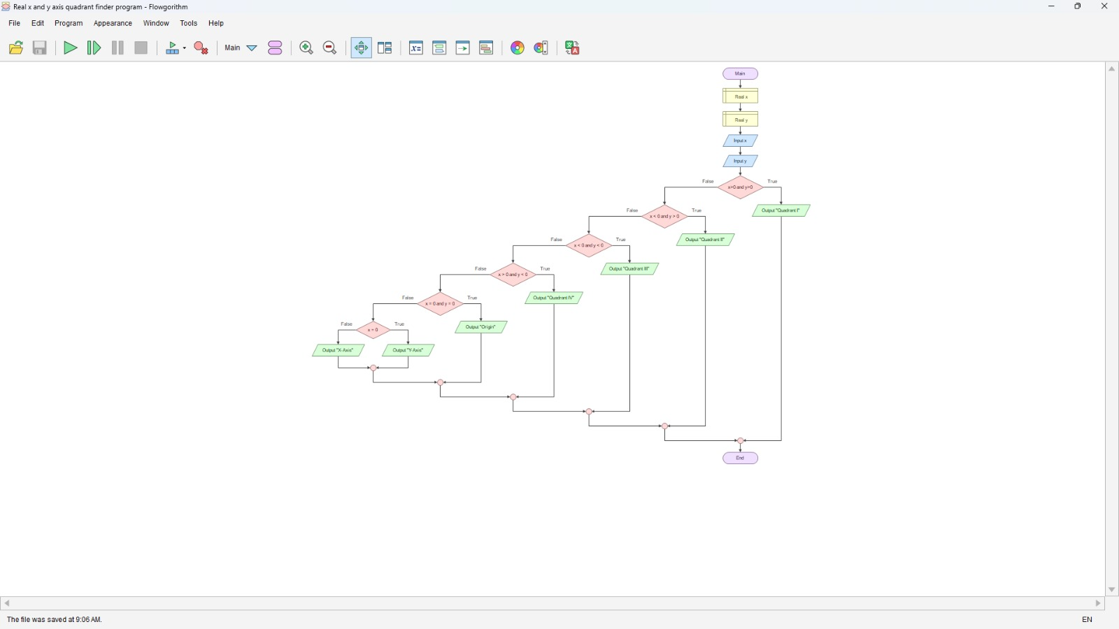
OUTPUT:

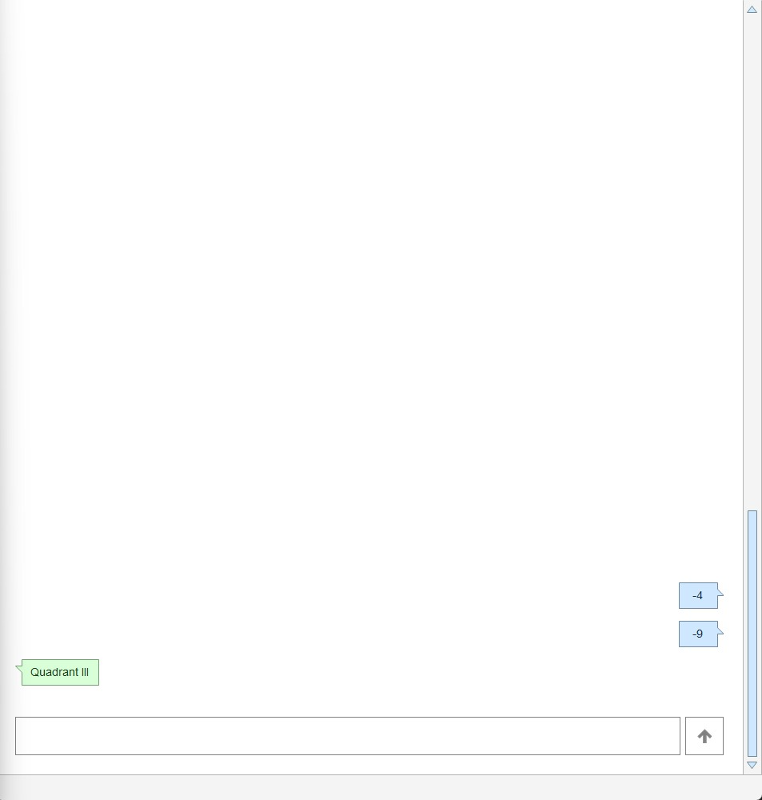

2. Read two positive integers and calculate their GCD using repeated division; then compute the LCM.
Answer:
Function Main
Declare Integer a
Declare Integer b
Declare Integer temp1
Declare Integer temp2
Declare Integer gcd
Declare Integer lcm

Input a
Input b
Assign temp1 = a
Assign temp2 = b
While temp2 <> 0
Assign gcd = temp2
Assign temp2 = temp1 Mod temp2
Assign temp1 = gcd
End
Assign gcd = temp1
Assign lcm = (a * b) / gcd
Output "GCD = "
Output gcd
Output "LCM = "
Output lcm
End
FLOWCHART:
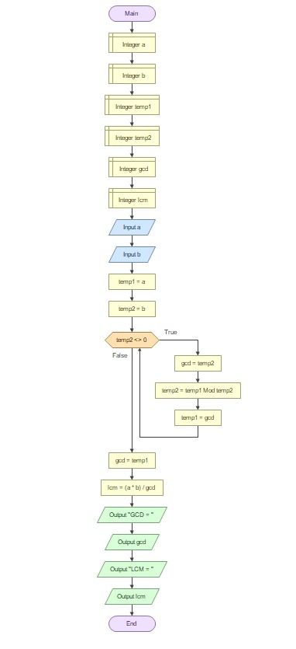
OUTPUT:
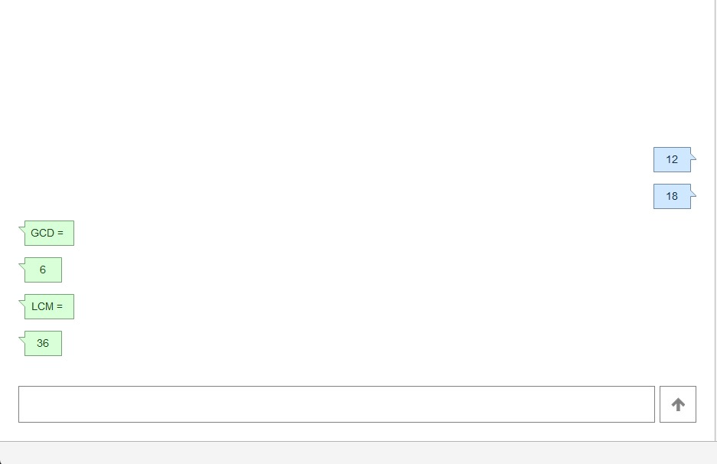

3.s

