2. Setting Up a Zoho Creator Account and Exploring the Platform Architecture and Interface
Aim:
To create a Zoho Creator account and explore the platform architecture, features, and user interface for developing low-code applications.
Overview:
Zoho Creator is a cloud-based low-code application development platform that enables users to build custom business applications with minimal coding. It provides a visual development environment where applications can be designed using drag-and-drop components, forms, workflows, reports, and dashboards.
The platform architecture consists of the following components: Applications (containers that hold all forms, reports, workflows, pages, and settings), Forms (used to collect and store user data), Reports (display and manage stored data in various formats), Pages (custom interfaces that combine multiple components), Workflows (automate tasks using event-based actions), Deluge Script (scripting language for advanced functionality), and Users and Permissions (control access and define roles).
The Zoho Creator interface includes the Home Dashboard, Application Builder, Form Designer, Report Builder, Workflow Builder, Navigation Panel, and Settings menu, allowing users to efficiently design, test, and deploy applications.
Procedure:
1. Open a web browser and navigate to the Zoho Creator website. Create or access the Zoho Creator account and open the Zoho Creator home dashboard.
2. Create a Zoho account or sign in using existing credentials. After signing in, the Zoho Creator home page provides access to the applications available to the user.
3. Access the Zoho Creator dashboard. The Creator dashboard provides access to existing applications and options for creating new applications. An application can be created from scratch or using a pre-built template.
4. Create a new application using either a blank application or a pre-built template. After creating the application, open it in Edit Mode. The edit mode is the main development environment where forms, reports, pages, and workflows can be created and modified.
5. Explore the Application Builder interface and its navigation options. The Application Builder provides access to the major components. The + option can be used to add components such as Forms, Reports, Pages, and Workflows.
6. Examine the Form Designer and add sample fields such as text, number, date, and email. Forms provide the interface through which users enter and store structured data.
7. Enter sample data into the created form. Open the form in live/user mode and enter sample information into the fields.
8. Explore the Report Builder to view the generated records. Submit the sample form and open the generated report. Reports display the data collected through forms.
9. Navigate through the Workflow section to understand automation features. Open the Workflow section and explore the available workflow options.
10. Explore Pages and the Page Builder. Create or open a Page and explore the Page Builder components such as graphs, buttons, panels, forms, and reports.
11. Explore the application navigation menu and observe how forms, reports, and pages can be organized for easier access.
12. Explore Settings, User Management, and Application Permissions. Navigate to the application settings and explore user management and permission options.
13. Explore the Deluge Script environment to understand how advanced functionality and automation can be implemented.
14. Observe the overall platform architecture and note the functions of each component: Forms collect data, Reports display data, Pages provide interfaces, Workflows automate tasks, Deluge implements logic, and Users & Permissions control access.
Screenshots:
Fig. 2.1:
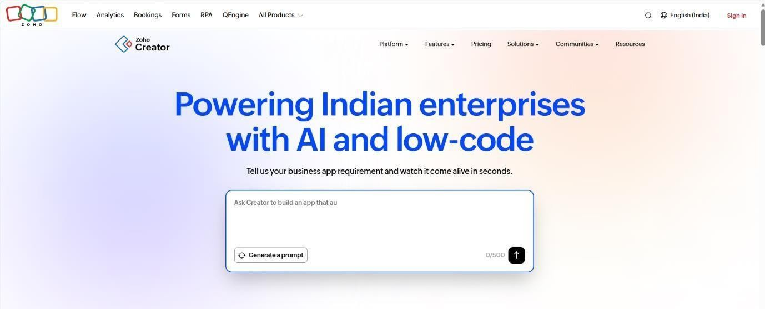
Fig. 2.2:
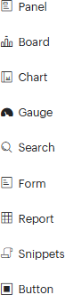
Fig. 2.3:
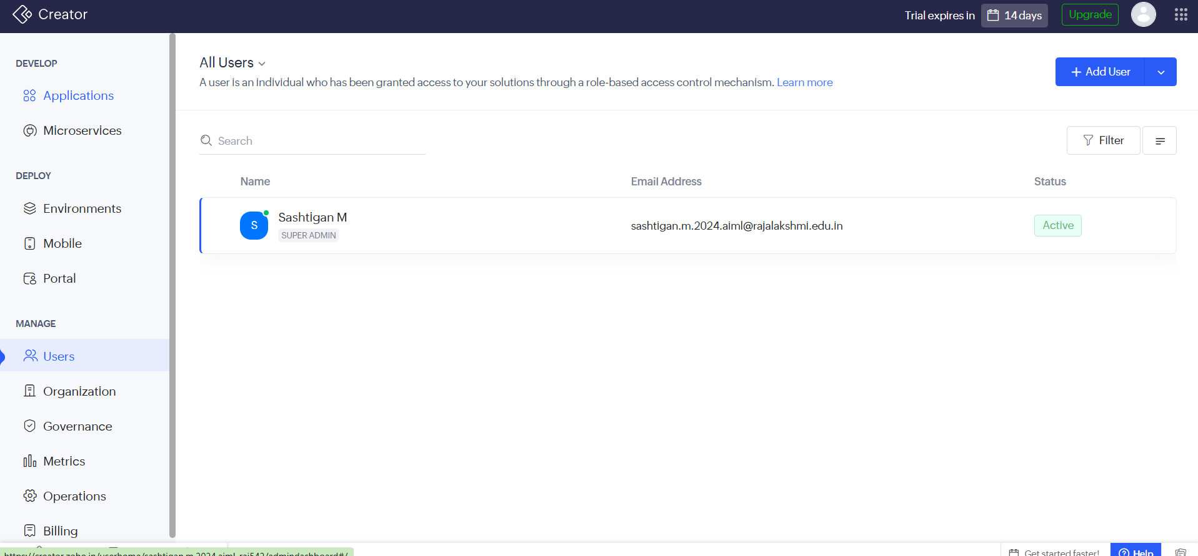
Fig. 2.4:
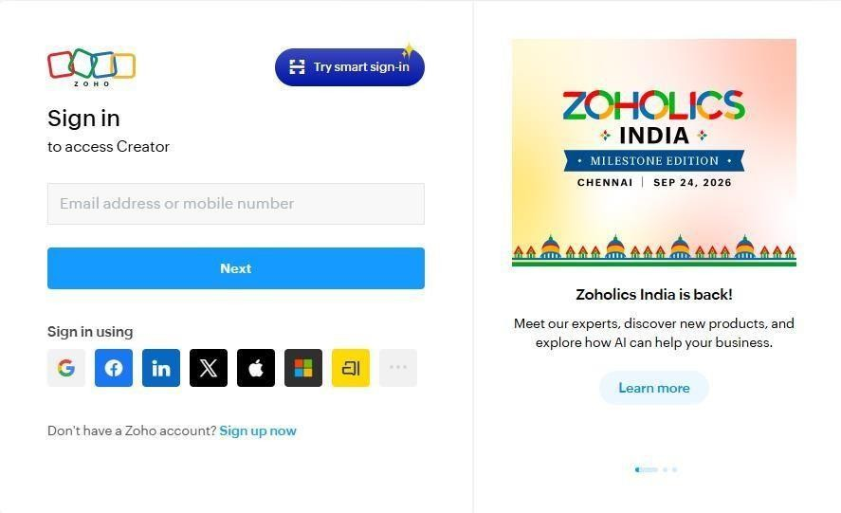
Fig. 2.5:
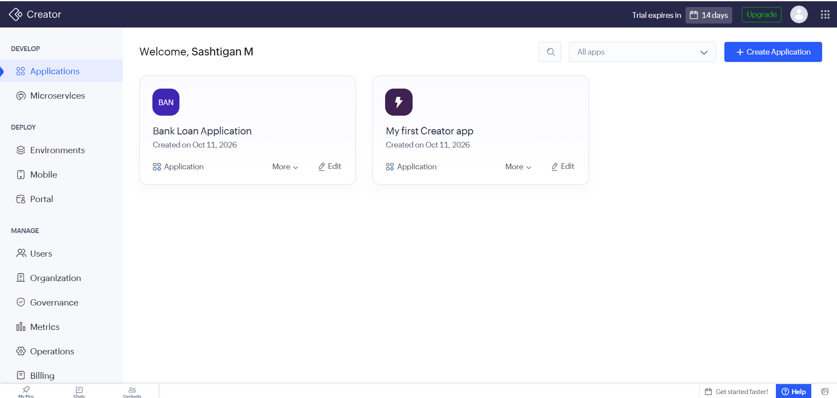
Fig. 2.6:
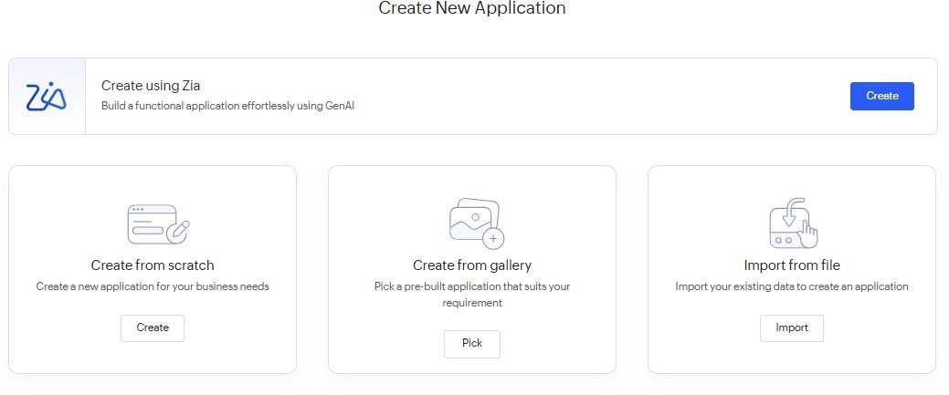
Fig. 2.7:
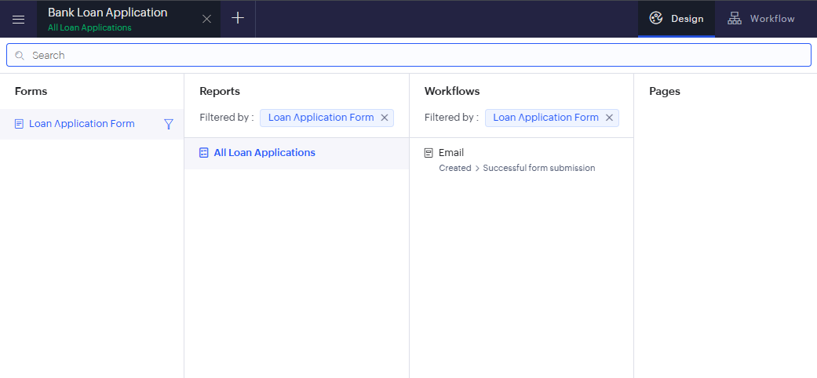
Fig. 2.8:
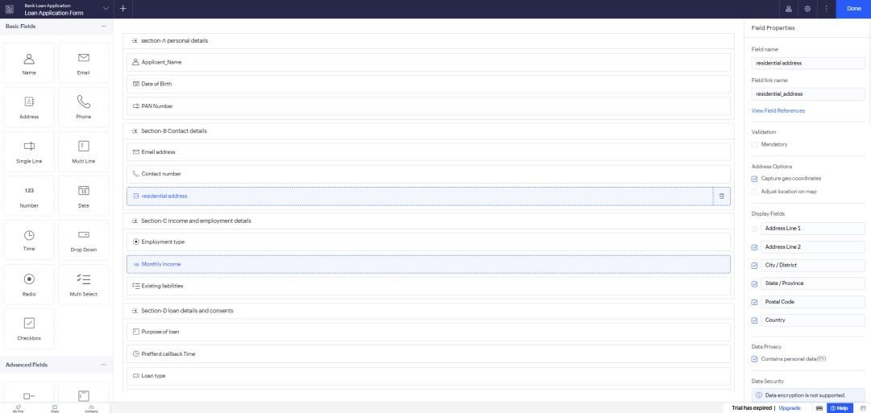
Result:
A Zoho Creator account was successfully created, and the platform architecture and user interface were explored. The experiment demonstrated that Zoho Creator provides an intuitive low-code environment with tools such as forms, reports, workflows, pages, and dashboards, enabling rapid application development with minimal programming effort.

