9. AI-Assisted Features & Zia Analytics in Zoho Creator
Aim:
To explore and configure built-in artificial intelligence capabilities (Zia) and advanced analytics features within Zoho Creator for intelligent data querying, predictive forecasting, and automated insights.
Overview:
Zoho Creator integrates Zia (Zoho’s conversational AI and analytics assistant) to empower low-code developers with natural language processing, automated chart creation, anomaly detection, and predictive analytics. Key capabilities include Zia Voice & Chat (query application data and trigger reports via conversational commands), Smart Analytics (automatically suggests metrics, pivot tables, and visual charts based on dataset patterns), and Anomaly Detection (flags irregular data entries, performance delays, or transaction spikes using machine learning).
Procedure:
1. Enable Analytics & Zia: Open the Zoho Creator application workspace, navigate to the Analytics module, and ensure Zia AI assistant integration is active for the target data tables.
2. Generating AI-Driven Dashboards: Use the natural language query prompt box to type commands such as “Show total revenue grouped by month as a bar chart” or select Zia’s automated dashboard recommendations.
3. Configuring Predictors & Insights: Set up data prediction models to forecast future trends based on historical application records (e.g., project completion dates or order volumes).
4. Test anomaly detection by introducing sample irregular data and verifying that Zia flags the anomalies.
5. Review the generated charts, insights, and predictions for accuracy and usefulness.
Screenshots:
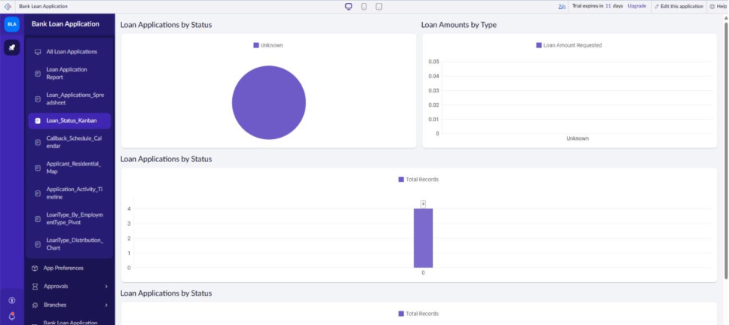
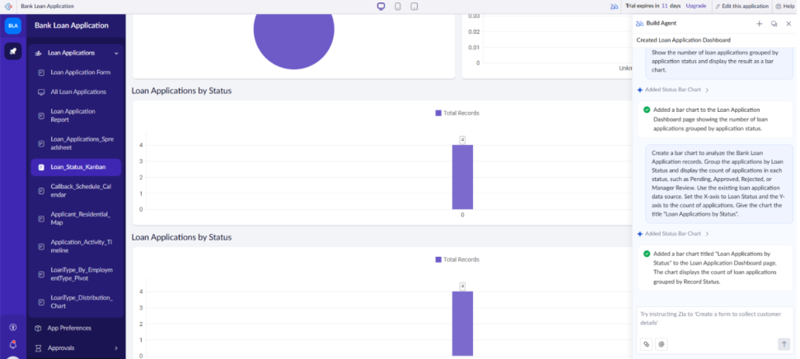
Result:
The experiment successfully demonstrated the integration of AI-driven analytics using Zia in Zoho Creator, proving its efficiency in delivering automated business intelligence and natural language data exploration without manual script coding.

