8. User Management & RBAC in Zoho Creator
Aim:
To configure granular User Management and Role-Based Access Control (RBAC) within a Zoho Creator application to secure modules, restrict data visibility, and assign designated operational roles.
Overview:
Role-Based Access Control restricts system access based on the organizational role of a user. In this lab, an enterprise application in Zoho Creator is configured with three distinct user tiers: Administrator (Full Create, Read, Update, Delete across all records), Manager (Read, Update, Approve Records for assigned Region/Department), and Standard Employee (Create & Read own submissions only). Profiles further refine module-level permissions for form creation, report viewing, and edit/delete rights.
Procedure:
1. Access Developer Mode: Log into Zoho Creator, open the target application, and navigate to the Settings tab in the left-hand builder menu.
2. Configure Users & Roles: Click on Users & Permissions under the Users section. Select the Roles sub-tab and create custom roles (e.g., Manager, Employee) alongside the default Administrator role. Establish hierarchy reporting lines if required.
3. Define Profiles & Permissions: Navigate to Profiles to fine-tune module-level permissions (Form creation, Report viewing, Edit/Delete rights).
4. Assign users to the appropriate roles and test access by logging in as each role type to confirm data isolation and permission boundaries.
5. Verify that Administrators see all records, Managers see only assigned regional data, and Employees see only their own submissions.
Screenshots:
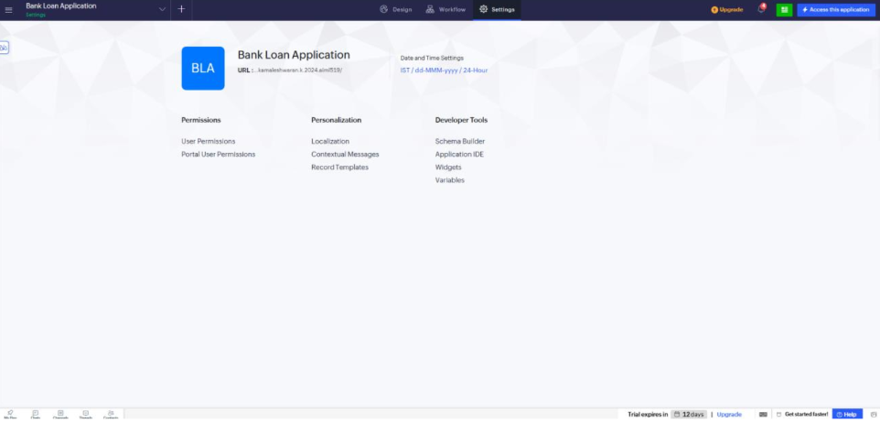
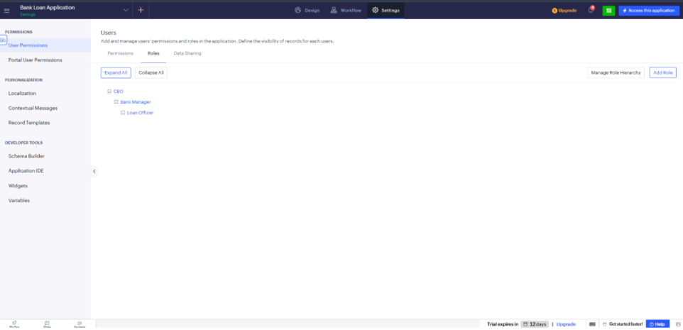
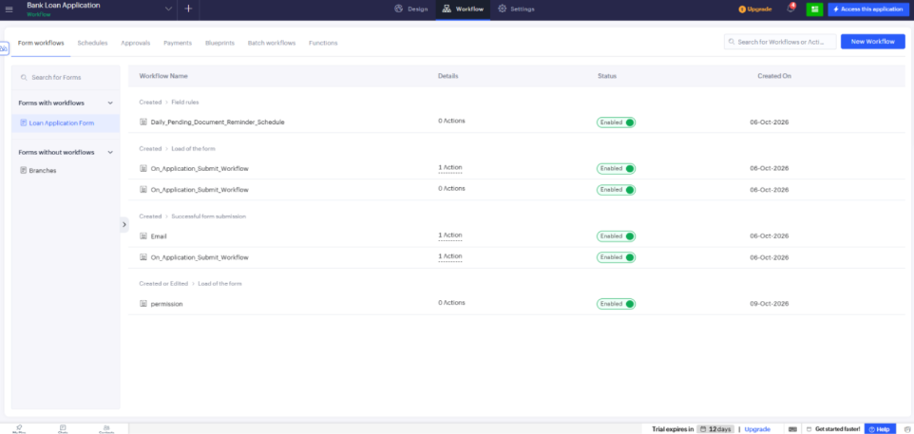
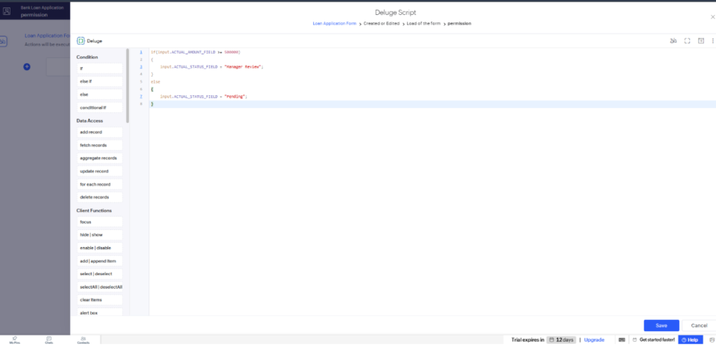
Result:
User management and RBAC rules were successfully configured and tested in Zoho Creator, ensuring robust application security, data isolation, and structured multi-user workflow execution.

