4.b Advanced Data Modelling and Form Design – Bank Loan Application
Aim:
To extend the Bank Loan Application in Zoho Creator by implementing advanced field types and features such as lookup fields, image and file uploads, numeric validation, subforms, URL fields, video/file uploads, fee and accommodation details, rich text content, and digital signatures.
Overview:
Advanced data modelling in Zoho Creator involves using specialized field types and advanced form components to collect, manage, and validate detailed participant information. In this experiment, the basic Bank Loan Application is extended with advanced sections that demonstrate the use of lookup fields, image upload, file upload, decimal/number fields, subforms, URL fields, media upload, fee-related fields, rich text fields, and digital signature fields.
The advanced form contains the following sections: Section E — Branch Verification & KYC (Servicing Branch Lookup, Applicant Photo, Income Proof Upload, Debt-to-Income Ratio); Section F — Joint Application & Media Details (Co-Applicant Details SubForm, Property Listing URL, Property Video Walkthrough, Loan Purpose Voice Note); Section G — Loan Terms & EMI Computation (Has Existing Loan, Loan Amount Requested, Interest Rate Offered, Estimated Monthly EMI Formula); Section H — Declaration & System-Generated Values (Loan Terms Display Rich Text, Applicant Digital Signature, Application Submitted On, Loan Application ID, Application Tracking QR Code).
Procedure:
1. Open the Bank Loan Application created earlier.
2. Add Section E – Branch Verification & KYC. Add the Servicing Branch Lookup field, Applicant Photo image upload, Income Proof Upload file field, and Debt-to-Income Ratio decimal field.
3. Create Section F – Joint Application & Media Details. Add a SubForm for co-applicant member details (Member Name, Member Email, Member Role). Add Property Listing URL field, Property Video Walkthrough, and Loan Purpose Voice Note.
4. Create Section G – Loan Terms & EMI Computation. Add Has Existing Loan With Bank decision box, Loan Amount Requested currency field, Interest Rate Offered percent field, and Estimated Monthly EMI formula field.
5. Create Section H – Declaration & System-Generated Values. Add Loan Terms Display rich text field, Applicant Digital Signature field, Application Submitted On date-time field, Loan Application ID auto-number, and Application Tracking QR Code.
6. Configure the required advanced field properties and validations.
7. Save and preview the completed form.
8. Enter sample data into the advanced fields, add sample co-applicant members through the SubForm, upload required image/file information, provide URL, fee, declaration, and signature information.
9. Submit the completed form and verify the submitted information in the Bank Loan Application report.
Screenshots:
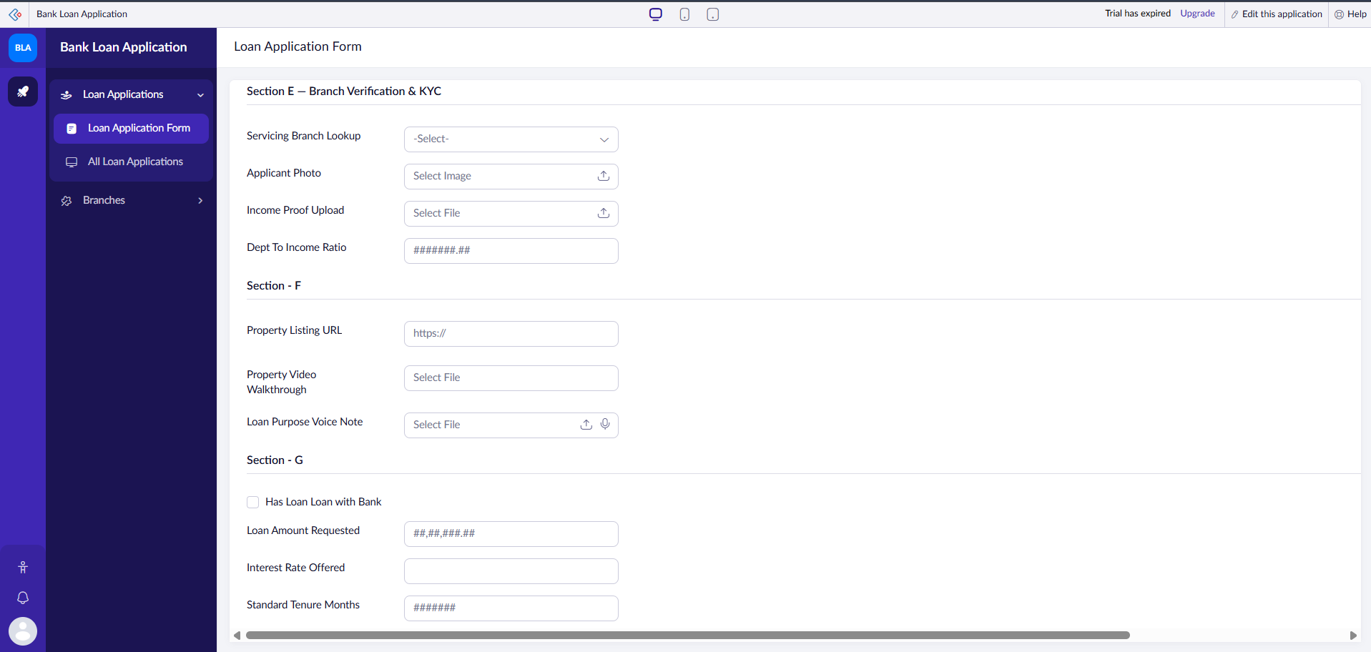
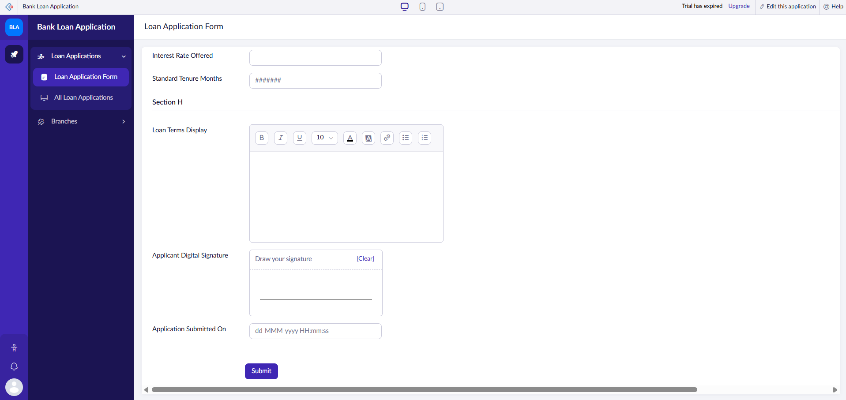
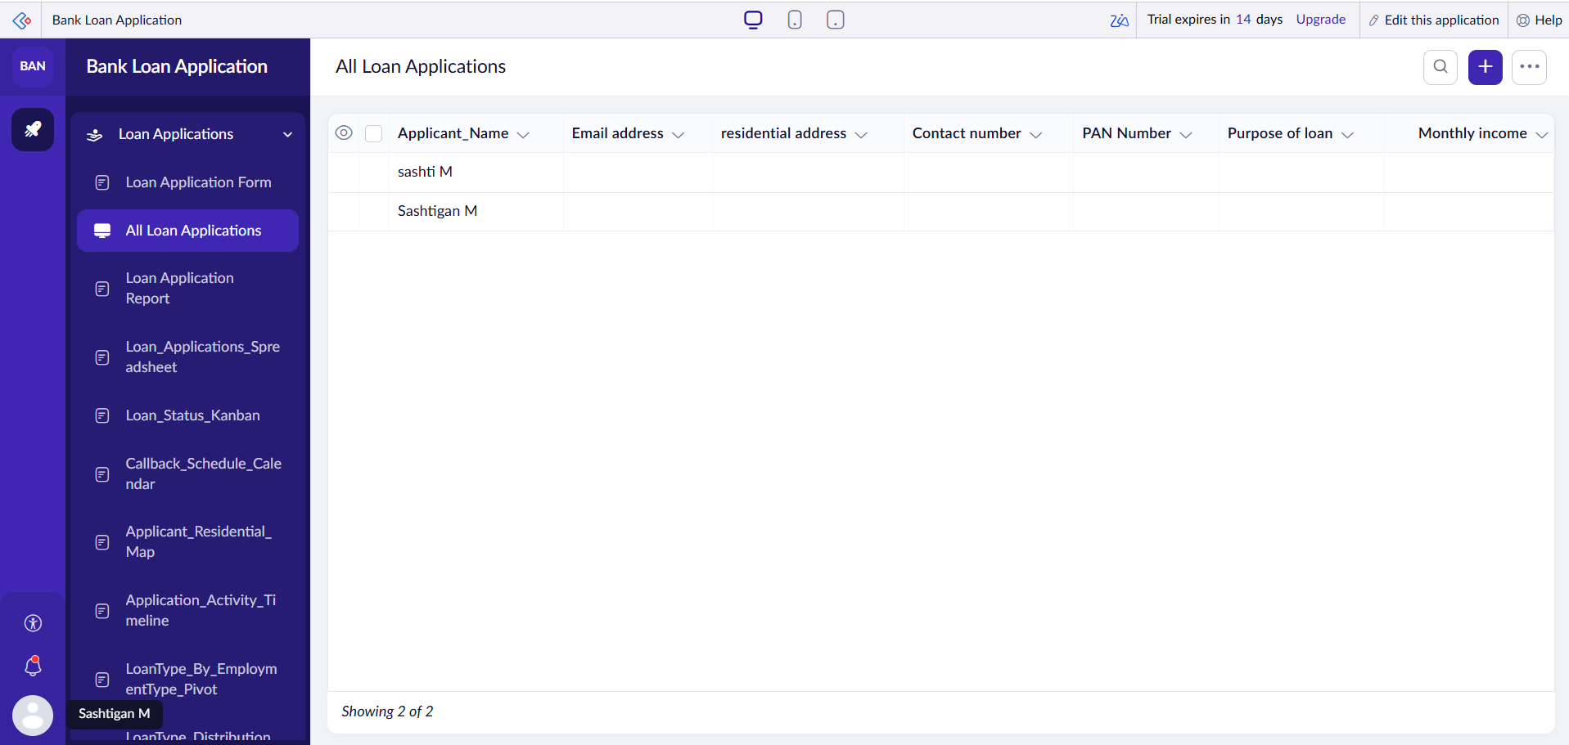
Result:
The Bank Loan Application was successfully extended in Zoho Creator with a structured advanced data model, appropriate validations, and organized sections. Participant records with advanced fields were successfully submitted and displayed in the Loan Application Report, enabling efficient verification and processing.

