6. Bank Loan Application – Automation Suite & Workflow Options
Aim:
To build and document the automation layer for the Bank Loan Application process using Zoho Creator workflow options, covering form workflows, schedules, approvals, payments, blueprints, batch workflows, report workflows, and functions.
Overview:
This experiment demonstrates the use of the eight Zoho Creator workflow options for automating the entire bank loan lifecycle from initial application submission to final disbursement and account settlement. The workflow mapping includes: Form Workflow (On_Loan_Submit_Workflow for acknowledgement emails and notifications), Schedule (Daily_Missing_Document_Reminder_Schedule), Approval (HighValue_Loan_Approval for multi-level credit committee), Payment (Loan_Disbursement_Payout_Workflow), Blueprint (Loan_Lifecycle_Blueprint with stages Submitted → Under Review → Approved → Disbursed), Batch Workflow (Bulk_Cibil_Reconciliation_Batch), Report Workflow (OnEdit_Recalculate_EMI_Workflow), and Function (Generate_Loan_Sanction_Letter_Function).
Procedure:
1. Configure the Form Workflow (On_Loan_Submit_Workflow) to trigger acknowledgement emails to the applicant and internal loan processing cell upon successful form creation.
2. Create the Schedule Workflow (Daily_Missing_Document_Reminder_Schedule) to run daily at 10:00 AM and send reminders for pending document submissions.
3. Set up the Approval Workflow (HighValue_Loan_Approval) with On Start and Level 1 Approver events, including Approve and Reject branching with corresponding email actions.
4. Define the Blueprint (Loan_Lifecycle_Blueprint) with stages Submitted, Under Review, Approved, and Disbursed, and configure the transitions Start_Review, Approve_Loan, Reject_Loan, and Disburse_Loan.
5. Create the Batch Workflow (Bulk_Cibil_Reconciliation_Batch) to execute automated credit bureau updates in batches during off-peak hours.
6. Configure the Report Workflow (OnEdit_Recalculate_EMI_Workflow) to recalculate loan eligibility and EMI metrics after report-level edits.
7. Implement the reusable Function (Generate_Loan_Sanction_Letter_Function) that fetches loan records by ID and sends structured sanction letters using confirmed field link names.
8. Test each workflow with sample records and verify the expected actions and stage transitions.
Screenshots:
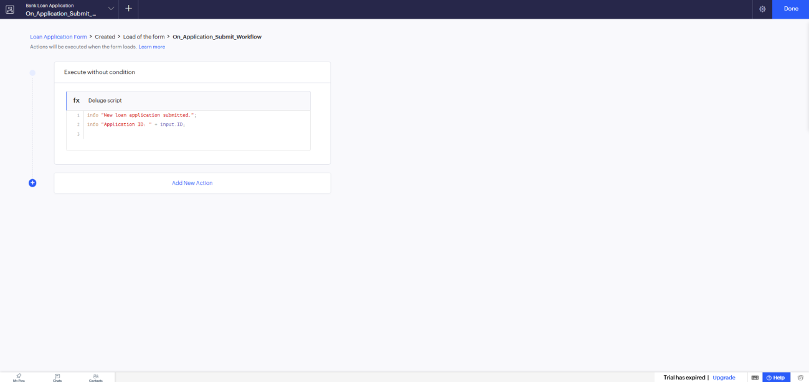
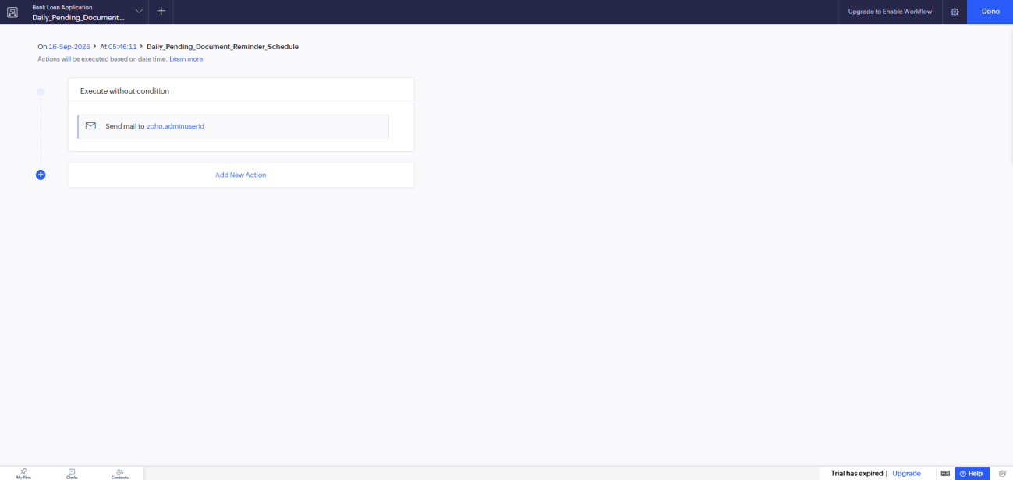
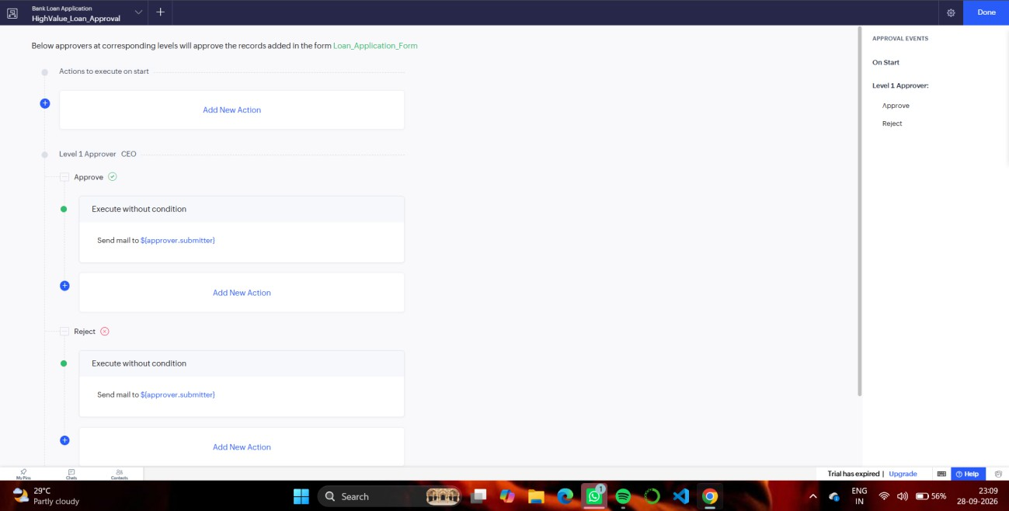
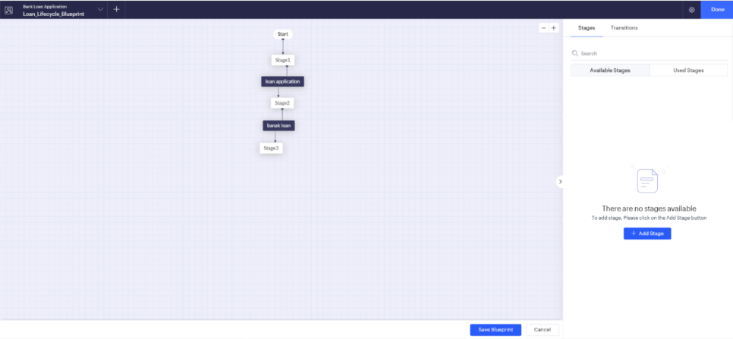
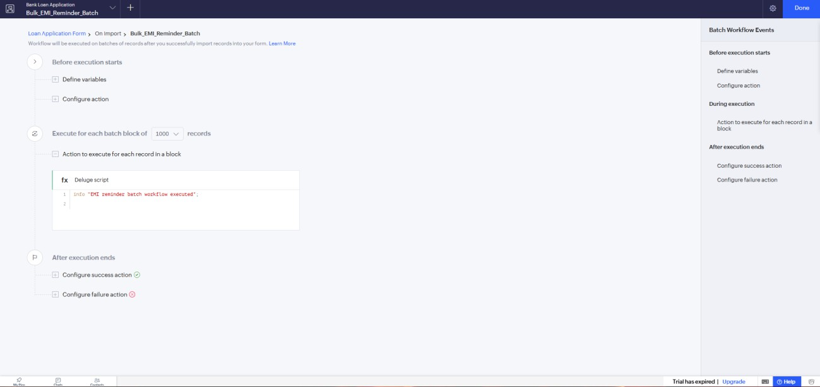
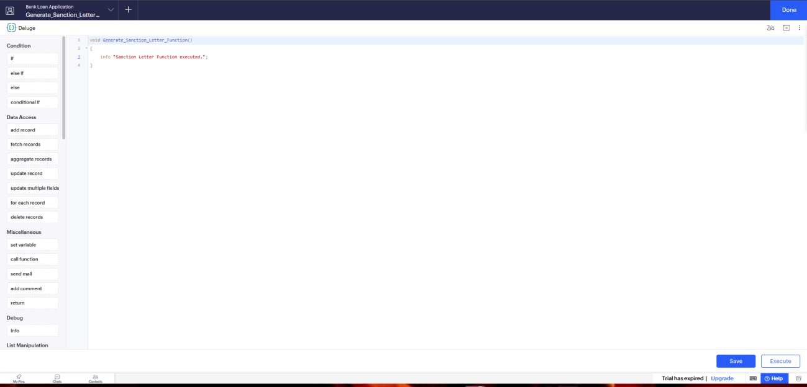
Result:
The Bank Loan Automation Suite was successfully designed, configured, and documented using Zoho Creator’s advanced workflow builder framework, covering form triggers, schedules, approvals, blueprints, batch processing, and custom Deluge functions tailored specifically to bank loan operations.

