5.b Bank Loan Application – Zoho Creator Command Center Page
Aim:
To design and build a single internal Command Center Page in Zoho Creator for the existing Bank Loan Application, demonstrating the correct usage of all eleven Page Builder elements (Panel, Board, Chart, Gauge, Search, Form, Report, Snippets, Button, Widgets, and Viewer) so that the Loan Processing Cell has one unified workspace to monitor, manage, and act on loan application data.
Overview:
The Command Center Page brings together all key page elements into a single operational workspace. Elements used include: Panel (Command_Center_Main_Panel), Board (Loan_Status_Board), Chart (LoanType_Popularity_Chart_Widget), Gauge (Loan_Disbursement_Target_Gauge), Search (Applicant_Search_Bar), Form (Quick_Counter_Loan_Form), Report (Full_Loan_Applications_Report), Snippets (Loan_Approval_Checklist_Snippet), Button (Send_Interview_Reminder_Button), Widgets (Disbursement_And_Interest_Rate_Widgets), and Viewer (PAN and Income Certificate Viewer).
The page is organized into five sections: Overview Strip (Gauge, Chart, Search), Processing Workspace (Button, Board), Detailed Data (Report), Reference & Quick Actions Sidebar (Snippet, Viewer, Form), and Operations Strip (Widgets). All sections are contained within the main structural Panel.
Procedure:
1. Open the Bank Loan Application in Zoho Creator and create a new Page named Command Center.
2. Add a Panel element named Command_Center_Main_Panel to serve as the structural container for the entire page.
3. In Section 1 (Overview Strip) place the Loan Disbursement Target Gauge, Loan Type Popularity Chart Widget, and Applicant Search Bar.
4. In Section 2 (Processing Workspace) add the Send Interview Reminder Button and the Loan Status Board.
5. In Section 3 (Detailed Data) embed the Full Loan Applications Report.
6. In Section 4 (Reference & Quick Actions Sidebar) add the Loan Approval Checklist Snippet, PAN and Income Certificate Viewer, and the Quick Counter Loan Form.
7. In Section 5 (Operations Strip) place the Disbursement Availability and Interest Rate Widgets.
8. Configure layout, sizing, and data sources for each element so that live loan data is displayed.
9. Save the page and test it in live mode to confirm all components load and interact correctly.
Screenshots:
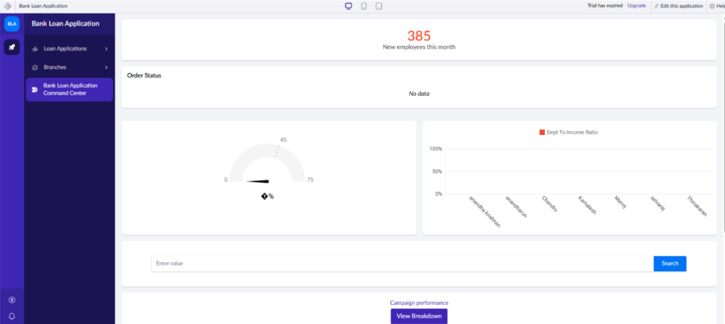
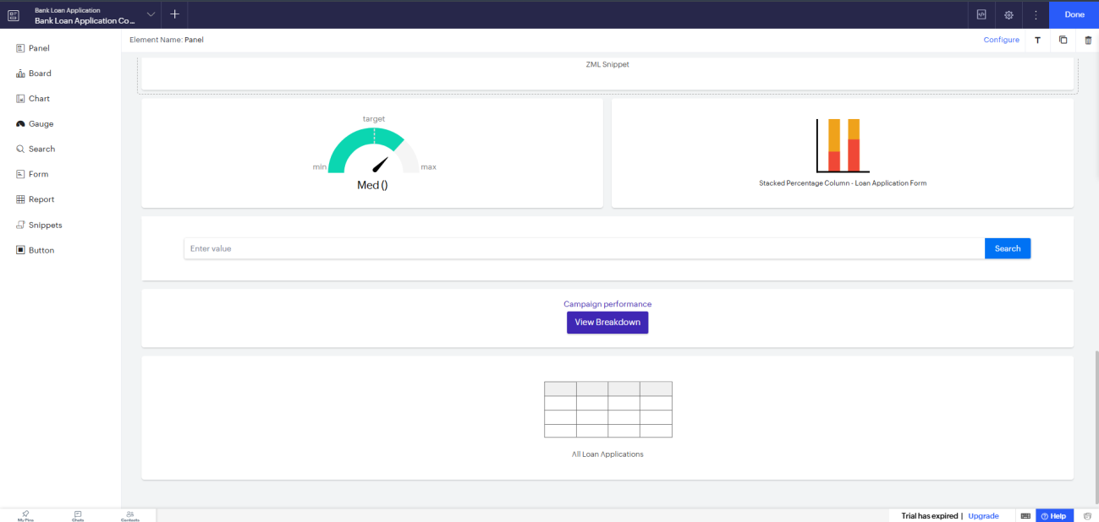
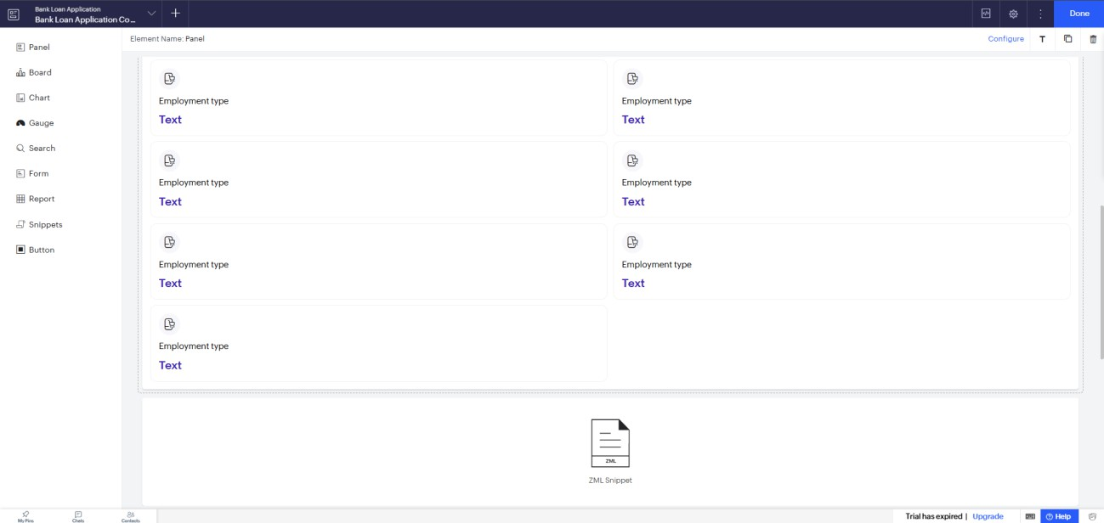
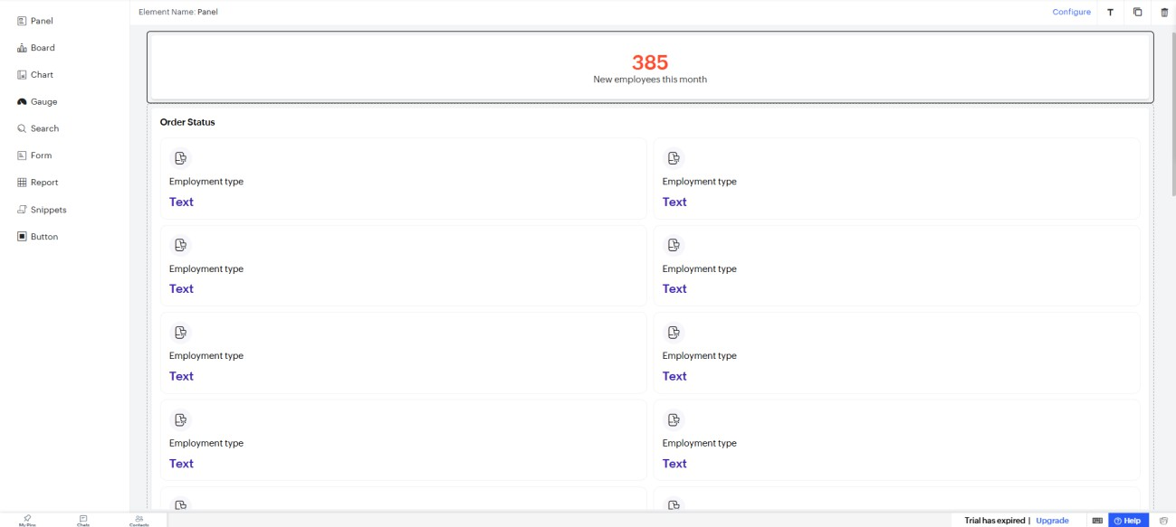
Result:
A single internal Command Center Page in Zoho Creator for the existing Bank Loan Application was successfully created, incorporating all eleven Page Builder elements into a unified workspace for the Loan Processing Cell.

