5.a Bank Loan Application – Zoho Creator Reports Suite
Aim:
To design and build a complete suite of Reports in Zoho Creator for the Bank Loan Application, demonstrating the correct usage of all nine Report Types available in Zoho Creator.
Overview:
A complete reports suite was created using the nine report types available in Zoho Creator: List View (Loan Application Report), Spreadsheet View (Loan_Applications_Spreadsheet), Kanban View (Loan_Status_Kanban), Calendar View (Callback_Schedule_Calendar), Map View (Applicant_Residential_Map), Timeline View (Application_Activity_Timeline), Pivot Table (LoanType_By_EmploymentType_Pivot), Chart View (LoanType_Distribution_Chart), and Summary View (Loan_Wise_Summary).
Each report serves a specific operational purpose: the List View acts as the default landing report with search and filters; Spreadsheet View enables quick inline updates; Kanban provides a visual pipeline for status tracking; Calendar manages callbacks and interviews; Map visualizes applicant geography; Timeline tracks activity velocity; Pivot summarizes relationships; Chart offers graphical distribution; and Summary aggregates portfolio metrics for committee review.
Procedure:
1. Open the Bank Loan Application in Zoho Creator and navigate to the Reports section.
2. Create the Loan Application Report as a List View with global search, sorting, and column filters for applicant details, PAN, email, contact, address, and employment type.
3. Create Loan_Applications_Spreadsheet as Spreadsheet View allowing inline editing for verification and employment fields while keeping baseline details read-only.
4. Create Loan_Status_Kanban as Kanban View with columns for different review stages; enable drag-and-drop status updates.
5. Create Callback_Schedule_Calendar as Calendar View for monitoring client callbacks, follow-ups, and interview dates with monthly/weekly/daily grids.
6. Create Applicant_Residential_Map as Map View with geocode-enabled pins to visualize applicant distribution.
7. Create Application_Activity_Timeline as Timeline View to track application inflow and peak submission periods.
8. Create LoanType_By_EmploymentType_Pivot as Pivot Table summarizing relationships and aggregate metrics.
9. Create LoanType_Distribution_Chart as Chart View for visual comparison of loan distributions with filters.
10. Create Loan_Wise_Summary as Summary View displaying calculated totals and category groupings for executive review.
11. Verify each report loads correctly and displays the expected data.
Screenshots:
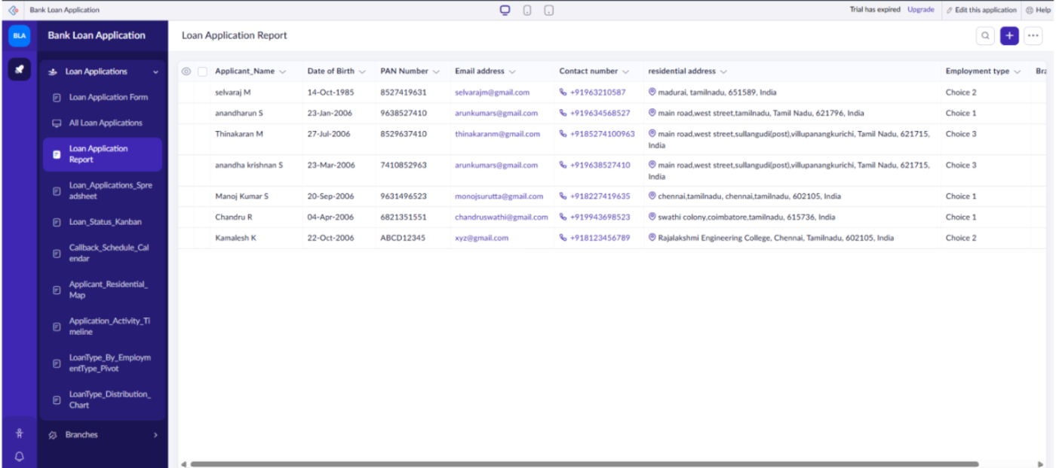
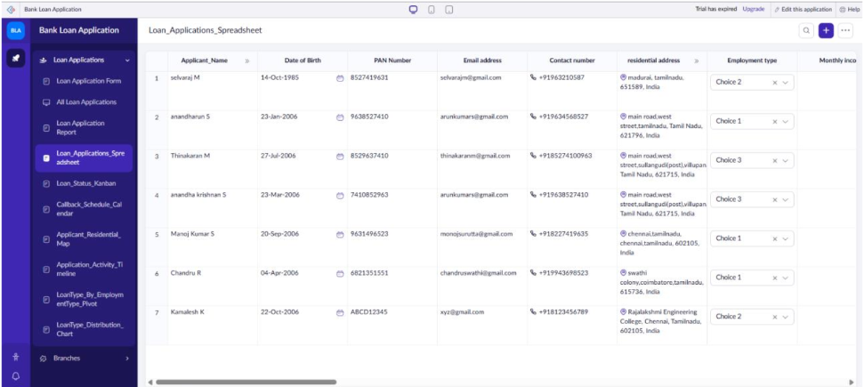
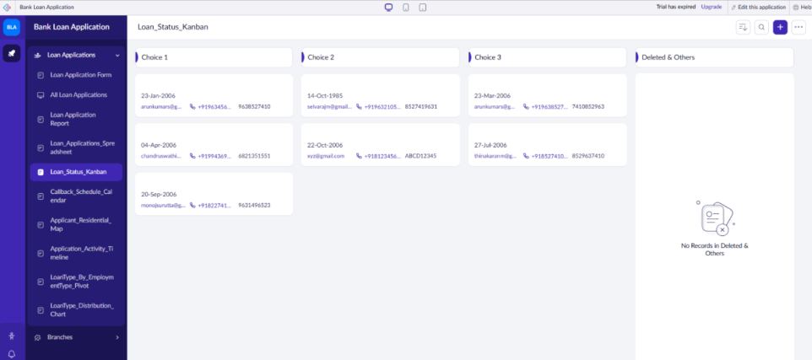
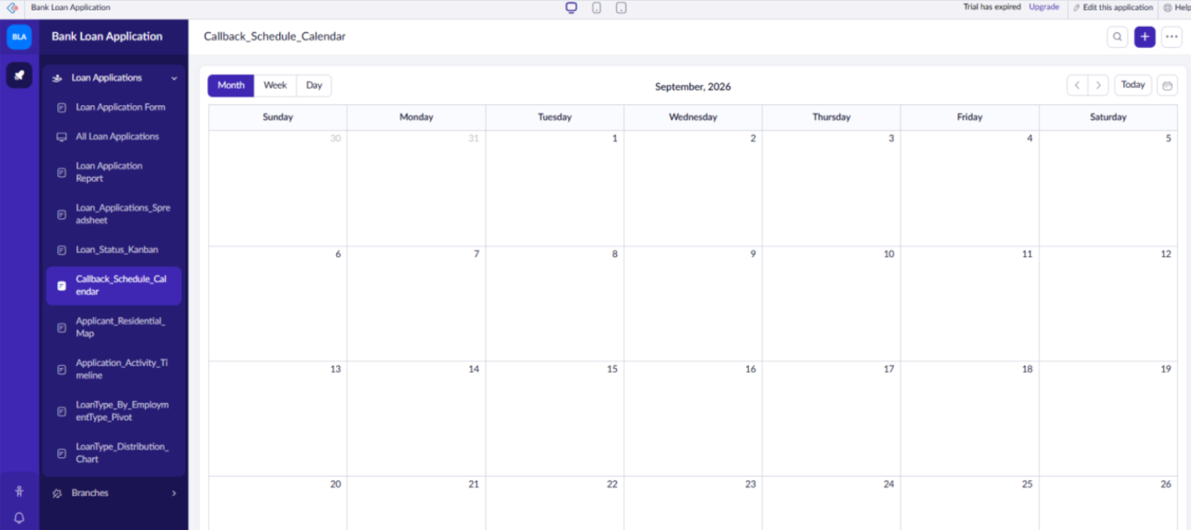
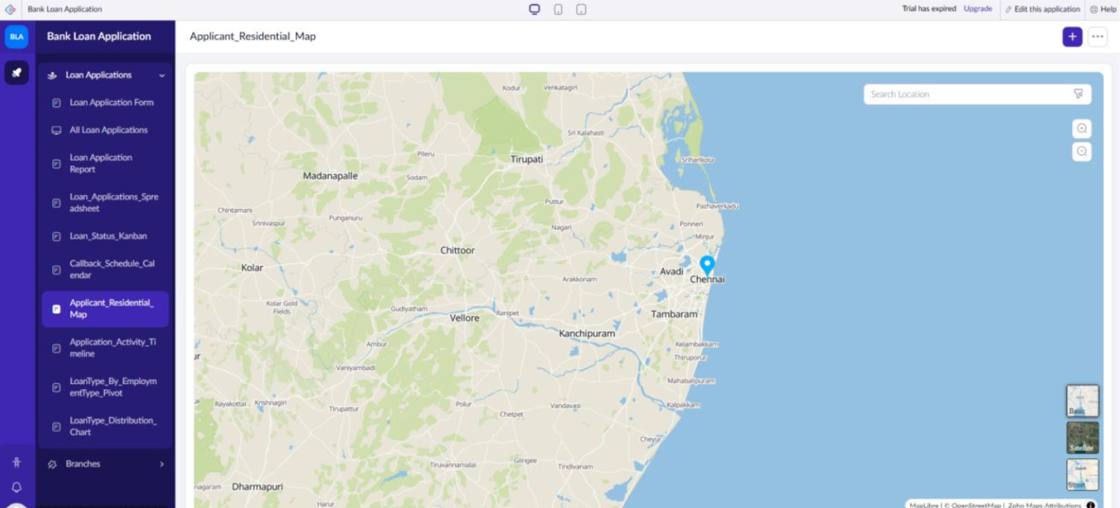
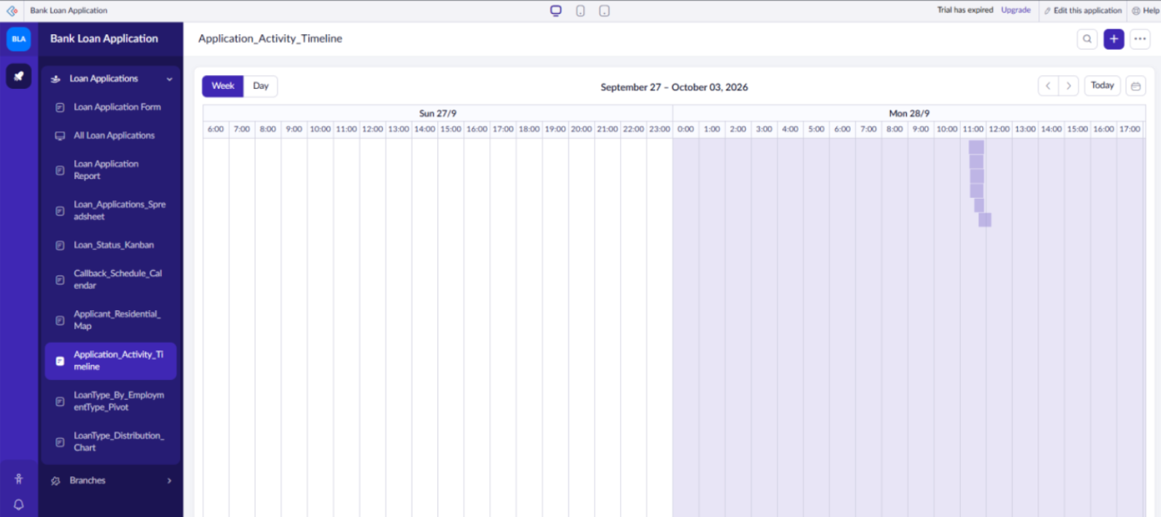
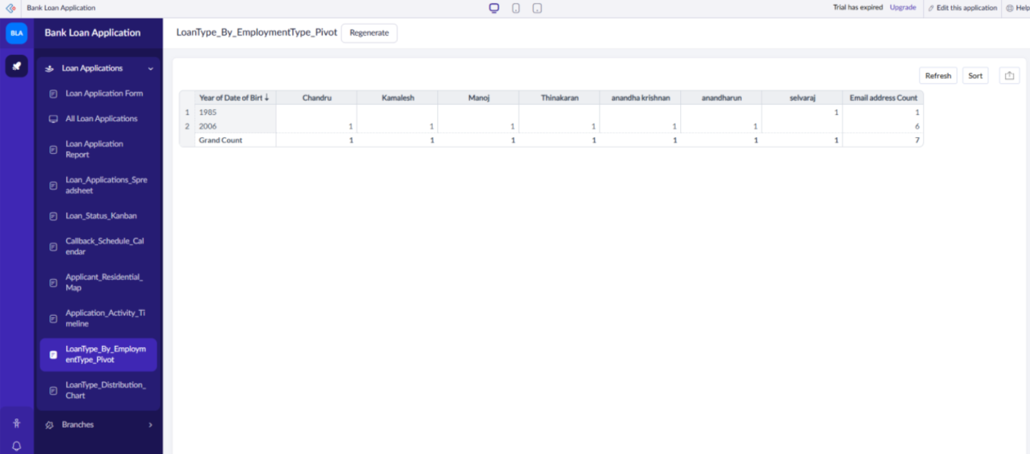
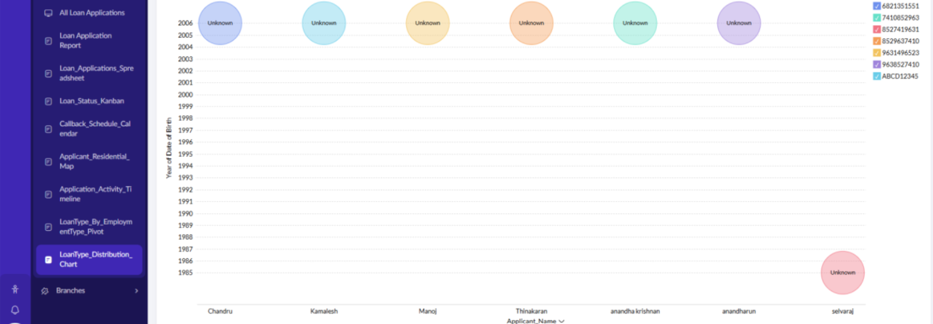
Result:
A complete suite of nine custom Zoho Creator reports for the Bank Loan Application project has been successfully configured, verified, and documented, covering List, Spreadsheet, Kanban, Calendar, Map, Timeline, Pivot, Chart, and Summary views.

