11. Deploying Zoho Creator App to Production
Aim:
To understand and execute the deployment lifecycle of a Zoho Creator application, moving components from the sandboxed Development Environment to the Live Production Environment safely and efficiently.
Overview:
Zoho Creator provides distinct environments to separate application building and testing from live user operations. Proper deployment ensures data integrity and seamless release management. Development (Sandbox) is used for building forms, writing Deluge scripts, and testing features without impacting live data. Production (Live) is the environment accessed by end-users, containing active transactional data and strict access controls. Migration & Publish is the controlled process of pushing schema changes, workflows, and configurations from Dev to Prod.
Procedure:
1. Pre-Deployment Validation: Open the fully tested application in the Zoho Creator development workspace. Verify that all Deluge scripts, workflow triggers, and reports are fully functional.
2. Initiating Migration: Navigate to the deployment manager or settings menu and select the option to push or migrate changes to the production environment.
3. Reviewing Schema & Component Diffs: Inspect the comparison report generated by Zoho Creator, which highlights newly added forms, modified fields, or updated script blocks.
4. Resolve any conflicts or missing dependencies shown in the diff report.
5. Confirm the migration and publish the changes to the live Production environment.
6. Perform a post-deployment smoke test on the live application to ensure forms, workflows, and reports behave as expected.
Screenshots:
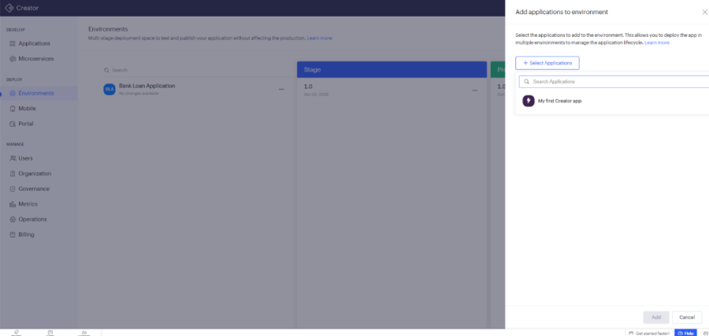
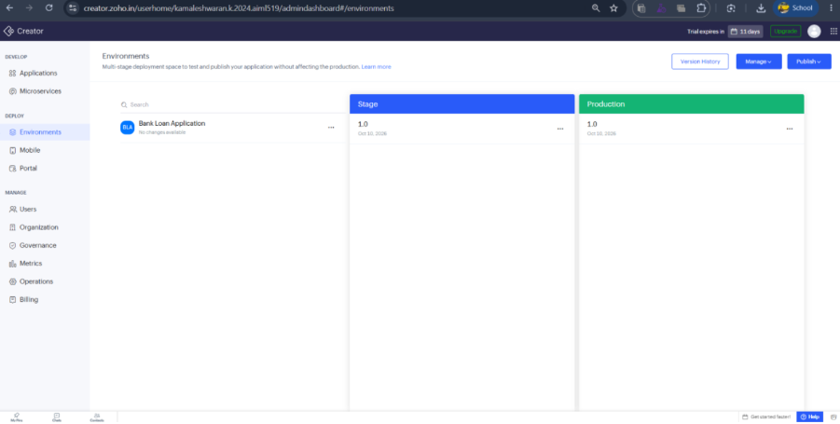
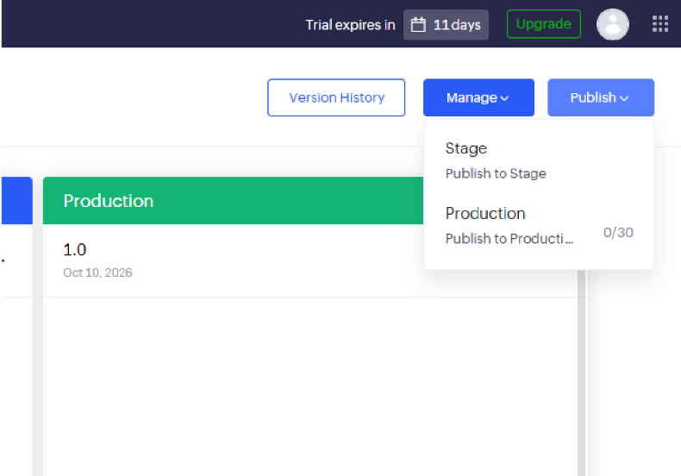
Result:
The deployment lab successfully demonstrated the transition lifecycle of a low-code application from development to production in Zoho Creator, emphasizing safe release management and environment isolation.

