**AIR QUALITY MONITORING**

**INTRODUCTION:**

The main goal of this project is to create a system that can measure various air quality parameters and display or transmit this information for real-time monitoring. This system is particularly useful for individuals, schools, communities, or environmental enthusiasts who want to keep track of air quality in their immediate surroundings.

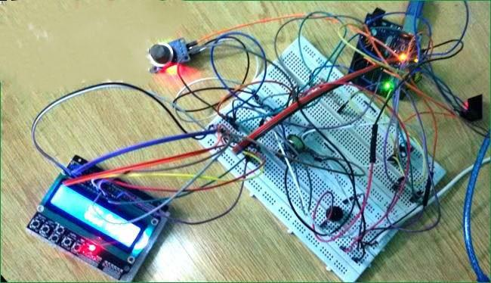

**Air Quality Monitoring System using Arduino**

**COMPONENTS AND SENSORS:**

**The project involves the use of several components and sensors:**

* Arduino Board
* Air Quality Sensor (MQ135 Gas sensor)
* Display (16X2 LCD)
* Wi-Fi Module (ESP8266)
* Power Supply
* Breadboard and Jumper Wires
* Buzzer (optional)
* 10K potentiometer
* 220 ohm resistor
* 1K ohm resistors

**CIRCUIT DIAGRAM AND EXPLANATION:**

First of all we will connect the ESP8266 with the Arduino. ESP8266 runs on 3.3V and if you will give it 5V from the Arduino then it won’t work properly and it may get damage. Connect the VCC and the CH_PD to the 3.3V pin of Arduino. The RX pin of ESP8266 works on 3.3V and it will not communicate with the Arduino when we will connect it directly to the Arduino. So, we will have to make a voltage divider for it which will convert the 5V into 3.3V. This can be done by connecting three resistors in series like we did in the circuit. Connect the TX pin of the ESP8266 to the pin 10 of the Arduino and the RX pin of the esp8266 to the pin 9 of Arduino through the resistors.

ESP8266 Wi-Fi module gives your projects access to Wi-Fi or internet. It is a very cheap device and make your projects very powerful. It can communicate with any microcontroller.

Then we will connect the MQ135 sensor with the Arduino. Connect the VCC and the ground pin of the sensor to the 5V and ground of the Arduino and the Analog pin of sensor to the A0 of the Arduino.

Connect a buzzer to the pin 8 of the Arduino which will start to beep when the condition becomes true.

**CONNECT LCD WITH ARDUINO:**

The connections of the LCD are as follows,

* Connect pin 1 (VEE) to the ground.
* Connect pin 2 (VDD or VCC) to the 5V.
* Connect pin 3 (V0) to the middle pin of the 10K potentiometer and connect the other two ends of the potentiometer to the VCC and the GND. The potentiometer is used to control the screen contrast of the LCD. Potentiometer of values other than 10K will work too.

* Connect pin 4 (RS) to the pin 12 of the Arduino.
* Connect pin 5 (Read/Write) to the ground of Arduino. This pin is not often used so we will connect it to the ground.
* Connect pin 6 (E) to the pin 11 of the Arduino. The RS and E pin are the control pins which are used to send data and characters.
* The following four pins are data pins which are used to communicate with the Arduino.
* Connect pin 11 (D4) to pin 5 of Arduino.
* Connect pin 12 (D5) to pin 4 of Arduino.
* Connect pin 13 (D6) to pin 3 of Arduino.
* Connect pin 14 (D7) to pin 2 of Arduino.
* Connect pin 15 to the VCC through the 220 ohm resistor. The resistor will be used to set the back light brightness. Larger values will make the back light much more darker.
* Connect pin 16 to the Ground.

**DESIGN FOR BASIC CONNECTIONS**

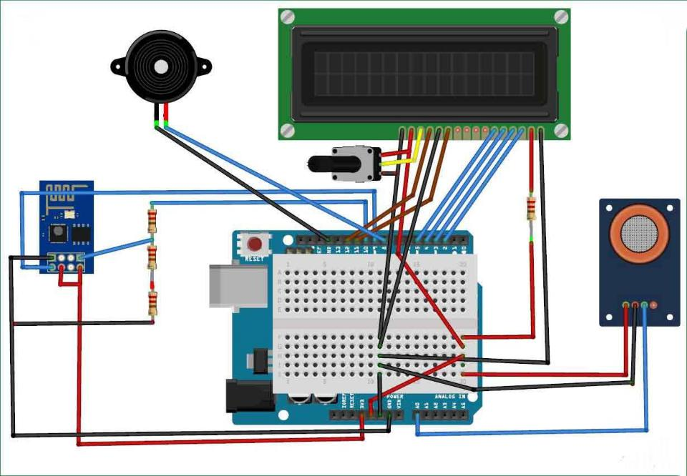

**PROGRAMING CODE:**

#include <LiquidCrystal_I2C.h>

#include <Wire.h>

LiquidCrystal_I2C lcd(0x27, 16, 2);

const int buzzerPin = 7; // Buzzer connected to pin 7

const int sensorPin = A0; // MQ135 analog pin

void setup() {

lcd.begin(16, 2);

lcd.print("Air Quality");

lcd.setCursor(0, 1);

lcd.print("Monitoring");

pinMode(buzzerPin, OUTPUT);

}

void loop() {

float ppm = readMQ135(); // Read pollution level in PPM

lcd.clear();

lcd.print("Pollution Level:");

lcd.setCursor(0, 1);

lcd.print(ppm);

if (ppm < 1000) {

noTone(buzzerPin); // Turn off buzzer

} else if (ppm < 2000) {

tone(buzzerPin, 1000); // Start beeping if pollution exceeds 1000 PPM

lcd.clear();

lcd.print("Poor Air, Open");

lcd.setCursor(0, 1);

lcd.print("Windows");

} else {

tone(buzzerPin, 2000); // Continuous beeping if pollution exceeds 2000 PPM

lcd.clear();

lcd.print("Danger! Move to");

lcd.setCursor(0, 1);

lcd.print("fresh Air");

**}** delay(5000); // Delay for 5 seconds between readings

}

float readMQ135() {

int sensorValue = analogRead(sensorPin);

float voltage = sensorValue * (5.0 / 1024.0); // Convert analog reading to voltage

return voltage;

}

**WORKING EXPLANATION:**

The MQ135 sensor can sense NH3, NOx, alcohol, Benzene, smoke, CO2 and some other gases, so it is perfect gas sensor for our Air Quality Monitoring Project. When we will connect it to Arduino then it will sense the gases, and we will get the Pollution level in PPM (parts per million). MQ135 gas sensor gives the output in form of voltage levels and we need to convert it into PPM. So for converting the output in PPM, here we have used a library for MQ135 sensor, it is explained in detail in “Code Explanation” section below.

Sensor was giving us value of 90 when there was no gas near it and the safe level of air quality is 350 PPM and it should not exceed 1000 PPM. When it exceeds the limit of 1000 PPM, then it starts cause Headaches, sleepiness and stagnant, stale, stuffy air and if exceeds beyond 2000 PPM then it can cause increased heart rate and many other diseases.

When the value will be less than 1000 PPM, then the LCD and webpage will display “Fresh Air”. Whenever the value will increase 1000 PPM, then the buzzer will start beeping and the LCD and webpage will display “Poor Air, Open Windows”. If it will increase 2000 then the buzzer will keep beeping and the LCD and webpage will display “Danger! Move to fresh Air”.

**CONCLUSION:**

This project is a versatile and valuable tool for tracking air quality and can be customized to meet specific needs, whether for personal use or community monitoring efforts. It helps raise awareness about air quality issues and empowers individuals and communities to take action to improve environmental condition.