Advanced Wireless Power Transfer System

The project is a device to transfer power wirelessly instead of using conventional copper cables and current carrying wires. The concept of wireless power transfer was introduced by Nikolas Tesla. This power is made to be transferred within a small range only for example charging rechargeable batteries etc.
For demonstration purposes we have used a fan instead of battery that operates by using wireless power. This requires an electronic circuit for conversion of AC 230V 50Hz to AC 12V, high frequency and this is then fed to a primary coil of an air core transformer.
The secondary coil of the transformer develops 12V high frequency. Therefore by this way the power gets transferred through primary coil to secondary coil that are separated by certain distance around 3cm. Here the primary coil acts as transmitter and secondary coil receives the power to run a load. This project can be used to charge batteries of a pace maker and similar applications.

Block Diagram:

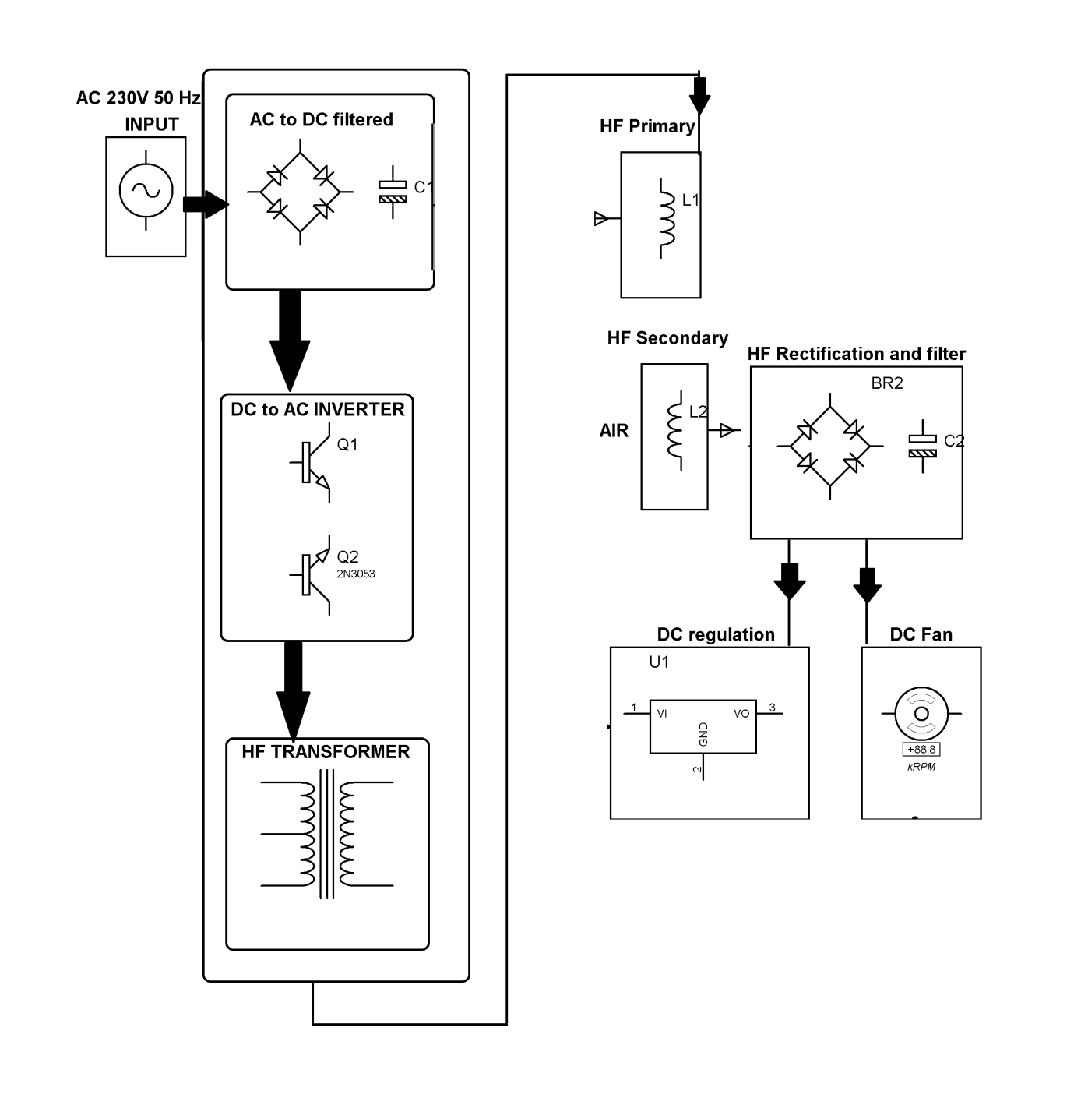

Hardware Specifications
- HF-Transformer
- Two air filled inductor coils
- Rectifier
- Transistors
- HF-diodes
- BLDC fan
- Voltage regulator

