IOT based Anti-theft Flooring System using Raspberry Pi
Security and safety have always become a basic necessity for the urban population. With the rapid urbanization and development of big cities and towns, the graph of crimes is also on the rise. To secure and guard our house in our absence, this system came up with the rescue. This system is secure flooring tile connected with IOT when we go out of house, the system is on, then whoever comes inside the house it passes the information over IOT. This system powered is by Raspberry pi it includes, two tiles for demonstration purpose, Piezo sensor. Whenever the thief enters in the house, and steps on the floor immediately it will send a message on IOT system.

Block Diagram:

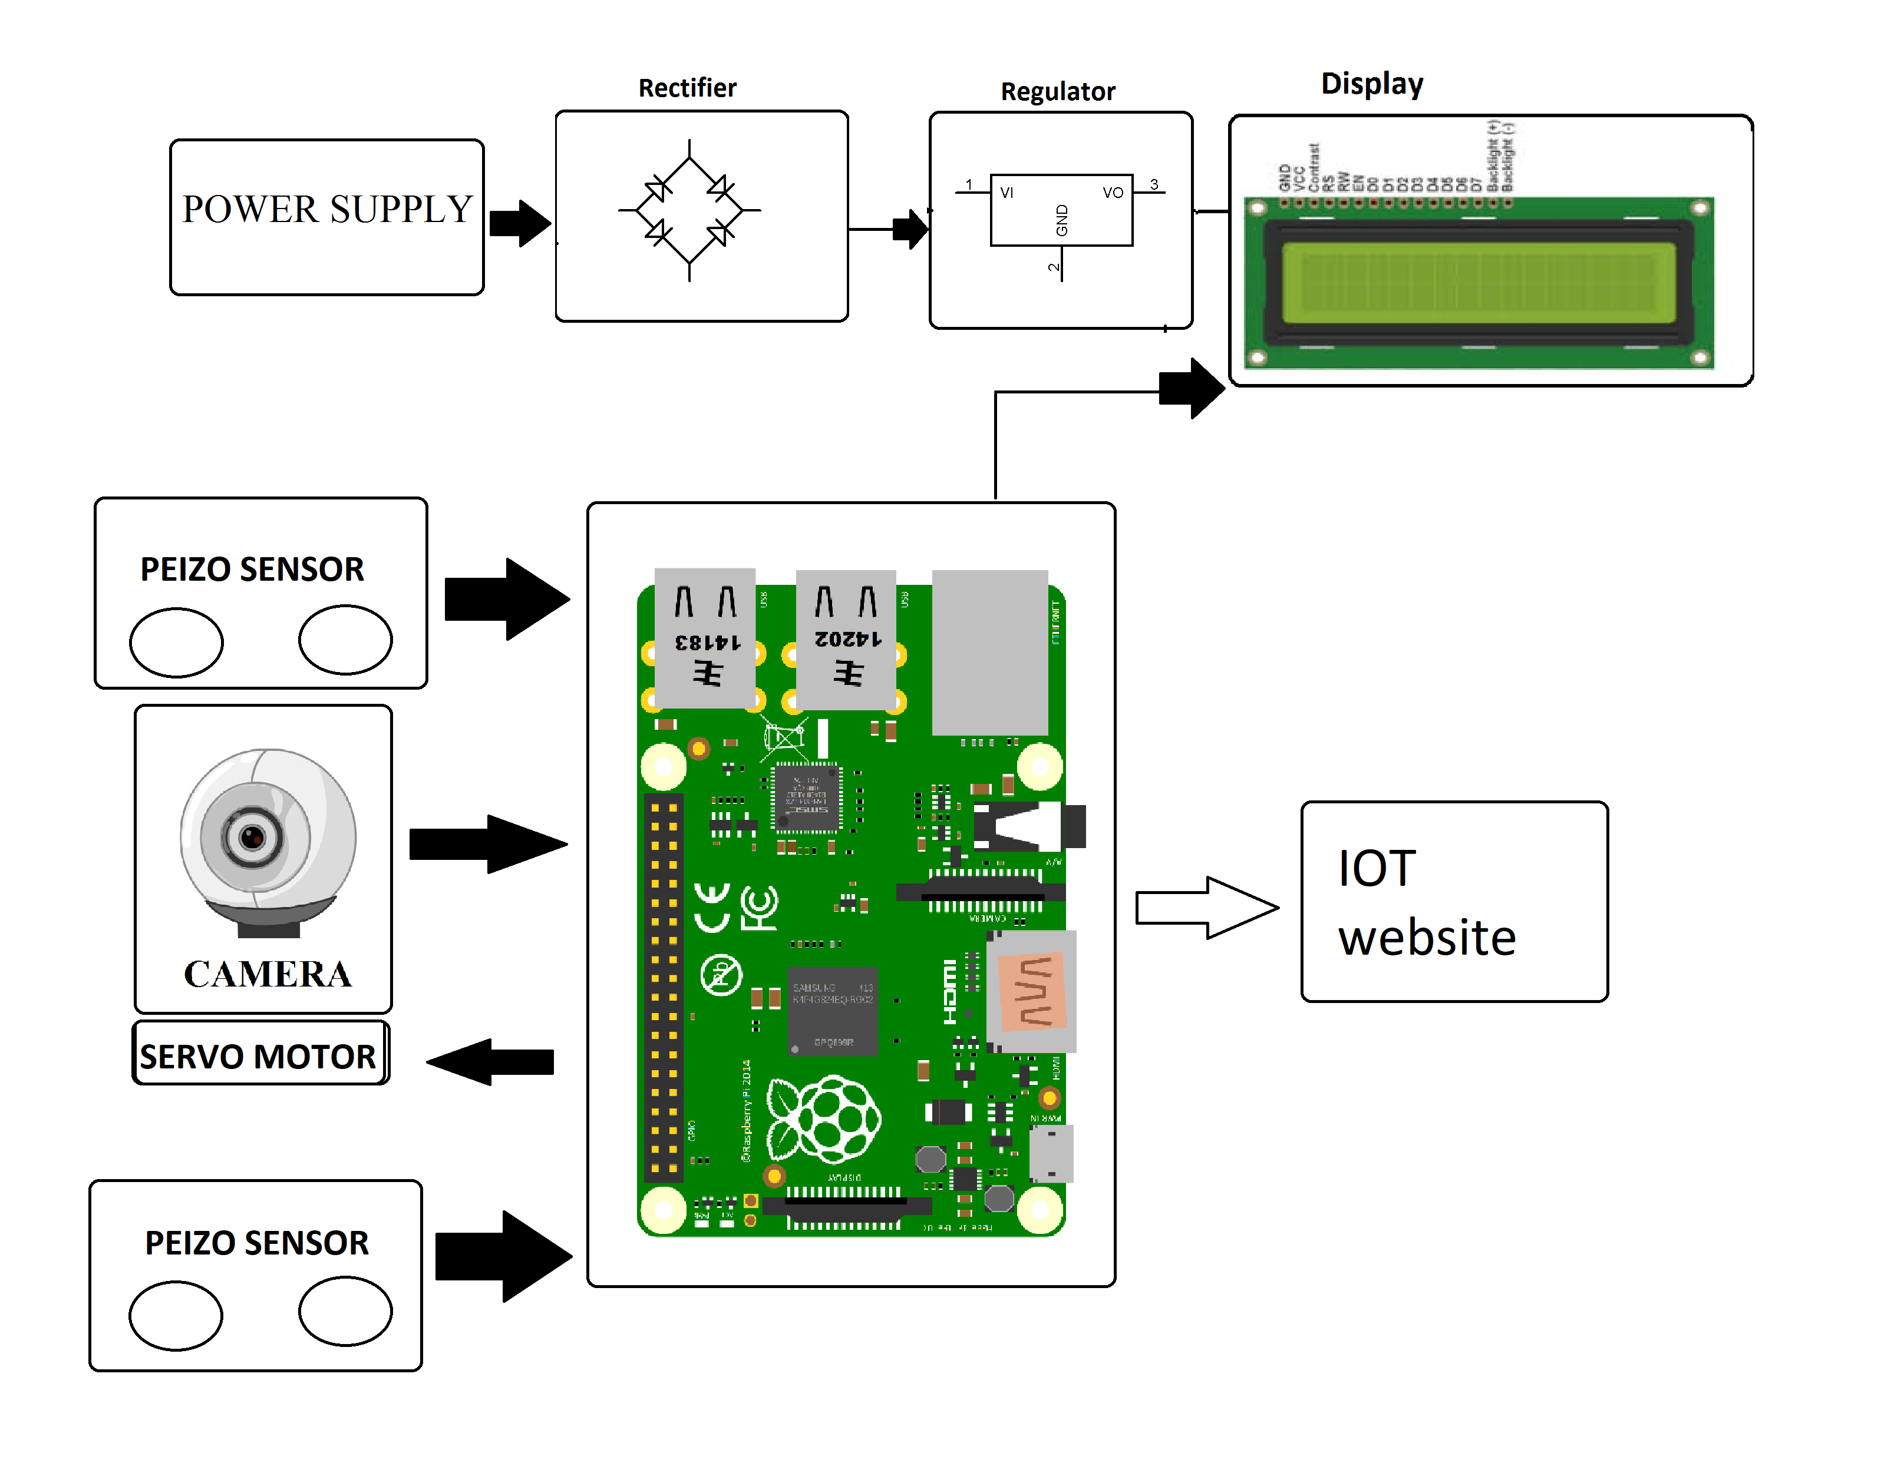

Hardware Specifications

- Raspberry Pi
- Peizo Sensor
- Wifi Modem
- Buzzer
- Resistor
- Capacitors
- Transistors
- Cables and Connectors
- Diodes
- PCB and Breadboards
- LED
- Transformer/Adapter
- Push Buttons
- Switch
- IC
- IC Sockets

Software Specifications

- Python 3 compiler
- Programming Language: Python

